Test assignment

For the position of Game Client Developer at NetEnt

Table of Contents

Introduction 3

Advanced mode 3

Assessment 3

Recommendation 3

Submission notes 3

Specification 4

Overview 4

Layout 4

Loading 4

Game 4

Winning 5

Flow 5

Mathematics 6

*Feature 6

Technical specification 7

Loading 7

Assets 7

References 8

# Introduction

Test assignment is given to showcase candidate`s skills in analyzing requirements, programming and delivering together with his/her technology awareness.

This specification describes basic requirements abstracting from details. So, feel free to add your personality to the implementation.

## Advanced mode

Advanced options are presented to help candidate better showcase his/her capabilities and may be especially useful for more junior candidates with lack of commercial and delivery experience to stand out among other candidates.

## Assessment

When assessing this assignment next priorities take place in order of importance:

1. Working solution  
   First of all you game should playable.
2. Code complexity  
   Your code should represent your skills to be neat and brief with implementation, not overcomplicating implementation.
3. Project structure  
   How you structure and build your code can give us a brief idea of how you understand and feel the process of modern web development.
4. Code style  
   The last but not least is your code style, how you keep it and what value you see in it.

### Recommendation

If you are an experienced developer pay more attention to structure and style, rather that functionality, as your experience usually already shows that you can make things done, while if you are more junior developer – try to show that you can makes things done with functionality, as structure and style are things that come with experience.

## Submission notes

To submit completed test assignment, send a link to the repository with read permissions for hiring manager and reviewing engineer or send a .zip file with your project.

In some cases, with approval from hiring manager, another recent game may be submitted if it satisfies next conditions:

* game developed by candidate alone
* game developed within a year
* game based on position relevant technologies.

# Specification

## Overview

Create video slot game 1x3 – 3 reels with one line. 6 symbols, including one wild symbol.

## Layout

The game should consist of 3 screens: loading, game, winning.

### Loading

Loading should be represented with white text “Loading” in the center of the screen on black background.

### Game

Game should be represented with reels and button “Play”.

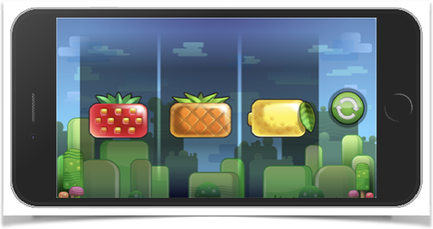

Figure . Game screen

*Advanced Game screen includes more visible symbols and game state – cash amount and win amount.

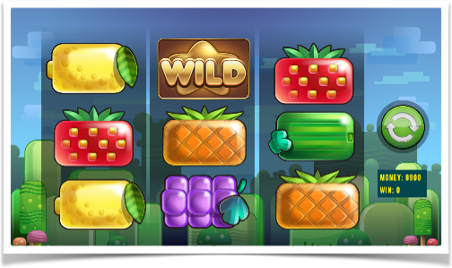

Figure . Advanced Game screen with more symbols visible and game state

### Winning

Winning screen should display win announce.

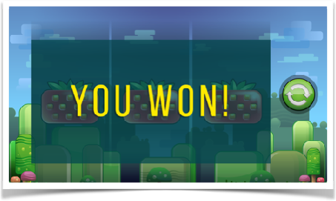

Figure . Winning screen

*Advanced screen may also display win amount.

## Flow

Game flow includes screen transitions and game state update.

On game start Loading screen is started, that after assets are loaded Game screen appears. On “Play” button click game state changes – symbols on reels changing and “Play” button becomes “grey”. Symbols change is animated. After animation ends, or if user clicks “Play” button symbols combination is displayed and “Play” button becomes “green”. If symbols form a winning combination – Winning screen appears for 3 seconds, or till user clicks anywhere on the screen, while winning screen is shown “Play” button is grey and can’t be clicked. Then Game screen is shown and “Play” button is green.

Figure . Game flow, where blue rectangle is screen, orange ellipse - action or animation and arrows for game events

## Mathematics

Video slots are games based on math model. Math is out of scope of this assignment, so consider random symbols with one win per 5 spins.

*Advanced math adds player state with cash and fixed bet per spin. Assume player cash is 100 coins and bet - 5 coins. When player clicks “Play” button (spins) he pays 5 coins. In case of loose nothing happens, in case of win, he earns x2 (10 coins). Player can spin only while he has enough coins for the bet.

## *Feature

Advance assignment also includes Wild feature. Wild feature is a symbol that can replace any other symbol but is not a winning symbol itself. Consider next paytable:

* 3 wilds – loss
* 1 any symbol and 2 wilds – win
* 2 any same symbols and 1 wild – win

Reel number or order of the symbols in a sequence does not matter.

# Technical specification

Assignment should be completed using web technologies, being a web app. Game should be playable on desktop with Chrome, Firefox or Safari browsers.

Recommended technologies:

* Typescript or ES2015+
* pixi.js
* webpack or gulp

*Advanced requirements include mobile friendly implementation in landscape and portrait keeping layout.

## Loading

All assets should be preloaded on the start of the game and listed in .json file, that should be fetched by AJAX request on the start of the game.

## Assets

All required assets provided with this assignment, feel free to use custom assets at will.

# References

1. NetEnt Games // <https://games.netent.com>
2. Pixi.JS rendering engine // <https://www.pixijs.com>
3. Typescript // <https://www.typescriptlang.org>
4. Webpack bundler // <https://webpack.js.org>
5. How Slots Work // <https://www.onlinegamblingsites.com/casino/slots/how-slots-work/>
6. Slots Math // <https://www.gamblersbookcase.com/Slots-Math.htm>