**Installation & Set up tips**

This document contains a few miscellaneous notes on the installation and set-up of SAS University Edition. Copies of the documentation referred to are also included in the online materials.

**Hardware Virtualization Support**

In the document **SAS® University Edition: Installation Guide for Windows,** Chapter 1: ‘Requirements’ includes

“Hardware virtualization (sometimes abbreviated as VT, VT-x, or AMD-V) must be supported and enabled in the system’s BIOS. For more information see http://support.sas.com/kb/46/250.html. ”

Unfortunately, it is not easy to tell whether this requirement is met. On most modern 64bit PCs it will be. On some older PCs it might not be. The link gives further information which shows how to determine if hardware virtualization is supported, but the procedure is somewhat involved. Many users will be tempted to continue.

VirtualBox and VMWare Player may both install without errors or warnings, but will fail when trying to run SAS University Edition.

On a PC with an Intel Core2 duo processor VirtualBox generated the following error message.

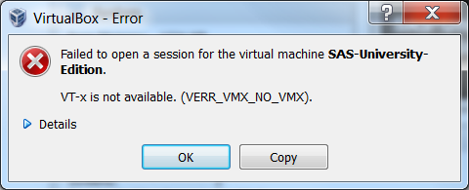

The important piece of information is “VT-x is not available”.

On the same PC, VMWare player generated an initial error message:

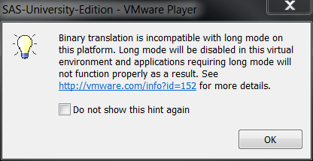

This was followed by a second, more informative error message

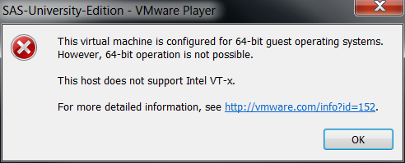

Here the important phrase is “This host does not support Intel VT-x.”

On PCs with AMD processors the corresponding error messages might be phrased in terms of the availability or support for ‘AMD-V’.

Faced with a message like this it is necessary to follow the procedure detailed in the link to determine whether the processor supports hardware virtualization. If it does, it may be that virtualization needs to be enabled in the BIOS.

**Installing VMware Player**

The Quick Start Guide for VMware Player directs you to <http://www.vmware.com>. However, it is by no means easy to find where on the website to download the free version. At the time of writing it was here:

<https://my.vmware.com/web/vmware/free#desktop_end_user_computing/vmware_workstation_player/12_0>

but it may have been moved or renamed by the time you read this.

**Shared Folders**

The instructions for setting up shared folders can be confusing as they refer in some places to “myfolders” and others to “My Folders” whilst at the same time warning the reader that the shared folder name is case sensitive, which it is. If in doubt, it is safer to use “myfolders” (lower case, all-one-word) throughout.

**Amazon Web Services Marketplace**

Step 2 of the Quick Start Guide for AWS Marketplace says “open the page for SAS University Edition.” There is a link behind “SAS University Edition” which is

<https://aws.amazon.com/marketplace/pp/B00WH10IKW> and will take you to the correct page. Otherwise, type “SAS University Edition” in the search box.

There is no charge for using SAS University Edition on AWS, but there is a small hourly charge for using AWS itself. The price varies according region and EC2 instance type. The smallest and cheapest instance, type t2.micro, is adequate for any example in this book.