SCIM-INVENTORY

Workflow & Process Guide
  - Inventory, Procurement, Warehouse, Vendor, Logistics, and Recruitment Operations
A practical operating model for administrators, procurement teams, warehouse teams, vendors, recruiters, and auditors.
Version 1.0 | September 20, 2026
Prepared from the implemented application architecture

How to use this guide
This document describes the operating workflows implemented in SCIM-Inventory. It is intended for process walkthroughs, user onboarding, project defense, testing, and future implementation planning.
Core control principle
Inventory quantities are changed through controlled stock movements—not by directly editing a balance. Every tenant-scoped operation is protected by membership, role checks, row-level security, and audit history.

Contents
Section | Purpose
1. Operating model | Actors, modules, ownership, and system boundaries
2. Inventory and warehouse | Products, locations, balances, movements, transfers, and tasks
3. Procurement | Requisition through purchase order and receiving
4. Vendor lifecycle | Onboarding, portal access, collaboration, shipment, invoice, and performance
5. Recruitment and AI | Public application, controlled stages, explainable ranking, and human review
6. Notifications and communication | In-app events, email notifications, and transaction messages
7. Security and governance | RBAC, MFA, tenant isolation, audit, documents, and reset controls
8. Status and responsibility reference | Operational status meanings and role ownership

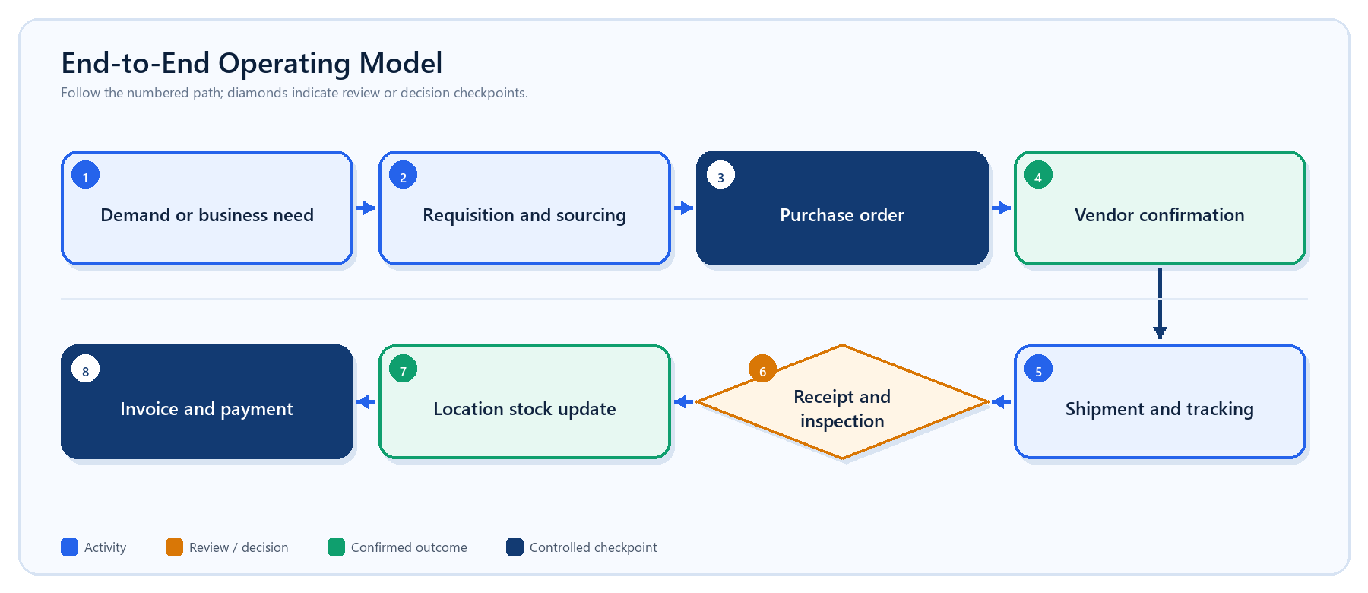
Master workflow from demand signal to inventory and financial closure.

1. Operating model
SCIM-Inventory is a multi-tenant operations platform. Each organization owns its products, warehouses, procurement records, vendors, recruitment records, documents, notifications, and audit trail. Users gain access through organization membership; vendor personnel use a separately scoped portal.
Actor | Primary responsibility | Typical access
Owner | Organization governance and final control | All modules, membership, reset, audit
Administrator | Cross-functional operational administration | Operations, vendors, recruitment; no ownership transfer
Procurement manager / Buyer | Sourcing, supplier, and purchase records | Products, vendors, requisitions, RFQs, quotations, POs
Warehouse manager / Operator | Physical stock execution | Locations, movements, receiving, putaway, picking, counts
HR manager / Recruiter | Hiring workflow and screening review | Jobs, applicants, pipeline, AI screening
Vendor user | Supplier-side transaction collaboration | Vendor-scoped orders, shipments, invoices, documents, messages
Viewer | Read-only operational visibility | Permitted supply-chain records without mutation rights

System navigation
- Overview provides real-time KPIs, service level, attention items, inbound orders, and recent movements.
- Inventory owns product master data, location-aware stock, immutable movements, transfers, and cycle counts.
- Warehouse owns receiving, putaway, picking, and physical location definitions.
- Procurement owns requisitions, RFQs, quotations, and purchase orders.
- Vendors provides onboarding, portal users, transactions, performance, documents, and conversation history.
- Recruitment manages job openings, public applications, the hiring pipeline, and assisted ranking.
- Administration manages users, roles, warehouses, assignments, audit history, and controlled workspace reset.

2. Inventory and warehouse workflow
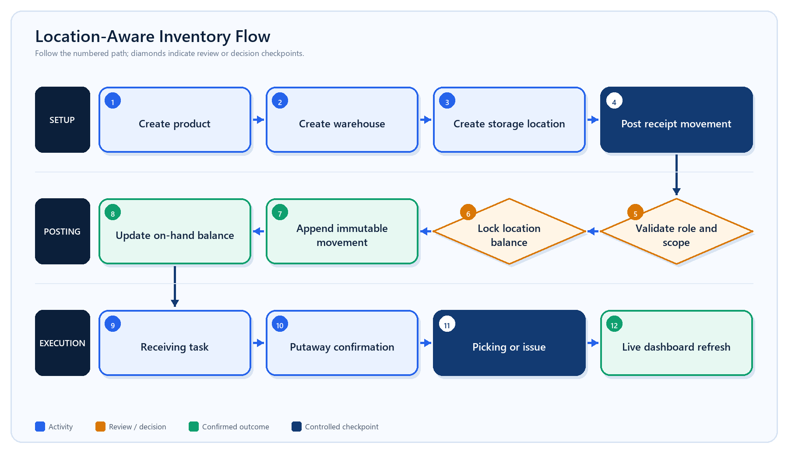
A quantity is always posted through a controlled movement and tied to a warehouse location.

Inventory rules
- Create the product master with its automatically generated SKU, category, unit of measure, and reorder point.
- Create a warehouse and one or more active physical locations such as receiving, storage, picking, staging, or quarantine.
- Post a movement by selecting the warehouse, location, product, movement type, quantity, and notes.
- The server validates permissions and confirms that the product, warehouse, and location are active and belong to the organization.
- A receipt or transfer-in increases stock; an issue or transfer-out decreases stock; an adjustment applies the signed quantity.
- The database prevents a transaction that would make location stock negative.
- The immutable movement is appended and the balance projection is updated in the same transaction.
- Realtime refresh updates the Overview, Stock, Movement, and Location screens.
Existing stock migration rule
When location inventory is enabled, stock is automatically assigned only if a warehouse has exactly one active location. If multiple locations exist, historical stock remains labeled Unallocated until staff post a controlled location movement.
Movement | Balance effect | Common use
Receipt | + absolute quantity | Purchased or returned goods received
Issue | - absolute quantity | Consumption, outbound fulfillment, or disposal
Adjustment | +/- entered quantity | Approved correction following verification
Transfer out | - absolute quantity | Dispatch from source location
Transfer in | + absolute quantity | Receipt into destination location

Warehouse execution
Workflow | Typical statuses | Completion evidence
Receiving | Open → Assigned → In progress → Completed | Received quantity, inspection, reference, date
Putaway | Open → Assigned → In progress → Completed | Destination location and confirmed quantity
Picking | Open → Assigned → In progress → Completed | Picked quantity and outbound context
Cycle count | Draft → Submitted → In progress → Completed | Expected count, result, and approved variance
Transfer | Draft → Submitted → In progress → Completed | Source, destination, quantity, and paired movements

3. Procurement workflow
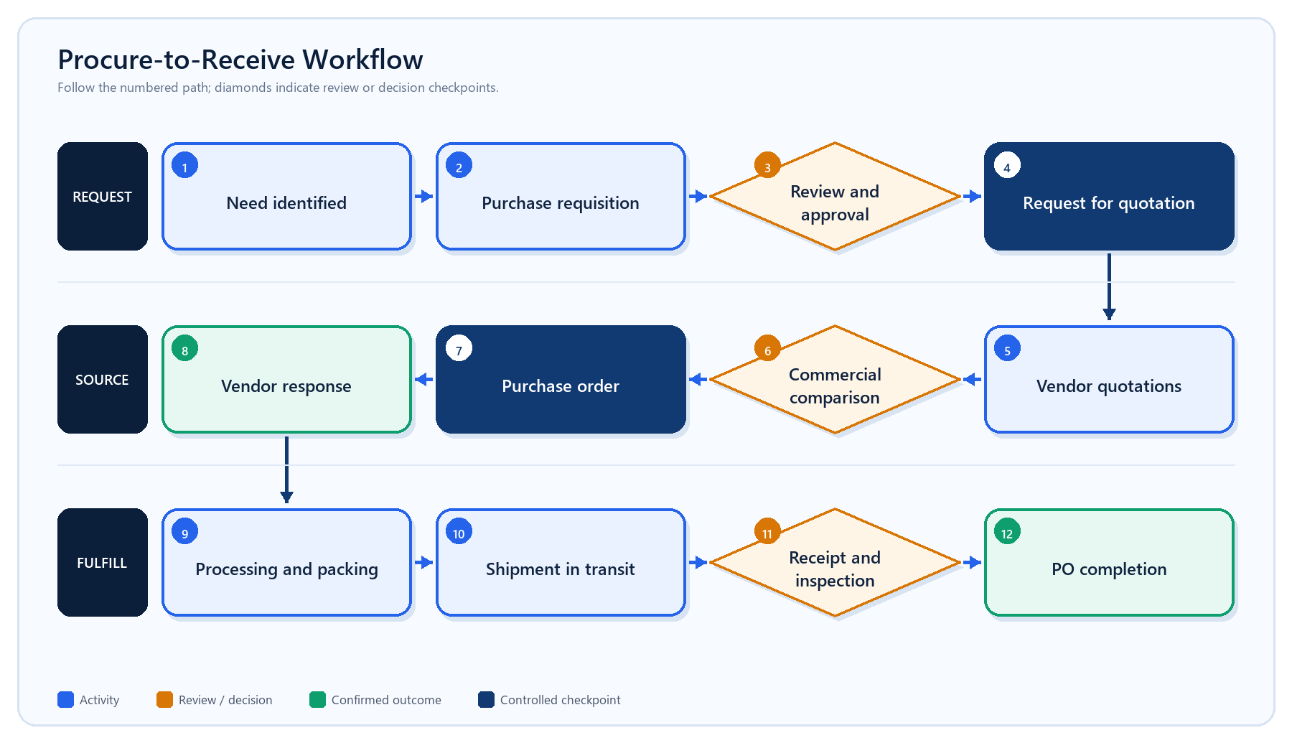
Procurement records retain references, organization scope, status, value, supplier, warehouse, due date, and audit history.
- A user creates a requisition manually or in response to low stock and operational demand.
- The requisition is submitted and reviewed according to role and organization controls.
- An RFQ is issued to qualified vendors, and quotations are captured for comparison.
- The buyer selects the commercial option and creates a purchase order with supplier, warehouse, amount, due date, and terms.
- The vendor confirms, proposes a revision, or rejects the purchase order through the portal.
- Accepted work progresses through processing, packing, ready for shipment, and transit.
- Warehouse staff receive and inspect delivered goods. Accepted quantity updates inventory; partial or rejected quantity creates an exception path.
- The purchase order is closed only after operational and document requirements are complete.

Procurement controls
- References are generated automatically and displayed as read-only values.
- Organization and role checks are repeated on the server for every mutation.
- Purchase order acknowledgement preserves confirmed, revised, or rejected responses.
- Amounts use PHP as the current default currency.
- Changes create audit or workflow events; stock is never increased merely because a PO exists.

4. Vendor lifecycle and portal workflow
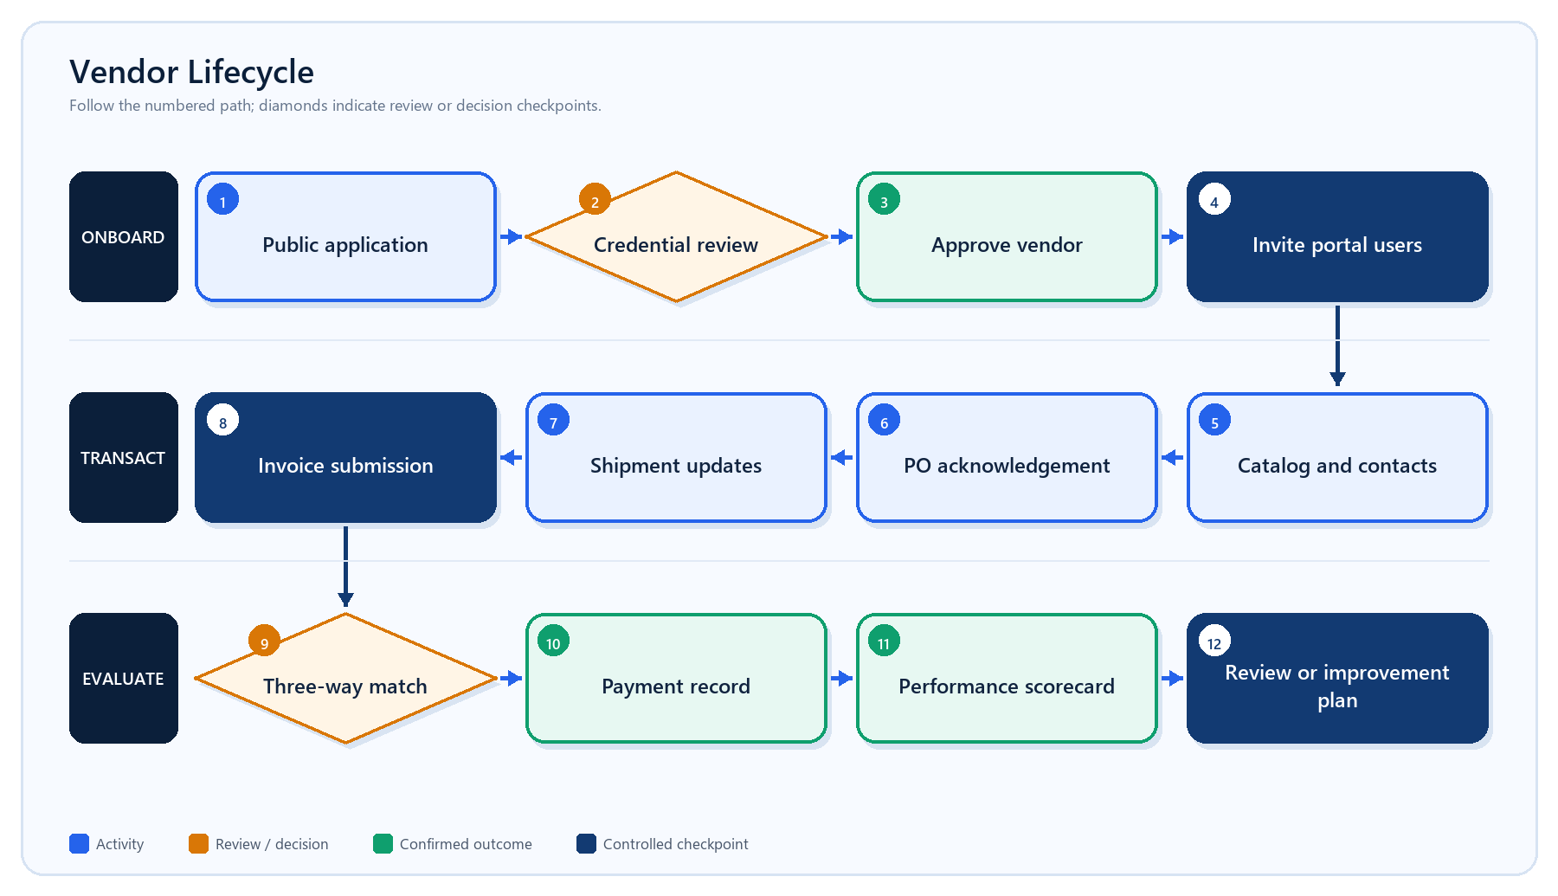
Vendor users are scoped to one organization and supplier. Internal users retain approval and governance responsibilities.

Phase A — onboarding and setup
- Vendor submits company, contact, service, location, delivery, certification, tax, and legal information.
- Internal staff review credentials and move onboarding through draft, submitted, under review, changes requested, approved, rejected, suspended, or archived.
- Approved vendors receive a unique vendor code and may be assigned categories, commercial terms, risk rating, catalog items, shipping rules, contacts, and addresses.
- An owner or authorized procurement user invites vendor personnel to the portal.

Portal roles
Vendor role | Purpose | Typical capabilities
Admin | Vendor account administrator | Manage vendor profile and portal users; broad vendor access
Member | General transaction user | Catalog and routine purchase-order collaboration
Finance | Billing contact | Invoices, financial documents, and payment visibility
Logistics | Shipment coordinator | Shipment creation, milestones, tracking, and delivery updates

Phase B — transaction collaboration
- Admin sends the purchase order digitally and the vendor receives it in the portal.
- Vendor responds Confirmed, Revised, or Rejected. Proposed price, quantity, date, and message remain traceable.
- Vendor creates a shipment linked to the purchase order, then posts milestones and tracking updates.
- Delivery creates internal and vendor notifications. Warehouse staff perform receipt and inspection.
- Vendor submits an invoice. The system compares invoice, PO, and received quantity and records matched or exception status.
- Authorized staff approve and record payment according to agreed terms.

Performance model
Indicator | Meaning | Weight in overall score
On-time delivery | Delivered by expected arrival or due date | 30%
Fulfillment | Received quantity compared with ordered quantity | 30%
Quality | Accepted quantity compared with inspected quantity | 20%
Accuracy | Matched invoices compared with total matches | 15%
Response | Acknowledgement speed, normalized across 48 hours | 5%

5. Recruitment and AI-assisted screening
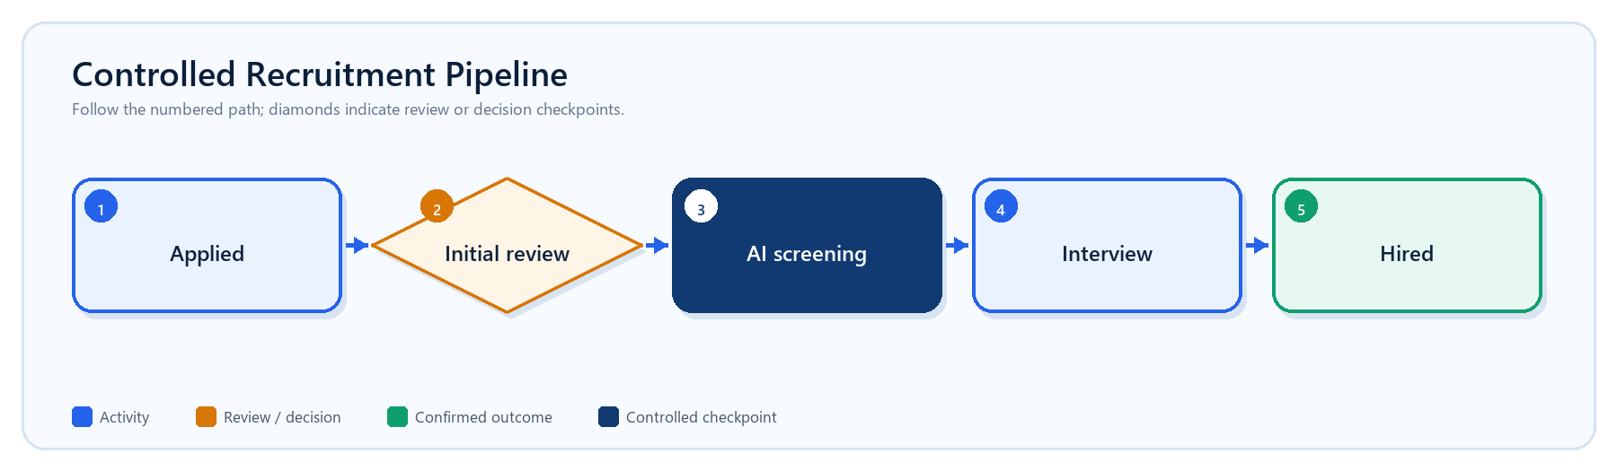
The simplified hiring pipeline. Rejected and withdrawn outcomes are stored separately without creating extra active stages.
- HR publishes an open job with description, required and preferred skills, minimum experience, and education requirement.
- A candidate applies through the public careers page, gives screening consent, and uploads a PDF or DOCX resume.
- The application receives an automatic reference and enters Applied.
- A recruiter checks completeness and moves the candidate to Initial review.
- Authorized staff run AI screening for the selected job. The service receives identity-minimized resume content and structured qualifications.
- The system records scores, rank, matched skills, missing skills, model name, model version, weights, and explanations.
- A human recruiter reviews the evidence and decides whether to move the candidate to Interview and then Hired.
- Stage changes can trigger applicant email notifications when mail delivery is configured.

How the match score is calculated
Signal | Default weight | Calculation
Semantic similarity | 40% | TF-IDF unigrams/bigrams plus cosine similarity between job and resume text
Skills | 35% | 80% required-skill coverage plus 20% preferred-skill coverage
Experience | 15% | Applicant years divided by required years, capped at 100%
Education | 10% | Applicant education level compared with requested level, capped at 100%

Responsible-use rule
The ranking supports recruiter review; it does not make the hiring decision. Name, email, phone, age, gender, ethnicity, and address are not supplied to the model. A human must evaluate evidence, accommodations, and job relevance before changing a hiring stage.

6. Notifications, messaging, and delivery updates
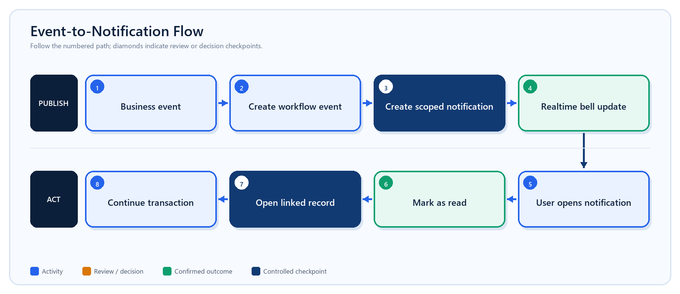
Notifications are organization-scoped, role-protected, published in real time, and linked to the related dashboard record.
Trigger | Audience | Result
New vendor application | Internal | Bell notification links to vendor review
Vendor document submitted | Internal | Verification work becomes visible
Shipment created or updated | Internal and/or vendor | Tracking and exception status is synchronized
Invoice submitted | Internal | Finance is prompted to perform three-way matching
Recruitment stage changed | Applicant | Configured email communicates the new stage
Transaction message | Internal or vendor conversation | Conversation remains linked to PO, shipment, invoice, or general context

- The bell displays the exact unread count and the 20 newest items.
- Users can mark one item or all visible-scope items as read.
- Opening a notification marks it read and routes to a validated internal dashboard URL.
- Realtime database events refresh the shell without requiring a manual page reload.
- Email delivery is separate from in-app notifications and depends on the configured SMTP provider.

7. Security and governance
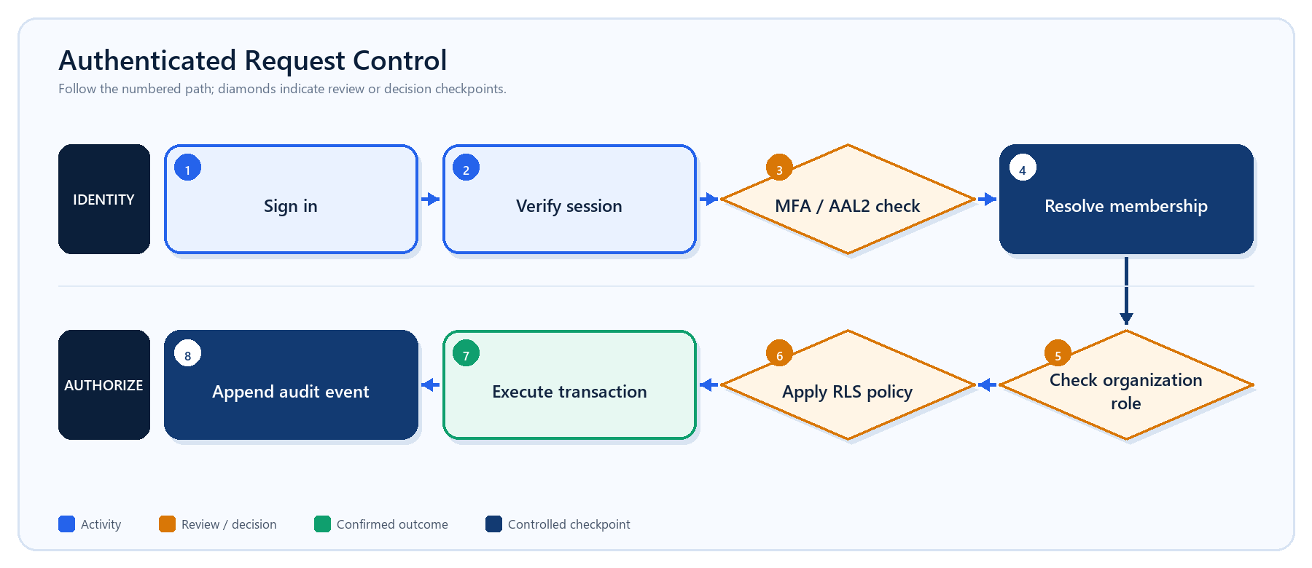
UI visibility is a convenience; server authorization and database RLS are the enforcement boundaries.
Control | Implementation | Risk reduced
Tenant isolation | organization_id plus forced row-level security | Cross-organization data access
Role-based access | Membership roles and permission checks | Unauthorized business actions
Vendor isolation | Vendor-user membership scoped to supplier | Access to another vendor’s transactions
MFA | TOTP enrollment, challenge, and AAL2 checks | Account takeover for privileged roles
Private files | Private storage buckets and short-lived signed URLs | Public exposure of documents and resumes
Immutable records | Movement ledger and controlled RPC posting | Silent inventory-history alteration
Audit history | Actor, action, entity, metadata, and timestamp | Untraceable governance changes

Workspace data reset
- Only an organization owner can request a reset.
- The session must satisfy the privileged authentication level.
- The owner must type the exact organization name to confirm intent.
- An advisory lock prevents concurrent resets for the same organization.
- Operational, vendor, recruitment, inventory, document metadata, warehouse, and related scoped records are deleted transactionally.
- The organization, memberships, profiles, and pre-existing audit history remain.
- Trigger-generated deletion noise is collapsed into one organization.data_reset governance event containing the deleted-record count.
Destructive operation
A reset produces an empty operational workspace and cannot be undone from the application. Export or back up required records before execution.

8. Status and responsibility reference
Domain | Primary statuses | Business owner
Products | Active, Inactive | Procurement / Warehouse management
Inventory operation | Draft, Submitted, In progress, Completed, Cancelled | Warehouse management
Warehouse task | Open, Assigned, In progress, Completed, Cancelled | Warehouse management / Operator
Procurement | Draft, Submitted, Approved, Sent, Received, Completed, Rejected, Cancelled | Procurement manager / Buyer
Vendor onboarding | Draft, Submitted, Under review, Changes requested, Approved, Rejected, Suspended, Archived | Owner / Procurement
Shipment | Planned, Processing, Packing, Ready, Dispatched, In transit, Arrived, Delivered, Exception, Cancelled | Vendor logistics / Internal logistics
Goods receipt | Draft, Inspecting, Partial, Accepted, Rejected, Completed | Warehouse management
Invoice | Draft, Submitted, Matching, Exception, Approved, Scheduled, Paid, Overdue, Rejected, Cancelled | Finance-authorized vendor user / Internal procurement
Recruitment | Applied, Initial review, AI screening, Interview, Hired | HR manager / Recruiter

Recommended daily operating rhythm
When | Activity | Expected result
Start of day | Review Overview attention queue, service level, inbound work, and notifications | Priority exceptions assigned
During operations | Post receipts/issues, complete tasks, update shipments, and resolve vendor messages | Current stock and transaction status
Before close | Check negative/zero availability risks, overdue POs, invoice exceptions, and incomplete receipts | Controlled carry-over list
Weekly | Review supplier history, open improvement plans, aging invoices, and recruitment pipeline | Management follow-up
Monthly / quarterly | Refresh vendor scorecards and audit role, membership, warehouse, and security controls | Governance evidence and performance action

Process acceptance checklist
- Every record is scoped to the correct organization and, where applicable, warehouse, location, supplier, or job.
- The acting role is authorized for the requested transition.
- References are generated automatically and remain visible throughout the workflow.
- Inventory quantity changes are supported by immutable movement records.
- External or financial changes have the necessary document and status evidence.
- Exceptions are visible in the attention queue, notification center, workflow history, or audit log.
- A human remains responsible for approvals, supplier action, inventory corrections, and hiring decisions.

