Mobile Ebola diagnostic assay to contain future outbreaks?

Recent attempts to detect Ebola virus

***Ebolavirus*** is an enveloped single-stranded RNA virus that has five known species, four of which are pathogenic to humans. The virus was ***first identified*** (4) in 1976 in association with two simultaneous outbreaks of haemorrhagic fever in Sudan and Zaire which involved 500 individuals, with case fatality rates of 88% in Zaire and 53% in Sudan (4). Through 2013, the ***WHO*** reported a total of 1,716 cases in 24 outbreaks. The current outbreak in West Africa, which started in March 2014, is a result of the spread of the Zaire ebolavirus, the most virulent strain of Ebolavirus family and is the largest and most complex Ebola outbreak in the history. ***CDC*** has reported more than 20,000 cases of Ebola infection which killed more than 9,000 people so far, mainly in Sierra Leone, Liberia and Guinea.

*“CDC has reported more than 20,000 cases of Ebola infection which killed more than 9,000 people so far, mainly in Sierra Leone, Liberia and Guinea. “*

Ebola virus is transmitted 3to people from wild animals and spreads in the human population through ***human-to-human transmission*** either by direct contact with the blood, secretions, organs or other bodily fluids of infected people or with surfaces and materials contaminated with these fluids. The epidemic occurring in West Africa most likely started from a single ***zoonotic transmission*** 6 to a 2-year old boy in Meliandou, Guinea who might have been infected by hunting or playing with insectivorous free‐tailed bats living in a nearby hollow tree. It is suggested that the disease spread further by human-to-human transmission.

The incubation period is 2 to 21 days and illness is characterized by the sudden onset of fever, intense weakness, muscle pain, headache and sore throat. This is followed by vomiting, diarrhoea, rash, impaired kidney and liver function, and in some cases, both internal and external bleeding (3). Due to easy transmission, the number of cases increase rapidly and it is essential to establish diagnosis early in the course of the disease in order to prevent spreading of the virus.

*“…it is essential to establish diagnosis early in the course of the disease in order to prevent spreading of the virus”*

As Ebola symptoms are similar to other diseases such as malaria, typhoid fever and meningitis, the diagnosis of Ebola infection can present a challenge. The disease is normally confirmed by one of the current detection methods: virus isolation by cell culture, electron microscopy, antibody-capture enzyme-linked immunosorbent assay (ELISA), antigen-capture detection tests, serum neutralization test and reverse transcriptase polymerase chain reaction (RT-PCR) assay (3). The CDC are indicating the use of probe-based real-time RT-PCR assays (RT-qPCR) for acute infections. As reported by *Biosearch Technologies* RT-qPCR detection was used in previous outbreaks as well as the current crisis as a sensitive, reliable and rapid method.

Several real-time PCR diagnostic kits for detection of Ebola virus in human samples such as serum and plasma are in the development or on the market already. Some of them target all known subtypes of Ebola virus (RealStar Ebolavirus RT-PCR Kit 1.0. from Altona, Ebola Virus (EBOV) Real Time RT-PCR Kit from LiferiverTM ), while others detect only some of the subtypes, in most of the cases Zaire subtype (e.g. AccuPower® EBOV Real-Time RT-PCR Kit (EBO-1111) from Bioneer, Ebola Zaire Real-TM from Sacace, EBOV dtec-RT-qPCR Test from GPSTM) which is also a cause of the current epidemic. However, these kits require expensive qPCR equipment which in most of the cases is not available in the laboratories close to the regions where Ebola disease is the most emergent.

*" Real-time PCR diagnostic kits for detection of Ebola virus require expensive qPCR equipment which in most of the cases is not available in the laboratories close to the regions where Ebola disease is the most emergent.”*

Recently the companies Integrated DNA Technologies (IDT), and Ubiquitome have announced a partnership to develop a ***mobile Ebola test (9)***. The Ubiquitome Freedom4 Real-Time RT-PCR Ebola Virus Assay will be developed by IDT using the firm's PrimeTime qPCR Assay components and will run on the Ubiquitome’s Freedom4 battery power real-time PCR instrument. It will allow for rapid and accurate field testing of Ebola virus disease. This way also the regions which are far away from an established laboratory will get the opportunity to efficiently test for Ebola virus and thus enable early detection and help control the spread of this devastating disease.

*“Mobile Ebola test will allow for rapid and accurate field testing of Ebola virus disease.”*

1. Feldmann H, Geisbert TW. Ebola haemorrhagic fever. Lancet. 2011; 377: 849-862.
2. Emond RT, Evans B, Bowen ET, Lloyd G. A case of Ebola virus infection. British Medical Journal. 1977; 2(6086): 541–544.
3. "Ebola virus disease Fact sheet No. 103". World Health Organization. September 2014. <http://www.who.int/mediacentre/factsheets/fs103/en/>
4. Johnson KM, Webb PA, Lange JV, Murphy FA. Isolation and partial characterisation of a new virus causing acute haemorrhagic fever in Zaire. Lancet. 1977; 1(8011): 569-571.
5. Wauquier N, Becquart P, Padilla C, Baize S, Leroy EM. Human fatal zaire ebola virus infection is associated with an aberrant innate immunity and with massive lymphocyte apoptosis. PLoS Negl Trop Dis. 2010 Oct 5; 4(10): e837 <http://www.plosntds.org/article/fetchObject.action?uri=info:doi/10.1371/journal.pntd.0000837&representation=PDF>
6. Marí Saéz A, Weiss S, Nowak K, Lapeyre V, Zimmermann F, Düx A, Kühl HS, Kaba M, Regnaut S, Merkel K, Sachse A, Thiesen U, Villányi L, Boesch C, Dabrowski PW, Radonić A, Nitsche A, Leendertz SA, Petterson S, Becker S, Krähling V, Couacy-Hymann E, Akoua-Koffi C, Weber N, Schaade L, Fahr J, Borchert M, Gogarten JF, Calvignac-Spencer S, Leendertz FH. Investigating the zoonotic origin of the West African Ebola epidemic. EMBO Molecular Medicine. 2015. 7: 17-23.
7. “2014 Ebola Outbreak in West Africa - Case Counts”. Centers for Disease Control and Prevention. <http://www.cdc.gov/vhf/ebola/outbreaks/2014-west-africa/case-counts.html>
8. Biosearch Technologies, <http://blog.biosearchtech.com/TheBiosearchTechBlog/bid/103986/RT-qPCR-Molecular-Diagnostics-Assist-Workers-at-the-Forefront-of-Ebola-Outbreak>
9. IDT And Ubiquitome Partner To Develop Mobile Ebola Test. <http://www.prnewswire.com/news-releases/idt-and-ubiquitome-partner-to-develop-mobile-ebola-test-300003447.html>

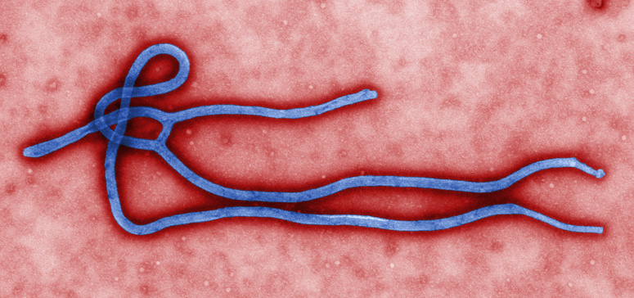

Source CDC: <http://www.cdc.gov/vhf/ebola/modules/flexslider/about-ebola.jpg>