ALL VARIABLES: WHAT WILL BE HELD CONSTANT AND WHAT COULD CHANGE?

**Location:**

* NREL solar resource library
* NSRDB weather files
* Latitude
* Longitude

Weather data will be constant based on the location of the site. Latitude and Longitude will not be optimized per say but can be used to create multiple different real life scenarios of areas were solar installations are less common. (Maine + Washington State or other combinations)

**Module:**

* Model
* Wattage
* **Price**

Model and Wattage changing to optimize the design is not the purpose of the project, so instead it will be simpler to use a basic, space optimized solution. This means we will also assume a constant amount of available space on a roof. Solving a price/space efficiency optimization by testing many different modules and inverter combos would be an interesting problem to solve. Pricing these would be difficult. The price of a module can be considered constant, but to decrease the price of an install module price could be the main thing to change (i.e. what would a 5% price decrease mean?)

Inverter:

* Model
* Limits
* **Price**

See above. Inverters are a small amount of the price of an install and different sizes are only about $100+ more. Could be considered (i.e. 5% discount on components for installation)

**System Design:**

See above. Will be constant. inverter + module combination and available space. Will always be south facing. **Tilt angle** may be an interesting factor to figure. An advanced topic to explore would require editing this design. Imagine a house with one south facing and one north facing roof. By using subarrays both roofs could have solar panels on them but the northern panels will be less efficient. The install will often be worth it in net positive benefit. Can we craft an incentive to dissuade inefficient solar panel use in higher capacity markets to spread the benefits of solar installations to poorer/more customers? or… Is the risk worth the reward? (panel has shitty warranty. More panels means more likely breakage and service charges reducing net positive value)

**Shading and Layout:**

* Box
* Roof
* **Tree**
* Active Surface

See above. Trees will be place in different arrangements to simulate real life situations.

**Losses:**

All variables are constant based on research

**Grid Limits:**

No grid limits

**Lifetime and Degradation:**

Constant based on module specification

**System Cost:**

* **$/unit module**
* **$/unit inverter**
* System equipment
* Installation labor
* Margin + overhead
* Indirect costs
* O&M

As above component costs can be changed. All other pricing is often either a constant fee or a % of component cost so they can be kept constant. From research most solar contractors follow this pricing model

**Financial Parameters:**

* Loan type
* **Loan parameters**
* Analysis parameters
* Project tax and Insurance
* Salvage value

Constant 25 year analysis period and other values are constant based on location basically. Loan parameters may be changed. Because putting 50% down payment on a system will increase your net system value.

**Incentives:**

* **Investment Tax Credit**
* **Production Tax Credit**
* **Investment based incentive (cash)**
* **Capacity based incentive**
* **Production based incentive**

We can slightly modify or invent new incentives to push certain regions into net positive value for limited government cash. (The minimal incentive to increase solar adoption in a state…)

**Electricity Rates:**

To confusing. Keep constant for now.

**Electric Load:**

Constant system design means constant load.

What is left for first model?

System Cost, Financial Parameters, Incentives, Electricity Rates, Electric Load

Scripting: Read documentation:

Create a script which instantiates a simple house and pv system, while creating a random assortment of trees some by randomizing some of the values within certain ranges.

X: -10, 10 -> -20, 20

Y = -12,12

Diameter = 3,20

Height =25,50

Top Diameter = 5,10

Trunk Height = 5,15

Decided on LG for panels and SMA-America for Inverters. (25 Year Warranties)

SAM modeling:

Incentive Database: DSIRE Incentives Database <https://www.dsireusa.org/>

Utility Rates: Open EI utility rates database <https://openei.org/wiki/Utility_Rate_Database>

Need to research capital costs etc.

Plan to figure out what can be simplified.

Easy: load, module, inverter, system design

Research Plan:

1. Create as much of a PV system model as possible, This is for me to learn more about things and will probably not be used in the final project. I want to use this to learn about modeling physical systems, as well as learn more about the inner working of PV systems
2. Learn the System Advisor Model (SAM). A technical and financial model for alternative energy systems.
3. Use SAM model and external scripts to create an optimization problem to be able to solve this problem. “Given an existing building, what new solar panel technologies would be required to make the installation financially viable (new material aka perovskite, more efficient model, more efficient battery technology, etc.)

|  |  |  |  |
| --- | --- | --- | --- |
| Need to do | Working on | Need testing | Completed |
| Tracking | Module input (what type of solar panel system are we working with?) | Sun Position Tracking | Weather/Irradiance conditions input |
| POA irradiance |  |  |  |
| Module Cover |  |  |  |
| Module/Inverter model |  |  |  |

**Solar Irradiance/Radiation: 3 Varying Approaches**

**NREL DATA:**

<https://maps.nrel.gov/nsrdb-viewer/?aL=x8CI3i%255Bv%255D%3Dt%26ozt_aP%255Bv%255D%3Dt%26ozt_aP%255Bd%255D%3D1&bL=clight&cE=0&lR=0&mC=41.61852234700827%2C-72.84896850585938&zL=10>

<https://nsrdb.nrel.gov/>

<https://www.nrel.gov/docs/fy14osti/62641.pdf>

Attributes that are required for the SAM PV models.

* DHI
* DNI
* Dew Point
* Surface Albedo
* Wind Speed
* Relative Humidity
* Temperature
* Pressure

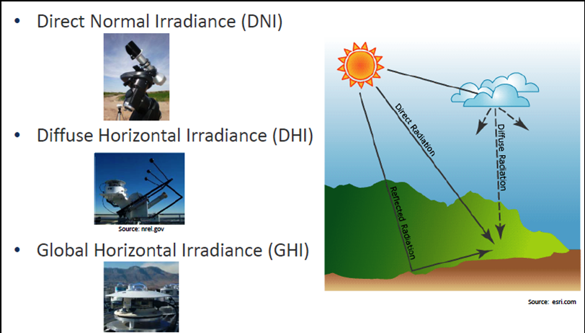

https://firstgreenconsulting.wordpress.com/2012/04/26/differentiate-between-the-dni-dhi-and-ghi/

**WEATHER SIM:**

**CLOUDINESS COEFFICENT:**

**What are the environmental inputs which define a solar panels output? How can we model these?**

* “The maximum power output is the peak power which a solar cell can deliver at STC.  While common to rate PV installations based on this value, it is unlikely these power levels will be achieved in practice.”
* We can hopefully model these subtle changes
* Nominal Rated Maximum Power $kWp=n*Wp/1000$
* Average Energy Per Year $Ep=Ema*kWp*n$
* Ema is average annual radiation for location, Instead, we can use an hourly Ema to find hourly energy production, I need to research more about solar radiation/irradiation data, we can either use NREL data or make a simple simulation based on patterns and slight randomness (cloudy day etc.)
* N is efficiency, we can hand wave this by giving it a generic value either based on manufacturer. How is efficiency calculated?
  + Temperature dependence $Nt=1-[γ*(Tc-Tstc)$ Tstc = 25degC, $γ= .005$
  + Several factors affect the measurement of PV efficiency, including:
    - wavelength - PV cells respond differently to differing wave lengths of light, producing varying qualities of electricity
    - materials - different PV materials behave differently
    - temperature - cells work better at lower temperatures, with efficiency dropping off at higher temperatures
    - reflection - any reflected light decreases the efficiency of the cell
    - resistance - the cells electrical resistance creates losses, affecting the efficiency

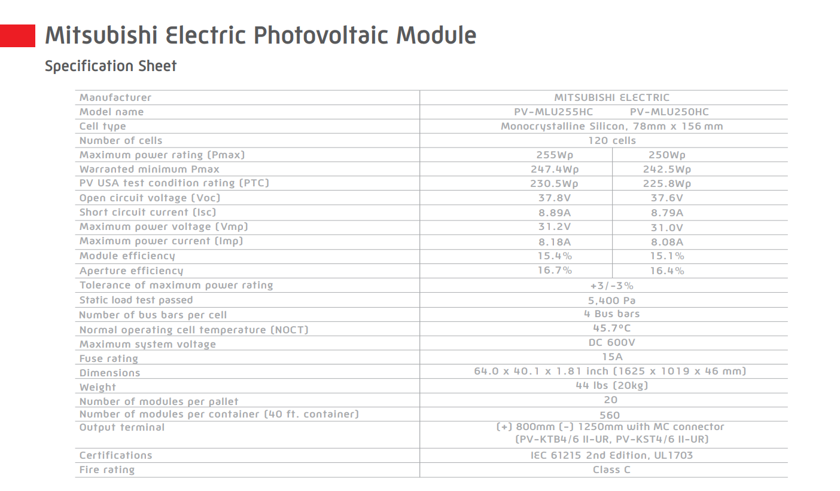

**What are the important attributes which define a solar panel, how do they relate to the output?**

Batteries.

**Will we need another output other than energy and battery %?**

**Sun Position Tracking**:

Implemented “Astronomical Almanac’s Algorithm” for sun position (azimuth and elevation)

**Module Inputs**:

Tilt angle?