ReadConfigFile.vi
Reads a stave configuration file.
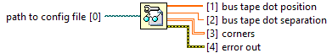
path to config file must point to a text file in the appropriate config file format (*.txt, *.csv).

bus tape dot position is the X and Y position (mm) of the left-most bus tape dot relative to the Z-stop.

bus tape dot separation is the X distance (mm) between the right-most and left-most bus tape dots.

corners 2D array of the X and Y displacement (mm) of each corner from the Z-stop.

error out contains error information. This output provides standard error out functionality.
Stave Configuration File Format:
{
[float], [float] # bus tape dot position
[float] # bus tape dot separation
[float], [float] # stave corner A
[float], [float] # stave corner B
[float], [float] # stave corner C
[float], [float] # stave corner D
}

Commenting in Stave Configuration Files:
All whitespace (except end of line characters) are ignored.
All text following a “#” symbol on the same line is ignored.

"ReadConfigFile.vi History"
Current Revision: 7

