Smart City Infra Reporting Group

smart-city-infra@googlegroups.com

Abstract

Elaborates system components and requirements for each component

Smart City Infrastructure Management

Basic Requirements & Design Document

Contents

1 System Diagram 1

2 Requirements 2

2.1 Mobile Application 2

2.1.1 User Interface 2

2.1.2 Interface with local system (mobile) 4

2.2 Web system 4

2.2.1 Web services interface (Server front end) for mobile app 4

2.2.2 Web based interface provides viewable summary report 4

2.2.3 Reporting engine 4

2.2.4 Configuration of server 4

3 Database Design 5

4 Interface Capturing 5

4.1 Web server front end 5

4.2 GIS Report and display engine 5

5 Related Mobile Applications & News 5

6 Requirement to be considered from initial ppt 5

7 Background and History 6

# System Diagram

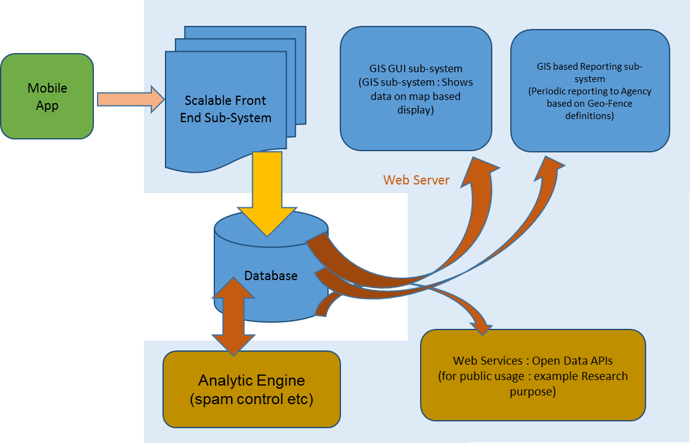

At top level system consist of a **mobile application** (front-end) and a **hosted system** with web services front-end and web based system

Hosted system has following interfaces:

* Web services interface for interfacing with mobile app (and extensions): Stores content in a backend database (will flat content / no-sql help in scaling up? Data should be scalable / spreadable across servers scalable as per geo contents)
* Web based interface provides data for public usage
* Reporting engine
  + For regular problem reporting (processes GIS data) at government and municipal agencies consumption.
  + [Optional] Problem aggregation and reporting engine for usage of Non-profit organizations like RWA Maintenance agencies etc. This doesn’t include ticket flow system as per current need, but can be customized to report problems to any such kind of system in an open interface basis.

# Requirements

## Mobile Application

### User Interface

#### Screen #1 : Home screen

1. Capture infra problem by way of capturing
2. Image (Geo tagging turned on)
3. Infrastructure problem type (Water, electricity, road, sanitation, other)
4. Severity Level (Red, Amber, Green)

(Capturing this screen assumes that application has by default GeoTagging turned on, and GPS option at system level is turned ON)

* Alternate Use case

How to handle a case where GPS tracking is not enabled

In GUI shown in image later, following things are expected

* + - Highlighting action happens on clicking specific option types as shown
    - For Words, it will be good to have also corresponding images as well (water, road, electricity etc)
    - It might be good to show approximate lat/long to show-case it has been captured just below image (in small font) -> Just to indicate that GPS / GeoTag is working

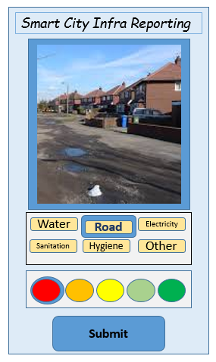

1. Once user provides above information, the application should submit following information to web-server service core front-end, providing following information
   1. Problem Type
   2. Severity Type
   3. Lat/Long
   4. Date-Time Stamp
   5. Mobile and Device IDs
   6. Geo Tagged Image
   7. [optional: authenticated open id : example Google / Facebook]
2. Mobile application will preserve the content locally (sqlite for data + file system for images)
3. In case mobile application is not able to connect to backend, it should try connecting the backend and submit it (every 15 minutes: this time can be configurable through a configuration screen).
4. Resolution of photograph taken should be of the order of 50K-100K in normal circumstance

#### Screen #2: Report Summary screen

1. User details (read-only: Later on)
   1. Submitted problems so far with details
   2. User popularity, trust and rating by others (by way of Ditto and other Feature)
   3. Action takens on reported problems
   4. Graph of submissions

#### Screen #3: Configurations / Settings screen

1. Configuration options
   1. Retrial frequency for submission
   2. Phtoograph Resolution (50K/100K/200K) {Higher resolutions are not supported because of space constraints on server side}
   3. Authenticated ID (can be dropped as well later)

### Interface with local system (mobile)

* Tracking GPS location
* Getting authority to access GPS and camera services

## Web system

### Web services interface (Server front end) for mobile app

1. Stores data content in a backend database (will flat content / no-sql help in scaling up? Data should be scalable / spreadable across servers scalable as per geo contents)
2. Stores images in a local / object storage file system

### Web based interface provides viewable summary report

1. Provides viewable summary report for various problems for public usage
2. Publicly downloadable data for specific regions. Current priority is LOW

### Reporting engine

1. Should be able to display reports visually while using following filters
   1. Problem Type
   2. Duration of reporting
   3. Severity Levels
   4. Zoom in / Zoom out of Geo Location
2. It should be able to get relevant data points from Database server

* For regular problem reporting (processes GIS data) at government and municipal agencies consumption.
* Problem reporting frequency can be configured in configuration section
* [Optional] Problem aggregation and reporting engine for usage of Non-profit organizations like RWA Maintenance agencies etc. This doesn’t include ticket flow system as per current need, but can be customized to report problems to any such kind of system in an open interface basis.

### Configuration of server

1. Frequency of problem reporting
2. Database configuration
3. Object storage mapping (additions / changes)
4. Geo fence specification of boundaries of Agencies

# Database Design

Database should be able to capture following in its tables

1. Reported data points capturing
   1. Reported ID
   2. Geo location (Lat/Lon)
   3. Date/Time Stamp
   4. Problem Type
   5. Problem Severity / State
   6. Mobile Number/ Device ID
   7. User Id (Optional, Facebook / Google / Twitter Oauth id)
   8. Object url of image
   9. Ditto Number
2. Geo Fence Definition of Various Government Agencies
3. User details (IF shared)
4. Ditto details
   1. User ID
   2. Reported ID

# Interface Capturing

## Web server front end

1. Should be able to accept a problem request and send back its Report ID
2. Problem Type
3. Severity Type
4. Lat/Long
5. Date-Time Stamp
6. Mobile and Device IDs
7. Geo Tagged Image
8. [optional: authenticated open id : example Google / Facebook]
9. Future
   1. Share Problems Reported by User
   2. Share Ditto Received by other viewers

## GIS Report and display engine

# Related Mobile Applications & News

1. One of mobile application already there (Meri Sadak) to report similar problems under Pradhan Mantri Gramin Yojna
2. Somewhat related applications

(Akosh? For reporting problems with Private product organizations, e.g. LG etc)

# Requirement to be considered from initial ppt

* Background and Focus: **Figuring out ways to communicate Infra problems to local government body PUBLICLY & EFFORTLESSLY**
  + *Type (Road, Water, Electricity, Sanitation, Hygine, Ettiquettes) !! => Later -> May be Law & Order*
  + *Location (Where it is)? (GeoTagging)*
  + *Intensity (Level of problem) : Through Photograph and level indication*
  + *Frequency (When and how frequent) : Photo time stamp*
  + *Geospatial and frequency + Analytics Data (in future)*
  + *Data open to use for anyone who wants to work on it further! (More community participation)*
* COPY-LEFT System (Opposite to Copy Right : Donated / Available to any Government willing to use in a non-profit mode)
* **Suggestions from volunteers / community members:**
  + Providing a chat (social media) platform for communication among its users (Meenal)
  + Creating a component to support this platform for problem reporting of specific apartment etc (complaints to maintenance office) (Vikas)
  + Explore use of whatsapp platform to effectively run this platform! (Hariom)
  + Exploration of a government agency / party there to support the cause can help minimize situational risks to people working for project.

# Background and History

* Citizens to use simple mobile application to report infra problems
  + Photograph capturing
  + 2 simple clicks and simple submit
* Application core (backend) consolidates reports, reporting major zone / areas where problems are reported of specific type
* Government Agencies gets report in simple format that clearly specifies
  + Major (Infra) Problem areas in various zones
  + Photographs of problems reported by citizens
  + GeoTagged Photographs provide precise location and time of problem!
* Analytics available for analysis by city planners, government and regulating agencies for further action & research
* Software available as Open Source for maintenance by OSS community and later adoption by any Government agency who wishes to enhance it!

|  |  |  |  |
| --- | --- | --- | --- |
| Version | Dated | Author | Changes |
| 0.1 | 28-Oct-2015 | Khelender | Basic Draft from ppt |
| 0.2 | 30-Oct-2015 | Khelender | Basic visualization being captured |
| 0.3 | 12-Dec-2015 | Khelender | Captured updated requirements and design from team |