A Program
Your compiler is an example of a program (the compiler) that uses another program (your .cpp file) as input. A web browser is another example of a program that reads in another program (this time written in HTML). Your task is to write a program that will read in other programs and try to determine how much space the computer will need to store the variables. Here is a sample of what the output might look like. (This output does not contain all the features that your program will).
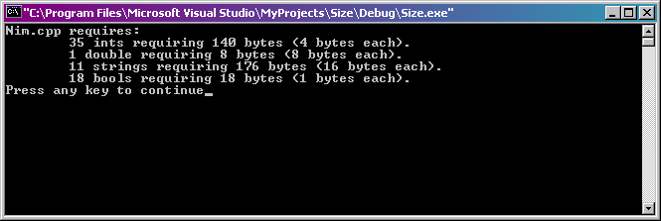
Your program should prompt the user for the name of a file (another .cpp program) and verify that the file can be accessed (the program should react properly if the file cannot be found).. It will then read in the file one word/command at a time and attempt to count the number of int, double, string, and bool variables. It will then use this information to calculate how much memory your computer will need to store all these variables, and generate a report similar to the one shown above explaining how the memory will be used. Your program should also display the total amount of memory used (not shown here) and then ask the user if she would like to check another file.
Try to create an effective user interface for your program. Part of your grade will be based on the quality of your user interface. Hint: 1 double, not 1 doubles.
Although the remaining details of this program will be left up to you (try to impress us), you may find the following information helpful:
  - The sizeof() function allows you to determine how many bytes of memory are used by a given type to store a variable on your machine. For example:
cout << "An int takes " << sizeof(int) << " bytes on this machine." << endl;
This line of code will tell you how many bytes an int will take on the machine the program is run on. The output may vary from machine to machine.
  - To read in the .cpp file one word at time, you may find it useful to write a loop:
  - string stuff; // call your variable something else
  - while( fin >> stuff ) {
  - // do stuff to stuff
}
You have seen this kind of construction before in one of the labs, so consult the lab for further information. Here, the loop will read in stuff as part of the condition, and process it inside the loop. When the program is unable to read anything in from the file (because it has reached the end of the file), the expression fin >> stuff will evaluate to false, causing the while loop to no longer be executed.
Guidelines
Your program should make extensive use of subprograms. In particular, you should not have any conditional branches (if statements), input or output statements to the console (you may have the while( fin >> stuff) shown above), or mathematical calculation beyond ++ and -- inside your main() program. All such activities should be delegated to subprograms.
As an additional condition, no subprogram should do more than one thing. For example, if you write a subprogram to display information on the screen, it should only display information on the screen. It should not perform calculations and then display the results of those calculations on the screen. These tasks should be kept in separate subprograms. (Hint: you may find pass by reference useful).
Test Data
Test your program with the following programs. Submit sample output as part of your test runs.
  - EnglishLength.cpp
  - NameChange.cpp
  - MPod.cpp
  - Pain.cpp (TRICKY!)
Hint: take a look at these files first to make sure you know what you're up against.
Hint: main() is not a variable.
Your program (and all subsequent programs) must use good style, including proper variable names, use of indentation and whitespace, and commenting. Students are advised to follow the style guidelines supplied by the Horstmann text in Appendix A. (You should also consult the on-line version found on the course web page which contains instructors' editorials).
Note that for this (and all) programs, you must supply appropriate documentation.
Click here to return to top of this page.

More Extra Credit for the Programming Assignment than You Know what to do with
(10 points) Give the user the option of displaying the output on both the screen and saving a report to file. The file should contain similar information as the screen output, but may need to include other information (you decide). Use this feature to create test logs for your program. Make sure this file has an appropriate name.
(10 points) Have you program modify the .cpp file that it scans by including the report as a comment at the end of the file (so the program will still run!). The comment should also include some kind of notice like "This file scanned and modified by my program...". Hint: make sure you back up the original file before your program starts messing with it!
(10 points) Get your program to correctly work with this file: Zodiac.cpp.
(10 points) You may only attempt this extra credit if you have completed all of the other 3 extra credit options above! Get your program to correctly work with this file: Subprograms.cpp. Hint: parameters passed by value take up memory; subprograms are not variables, and neither are prototypes. (Good luck!)
(10 points) You may only attempt this extra credit if you have completed all of the other 4 extra credit options above! Get your program to correctly work when it's run on itself. Hint: parameters passed by reference don't take up memory;

