John: no ideaa till now

Try ing the inteligent room ????

Fixing inteligent room ???

We have send git hub acccount to sir.

…..

Iot venoonn nirbhandamilla...But innovation????

Ellaam und

<http://www.instructables.com/id/Iot-Based-Home-Automation-System-With-Speech-Recog/>

Plz check this link

Checked...bt ithu common alle…...

**Blindesinu proteBlinds**nu valla protectionu pattiya any idea???

John annu paranna idea ella anti virus product

Idea kittyoo

John??

__________________________________________________________

Idea : Malware proof Hard disk

Feature : Unaffected by virus attacks, unwanted encryption .

Model : Implemented by mimicking web server client model.

Data to write is sent to an intermediate mini computer device attached to hard disk which allocates memory on the hard disk to store file… since the user’s computer has no direct access to the hard disk no programs can write directly or wipe out the hard disk… In short : reading is similar to sending request to server system and receiving file as response ( or download ).. Writing is similar to uploading file… The server system is replaced by a mini computing device attached to our hard disk….

_____________________________________________ Status :DONE… Git ?????? Elizabeth eldho nee evida….

Can someone put this in the readme file ??? Yeah?

John????

_______________________

Then we can fix that idea

Engane implement cheyunariyuo

Idea kollam….enna ithu tanne nokam…

Valo links valom indo…...kurachuude idea kitan

Ithu etra mani vareya….

Document indakande

Upload this chat

Bye

.start making ppt

Problem statement and solution john thanne thannittund

Add a few advantages and disdv.+

Document pore.

Scope

Mathiii..yes

Ee john itekunathu athu pole ita mathiyo solution ayit

Mathii..

Headings kodukk ...proper formatil. Thudangikkooo….

I'll check the problems associated with existingsystems

Importance of our idea

Who is making the ppt..

Eldho..U can make the ppt..ill send a few slides.

Document idankande apo

Njan ithu copy cheytu doc indaki

Saba u upload it to git hub

Any body

Status :DONE… Git ????.

Iam here

Git hub

pass word elizabeth1234

Neethane upload cheyadee

Emil id :[scisco@gmail.com](mailto:scisco@gmail.com)

Can someone put this in the readme file ??? Yeah? Eldho ...U do it..We can't access it.!

John????

plz suggest a heading

Malware proof Hard disk

Randilum nsame sadanm tananel oranm pore...entina docu & ppt

Eldhoo evide se...

Enik git keyaran patanilla

Saba’s making the document 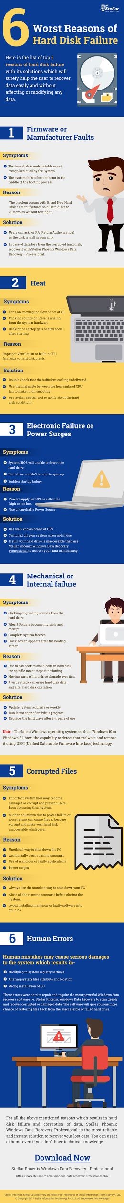

Subtopics wa

Elizabath eldho????what are you doing???