Star #1
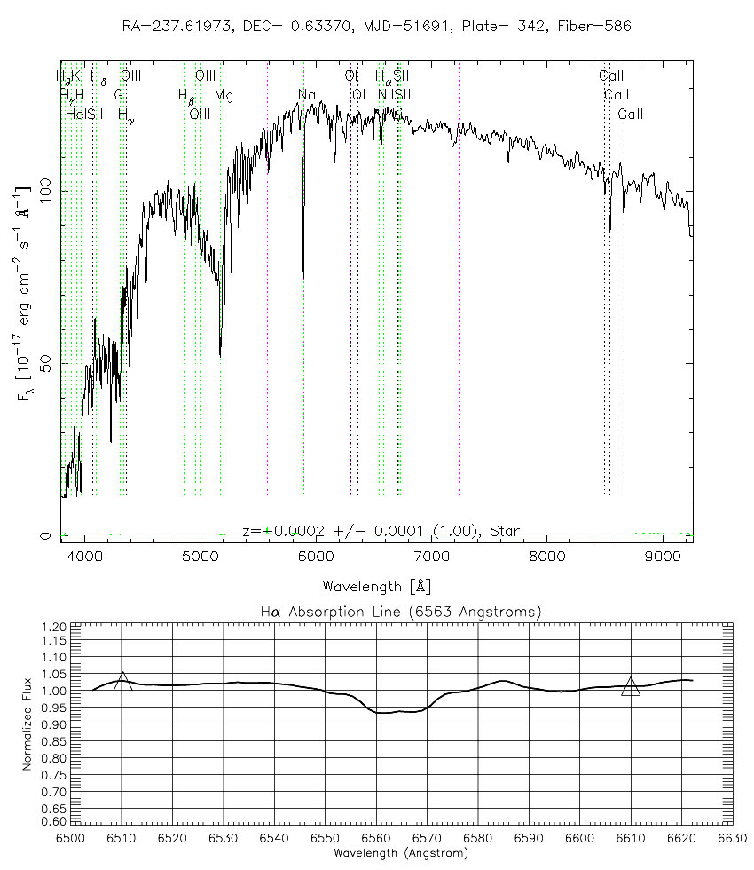

Star #2
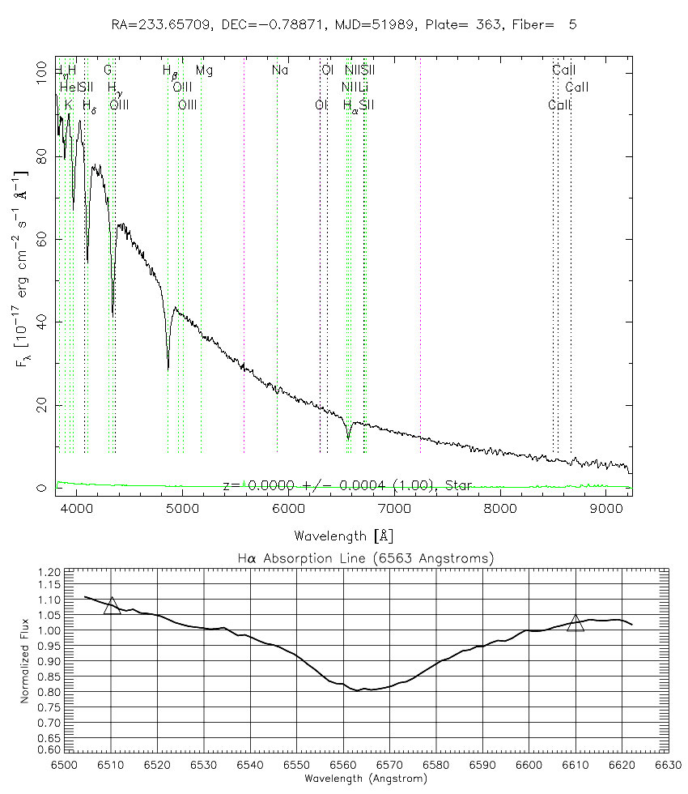
Star #3
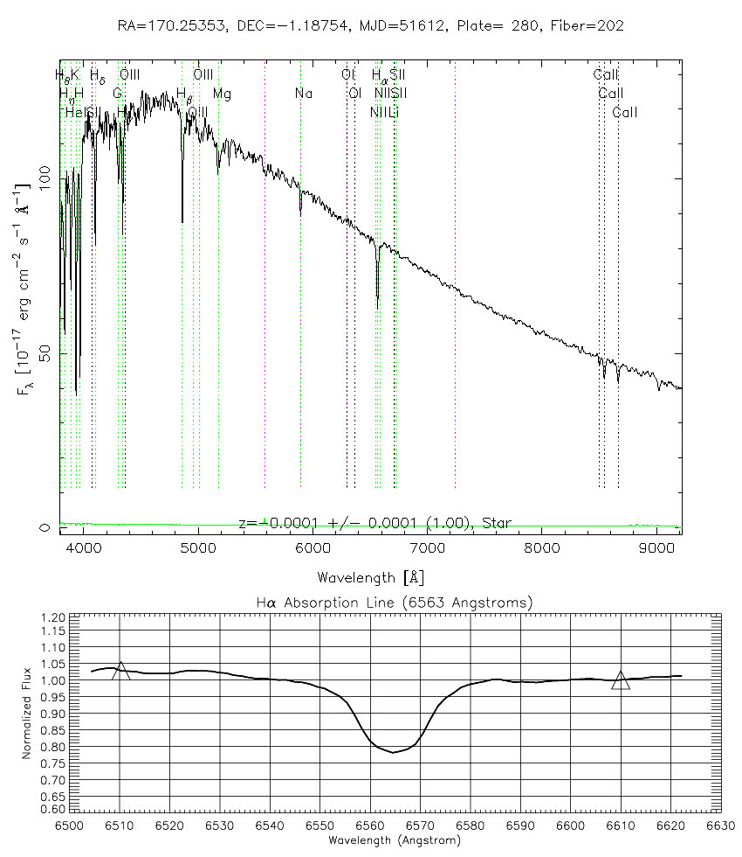
Star #4
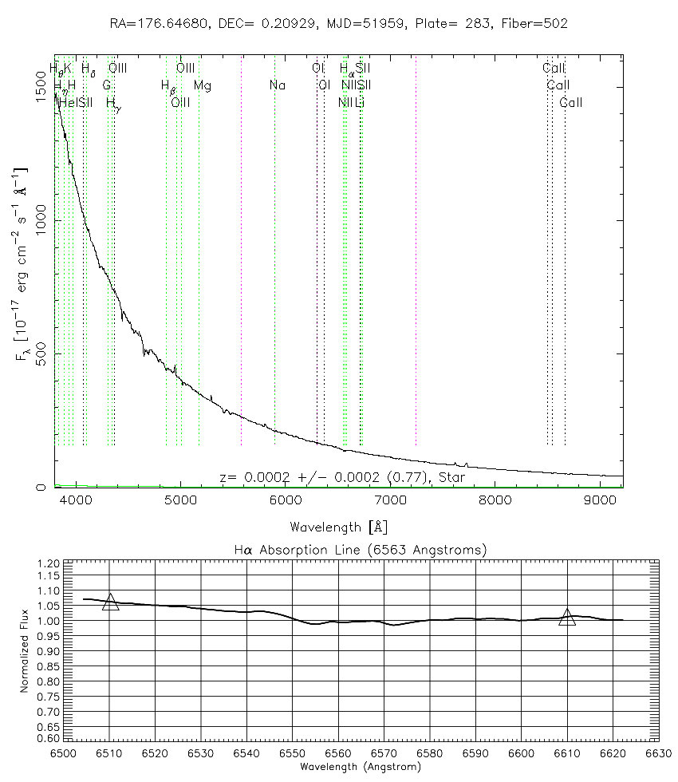
Star #5
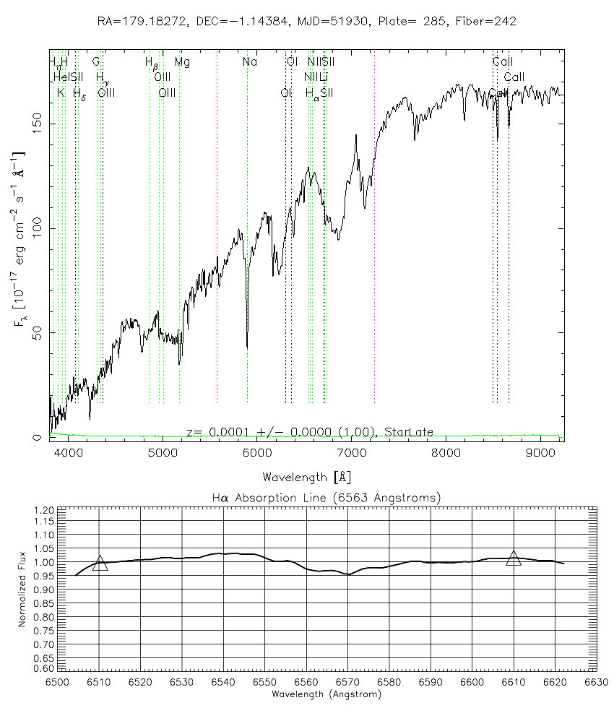
Star #6
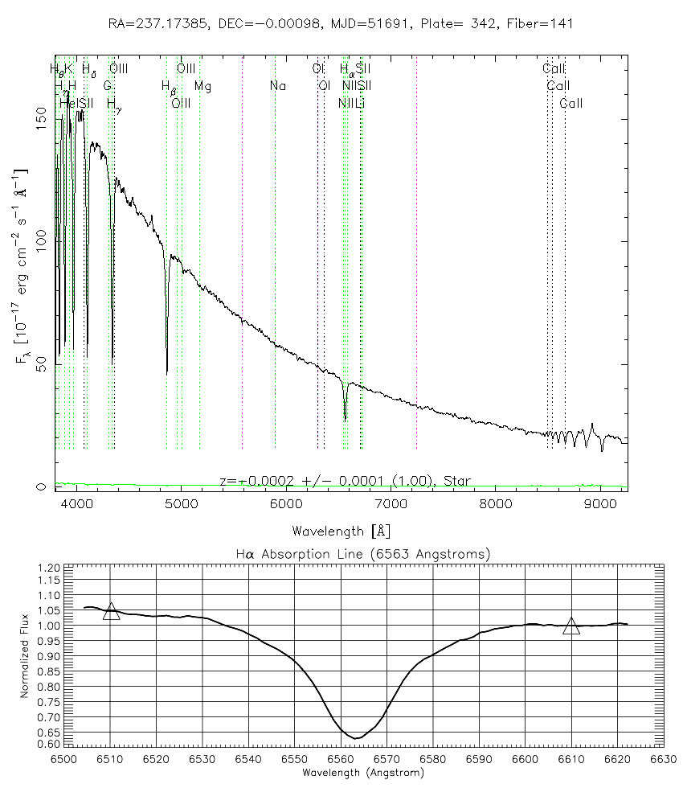
Star #7
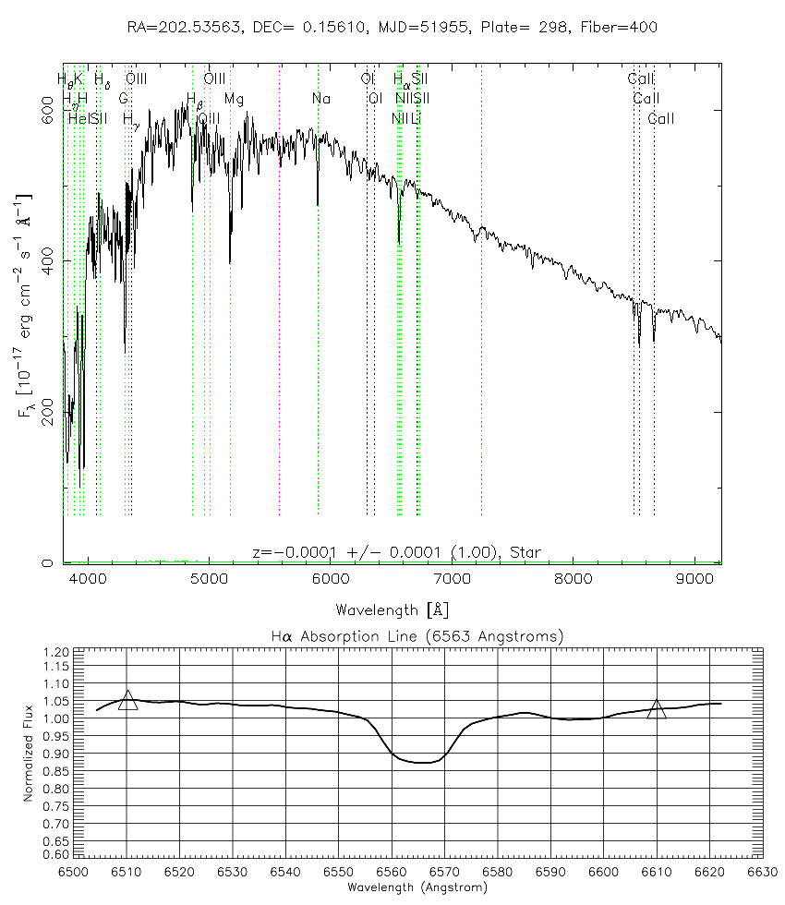
Explore 2-3

Line Strength | Star Number | Spectral Type
Strongest line
(greatest line area)
↓
↓
↓
↓
↓
Weakest line
(least line area)

Explore 4-5

Wavelength | Star Number
Longest continuum
peak wavelength
↓
↓
↓
↓
↓
Longest continuum
peak wavelength

Temperature | Star Number
Hottest
↓
↓
↓
↓
↓
Coolest

