TYPES OF STARS

When astronomers look through their telescopes, they see billions of stars. How do they make sense of all these stars?

Question 1. What do you notice about the 14 spectra from Explore 1? What are the most important features they all have in common?

Question 2. What differences do you notice among the spectra? How do the features you identified in Question 1 change among the 14 spectra?

Question 3. Do you notice a relationship between a star's color and what its spectrum looks like?

Absorption and Emission Lines
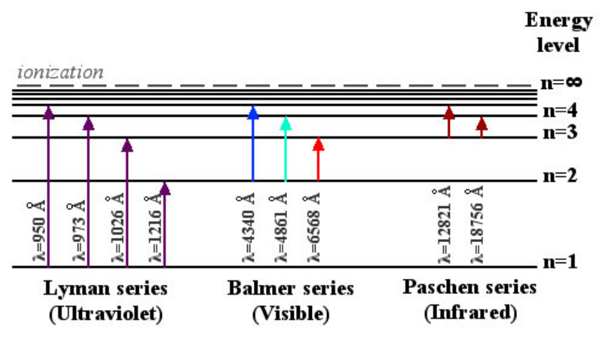

Question 4. To go up in energy level from n=1 to n=2, what wavelength of light must a hydrogen atom absorb? How do you know?

Question 5. The spectrum below is the spectrum of a typical star. Click the link to see the star's Quick Look entry. Below the spectrum is a zoomed-in view of the area around 6560 Ångstroms.
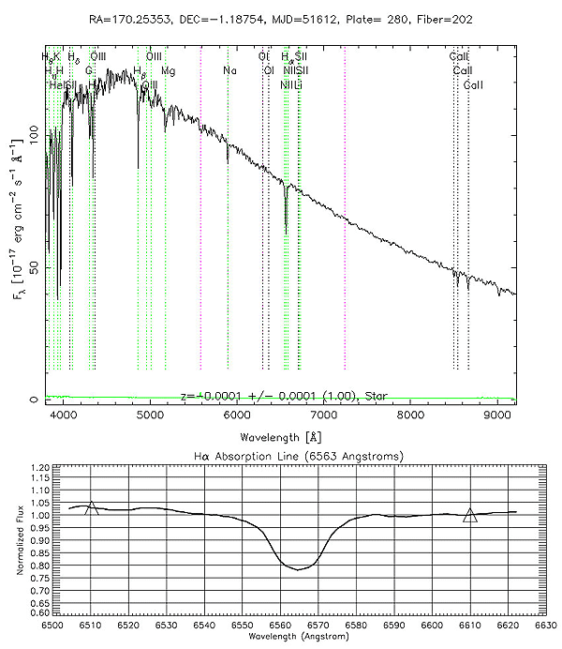

You saw in the table and graph above that the Hα transition is at 6563 Ångstroms. So, the zoomed-in view shows the Hα line for the spectrum. Does this star whose spectrum is shown here have more light at the Hα wavelength, or less light? How do you know?

Question 6. Given your answer to Question 5, is the Hα line in this spectrum an emission line or an absorption line? How do you know?

Question 7. Look again at the spectrum from Question 4. Can you find the lines labeled Hβ, Hγ, and Hδ? What transitions do you think these lines correspond to?

Classifying by Line Strength

We are going to classify stars based on the "strength" of their hydrogen absorption lines, specifically the H-alpha line.

Explore 2. Look at the spectra of the seven stars at the end of this worksheet. Using the spectra, rank the seven stars according to the strength of their Hα absorption lines.
If you can't rank them all easily, try coloring in the area between the line connecting the triangle centers and the actual spectrum, then count the number of grid squares filled - just like you saw in the example above. The number of filled grid squares is a measure of the line strength.
Rank the stars by writing each star number in the appropriate place in the second column of the table below.
Line Strength | Star Number | Spectral Type
Greatest line area
↓
↓
↓
↓
↓
Least line area

Explore 3. Originally, astronomers classified those stars with the strongest hydrogen lines as 'A' stars, stars with the next strongest lines as 'B' stars, the next strongest 'C' and so on. Eventually, they realized that some letters were unnecessary, and dropped them from the classification system. The letter assigned to a star is called its spectral class.
The spectral classes that remain are: A,B,F,G,K,M and O. In the third column of the table from Explore 2, write one of these spectral class letters for each star in the table. There is only one star of each class in this data.
Line Strength | Star Number | Spectral Type
Greatest line area
↓
↓
↓
↓
↓
Least line area

Classifying by Temperature

Question 8. Which is hotter: a star that peaks at 5000 Angstroms or a star that peaks at 6000 Angstroms?

Explore 4. Look at the spectra of the same seven stars you saw earlier. These are the same seven stars from when you classified by line strength.
For this exercise, you can ignore the zoom-in beneath each panel. For each spectrum, trace the underlying continuum shape - this is what the spectrum would look like if it had no emission or absorption lines. Find the continuum peak wavelength for each star. If the peak is not shown on the graph then estimate where you think it might peak.
Rank the stars according to peak wavelength of each star's thermal continuum, using the table below.

Peak Wavelength | Star Number
Shortest peak wavelength
↓
↓
↓
↓
↓
Longest peak wavelength

Explore 5. Now, use the inverse relationship between continuum peak wavelength and temperature to rank the stars according to temperature.

Temperature | Star Number | Spectral Class
Hottest
↓
↓
↓
↓
↓
Coolest

In the third column, fill in the spectral class for each star number that you chose when classifying by line strength; use the current scheme, letters 'A' through 'O'.

The Connection Between Temperature and Line Strength

Explore 6. Look back to the tables you created in Explore exercises 3, 4, 5, and 6. In the first row of the table below, list the stars (1-7) in order of decreasing Hα line strength (strongest on the left, weakest on the right.) In the second row, list the stars in order of decreasing temperature (hottest on the left, coolest on the right).

Strongest Hα Line |  |  |  |  |  |  |  | Weakest Hα Line
Hottest Temperature |  |  |  |  |  |  |  | Coolest Temperature

Are these two classification schemes the same?

Explore 7. Now, look back at the classification scheme you created for stars in Explore 2, with the letters A through O. Using the star numbers you wrote in Explore 6 as a guide, fill in the table below using the classes A through O rather than the star numbers.

Strongest Hα Line |  |  |  |  |  |  |  | Weakest Hα Line
Hottest Temperature |  |  |  |  |  |  |  | Coolest Temperature

Did you write the same letters in the same order in the two rows? Are these two classification schemes the same?

Question 9. What two classes of stars have the strongest Ha lines? Are these the hottest stars? The coolest? How hot are these stars?

Question 10. Which class of stars is the hottest? Which class of stars is the coolest? How strong are the Hα lines for these two classes of stars?

Question 11. Which transition corresponds to the Hα lines that you have been using to classify?
What energy state do the electrons in the stars with strong Ha lines start in (before making their transitions to other states)?

Question 13. A hydrogen atom with an electron in n=1 exists as neutral hydrogen; a hydrogen atom with electrons in a higher energy level loses an electron to become a hydrogen ion. What classes of stars have a lot of neutral hydrogen? How hot are these stars? What classes of stars have a lot of ionized hydrogen? How hot are these stars?

Question 14. Stars are composed primarily of hydrogen. But among the stars you classified, stars 1, 4, and 5 have other spectral lines that are much more prominent. If hydrogen is the main component of stars, why isn't Hα the most prominent absorption line in every star?

Question 15. The accepted ordering for spectral classes among astronomers is OBAFGKM. You may have learned the classes with the phrase "Oh, be a fine girl/guy, kiss me." Why do the classes appear in this order?
Why do you think astronomers decided to re-order the spectral classes instead of just redefining what the letters meant (that is, changing what a class "A" star was)?

Star #1
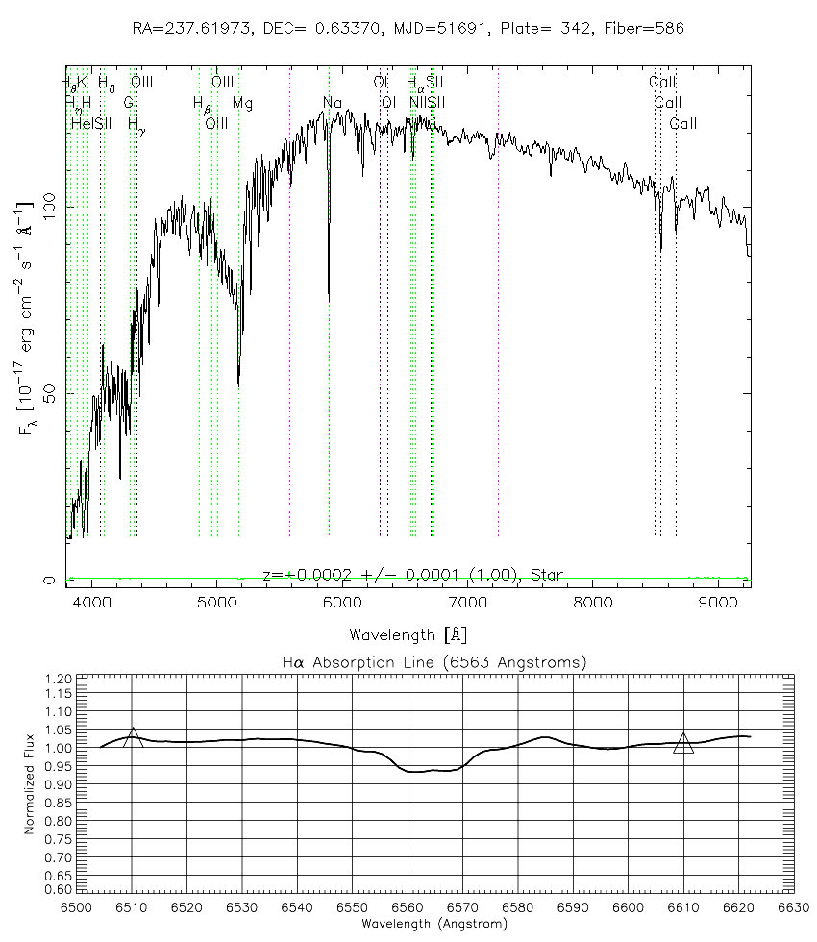

Star #2
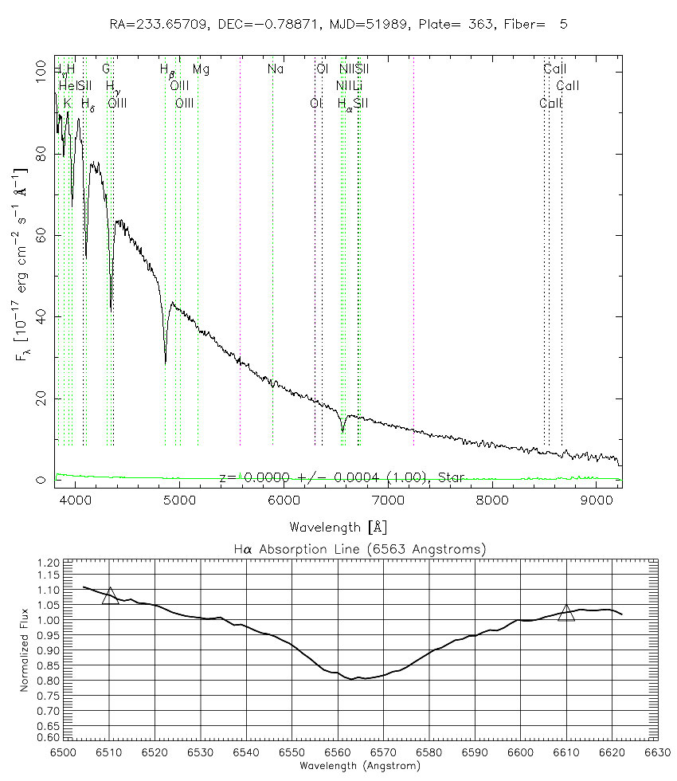
Star #3
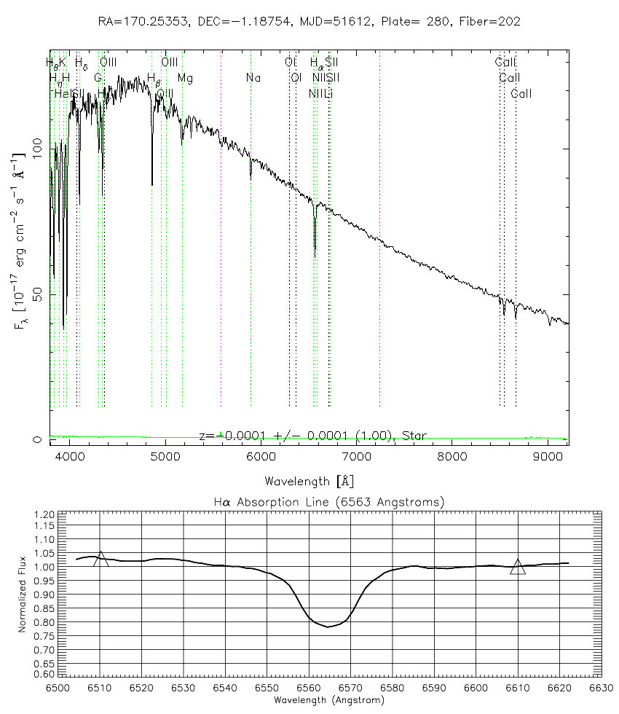
Star #4
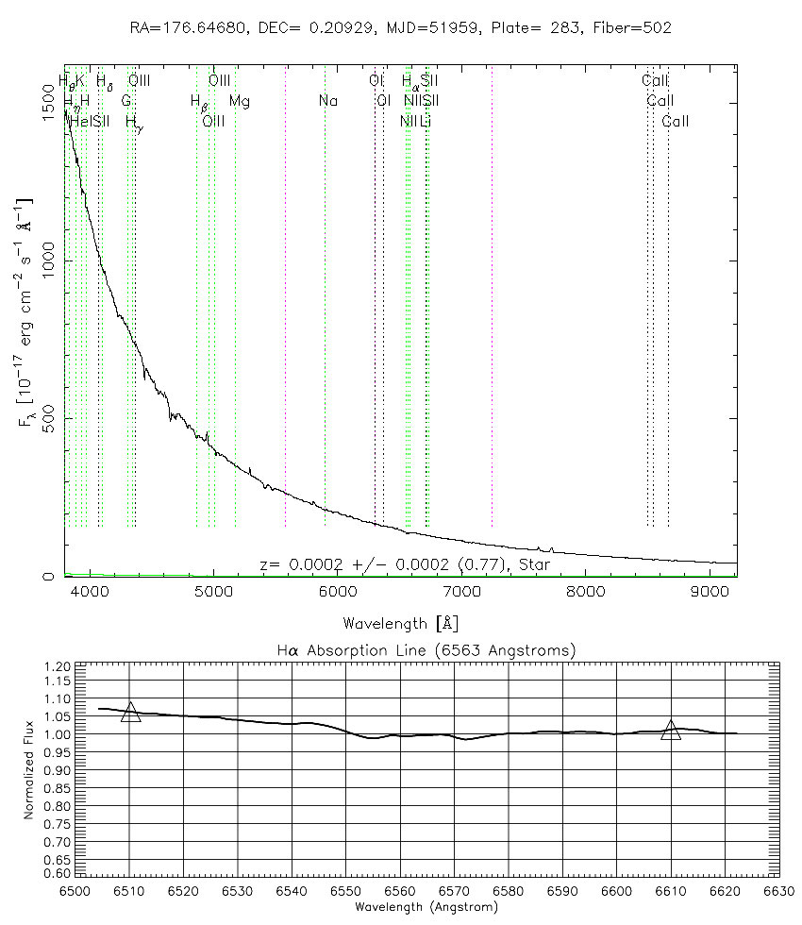
Star #5
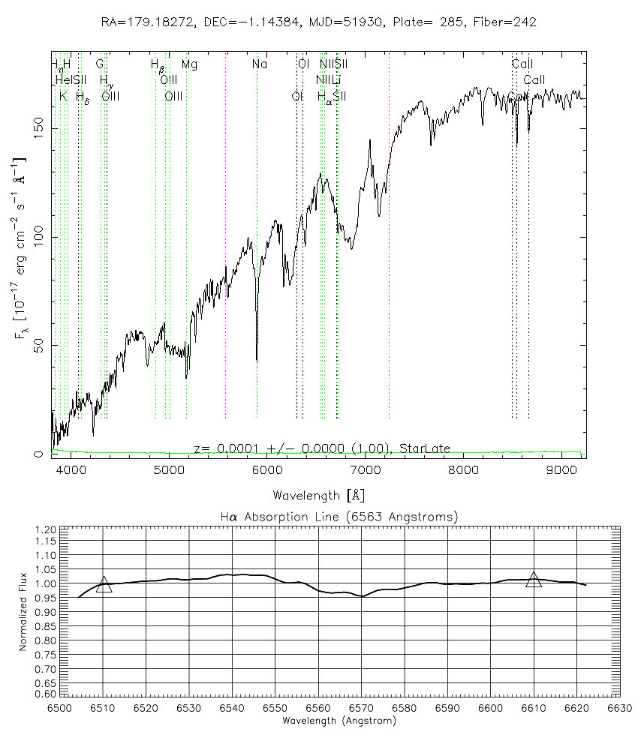
Star #6
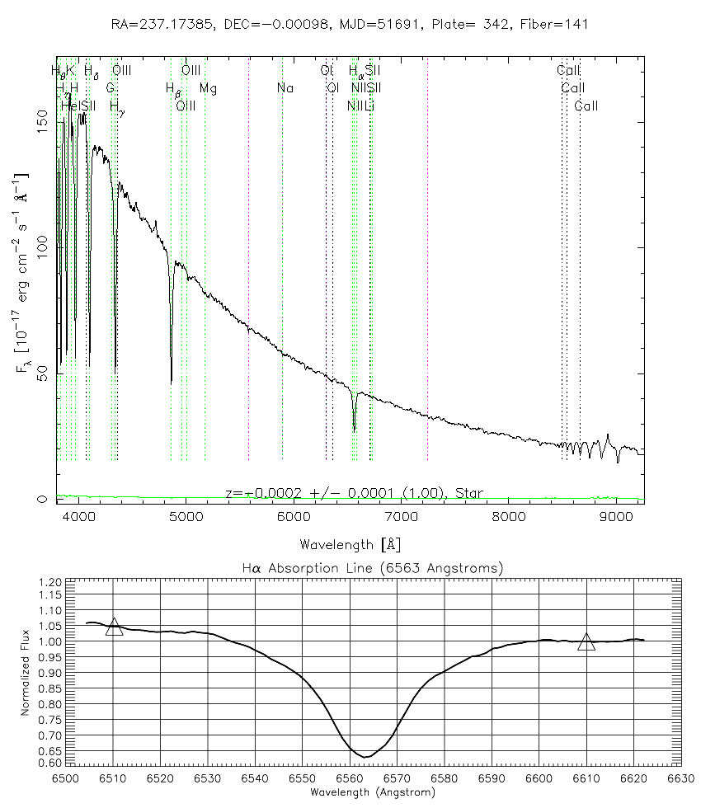
Star #7
