Simplify a Convex
Alex Szalay, Jim Gray
April 2004

The Problem
Consider a convex, consisting of N constraints. How can we quickly discard redundant constraints? How can we compute which constraints have visible intersections, and where are these vertex points? Which arcs and circles will be visible?

Definitions
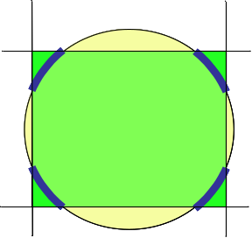
Figure 1: Four constraints in 2D define a convex of four patches (thick blue lines) on the unit circle. On a sphere, eight constraints of a cube can define 8 triangular patches.
Each constraint is determined by a three-dimensional normal vector n = (x,y,z) and offset c, where the plane normal to n intersects it. The intersection of this plane with the unit sphere defines a small or great circle with a definite inside. Given a point p = (x,y,z) on the unit sphere, p.n ≥ c means p satisfies the constraint (is inside the circle) and p.n < c means p is outside the circle. Negative values of c correspond to the outside of small circles, holes.
A convex is formed by the intersection of several half-space constraints and the unit sphere. A convex is not necessarily singly connected over the unit sphere, since the three-dimensional polyhedron of the half-spaces can cut out several areas from the sphere (see Figure 1). Each connected regions is called a patch of the convex. If two constraints intersect at a point on the sphere, and that point satisfies all other constraints, then that point is called a root of the Convex. All patch corners are roots and the patch edges can be traversed as directed arcs that connect two (not necessarily distinct) roots. Each root has one or more pairs of directed arcs. One arc of the pair is incoming and one is outgoing.

Eliminating Trivial Constraints
Several kinds of constraints can be trivially eliminated. All these are performed immediately after assembling the HalfSpace table.
These cases are the following:
- Duplicates
If the same constraint appears more than once, only one copy is kept.
- Complements
If a constraint and its exact complement appear, the Convex is NULL.
- All sky
A constraint that contains the whole sphere, i.e. c ≤ -1 can be dropped unless it is the only constraint of the convex.

Determining NULL Cases
It is necessary to quickly decide whether the Convex is a NULL, i.e. empty. Consider a pair of constraints, with opening angles of α = acos(c₁), and β = acos(c₂). The relative angle of the two normal vectors can be computed from their dot product as γ = acos(n₁.n₂). The trivial test whether the two constraints are mutually exclusive is the criterion (Figure 2.)
γ ≥ α + β. (1)
In this case we do not have to look further; the whole Convex can be rejected as NULL.
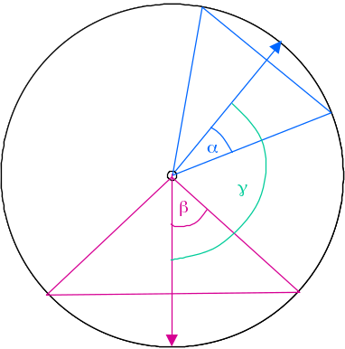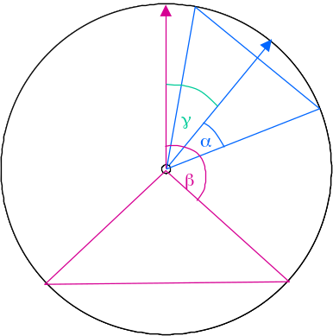
Figure 2. Two constraints with opening angles α, β and relative angle γ. On left, α+β<γ, so the constraints are exclusive, and the whole convex is NULL. On right, β>α and β-α≤γ so the constraint with β is redundant.

Eliminating Redundant Constraints
A similar argument can be applied to the case where one constraint can be dropped. This happens when one constraint is contained inside another. If we assume that β≥α, then Figure 2 one can see that β contains α and can be dropped if:
β-α ≥ γ. (2)
If there are N constraints, this process consists of computing the γ of each pair of constraints and comparing it to their β-α. It is an O(N²) computation but since N is typically 5 and generally less than 100, this is an inexpensive operation.

Computing the Roots of the Convex
First, all vertex points that define the pair-wise intersections of two constraints with the unit sphere must be computed. Once computed, there are additional decisions to be made: some of these points will be on the boundary of the Convex, and thus will be visible, others will be masked by yet another constraint. The patches spanned by the visible vertex points will not necessary form a singly connected region on the sphere (remember the cube of Figure 1).
Consider two constraints of the convex, described by (x₁,y₁,z₁,c₁), and (x₂,y₂,z₂,c₂). If the line defined by the intersection of these two planes pierces the unit sphere, then those line-sphere intersection points are candidate roots.
The intersection of the two planes is defined by simultaneous solution of the two plane equations:
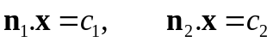 (3)
We seek the equation of the line in the following form:
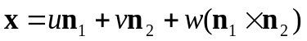 (4)
Here the first two terms give the shortest vector from the origin to the line. The cross product n₁×n₂ is a vector normal to both n₁ and n₂ and so is a vector in the normal plane of both (see Figure 3). Its length is sin θ , where θ is the angle between the two vectors. So it is the vector parallel to the intersection line of the two planes. If we multiply Eq. (4) with n₁ and n₂, respectively, we get two scalar equations. Using the fact that (1) the two n vectors are unit vectors (n₁.n₁ = n₂.n₂ = 1), (2) that they are normal to n₁×n₂ so that their product with it is zero, and (3) defining n₁.n₂ = cosθ = γ we get:
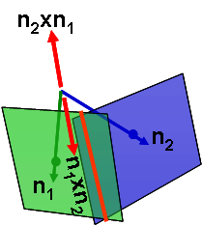
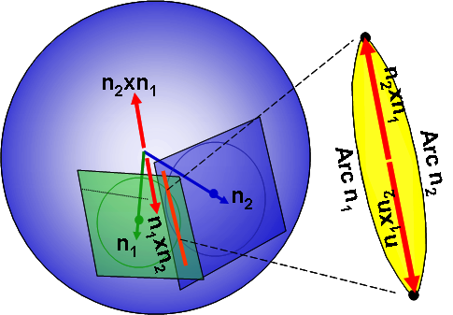
Figure 3: The cross product is orthogonal to the two vectors and so lies in the normal plane of both of them. The root defined by n₁×n₂ at the intersection of two constraints has arcs 1 and 2 in that order, defined by the left-hand rule. The other root is at n₂×n_{1.}
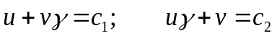 (5)
One necessary condition for the solution is that the two planes should not be parallel, i.e. γ ≠ ±1. We have to explicitly test for this condition, and exclude the pair of constraints from further consideration in the roots. Solving for u and v we obtain
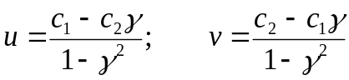 (6)
Next, we need to find the points x, which are on the unit sphere, given by x.x=1. When we square the vector x, we can again use the fact that n₁ and n₂ are unit vectors, and the fact that |n₁×n₂|² = sin²θ = 1- cos²θ = 1-γ². The result of squaring Eq.(4) is
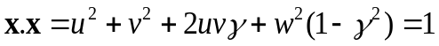 (7)
Now we need to solve this for w.
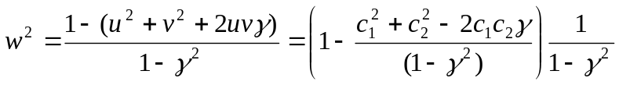 (8)
It is enough to consider only the positive root, since if we interchange the two normals their vector product changes sign. So we can get the two different roots by intersecting plane A with B, and the other by intersecting B with A.
The necessary conditions to have valid roots are
, (9)
where the equality means that we have a single root; not likely in floating point arithmetic.
This gives a maximum of N(N-1) possible roots. Now we need to determine, which of these are at the vertices of the convex. We need to test each of the roots against all the other (N-2) constraints. We mark each root that does not satisfy one of the halfspace constraints as not good. The unmarked roots (good roots) are the convex vertices.

Necessary Constraints and Bounding Circles
Using the list of good roots, we can assemble a list of all the constraints, which define these, by scanning through the list of parent constraints of all the good roots (two for each). These constraints are necessary to define the convex boundaries. But this set, the “good circles”, is not a complete one. Besides defining the good roots, they may also result in a set of roots, which must be excluded, since they do not appear on the list of “good” roots.
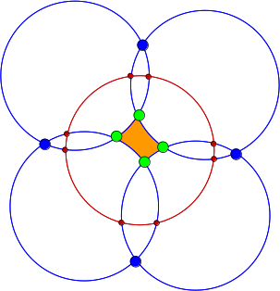
Figure 4: A convex (orange) formed by four holes (blue lines) and one bounding circle (red line). The four good roots are plotted in green. The holes also have bad roots (blue), which need to be excluded by the bounding circle.
In this case, some of the ‘bad” roots may have been masked by constraints not yet in the “good circles” list. We need to identify, which constraints should be added to the “good circles” list, in order to have the good and bad roots correctly masked.
The allroots table contains a flag called good. The good roots have good=1, see green dots on Fig. 4. A root has good=0, if it is formed by two constraints from the “good circles”, and it is also masked by another “good circle”. The roots, which are not formed by two “good circles” are designated with good=-1. The last possibility is to have a root, which is formed by two “good circles”, but it is only masked by a constraint outside that list. We mark these roots temporarily with good=-2. These are marked in blue on Fig. 4. In the end, there should be no roots with such a flag value.
We iterate though the roots with good=-2, and find the constraint that eliminates most of them. Then we add that constraint to “good circles”. We change the status of the roots involved to good=0. We iterate until there are no more roots left with a flag of –2. The closed set means that all intersections of the circles on the list are correctly masked. We call these constraints added later as the “bounding circles”. For example, we would add the bounding circle (red) in Fig. 4 during this process.
All other constraints which are related to roots, beyond the ones on this list are redundant, thus can be removed. We are left with non-intersecting holes. Of those we need to determine which ones are visible, keep those and delete the others.

Removing Additional Constraints
Loop through the circles that do not have good roots. At this point they still have an unknown state. These circles must be entirely inside or entirely outside of the convex (since they have no good roots).
We can remove all holes fully outside the convex. The easiest test for this is to see if the hole’s anti-center is outside the convex. Since nested holes have been already eliminated, we keep inside holes and remove the rest.

Determining if a Constraint is Visible
This test arises, when a constraint is not involved in any of the roots. The constraint can be either a bounding circle or a hole. It is either inside or outside the convex in its entirety. In order to test which of these two cases is valid, we need to pick an arbitrary point on its perimeter, and test it against the convex.
We will pick a point West from the center of the circle. If the angular coordinates of the center are given by (α,δ), then we can write the normal vector n and the westward normal vector w in terms of these as
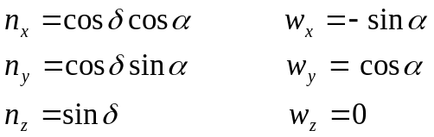 (10)
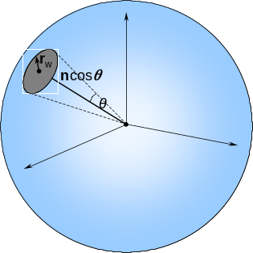Figure 5: Construction of n and r_{w}.
It is clear that the two vectors are orthogonal. If the opening angle of the constraint is cosθ = γ, then the vector of the point exactly west of the center is given by
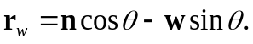 (11)
These points are precomputed for each constraint; since they are used in several contexts later (see patches). The visibility test for the nonintersecting circles consists of testing whether this point is contained in the convex. For these circles if any point is inside, then all points are inside the convex.

Visible Constraints
For each bounding circle we do the visibility test, and mark the result, but we keep the constraint. For holes, we determine the visibility using the test above, and remove holes that are not visible.

Determining the Arcs
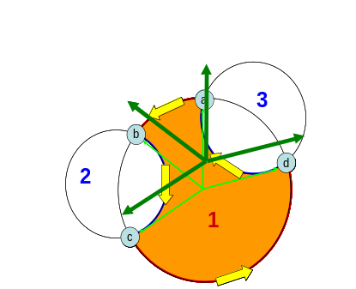 Figure 6. Assembling a patch from the roots (a,b,c,d) along the boundary of a convex, consisting of constraints (1,2,3). The roots are connected with the directed arcs denoted by the yellow arrows. All roots are on the same circle (1), and can be ranked by the angle of the arrows.
What is the geometry of the patches? We have a table of good roots, which contains the position of the root, and the constraintID of the two circles defining the root. It is easy to invert this table into a table of arcs, which contain the constraintID, and the rootID of the beginning and the end of the arc, as long as the constraintID appears only twice in the root list. But, the good roots table can be very degenerate. One constraint can have many different pairs of roots (constraint 1 in Figure 6 has 4 roots.) In this case additional computations, described next decide which pairs of roots define arcs.
Figure 6 shows the roots of a convex connected by directed arcs, denoted with the yellow arrows. The Roots table has four entries shown in Table 1. The first column of the table identifies a root. The second column constains the constraintID of the arc leading into the point, the third column has the constraintID of the arc leaving the vertex.
Table 1: Roots
b 1 2
a 3 1
d 1 3
c 2 1
From Table 1 it is obvious, that there is a single arc for constraint 2, starting with b, ending in c, written as [2:b,c] and another one for constraint 3, starting with d, ending in a, represented as [3:d,a]. So, we can copy these two rows into the arcs table. In general, if a constraint A has one root r, then add [A: r, r] to Arcs. If it has two roots, r1, r2 then add [A: r1, r2] or [A: r2, r1] to Arcs. However, we see that all four of the roots are related to constraint 1, and it is not clear which root is connected to which.
In order to solve this degeneracy and to order (r1, r2), we impose a counterclockwise ordering of the roots and arcs within the same circle. This is done by transforming the problem into the plane of the constraint, as shown on Figure 6. Calculating the angle (measured from North) of the green position vectors connecting the center of circle C1 to each of the four roots, the counterclockwise rank ordering of the roots would be (b,c,d,a). Since c is the beginning of an arc of C1, and the consecutive d is an end, it is clear that [1:c,d] is an arc. The other connected arcs are also easily obtained. The resulting arcs table is shown on Table 2.
Table 2: Arcs
2 b c
3 d a
1 c d
1 a b
How can we compute the projection of the roots on the plane of the circle? Each root can be expanded as the linear combination of three normal vectors, the normal vector n, the westward normal w, and the northward vector u. This latter vector can be obtained as u = w × n. Once this is done, we can write the root r as
(12)
As a result, we can get the lateral angle φ from the arctan of the u, w coefficients.
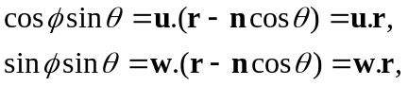 (13)
since u is perpendicular to n. By sorting the roots in a circle by increasing φ, we get the required counter-clockwise ordering, and we know which segments are visible, since the start and end roots are known. These visible arcs are then inserted into the arcs list.
Once we iterated over the list of all circles, we have a unique list of all arcs. This are still not ordered in the correct fashion, so that they form closed patches.

Assembling Arcs into Patches
The next step is to assemble the arcs into closed patches. We have to go in a particular order, since we want to be able to use the same output list of arcs to drive the visualization. The inside of a visualized polygon depends on the winding number, therefore we first have to output the bounding circles, followed by the rooted constraints, ending with the unrooted holes.
Bounding Circles
The list of patches must be started with the bounding circle, and its visibility must be marked. For each of these standalone circles we write the westward point as the beginning and end point.
Rooted Constraints
We start with the root of the smallest rootid, and get the arc it starts with this root. Then we enter a loop, where the next root is picked from the endpoint of the previous arc. Once we reach the end, i.e. we get back to the root we started with, we increment the patch number. Again, get the smallest rootid from the remainder list and loop.
Table 3: Patch
1 a b
2 b c
1 c d
3 d a
Following our example from Figure 5, we would pick the arc that starts with a. Since this arc ends in b, the next one will have to start in b. Since that ends in c, the next one starts with c, and so on. The resulting Patch is seen on Table 3.
Unrooted Holes
At the end we need to output the circles making up the enclosed holes. They are written in the same format as the bounding circles; the westward point is the beginning and end point of the arc.

