Proposal for breaking up FINISH step into individual sub-steps
Ani Thakar, July 2, 2004

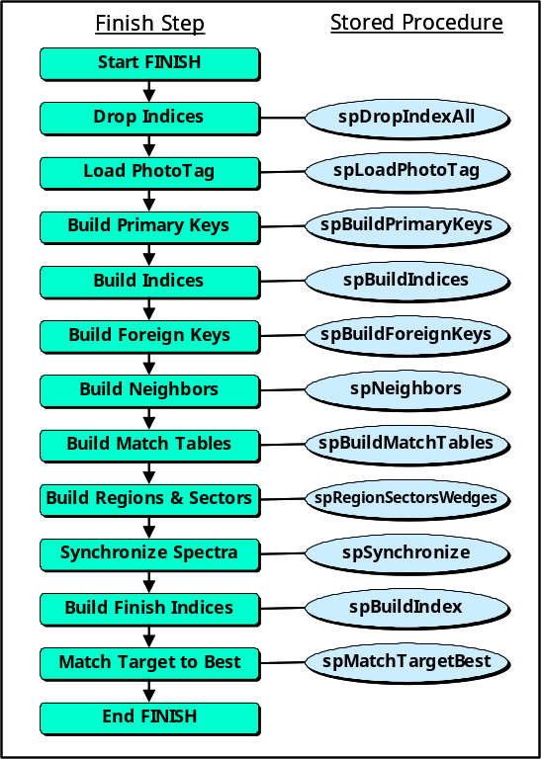
The current FINISH step flow is shown in Figure 1. Each of the functions in the FINISH step is already executed by its own stored procedure. It is therefore not too difficult to split the FINISH step into individual steps that performs each of these functions, so that the loadadmin can invoke each step as needed from the Load Monitor.

The proposed design is to move the FINISH task administration from the New Task page to a new Finish page in the Load Monitor. On this page, there will be several choices for the FINISH function(s) that can be invoked. The parameters that the loadadmin will have to enter on this page are:
- Dataset – the release or dataset for which the FINISH is being run, e.g., TEST, DR1, DR2, etc.

- Export Type – the skyVersion, one of BEST, TARGET or Both. Both is the default.
- FINISH Step – the function within the FINISH step that is to be executed. Choose one of the following:
• ALL – executes all the following steps (entire FINISH, default)
• Drop Indices – drops all indices
• Load PhotoTag – loads the phototag table (truncates previous contents)
• Build Primary Keys – builds primary key indices for all tables
• Build Indices – builds covering indices for all tables
• Build Foreign Keys – build foreign key indices for all tables
• Compute Neighbors – recalculates neighbors for Neighbor table
• Build Match Tables – build the Match and MatchHead tables
• Regions & Sectors – computes the regions, sectors and wedges
• Synchronize Spectra – updates spectro tables, does spectro-photo matchup
• Build Finish Indices – builds finish group of indices
• Match Target to Best – matches target photometry to best photometry.
- Execution Mode – whether the execution should stop after the step selected in 3, or whether execution should continue to the end of the FINISH. The two possible values are Single Step or Resume. The default is Single Step. If the step selected in 3 is ALL, this parameter has no effect.

