Creating Sectors for SkyServer
Alex Szalay, Gyorgy Fekete, Tamas Budavari, Jim Gray, Adrian Pope, Ani Thakar August 2003, revised March 2004, revised December 2004

The Problem

The SDSS spectroscopic survey will consist of about 2000 circular Tiles, about 1.5º radius, which contain the objects for a given spectroscopic observation. Where the tiles overlaps the efficiency of the tiling is higher (more objects in that region can be observed). At the same time, objects are not targeted uniformly over a plate. The targeting is driven by a program that uses the photographic observations of the SDSS to schedule the spectroscopic observations. These photographic observations are 2.5º wide stripes across the sky. But the strips overlap about 15%, so the sky is partitioned into disjoint staves and their tiling is actually done in terms of these staves (often misnamed stripes in the database.)
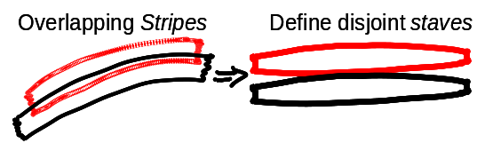
Figure 1: Observations consist of overlapping stripes partitioned into disjoint staves. Tiling Runs work on a set of staves, and each Tiling Geometry region is contained within a stave.

Spectroscopic targeting is done by a tiling run that works with a collection of staves – actually not whole staves but segments of them called chunks. The tiling run generates tiles that define which objects are going to be observed (actually, which holes to drill in a SDSS spectro plate.) The tiling run also generates a list of TilingGeometry rectangular regions that describe the sections of the staves that were used to make the tiles. Some TilingGeometry are positive, others are negative (masks or holes.) Subsequent tiling runs may use the same staves (chunks) and so tiling runs are not necessarily disjoint. These form rather complex intersections.

Figure 2. A wedge and sector covered by one plate. There are adjoining wedges covered by 2, 3, 4 plates. The lower left corner is an area that is not part of any wedge or sector. Skyboxes break wedges into sectors and may mask parts of a wedge.

The goal is to compute contiguous sectors covered by some number of plates and at least one positive TilingGeometry. We also want to know how many plates cover the sector.
This is a surprisingly difficult task because there are subtle interactions. We will develop the algorithm to compute sectors in steps. First we will ignore the TilingGeometry and just compute the wedges (Boolean combinations of tiles). Then we will build TilingBoxes, quadrilateral partitions of each tiling region that cover the regions. SkyBoxes are the synthesis of the TilingBoxes into a partitioning of the survey footprint into disjoint quadrilaterals. Now, to compute sectors, we simply intersect all Wedges with all Skyboxes. The residue is the tile coverage of the survey. A tile contributes to a sector if the tile contributes to the wedge and the tile was created by one of the tile runs that contain the SkyBox (you will probably understand that last sentence better after you read to the end of this paper.)

Wedges

A Wedge is the intersection of one or more Tiles (or the intersection of some tiles with the complements of some others). Each wedge has a depth: the number of positive Tiles covering the wedge (see figures 2, 3). The two intersecting tiles in figure 2, A and B, have (A-B) and (B-A) wedges of depth 1, and the intersection (AB) is a depth 2 wedge.

Figure 4. This shows how the tiles and TilingGeometry rectangles intersect to form Sectors. On the figure we have a layout that has wedges of various depths, depth 1 is gray, depth 2 is light blue, depth 3 is yellow and depth 4 is magenta. The wedges are clipped by the TilingGeometry boundary to form sectors.

Figure 3. Tile A has a blue boundary; tile B has the red boundary, both Regions of depth 1. Their intersection is yellow, a Region of depth 2. The crescents shaded in blue and green are the two wedges of depth 1, and the yellow area is a wedge of depth 2. Nodes are purple dots.

A Sector is a wedge modified by intersections with overlapping TilingGeometry regions. If the TilingGeometry regions are complex (multiple convexes) or if they are holes (isMask=1), then the result of the intersection may also complex (a region of multiple wedges). By going to a SkyBox model we keep things simple. Since skyboxes partition the sky into areas of known tile-run depth, SkyBox boundaries do not add any depth to the sectors; they just truncate them to fit in the box boundary and perhaps mask a tile if that tile is in a Tiling Geometry hole or if the tile that contributes to that wedge is not part of the tiling geometry (one of the tiling runs) that make up that skybox.

To get started, spCreateWedges() computes the wedge regions, placing them in the Sectors table, and for each wedge W and each tile T records the T->W in the Sectors2Tiles table (both positive and negative parents).

Boxes
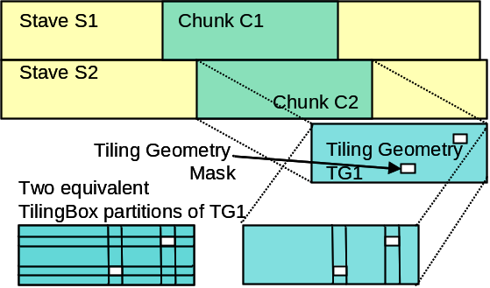
Figure 5: Staves (convex sides not illustrated) are processed in chunks. Tiling geometry is a chunk/stave subset with holes (masks). Tiling boxes cover a TilingGeometry with disjoint spherical rectangles. There are many such coverings, two are shown for TG1. The one at left has 23 TileBoxes while the one at right has 7 TileBoxes.
A particular tiling run works on a set of (contiguous) staves, and indeed only a section of each stave called a chunk. These areas are defined by disjoint Tiling Regions. To complicate matters, some TilingRegions have rectangular holes in it them that represent bad seeing (bright stars, cosmic rays or other flaws). So a tiling run looks something like Figure 5. And each TilingGeometry is spherical rectangle with spherical-rectangular holes (see Figure 5.)

To simplify matters, we want to avoid the holes and work only with simple convex regions. So we decompose each TileGeometry to a disjoint set of TileBoxes.
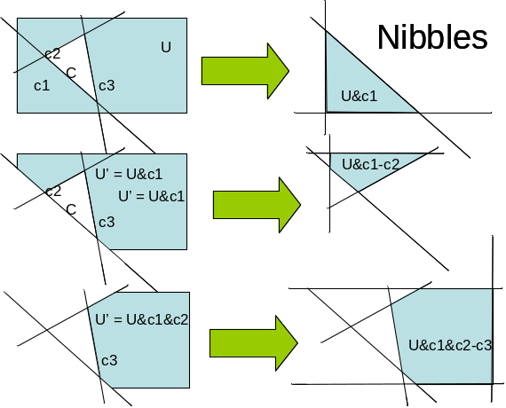Figure 6: One constructs a tiling of U-C with disjoint convexes as a sequence of nibbles. Each nibble is of the form: U&c₁&..&c_{i-1}&~c_{i}.

It is not immediately obvious how to construct the TileBoxes. Figure 6 gives some idea.

First, the whole operation of subtracting out the masks happens inside the larger TilingGeometry, called the Universe, U. We are going to construct nibbles which are a disjunctive normal form of the blue area with at least one negative hole edge to make sure we exclude the hole. These nibbles are disjoint and cover the TileGeometry and exclude the mask (white) area.

Compute N = U – C where U and C are convex regions (C is the “hole” in U)
the idea is
R = {ui} – {ci}
= U &{~c1} | U&{~c2} | …| U&{~cm}
= U&~c1 | U&c1&~c2 | … | U&c1&c2&…&cm-1&~cm
The terms in the last equation are called nibbles.
They are disjoint (look at the terms if each term has a unique ~c_{i}) and together they cover R and exclude C (each ~c_{i} excludes C).

Algorithm:
R= {} -- the disjoint regions will be added to R.
NewU = spRegionCopy U -- make a copy of U so we do not destroy it
for each c in C -- for each constraint in c that is an arc of the hull
Nibble = NewU &{ ~c } -- intersect Not c with the current universe
if Nibble not empty -- if Not c intersects universe then
add Nibble to R -- Add this Nibble to answer set
NewU = NewU & {c} -- Not c is covered, so reduce the universe
When each positive TilingGeometry is “nibbled” by its masks, the resulting nibbles are the TileBoxes we need.

The procedure spCreateTileBoxes creates, for each tiling geometry, a set of TilingBox regions that cover it. That procedure also records in Region2Boxes a mapping of TilingGeometry-> TileBox so that we can tell which TilingGeometry region covers a box.

Skyboxes are the unification of all TileBoxes into a partitioning of the entire sky. Logically, skyboxes are the Boolean combination of all the TileBoxes – somewhat analogous to the relationship between wedges and tiles. A skybox may be covered by multiple TilingGeometries (and have corresponding tiling runs); Region2Boxes records this mapping of TilingGeometry -> TileBox. Figure 7 illustrates how SkyBoxes are computed and how the TilingGeometry relationship is maintained.
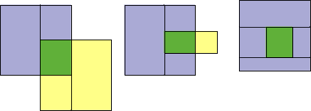
Figure 7. SkyBoxes are the intersection of tileboxes. A pair can produce up to 7 SkyBoxes. The green areas are covered by the union of the tiling runs of the two boxes and the other skyboxes are covered by the tiling runs of their one parent box.

spCreateSkyBoxes builds all the skyboxes and records the dependencies. spCreateSkyBoxes uses the logic of spRegionQuradangleFourOtherBoxes to create the SkyBoxes from the intersections of TileBoxes.

From Wedges and SkyBoxes to Sectorlets to Sectors

We really want the sectors, but it is easier to first compute wedges and SkyBoxes. Recall that:
Wedge: a Boolean combination of tiles.
Skybox: a convex region of the survey covered by certain Tiling Runs.
So, the sectors are just
Wedge ∩ Skybox.
This is may be fine a partition – two adjacent areas might have the same list of covering TileGeometry and Tiles in which case they should be unified into one sector. So, this first Wedge-SkyBox partition is called sectorlets. These sectorlets need to be unified into sectors if they have the same covering tiles.

Sectorlets are computed as follows: Given a wedge W and a skybox SB, the area is just W ∩ SB. If that area is non-empty then we need to compute the list of covering tileGeometry and tiles. The Tiling geometries come from SB. The tiles are a bit more complex. Let T be the set of tiles covering W. Discard from T any tile not created by a tiling run covering SB. In mathematical notation:
T(sectorlet) = { T ε T(wedge) | ∃ TileRun TR covering SB and TR generated T}
T(sectorlet) is the tile list for the sectorlet W ∩ SB. This logic is embodied in the procedure spSectorCreateSectorlets. (note that wedges have positive and negative tiles).

But, a particular tile or set of tiles can create many sectorlets. We want the sector to be all the adjacent sectorlets with the same list of parent tiles (note that sectorlets have positive (covering) and negative (excluded) parents that make up the sector).

The routine spSectorCreateSectors unifies all the sectorlets with the same list of parent tiles into one region. This region may not be connected (masks or tiling geometry may break it into pieces which we then glued back together – see the example of 5 sectorlets creating one sector below.)

All these routines are driven by the parent spSectorCreate routine.

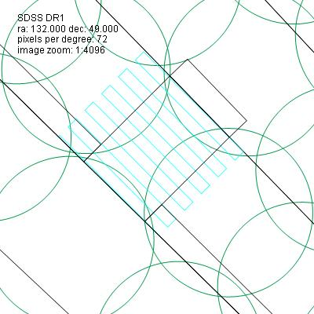
mask
1 sector
5 sectorlets
wedge
Tilebox &
SkyBox
tile
Figure 8: This diagram shows some SDSS data and demonstrates the concepts of Tile, Mask, TileBox, TilingGeometry, SkyBox, Wedge, Sectorlet, and Sector.

