Creating Sectors
Alex Szalay, Gyorgy Fekete, Tamas Budavari, Jim Gray, Adrian Pope, Ani Thakar August 2003, revised Jan 2004

The Problem

The spectroscopic survey will consist of about 2000 circular Tiles, each with radius of 1.5º that contain the objects for a given spectroscopic observation. Tiles are created by TilingRuns. These runs are not able to use all of a tile’s area for an observation. The useable part of the tile is called the TileRegion. TileRegions overlap forming Sectors: contiguous neighborhoods covered by the same TileRegions. Objects in these overlap areas have a higher probability of being selected as spectroscopic targets. The Sector’s depth is the number of covering TileRegions and indicates the increased chance of being targeted. The goal is to compute the sectors and their depths. Figure 1 at right diagrams these concepts.
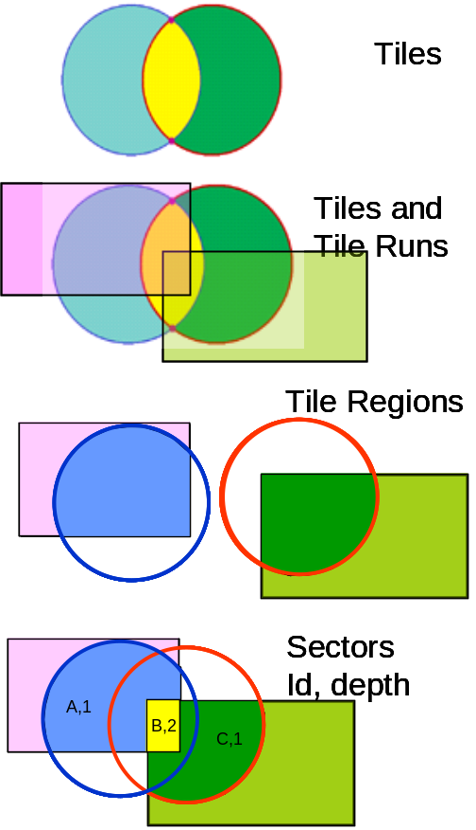 Figure 1. Tiles are created by tiling runs. The runs use only a part of the tile – called the tile region. Tile regions may overlap. We want to compute the areas (sectors) covered by tile regions. And we want to compute how many tile regions cover each sector (the depth of the sector).

There is one further complication: there are “masks” that obscure TileRuns. Some masks are “global” and some are local to a run. The masks further limit the useful area of a tile and indeed the tiling regions are reduced by these masks. Both the TileRuns and Masks are defined as regions by the TilingGeometry table. So the object hierarchy is approximately the following where TileRegions are constructed as the intersections of Tiles with their TileRuns and the local and global masks. Sectors are the intersections of Tile Regions.
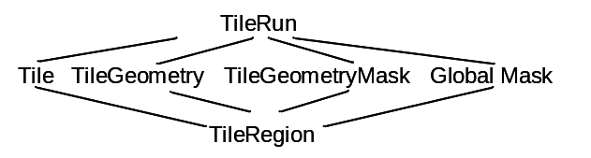

Algorithm

First we compute the #TileRegions table
#TileRegions (tileID, regionID, regionString):
For each tile,
intersect it with its TilingGeometry (same TilingRunNumber)
and subtract the masks of its TilingGeometry ( same TilingRunNumber)
and subtract the global masks.
Simplify the result
This logic heavily uses our Boolean algebra on Regions and the HTM simplification logic of
fHtmToNormalForm(region) -> simplified region

We now build the #Sectors table
#Sectors(SectorID, regionString)
And #TileRegionContainsSector(tileID, SectorID)
As follows:
For each tile TR in the #TileRegions table
Subtract all previous #TileRegions from TR
and add that region to #Sectors with a depth of 1.
Add (tileID, SectorID) to #TileRegionContainsSector
(this is the new area added by this TileRegion)

Now for each sector S in #Sectors,
delete S from the #Sectors and #TileRegionContainsSector
add TR∩S with depth+1
add #TileRegionContainsSector(TR, SectorID)
add #TileRegionContainsSector(S, SectorID)
and add S-TR with depth to the #Sectors table
add #TileRegionContainsSector(TR, SectorID)

Now simplify all the new sectors and discard the empty ones
using the fHtmToNormalForm function

In the end we have the sector table.

Appendix: some SQL

<to be added>

