Design of SkyServer Common Log
Jim Gray, Alex Szalay, Nolan Li, Wil O'Mullane, Maria Nieto-Santisteban, Ani Thakar, your name goes here
November 2003

SkyServer, SkyService, and SkyQuery nodes around the world are generating logs of their traffic activity. SdssQA and the CASjobs system are also keeping activity logs. These logs record the web traffic and SQL queries. They provide insight into how the systems are used, their performance, and their problems. Information distilled from the weblogs is a very crucial part of the annual reports to funding agencies and gives us a sense of what is being used.

We harvest these logs and consolidate them into a single global SdssAd2.weblog database at JHU. A summary of it is available at http://skyserver.sdss.org/log/en/traffic/ and it may be queried via (should this be at skyserver.org instead?) http://skyserver.sdss.org/log/en/tools/search/sql.asp with sql statements like
Select count(*) from SdssAd2.weblog..weblog and
Select top 100 * from SdssAd2.weblog..sqllog

Privacy is a big concern. There is no easy way to trace IP addresses back to individuals – indeed individual IP addresses generally vary from one session to the next. But, still the SDSS collaboration wants to keep its data and its data queries private. So, all the /collab/ traffic is gathered in the WebLogAll and SqlLogAll tables and contributes to aggregate statistics; but, detailed collab and CAS job records are hidden from the public. The public is shown the WebLog and SqlLog views that only contain log records from the public SkyServers.

At present there are two kinds of logs:
- Web logs that record requests to web servers (IIS) doing either HTTP or SOAP requests, and
- SQL logs recording SQL requests to SQL servers.

Each log source is described as a record in the LogSource table. A particular log has the dimensions:
- Location: The place where the server resides (FermiLab, JHU, …)
- Service: The kind of service being provided (SkyServer, SkyService, SkyQuery, SQL,…)
- Instance: The particular server providing this service (SdssAd6, SkyServer.pha.jhu.edu,..)
It also has dimensions that tell how to fetch the log and when it was last fetched. Each log source also has a unique LogID that is used as a foreign key in the actual log instance records. All these attributes are recorded in the LogSource table.

The logs are pulled from the active data sources either locally with file copy and bcp; or, they are gathered over the web. We have not yet implemented the web harvesting. The actual copy operation is driven by reading the LogSource table and executing the “data pull” into the common database. The logic is simple:
For each pull type
For each source of that type
Pull the recent records to a local temporary table.
Reformat it to the local format
Add it to the local log
Update the recent traffic statistics.
A SQL agent on the WebLog machine executes this logic once an hour.

There is one odd aspect to all this. If you look at the logs of a particular SQL server it has a SqlStatementLog and a SqlPerformanceLog. These files make Internet break-ins more difficult. They are unified by a SqlLog view that joins these two tables. The unified WebLog database has an actual SqlLogAll log table (not view) that is the unification of all the SQL logs from all the different log sources.
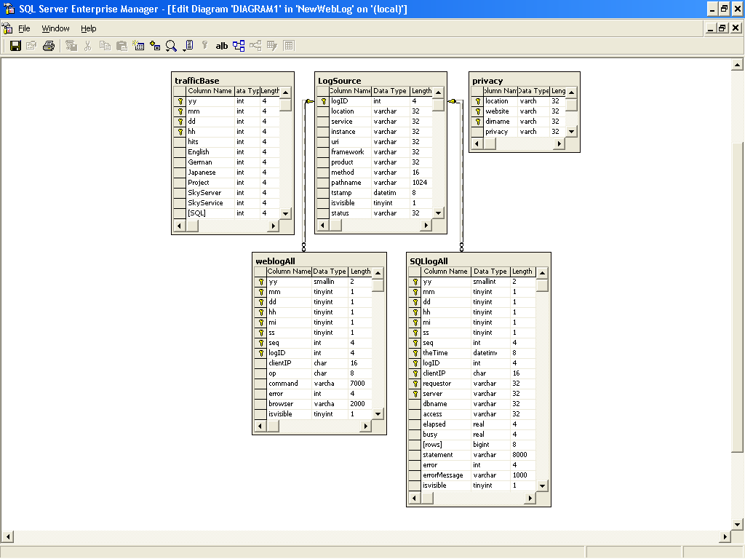
The LogSource table is
