**Demonstrating Astronomical Distances using an BOSS/eBOSS Plug Plate**

1. Go through the redshift Preflight section: <http://voyages.sdss.org/preflight/light/redshift/>
2. Discuss how redshift is used to find the distance to an object. The **plate packet introduction** document can help with this step: <https://voyages.sdss.org/for-educators/ground-control/sdss-plates-for-education/plate-workshop-resources/>
3. Go to <http://voyages.sdss.org/launch/milky-way/sdss-constellations/discovering-constellations-using-sdss-plates/>
4. Follow online instructions to get brightest stars but change ‘20’ in the code to ‘50’.
5. Export the result from the SQL query and open the file in Excel
6. Highlight all of the data, and sort the objects by class. ‘Sort’ can be found in the ‘data’ tab of the toolbar.
7. Ask the students to look for any significant differences in the data between the different classes of objects. A*nswer: stars all have a very small redshift (z) values*
8. Discuss why the stars will have a smaller redshift than galaxies and quasars.

*Answer: all the stars observed by SDSS are in our own galaxy, and therefore are much closer than other galaxies and quasars. Their velocities within the Milky Way are such that the observed redshift is very small. Some have a negative redshift, indicating that they are moving towards us.*

1. Check if there are enough quasars and galaxies to allocate one to each student, if not: run the SQL search again for a larger number of objects. If you have a large class you may wish to only allocate one object per pair or group of students. Keep in mind: a larger number of galaxies and quasars will result in a more impressive final display.
2. Once you have enough objects, randomly allocate a galaxy or quasar to each student/pair/group. It is best not to allocate stars, as their distance from us is too small to plot on the 3D display, but you may wish to still mark the bright stars on the plate with whiteboard marker or stickers.
3. Go to <https://voyages.sdss.org/for-educators/ground-control/sdss-plates-for-education/plate-workshop-resources/> and follow the link to the document **“Locating Objects on your Plate”**
4. Using the instructions to help, have each student find their object on the plate.
5. Go to <http://skyserver.sdss.org/dr15/en/tools/chart/navi.aspx> and ask each pupil to input the RA and DEC of their object into the navigator. This will result in an image and a spectrum* of the object. RA and DEC are astronomical coordinates. More information about them can be found at <http://voyages.sdss.org/preflight/locating-objects/ra-dec/>
6. Ask each pair/group/student to save and print the image and spectra of their object that they found using the navigator.
7. Go through the Preflight section on spectra: <http://voyages.sdss.org/preflight/light/spectra/>
8. Ask students to annotate their spectra and photos with information about the object that they have learned from the spectra Preflight section.

*In a few rare cases there may not be a spectrum for the object, this is due to errors such as faulty fibres

**Assembling the 3D Display**

There are two ways to transform your object into a 3D display; one involves attaching it to the ceiling, one to the wall. If you chose to create this display using either method **it is your responsibility to secure the plate safely and securely.** Attaching the plate to the ceiling results in the most effective display, but securing the plate to a ceiling may not be a viable option in all schools so the wall display is an effective alternative.

The idea behind the display is to provide a physical representation showing the distances to astronomical objects.

|  |  |
| --- | --- |
| **Additional Materials Needed for Making 3D Display** | |
| **Wall Display** | **Ceiling Display** |
| 1.5mm – 2mm thick wire. Thin enough to fit through holes on plate, strong enough to stay straight when held horizontally. | Beads with letters on them, or wooden beads that you can write letters onto with a marker pen |
| Pliers to cut and bend the wire safely | Thread strong enough to hold the beads |
| Masking tape or beads with letters on | Pipe cleaners |
| Duct tape/Gaffer tape | Scissors |
| Blue tack or hot glue | Bolts to hold plate to ceiling |
| Strong command strips or screws/c-hooks |  |

**Wall Display**

1. Attach the plate to your wall. You may do this using either screws, c-hooks or large command strips depending on the wall in your classroom. The plates are approximately 5kg. If attaching it to the wall is not a viable option in your classroom, you may lean the plate against a wall while it sits on a counter or desk; this will not look quite as impressive but will still be functional.
   1. **Command strips** can be found at this address: <https://tinyurl.com/amazoncommandstrips> be sure to follow the instructions on the package carefully. Once the plate is securely attached to the wall, the command strips act like Velcro, so the plate can be put up and removed from the wall as needed.
   2. 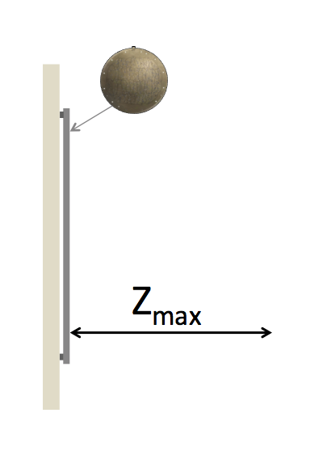If using **screws or c-hooks**: hold the plate to the wall where you wish to attach it, and then have someone mark out with a pencil where the large holes round the edge of the plate are on the wall. Remove the plate from the wall, and secure the hooks or screws into the points marked on the wall. Depending on the type of wall and the type of screws, you may not need screws in every hole, just ensure there are enough to securely hold the plate in place. Leave enough of the screw out of the wall that you can hang the plate on them.
2. While the plate is on the wall, work out the furthest distance out from the plate you could have wires protrude safely. This distance will be referred to as Zmax, as it is will be the largest z coordinate.
3. Out of the brightest objects on your plate, find the furthest away one. *Will this have a large redshift or a small redshift? Why?*
4. Convert the redshift distance into light years using the tables linked to at the bottom of this page

<http://voyages.sdss.org/launch/milky-way/sdss-constellations/discovering-constellations-using-sdss-plates/>.

This distance will be represented in the display by a length of wire that is Zmax long. You may find it useful to create a new column in your excel spreadsheet (from the SQL search) for approximate distance in light years.

1. Work out what lengths of wire would represent the distances to the other brightest objects on the plate using the equations below.

$$Z_{object}=Z_{max} \frac{{Distance}_{object}}{{Distance}_{max}}$$

You may want to also input all of these distances into a new column in the spreadsheet

1. 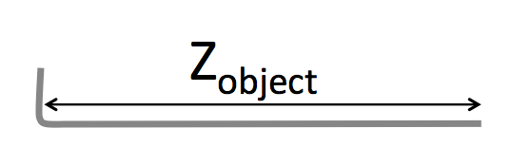For each object, cut a piece of 1.5 to 2mm thick wire to approximately Zobject + 3cm
2. Using pliers, bend one end of the wire at a right angle so that one end is exactly Zobject long.
3. Insert each of the wires into the correct hole on the plate for that object, with the ~3cm piece on the back of the plate.
4. 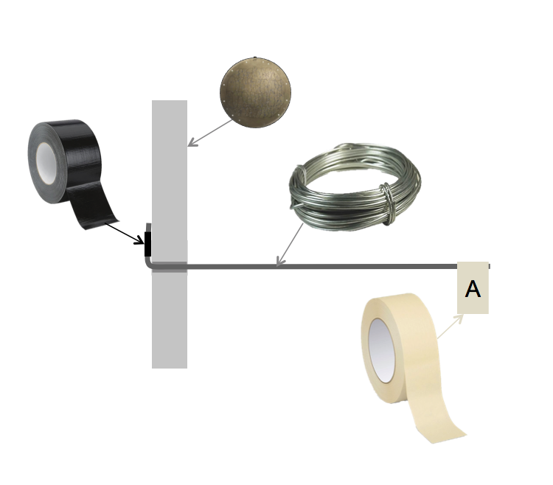Duct tape the ~3cm piece of wire to the back of the plate, with the end of the wire pointing up towards the tab.
5. Label the end of the piece of wire and keep track of the labels for each object on your excel spreadsheet. To label the wire you may want to use masking tape with a letter drawn on, or glue/blue tack a bead with a letter on it onto the wire. Consider using a different colour for galaxies and quasars.
6. **For safety reasons, you may want to cover the end of the wire with blue tack or hot glue.**
7. Repeat this for all of the brightest objects.
8. Once this has been done for all of the objects, reattach the plate to the wall.

**Suggestions for posters you can add to the wall around the plate**

1. An information sheet explaining what the plate is and what is used for.
2. 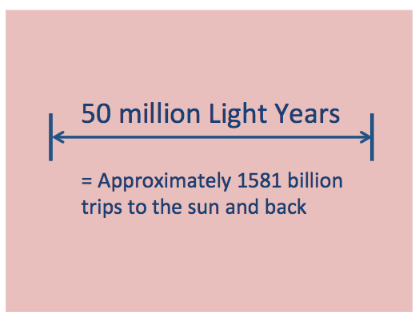A scale to demonstrate what the lengths of wire represent in real distances.
3. ‘Profiles’ of each of the brightest objects, labelled with the same letter that is on the piece of wire for that object. These profiles could include:
   1. The spectra of the object
   2. An image of the object
   3. A description of what kind of object it is.
   4. An explanation of what the features in the spectra represent
   5. What the colour of the object tells us about the object

*Take a photo of your final display and send it to us at* [voyages@SDSS.org](mailto:voyages@SDSS.org) *!*

**Ceiling Display**

If you chose to use this method, it is your responsibility to **safely and securely** attach the plate to the ceiling. This method results in a larger Zmax, so will demonstrate the scales more accurately that attaching it to the wall.

This display follows a similar idea to the wall set up, except instead of wire, thread is used, and instead of command strips, you must bolt the plate to the ceiling.

1. 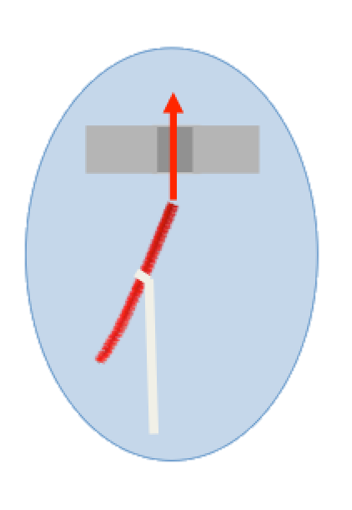Work out how you can securely attach the plate to the ceiling. You will not need to attach the plate to the ceiling until the end, so for now place the plate between two stools/desks/chairs with a gap between them that is a little smaller than the plate’s diameter. This way, you can access the top and bottom of the plate to assemble the display. Make sure the front of the plate (with the lines drawn on it) is facing the floor.
2. Follow steps 2 to 5 of the Wall Display instructions, but with Zmax being the longest distance you can hang a thread down from the ceiling.
3. For each object cut a length of thread about 5cm longer than Zobject. Tie one end of the thread onto a bead.

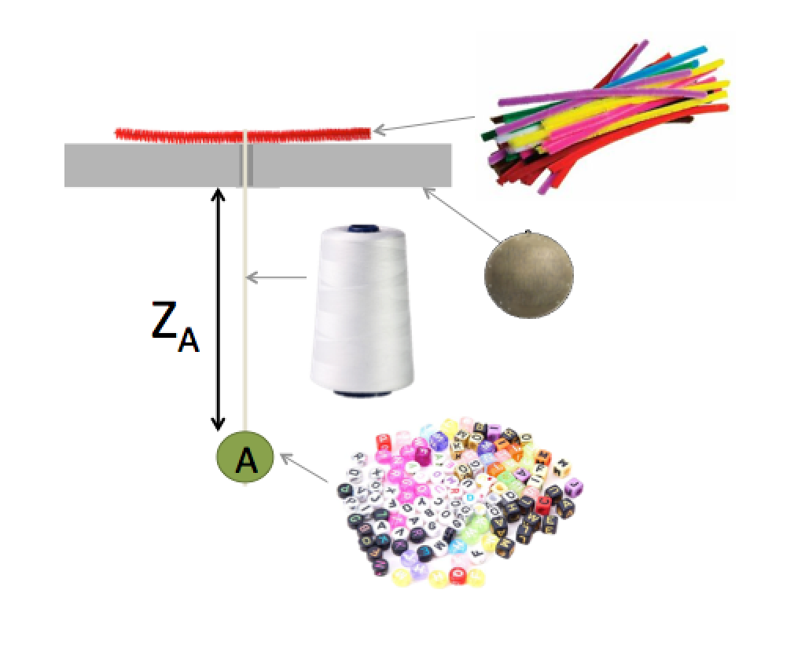In order to keep track of which object is represented by each string, it is a good idea to label the beads. This can either be done with wooden beads and a marker pen, or by using coloured beads with letters on. Keep track of which bead represents which object in your excel spreadsheet.

1. Cut a pipe cleaner into pieces approximately 5cm long. Cut enough pieces to have one for each object.
2. Tie the other end of the thread onto the middle of a piece of pipe cleaner so that there is a bead at one end, a piece of pipe cleaner at the other, and a length of thread between the pipe cleaner and the bead that is equal to Zobject.
3. Trim off any excess thread.
4. Locate the appropriate hole on the plate for this object, and insert the pipe cleaner through the hole from the front to the back. The thread should now be hanging below the plate.
5. 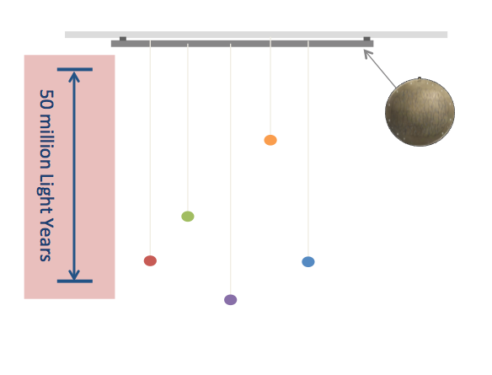Repeat this for all of the brightest objects, and attach the plate to your ceiling.
6. Take a look at the section on the previous page labelled **Suggestions for additional images and posters you can add to the wall around the plate.**

*Take a photo of your final display and send it to us at* [voyages@SDSS.org](mailto:voyages@SDSS.org) *!*