Guidelines for authors preparing an extended abstract to be submitted to the SciTech4Dev 2019 Parallel Paper Presentation

Author names: First name, initial, last name, underline presenting author

Author’s affiliations. Use numbering if more than one affiliation.

Highlights: Please provide a (50) fifty-word summary of the manuscript.

Key words: please provide up to 6 key words. Please try to stick to one line.

Introduction

The following provides all instructions for lay-out and style for preparing your extended abstract. We encourage you to use this document as a template.

Silvilaser (2015) invited extended abstracts covering one or more of the conference topics. The extended abstract should be 2 to 3 pages in length, including highlights, a figure and/or a table and references. A 3 pages abstract is expected if both a table and a figure are provided.

Authors will be informed of acceptance by September 13, 2019. Please, refer to the Important Dates section on the website for further details. All extended abstracts will be submitted to the chairperson of the thematic areas for review process. All accepted extended abstracts will be published in the conference proceedings.

Content

The extended abstract should contain a short (up to 50 words) highlight including a short collection of sentences conveying the core information and providing readers with a quick overview of the research. Highlights will be included with the conference program.

The introduction should include the scope of the study and state the objectives of the work presented. Material and methods should be explained briefly. Authors should emphasize on results and discussion sections. Afterwards, a brief conclusion should be stated, followed by acknowledgements (if any) and references (maximum 7). The extended abstract should be written in English. Use the metric system exclusively.

Lay-out and style

Page set-up

Use A4 paper with top and bottom margins of 2 cm (0.79 inch) and left and right margins of 2.5 cm (0.98 inches). Do not include page numbers or any other page header or footer. Footnotes are not allowed.

Font

Times New Roman.

Paragraph formats

Avoid using empty lines between paragraphs or before and after headings if using the word template. Most required blank spaces are already incorporated in the styles. Apply a 0.5 pt. indentation to the first line.

Title

The title is typed in bold, 12 pt. Do not capitalize words in the title except the first word of the title or whenever required. A 12 pt. space is required after the title. Do not add any additional line if using the word template (already incorporated in the Title style).

Authors

The authors are listed in one paragraph in 11pt. Put first name and initials first. Use superscripted numbering if authors have different affiliation. A 12 pt. space is required after the list of authors. Do not add any additional line if using the word template (already incorporated in the template)

Affiliation

Affiliation and e-mail address are in 10 pt. italic. Only one affiliation per line, numbered with the superscripted numbers used in the authors list.

Highlights & Keywords

Highlights and keywords are in 11 pt., italic for keywords. Highlights are preceded by a 36 pt. space.

Keywords are preceded and followed by a 18 pt. space.

Body text

In the remaining sections of the extended abstract, headings are formatted according to their ranking with paragraph formats 'Heading1' and 'Heading2' (see Table 1). One additional level, namely 'Heading3', is allowed but should be used sparingly. Text paragraphs are justified at both left and right margins and in 10pt (use paragraph format 'Body text').

Table 1: Formatting used in heading paragraph formats, table and figure.

|  |  |  |  |  |
| --- | --- | --- | --- | --- |
| Format name | Font size | Font style | Blanc space | |
|  |  |  | before | after |
| Heading 1 | 11 pt | Bold | 12 pt | 3 pt |
| Heading 2 | 11 pt | Italic | 6 pt | 3 pt |
| Heading 3 | 10 pt | Standard | 6 pt | 0 pt |
| Table title | 10 pt | Standard | 12 pt | 3 pt |
| Figure caption | 10 pt | Standard | 3 pt | 12 pt |

Tables & Figures

A maximum of 1 table and 1 figure is allowed. Please ensure that table and figure do not account for more than 2/3 of a page when taken together.

The table and the figure should be numbered independently. The table should have a table heading above. Only horizontal lines should be used for the table. Table and heading should be in 10pt, centred.

A figure can be incorporated in the abstract at the appropriate place. The figure should have a figure caption under it (10pt centred). Make sure the size of lettering within the figure is big enough.

The text should include references to both the table and the figure.

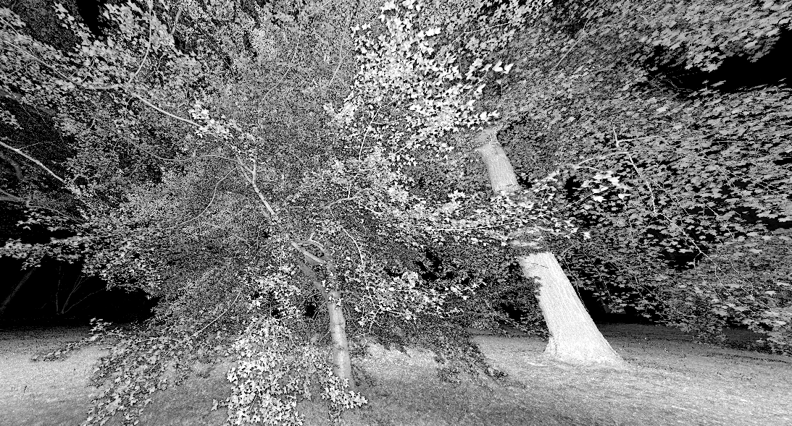

Figure 1: Formatting used for figure.

Formulae

Formulae should be typewritten (use, e.g., Microsoft Equation Editor). Subscripts and superscripts should be clear. Give the meaning of all symbols immediately after the equation in which they are first used. Equations should be numbered sequentially at the right-hand side in parentheses. In general only equations explicitly referred to in the text need to be numbered.

References

Like Mettam & Adams (2009), all publications cited in the text should follow the APA format (e.g. Strunk & White, 2000; Van der Geer, Hanraads & Lupton, 2010) and listed in alphabetical order. Work accepted for publication but not yet published should be referred to as “in press” or “unpublished”. References concerning unpublished data and “personal communications” should be avoided.

References

The following format for journals (Van der Geer, Hanraads & Lupton, 2010), books (Strunk & White, 2000) and chapters in an edited book (Mettam & Adams 2009), should be used while arranged in alphabetical order:

Mettam, G. R., & Adams, L. B. (2009). How to prepare an electronic version of your article. In B. S. Jones, & R. Z. Smith (Eds.), Introduction to the electronic age (pp. 281–304). New York: E-Publishing Inc.

Strunk, W., Jr., & White, E. B. (2000). The elements of style. (4th ed.). New York: Longman, (Chapter 4).

Van der Geer, J., Hanraads, J. A. J., & Lupton, R. A. (2010). The art of writing a scientific article. Journal of Scientific Communications, 163, 51–59.