Installation guide for the Cinglevue Code Challenge.

1. Create a database on Mongo ‘code_challenge’
2. Switched to the database and create a collection ‘school_details’ and insert below documents.

|  |
| --- |
| {  "school": {  "schoolName": "St. Aaron College"  },  "subject": "numeracy",  "latestY3": 413.55,  "latestY5": 494.25,  "latestY7": 0.0,  "latestY9": 0.0,  "rawGainY3Y5": 61.4917,  "factoredGainY3Y5": 69.81,  "glgY3Y5": 113.52757826,  "latestGainInGainY3Y5": -7.0  },  {  "school": {  "schoolName": "St. Alan College"  },  "subject": "numeracy",  "latestY3": 380.5125,  "latestY5": 469.9,  "latestY7": 510.85,  "latestY9": 558.7125,  "rawGainY3Y5": 84.6607,  "factoredGainY3Y5": 90.76,  "glgY3Y5": 107.20438726,  "latestGainInGainY3Y5": 0.0  },  {  "school": {  "schoolName": "St. Alexander College"  },  "subject": "numeracy",  "latestY3": 391.0125,  "latestY5": 513.925,  "latestY7": 0.0,  "latestY9": 0.0,  "rawGainY3Y5": 87.6917,  "factoredGainY3Y5": 77.06,  "glgY3Y5": 87.87608097,  "latestGainInGainY3Y5": 3.0  }, |

Verify your data.

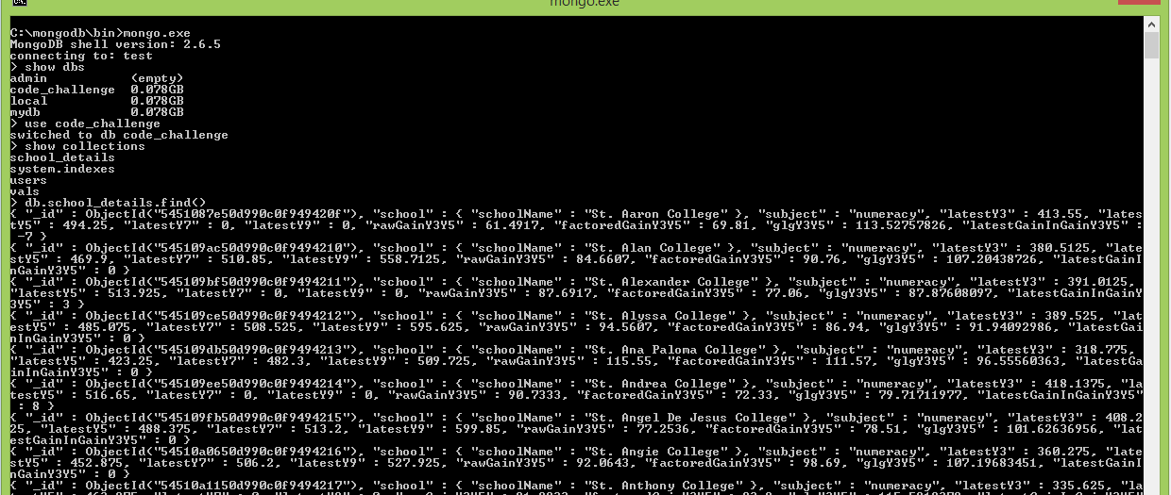

1. Update **dispatcher-servlet.xml** on **codeChallenge\src\main\webapp\WEB-INF** with your host address, mongo db port, database name.

<mongo:mongo host=*"127.0.0.1"* port=*"27017"* />

<mongo:db-factory dbname=*"code_challenge"* />

1. Now you can build the project with maven.

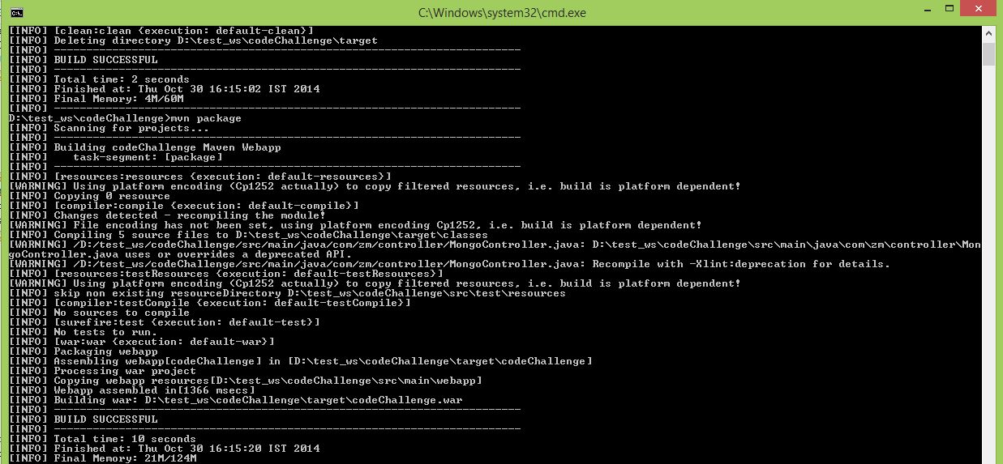

1. After the build project successfully, deploy it on jboss server. Copy **codeChallenge.war** from **codeChallenge\target** folder and paste it under **jboss-as-7.1.1.Final\standalone\deployments** folder. Then start jBoss server.

You can access the application on [**http://localhost:8080/codeChallenge/**](http://localhost:8080/codeChallenge/)

Change subject field to filter data.

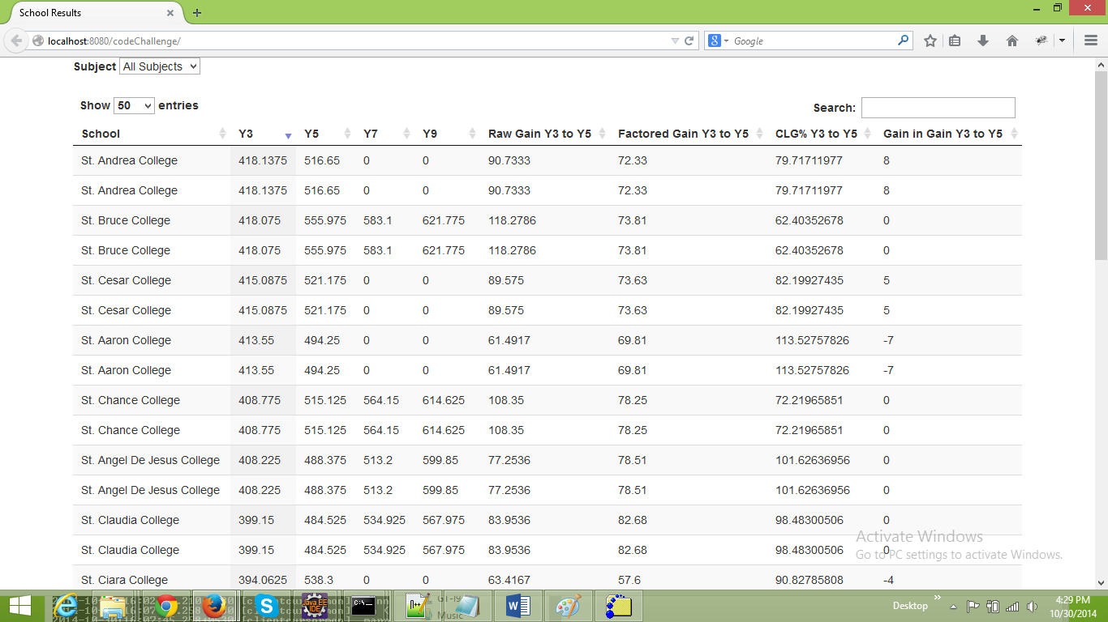

Go to **http://localhost:8080/codeChallenge/list?subject=all** to view all data and use **numeracy, reading** and **spelling** as parameters for subject.

