Progress Report

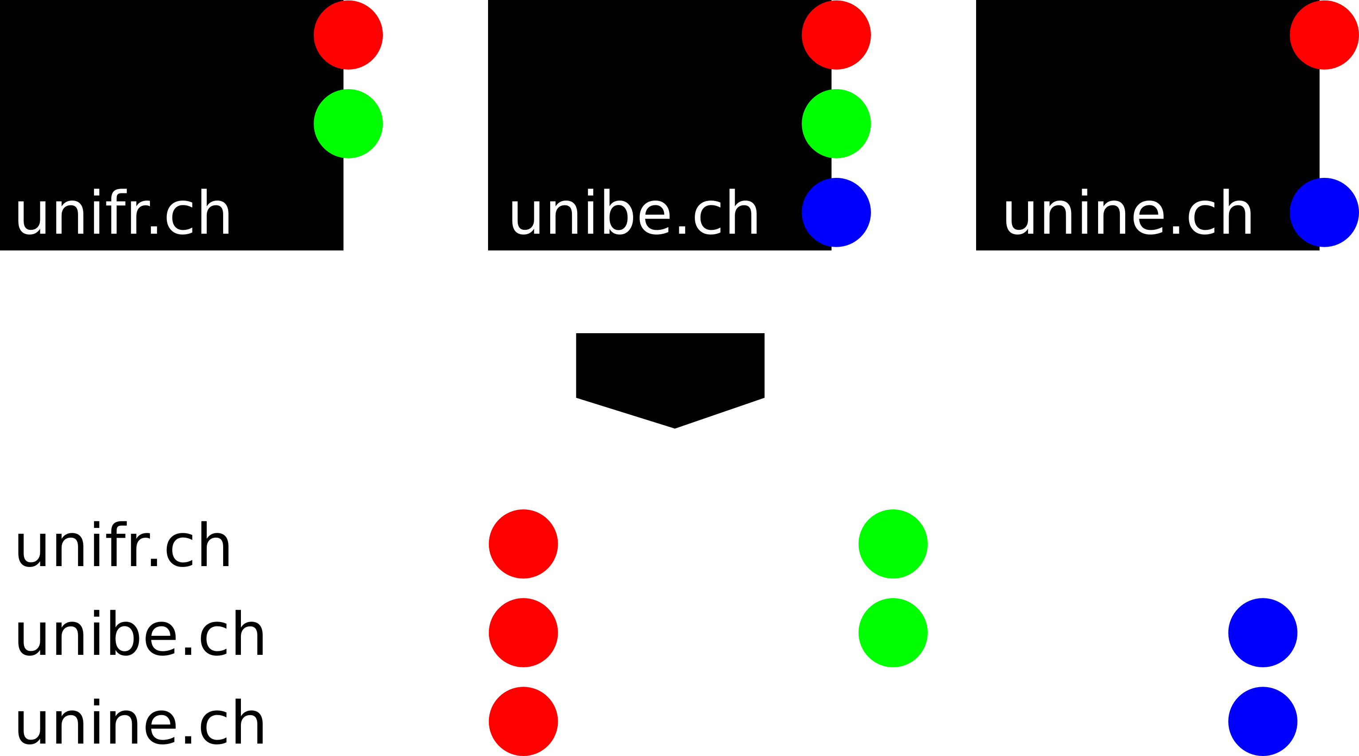
Project title: WeCompare
With WeCompare you are able to easily annotated stuff on the internet for later comparision. Put the pen away, we render your overview list for you!

Architecture
The prototype will be implemented as a client side application. Only the data storing will be handle by a server. This server is a Triplestore.

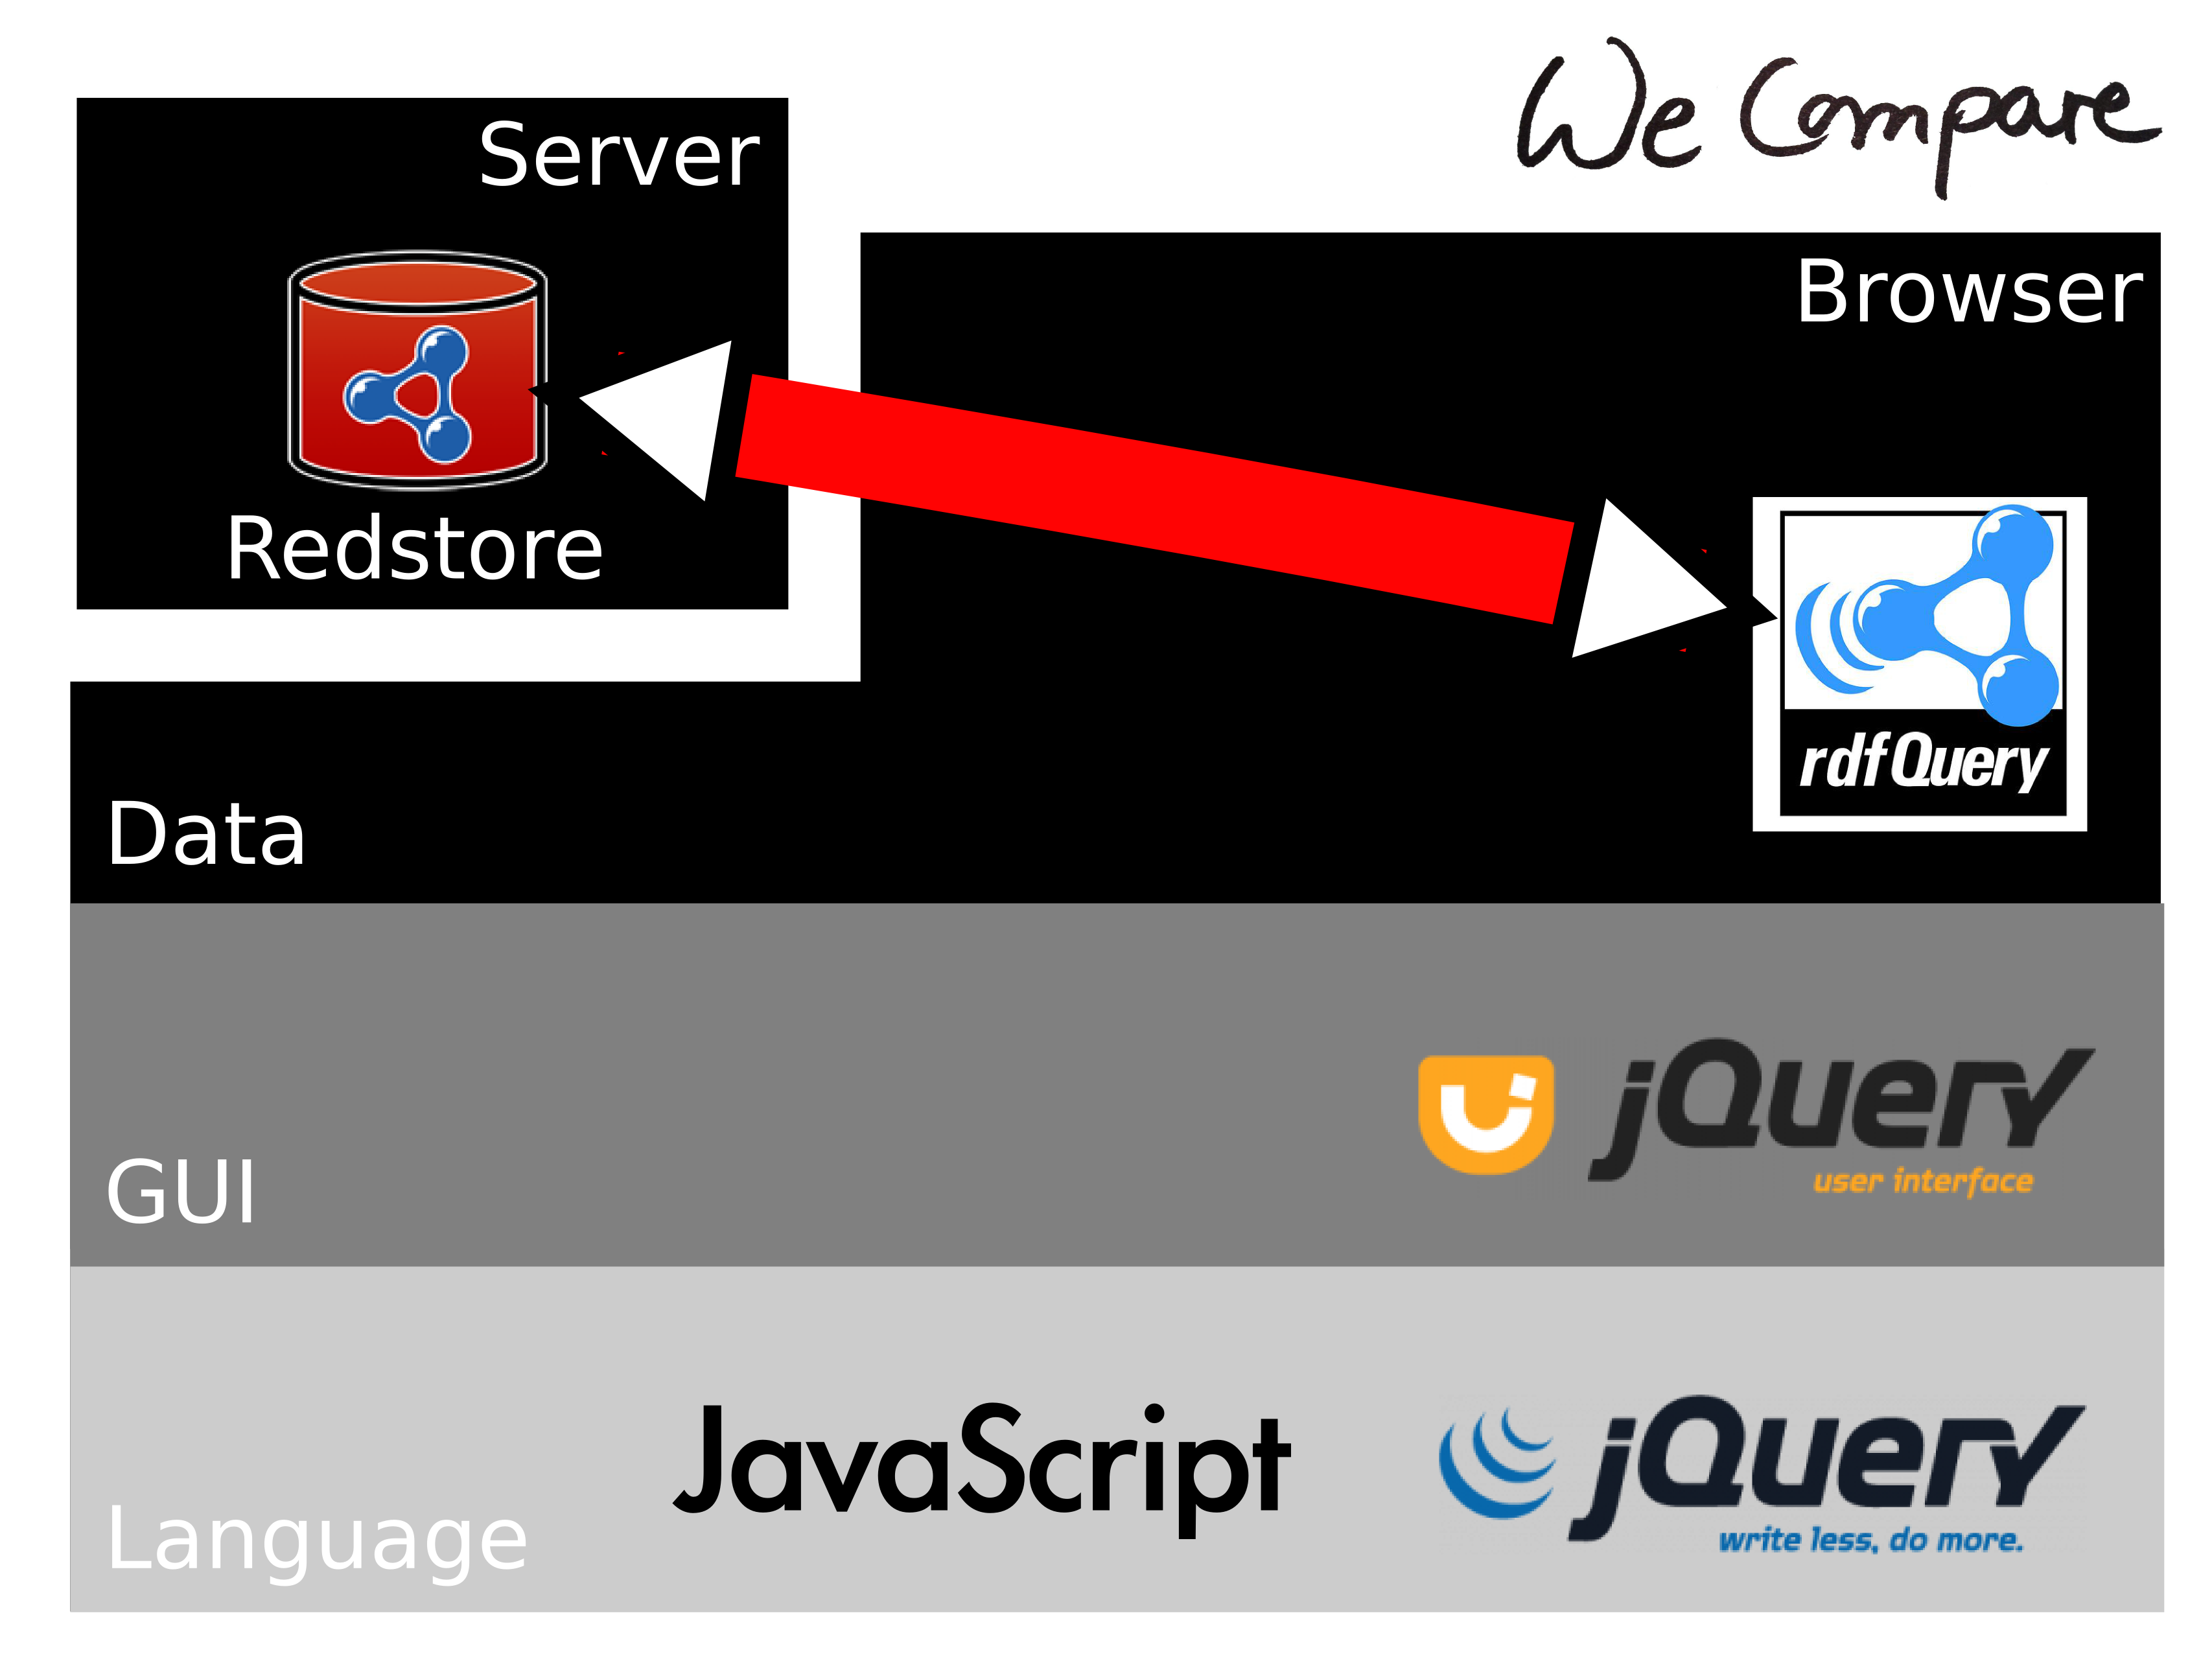

Actual status
<What was done so far.> <Up to Jörg!>

Remaining Tasks
<What is remaining.> <Up to Mariusz!>

Distribution of work
<Tasks of each group member.> <Up to Mariusz!>
My proposition is, to divide by DatabaseInterface, GUI-Interface-Design, GUI-Interface-Logic

Webhosting
<Do you need us to provide web hosting? If YES, what are your hardware and software requirements?>

<Please Jörg.. just say how it is hosted. (no details needed)>

