1. API to add roles dynamically

URL: localhost:8080/addroles

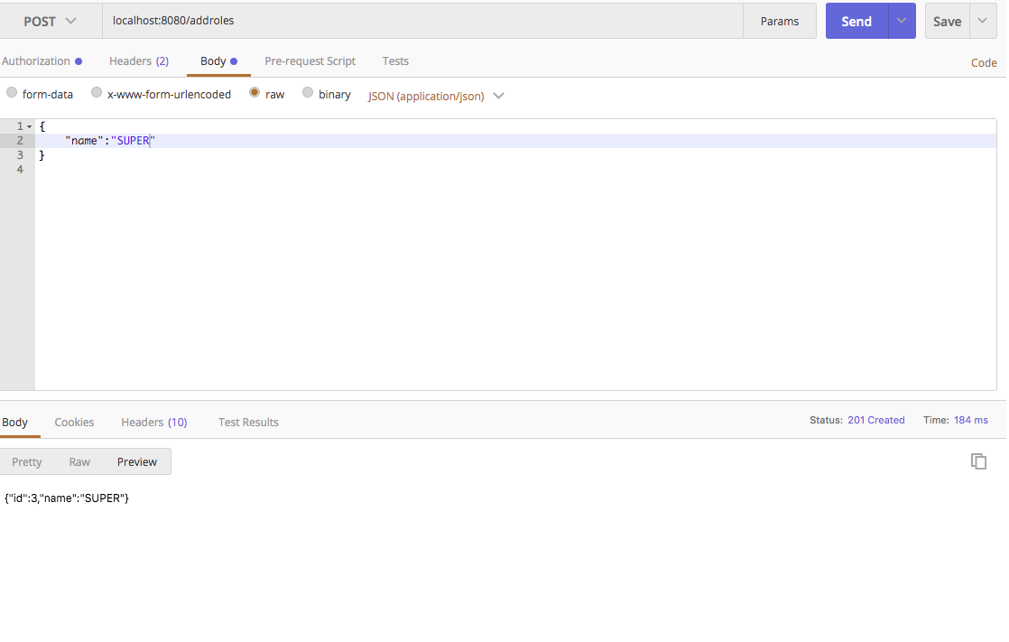

1. API to use add users dynamically

URL: localhost:8080/addusers

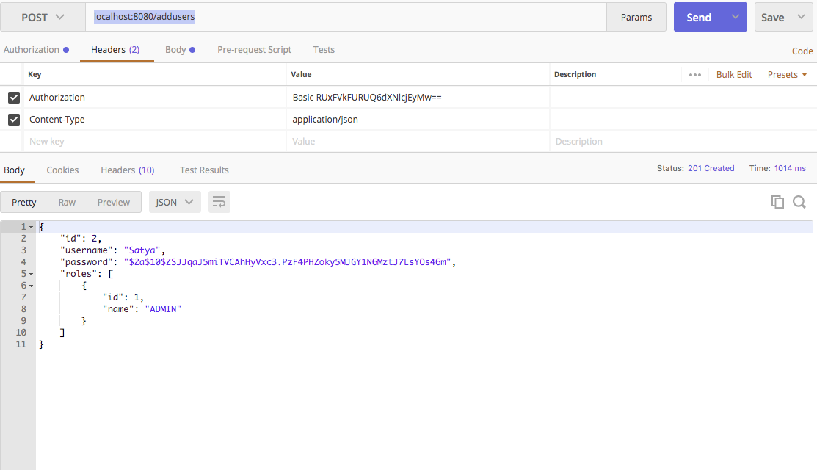

1. API to add employee

URL: localhost:8080/addemployee

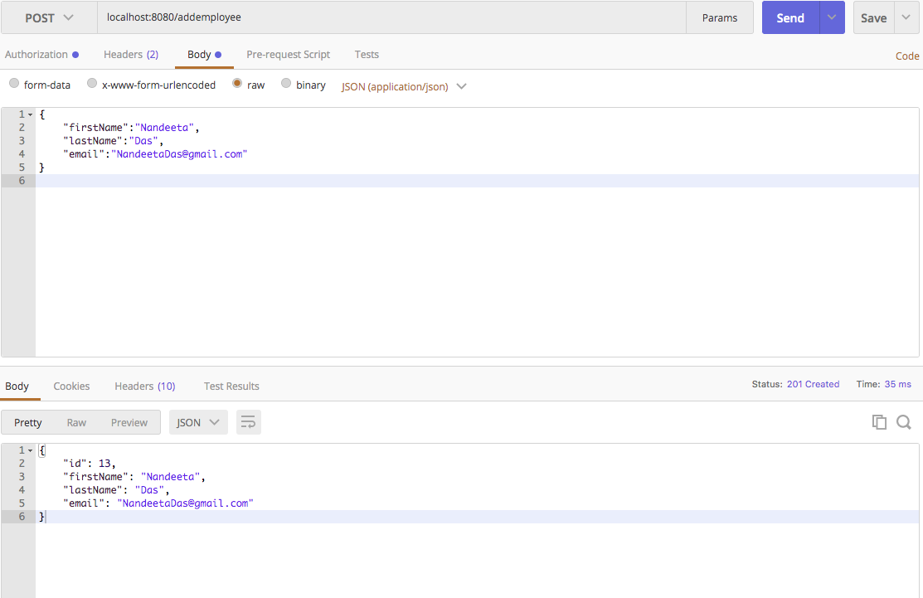

Add Employee with USER

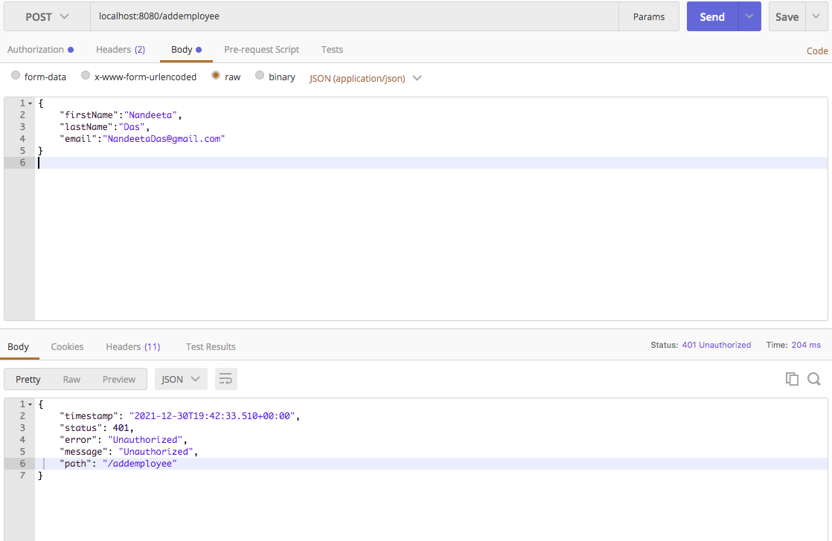

1. API to retrieve all employee details,

URL: localhost:8080/employeelist

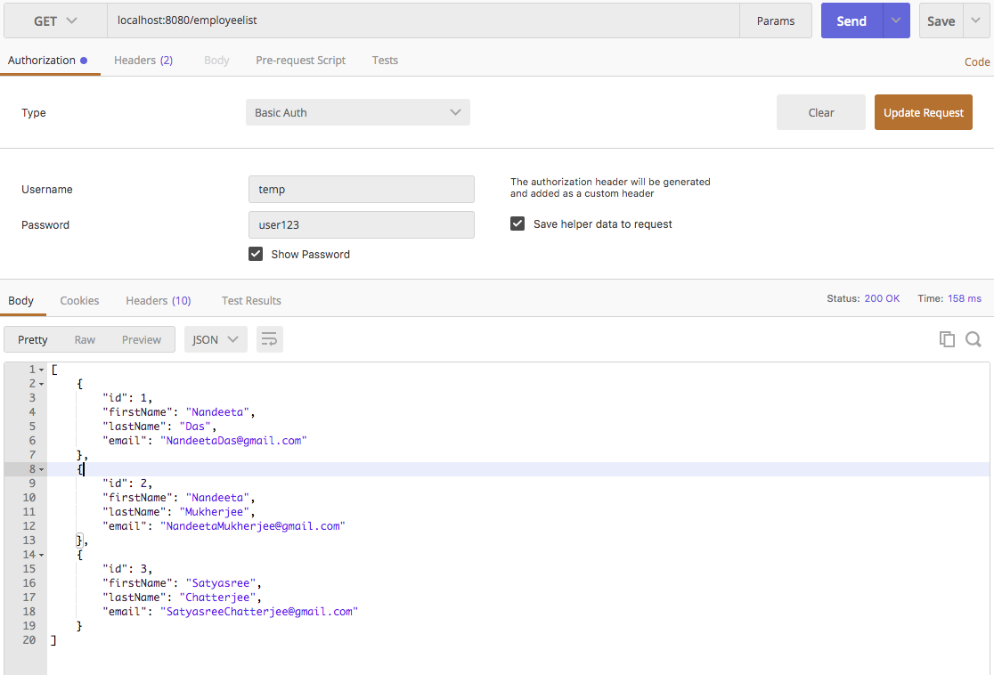

1. API to retrieve all employee details in sorted manner

URL : localhost:8080/sortedemployeelist?sortby=asc

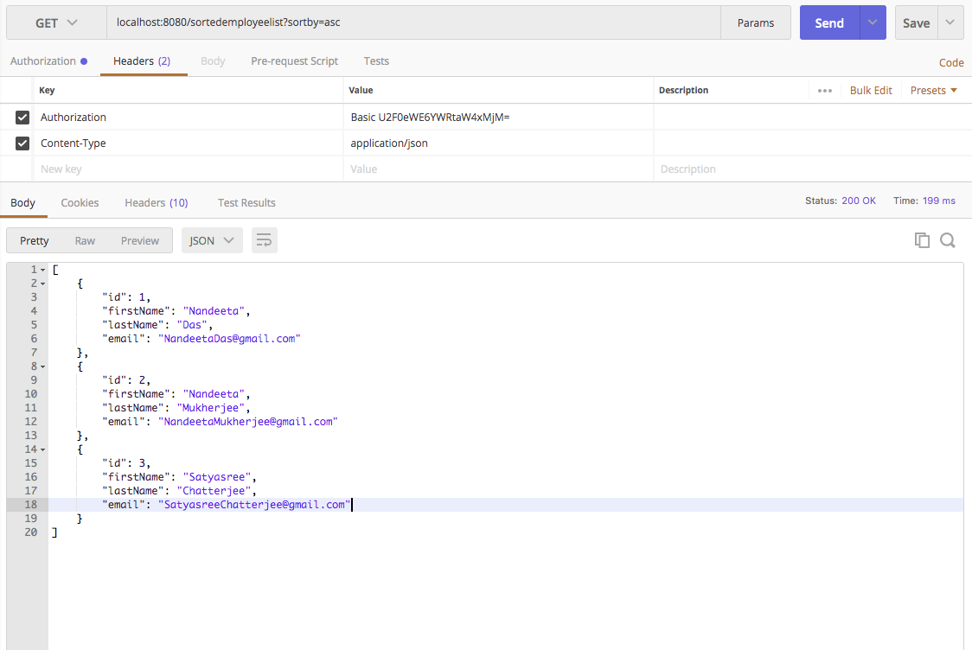

URL : localhost:8080/ sortedemployeelist?sortby=desc

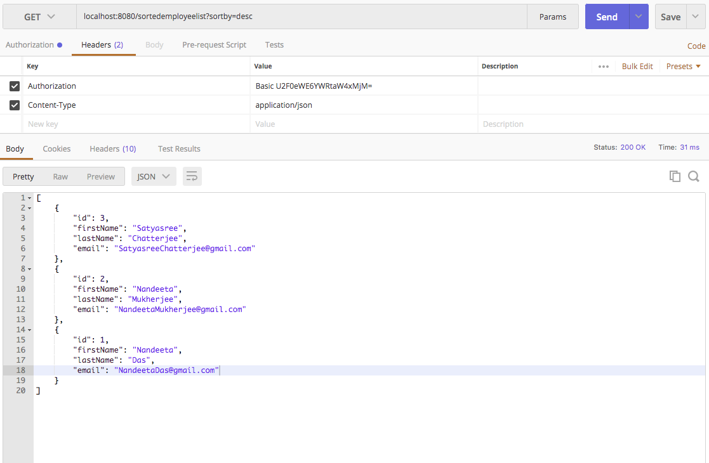

1. API to retrieve employee details by firstName

URL: localhost:8080/employeename/{firstName}

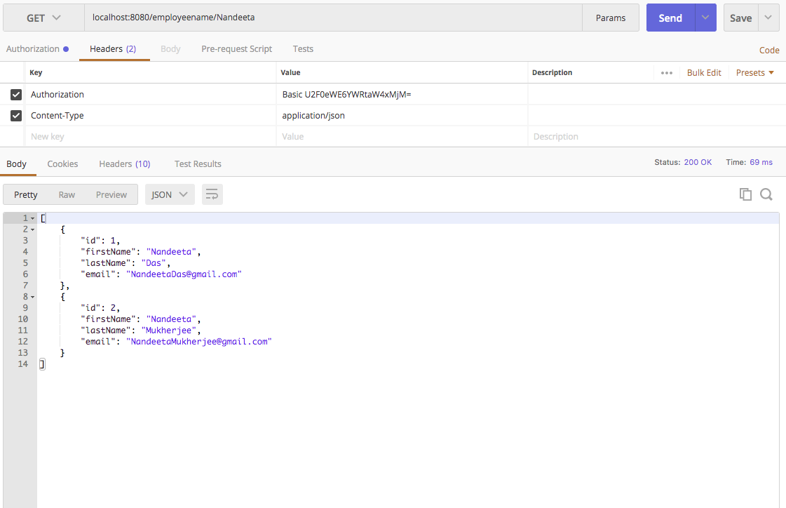

1. API to fetch employee details based on id ,

URL: localhost:8080/employee/{id}

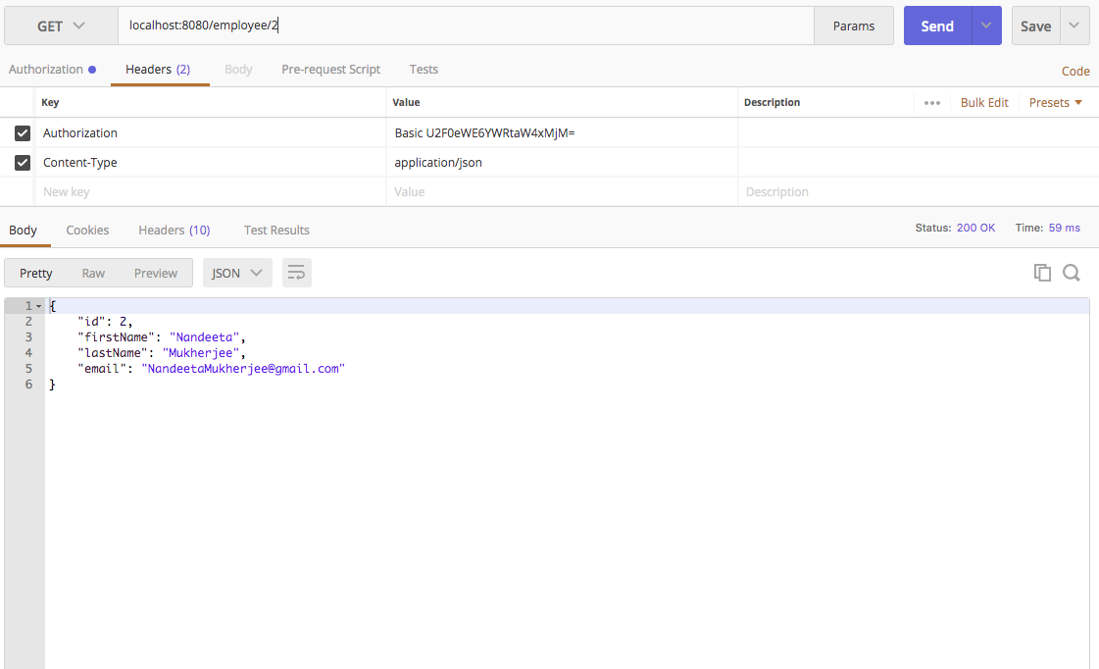

1. API to update the employee details

URL: localhost:8080/updateemployee

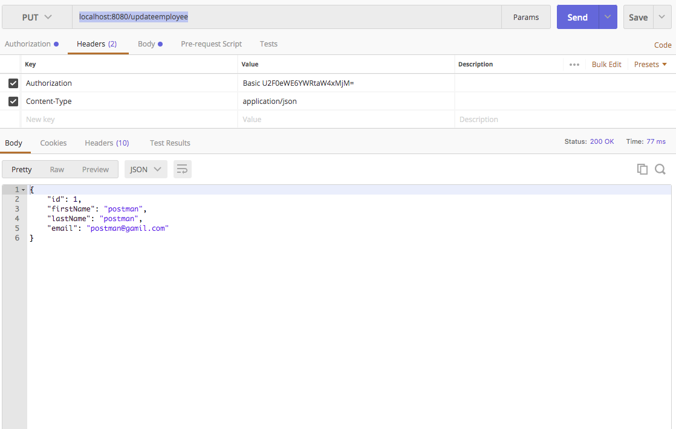

1. API to delete employee

URL: localhost:8080/delete/{id}

