TASK 1: Repository Setup
Goal: Initialize Git and create first commit
Steps:
1. Create a folder named git-assignment-yourfullname
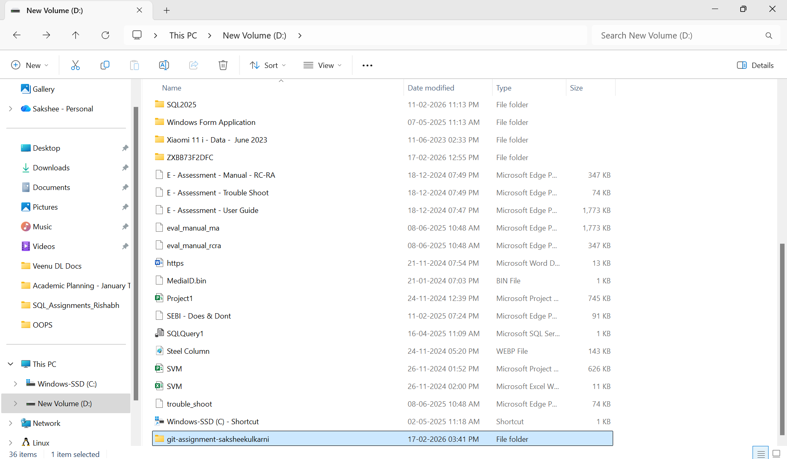
2. Navigate into the folder
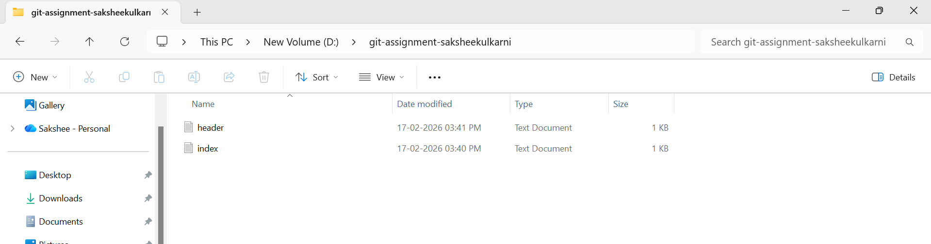
3. Initialize Git repository
4. Create a file named index.txt
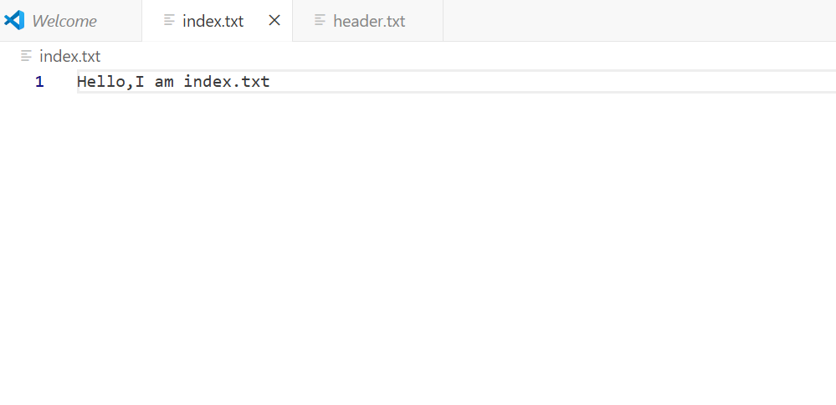

5. Check repository status
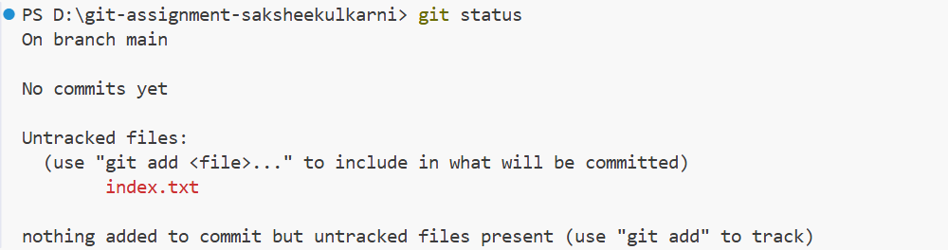
6. Stage the file
7. Commit with message:
Initial project setup

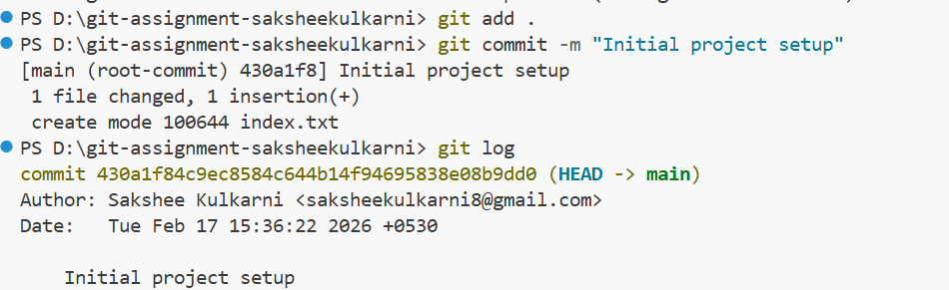
TASK 2: Branch Creation & Work Goal: Work independently in a branch Steps:
1. Create a branch named feature-header
2. Switch to feature-header
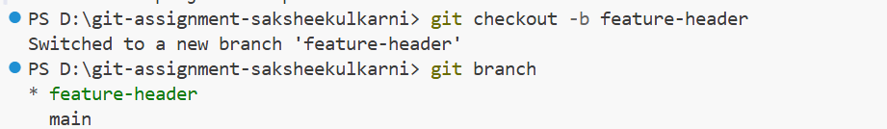
3. Create a file named header.txt
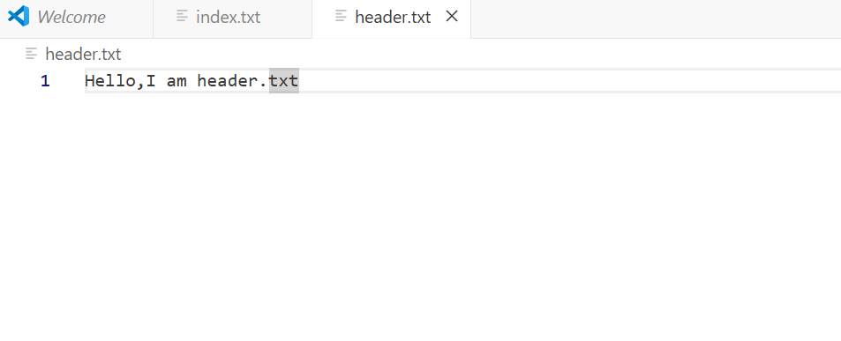
4. Stage the file
5. Commit with message:
Added header section
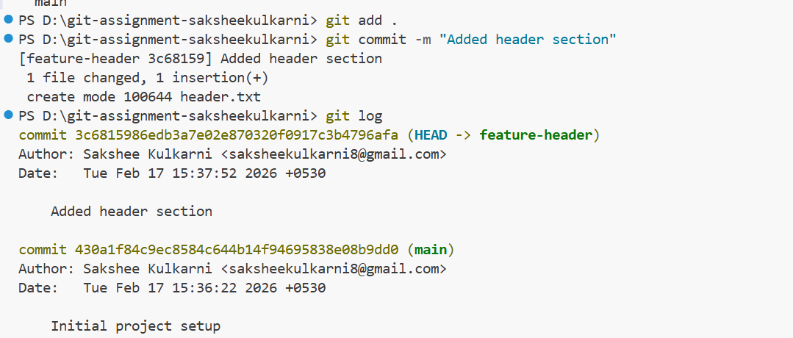
TASK 3: Branch Switching Observation Goal: Observe branch isolation
Steps:
1. Switch back to master
2. List files and observe
3. Switch again to feature-header
4. List files and observe
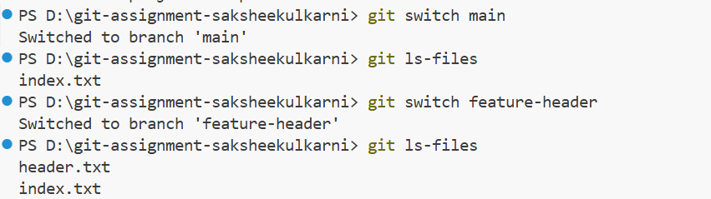
TASK 4: Undo a Mistake
Goal: Safely undo file changes
Steps:
1. In feature-header, modify index.txt
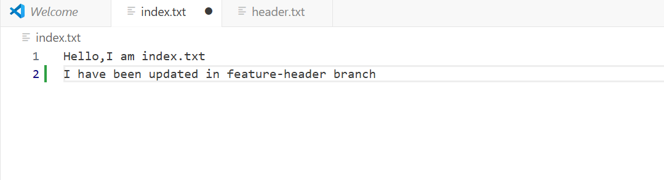
2. Check repository status
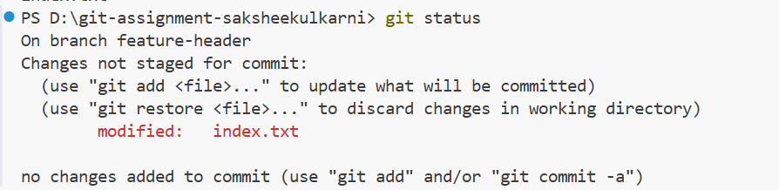
3. Undo the change using Git
4. Verify status again
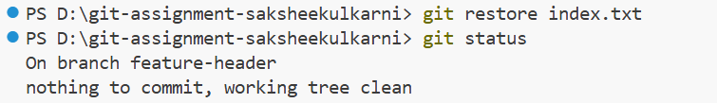
TASK 5: Merge Feature Branch
Goal: Combine work into master
Steps:
1. Switch to master
2. Merge feature-header
3. Verify merged files
4. Check commit history
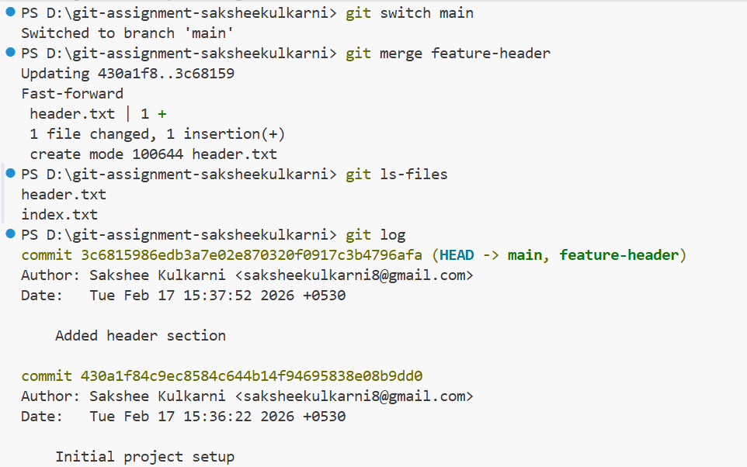
TASK 6: Checkout a Commit (Detached HEAD) Goal: Understand commit-level navigation Steps:
1. View commit history
2. Checkout any older commit
3. Check current branch status
4. Switch back safely to master
