## Load packages

library('car')  
library('lsmeans')  
library('plyr')  
library('dplyr')  
library('ggplot2')  
library('knitr')  
library('scales')

## Define some helper functions

get_means <- function(x){  
 list(means = as.data.frame(summary(x[[1]])),   
 diffs = as.data.frame(summary(x[[2]]))  
 )  
}  
  
gg <- function(){  
 list(  
 geom_point(size = 4),  
 geom_errorbar(limits, size = 1, width=0.2),  
 theme_grey(base_size = 18)  
 )  
}  
  
limits <- aes(ymax = lsmean + SE, ymin = lsmean - SE)  
  
# Define function to get quick summary by factor variable  
avg_by <- function(...){  
 dat_df %>%   
 group_by(...) %>%  
 summarise(rdm_mean = mean(rdm, na.rm = TRUE),  
 rdm_sd = sd(rdm, na.rm = TRUE),  
 rdm_n = length(na.omit(rdm)))  
}  
  
# Define function to get quick summary by factor variable, write to csv file  
write_csv <- function(.dat, var){  
 write.csv(.dat, file = sprintf("csvs/avg_by_%s.csv", var), row.names=FALSE)  
}  
write_mod_csv <- function(.dat, var){  
 write.csv(.dat, file = sprintf("csvs/%s.csv", var), row.names=FALSE)  
}

## Summary of data

Prep data

dat <- read.csv("dittes_data2.csv", stringsAsFactors = FALSE)  
dat$date <- as.Date(paste(as.character(dat$year), "-01-01", sep = ""), "%Y-%m-%d")  
dat <- dat[ !dat$habitat == 2, ] # drop habitat=32  
dat$rdm <- dat$rdm*100 # multiply rdm by 100  
dat$landform <- tolower(dat$landform)

Make a dplyr tbl_df object

dat_df <- tbl_df(dat)

by transect

avg_by(transect) %>% kable(format = "markdown")

|  |  |  |  |
| --- | --- | --- | --- |
| transect | rdm_mean | rdm_sd | rdm_n |
| AD10 | 1346.4 | 1142.5 | 84 |
| AD11 | 1847.6 | 1803.2 | 85 |
| AD12 | 1789.4 | 1287.7 | 85 |
| AL1 | 941.9 | 707.2 | 80 |
| BK5 | 840.0 | 688.7 | 70 |
| BL7 | 1677.6 | 1663.6 | 85 |
| ML9 | 1567.6 | 1913.6 | 85 |
| NF6 | 1146.7 | 802.3 | 75 |
| NV8 | 1246.1 | 1159.9 | 85 |
| PK2 | 1069.3 | 677.5 | 75 |
| PL3 | 725.5 | 686.4 | 85 |
| PL4 | 751.8 | 503.1 | 85 |

avg_by(transect) %>% write_csv("transect")

by year

avg_by(year) %>% kable(format = "markdown")

|  |  |  |  |
| --- | --- | --- | --- |
| year | rdm_mean | rdm_sd | rdm_n |
| 1997 | 1721.7 | 2574.7 | 60 |
| 1998 | 1887.5 | 1839.5 | 60 |
| 1999 | 2024.0 | 1920.7 | 50 |
| 2000 | 1267.6 | 1033.7 | 110 |
| 2001 | 1521.7 | 947.3 | 120 |
| 2002 | 1055.8 | 769.4 | 120 |
| 2003 | 727.7 | 407.7 | 110 |
| 2004 | 887.1 | 532.1 | 120 |
| 2005 | 1711.8 | 1326.1 | 110 |
| 2014 | 745.0 | 625.3 | 119 |

by soil type

avg_by(soil) %>% kable(format = "markdown")

|  |  |  |  |
| --- | --- | --- | --- |
| soil | rdm_mean | rdm_sd | rdm_n |
| Kc | 1069.3 | 677.5 | 75 |
| SuD | 1683.7 | 1317.0 | 46 |
| TfD | 1325.6 | 967.8 | 41 |
| TgD | 1472.5 | 1646.9 | 257 |
| TgE | 2160.0 | 1499.4 | 30 |
| ThE | 1526.8 | 1351.1 | 200 |
| ToE | 965.0 | 386.6 | 10 |
| TuB | 768.2 | 627.5 | 240 |
| Txc | 941.9 | 707.2 | 80 |

by slope_class

avg_by(slope_class) %>% kable(format = "markdown")

|  |  |  |  |
| --- | --- | --- | --- |
| slope_class | rdm_mean | rdm_sd | rdm_n |
| 1 | 1134.1 | 1281.9 | 523 |
| 2 | 1275.2 | 1055.5 | 204 |
| 3 | 1529.6 | 1324.0 | 240 |
| 4 | 795.8 | 628.3 | 12 |

by landform

avg_by(landform) %>% kable(format = "markdown")

|  |  |  |  |
| --- | --- | --- | --- |
| landform | rdm_mean | rdm_sd | rdm_n |
| foothills | 1524.0 | 1469.2 | 584 |
| terraces | 860.6 | 663.4 | 395 |

by habitat

avg_by(habitat) %>% kable(format = "markdown")

|  |  |  |  |
| --- | --- | --- | --- |
| habitat | rdm_mean | rdm_sd | rdm_n |
| grassland | 1156 | 1123 | 700 |
| woodland | 1508 | 1505 | 279 |

by transect for each year

note: full table not show, as 120 rows, see csv file in csvs/transect_year.csv

avg_by(habitat)  
#> Source: local data frame [2 x 4]  
#>   
#> habitat rdm_mean rdm_sd rdm_n  
#> 1 grassland 1156 1123 700  
#> 2 woodland 1508 1505 279

CSV files are written out for each variable, and one for all combinations (code not shown)

## Data analysis

All analyses are done with rdm (residual dry matter in lbs/sq acre) as the response variable. Plots use least square means for the y-variables since these take into account the statistical model that was used, wehreas raw data, although more meaningful, may be misleading. Confidence intervals on plots are 95% CI's.

### Prepare data a bit

dat <- dat_df %>% filter(!is.na(rdm), !rdm < 2) %>% mutate(soil = as.factor(soil))

### Does RDM differ between soil types?

mod <- dat %>% lm(log10(rdm + 1) ~ soil, data=.)   
# mod %>% plot  
mns <- mod %>% lsmeans(list(pairwise ~ soil), adjust = c("tukey")) %>% get_means  
write_mod_csv(mns$diffs, "tukey_soil")  
mod %>% Anova(type = "3") %>% kable(format = "markdown")

|  |  |  |  |  |
| --- | --- | --- | --- | --- |
|  | Sum Sq | Df | F value | Pr(>F) |
| (Intercept) | 651.61 | 1 | 5331.46 | 0 |
| soil | 13.81 | 8 | 14.13 | 0 |
| Residuals | 118.43 | 969 | NA | NA |

Plot by soil type

mns$means %>% ggplot(aes(soil, lsmean)) + gg()

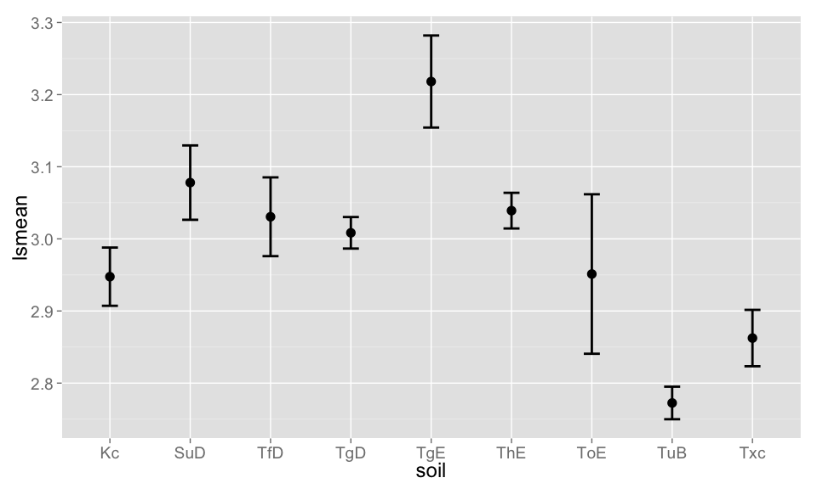

### Does RDM differ among years within each transect?

mods <- dat %>% mutate(year = as.factor(year)) %>% group_by(transect) %>% do(model = lm(log10(rdm + 1) ~ year, data=.))  
# mods$model[[1]] %>% plot  
mns_s <- lapply(mods$model, function(x) x %>% lsmeans(list(pairwise ~ year), adjust = c("tukey")) %>% get_means)  
for(i in seq_along(mods$model)) write_mod_csv(mns_s[[i]]$diffs, sprintf("tukey_%s", mods$transect[[i]]))  
for(i in seq_along(mods$model)){  
 cat("\n")  
 cat(sprintf("__%s__\n", mods$transect[i]))  
 mods$model[[i]] %>% Anova(type = "3") %>% kable(format = "markdown")  
}

**AD10**

|  |  |  |  |  |
| --- | --- | --- | --- | --- |
|  | Sum Sq | Df | F value | Pr(>F) |
| (Intercept) | 45.617 | 1 | 329.698 | 0.0000 |
| year | 3.037 | 9 | 2.439 | 0.0173 |
| Residuals | 10.239 | 74 | NA | NA |

**AD11**

|  |  |  |  |  |
| --- | --- | --- | --- | --- |
|  | Sum Sq | Df | F value | Pr(>F) |
| (Intercept) | 60.764 | 1 | 993.08 | 0 |
| year | 7.633 | 9 | 13.86 | 0 |
| Residuals | 4.528 | 74 | NA | NA |

**AD12**

|  |  |  |  |  |
| --- | --- | --- | --- | --- |
|  | Sum Sq | Df | F value | Pr(>F) |
| (Intercept) | 54.329 | 1 | 603.86 | 0.0000 |
| year | 2.453 | 9 | 3.03 | 0.0039 |
| Residuals | 6.748 | 75 | NA | NA |

**AL1**

|  |  |  |  |  |
| --- | --- | --- | --- | --- |
|  | Sum Sq | Df | F value | Pr(>F) |
| (Intercept) | 36.862 | 1 | 482.820 | 0e+00 |
| year | 2.983 | 8 | 4.885 | 1e-04 |
| Residuals | 5.421 | 71 | NA | NA |

**BK5**

|  |  |  |  |  |
| --- | --- | --- | --- | --- |
|  | Sum Sq | Df | F value | Pr(>F) |
| (Intercept) | 34.209 | 1 | 382.069 | 0 |
| year | 4.491 | 7 | 7.165 | 0 |
| Residuals | 5.551 | 62 | NA | NA |

**BL7**

|  |  |  |  |  |
| --- | --- | --- | --- | --- |
|  | Sum Sq | Df | F value | Pr(>F) |
| (Intercept) | 44.255 | 1 | 424.949 | 0.0000 |
| year | 2.921 | 9 | 3.116 | 0.0031 |
| Residuals | 7.811 | 75 | NA | NA |

**ML9**

|  |  |  |  |  |
| --- | --- | --- | --- | --- |
|  | Sum Sq | Df | F value | Pr(>F) |
| (Intercept) | 58.661 | 1 | 772.27 | 0e+00 |
| year | 3.247 | 9 | 4.75 | 1e-04 |
| Residuals | 5.697 | 75 | NA | NA |

**NF6**

|  |  |  |  |  |
| --- | --- | --- | --- | --- |
|  | Sum Sq | Df | F value | Pr(>F) |
| (Intercept) | 43.382 | 1 | 548.19 | 0e+00 |
| year | 2.735 | 8 | 4.32 | 3e-04 |
| Residuals | 5.223 | 66 | NA | NA |

**NV8**

|  |  |  |  |  |
| --- | --- | --- | --- | --- |
|  | Sum Sq | Df | F value | Pr(>F) |
| (Intercept) | 32.461 | 1 | 197.346 | 0.0000 |
| year | 2.758 | 9 | 1.863 | 0.0707 |
| Residuals | 12.337 | 75 | NA | NA |

**PK2**

|  |  |  |  |  |
| --- | --- | --- | --- | --- |
|  | Sum Sq | Df | F value | Pr(>F) |
| (Intercept) | 39.061 | 1 | 819.681 | 0 |
| year | 2.405 | 8 | 6.307 | 0 |
| Residuals | 3.145 | 66 | NA | NA |

**PL3**

|  |  |  |  |  |
| --- | --- | --- | --- | --- |
|  | Sum Sq | Df | F value | Pr(>F) |
| (Intercept) | 32.955 | 1 | 500.171 | 0 |
| year | 3.290 | 9 | 5.548 | 0 |
| Residuals | 4.942 | 75 | NA | NA |

**PL4**

|  |  |  |  |  |
| --- | --- | --- | --- | --- |
|  | Sum Sq | Df | F value | Pr(>F) |
| (Intercept) | 32.328 | 1 | 494.225 | 0.0000 |
| year | 1.676 | 9 | 2.847 | 0.0061 |
| Residuals | 4.906 | 75 | NA | NA |

Plot for each transect, among years

rbind_all(Map(function(x,y) data.frame(transect=y, x), lapply(mns_s, "[[", "means"), unique(dat_df$transect))) %>%  
 mutate(date = as.Date(paste0(year,"-01-01"), "%Y-%m-%d")) %>%  
 ggplot(aes(date, lsmean)) + gg() + facet_wrap(~ transect) + scale_x_date(labels = date_format("%Y"))

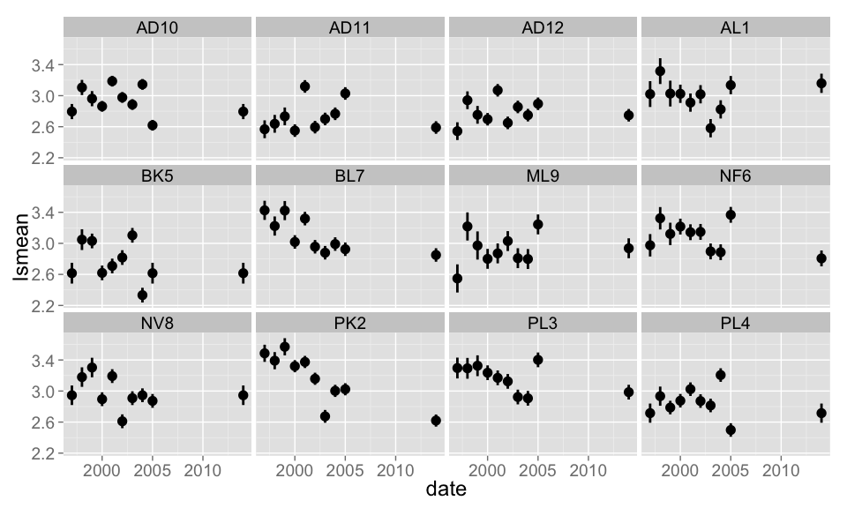

### Power analysis (to figure out appropriate sample size)

NOT DONE YET...