4925_2017 Homework #3, an advection/diffusion homework [relevant to the Kz and to AMOC lecture],

due 12 October.

Send your solution [word doc, xls, pdf] to [agordon@ldeo.columbia](mailto:agordon@ldeo.columbia) and to Laura Gruenburg: lkg2133@columbia.edu

*The objective is to calculate the Kz within a stratified layer separating the upper ocean from the deep, abyssal ocean.*

It’s a heat budget calculation: heat in equals heat out, i.e. a steady state condition.

A simple Box model is set up. There are 2 'boxes' of homogeneous water: upper ocean box, which is 13C and an abyssal box, which is 1.7C.

North Atlantic Deep Water [NADW] is produced as the 13C upper layer water is converted into NADW in the northern North Atlantic [details in the AMOC lecture] as heat is removed by air-sea interaction; the resultant 1.7C NADW is then transferred into the abyssal box.

NADW is composed of 3 components: Mediterranean Sea (Med) production rate 1 Sv, temperature 12C; Labrador Sea (Lab) production rate 3 Sv, temperature 3C; and Greenland/Iceland/Norwegian Seas (GINS) production rate 13 Sv, temperature 2C.

The NADW in the abyssal box got to get back into the upper layer box to close the loop. It does this by upwelling across the stratified layer between the upper layer and abyssal boxes (1.7C to 13C boxes).

Assume that the stratified layer is 500 m thick, spanning the 1.7C and 13C boxes. The upper ocean box and stratified layer have an area equal to 65% of the global ocean area [total ocean area is 3.62 x 1014 m2].

To complicate matters, there are two other factors that affect the heat input into the abyssal box: 1. geothermal heating of 2 x 1013 Watts; 2. heat is removed from the abyssal box in the southern ocean at a rate of 2.8 x 1014 Watts [details in the SOMOC lecture] as abyssal water upwells around Antarctica into the southern ocean box, cools (air-sea-ice interaction) to re-enters the deep ocean as Antarctic Bottom Water (AABW). AABW does not pass thru the upper ocean box; there is no communication between the upper ocean box and the southern ocean box across the polar front.

**Estimate the amount of heat that must pass across the stratified layer to maintain a steady state. Also estimate the Kz [vertical mixing coefficient] within the stratified layer. How does this compare to other estimates of Kz within the thermocline?**

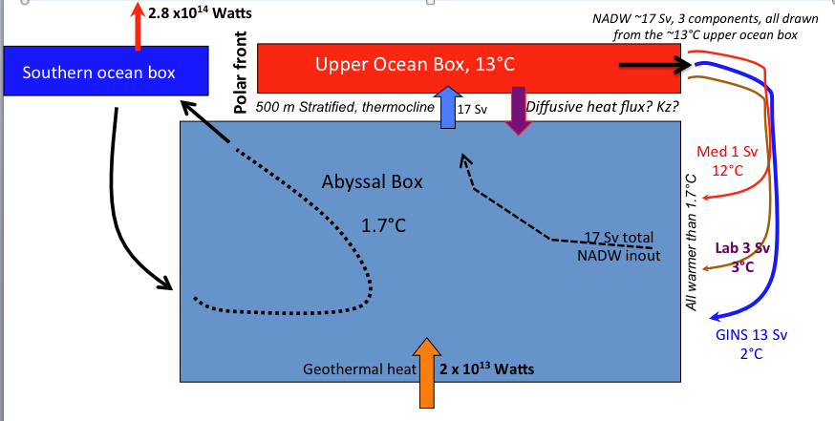HINT of how to approach...