Untitled

Jane Doe

John Doe

25 September 2019

Abstract text goes here.

Table of Contents

HEADER 1

Subheader 1

Sub-subheader 1

# HEADER

Body text goes here.

## Subheader

Body text goes here.

* List item 1
* List item 2
  + Sub-list item 1
  + Sub-list item 2

### Sub-subheader

Body text goes here.

Block quote

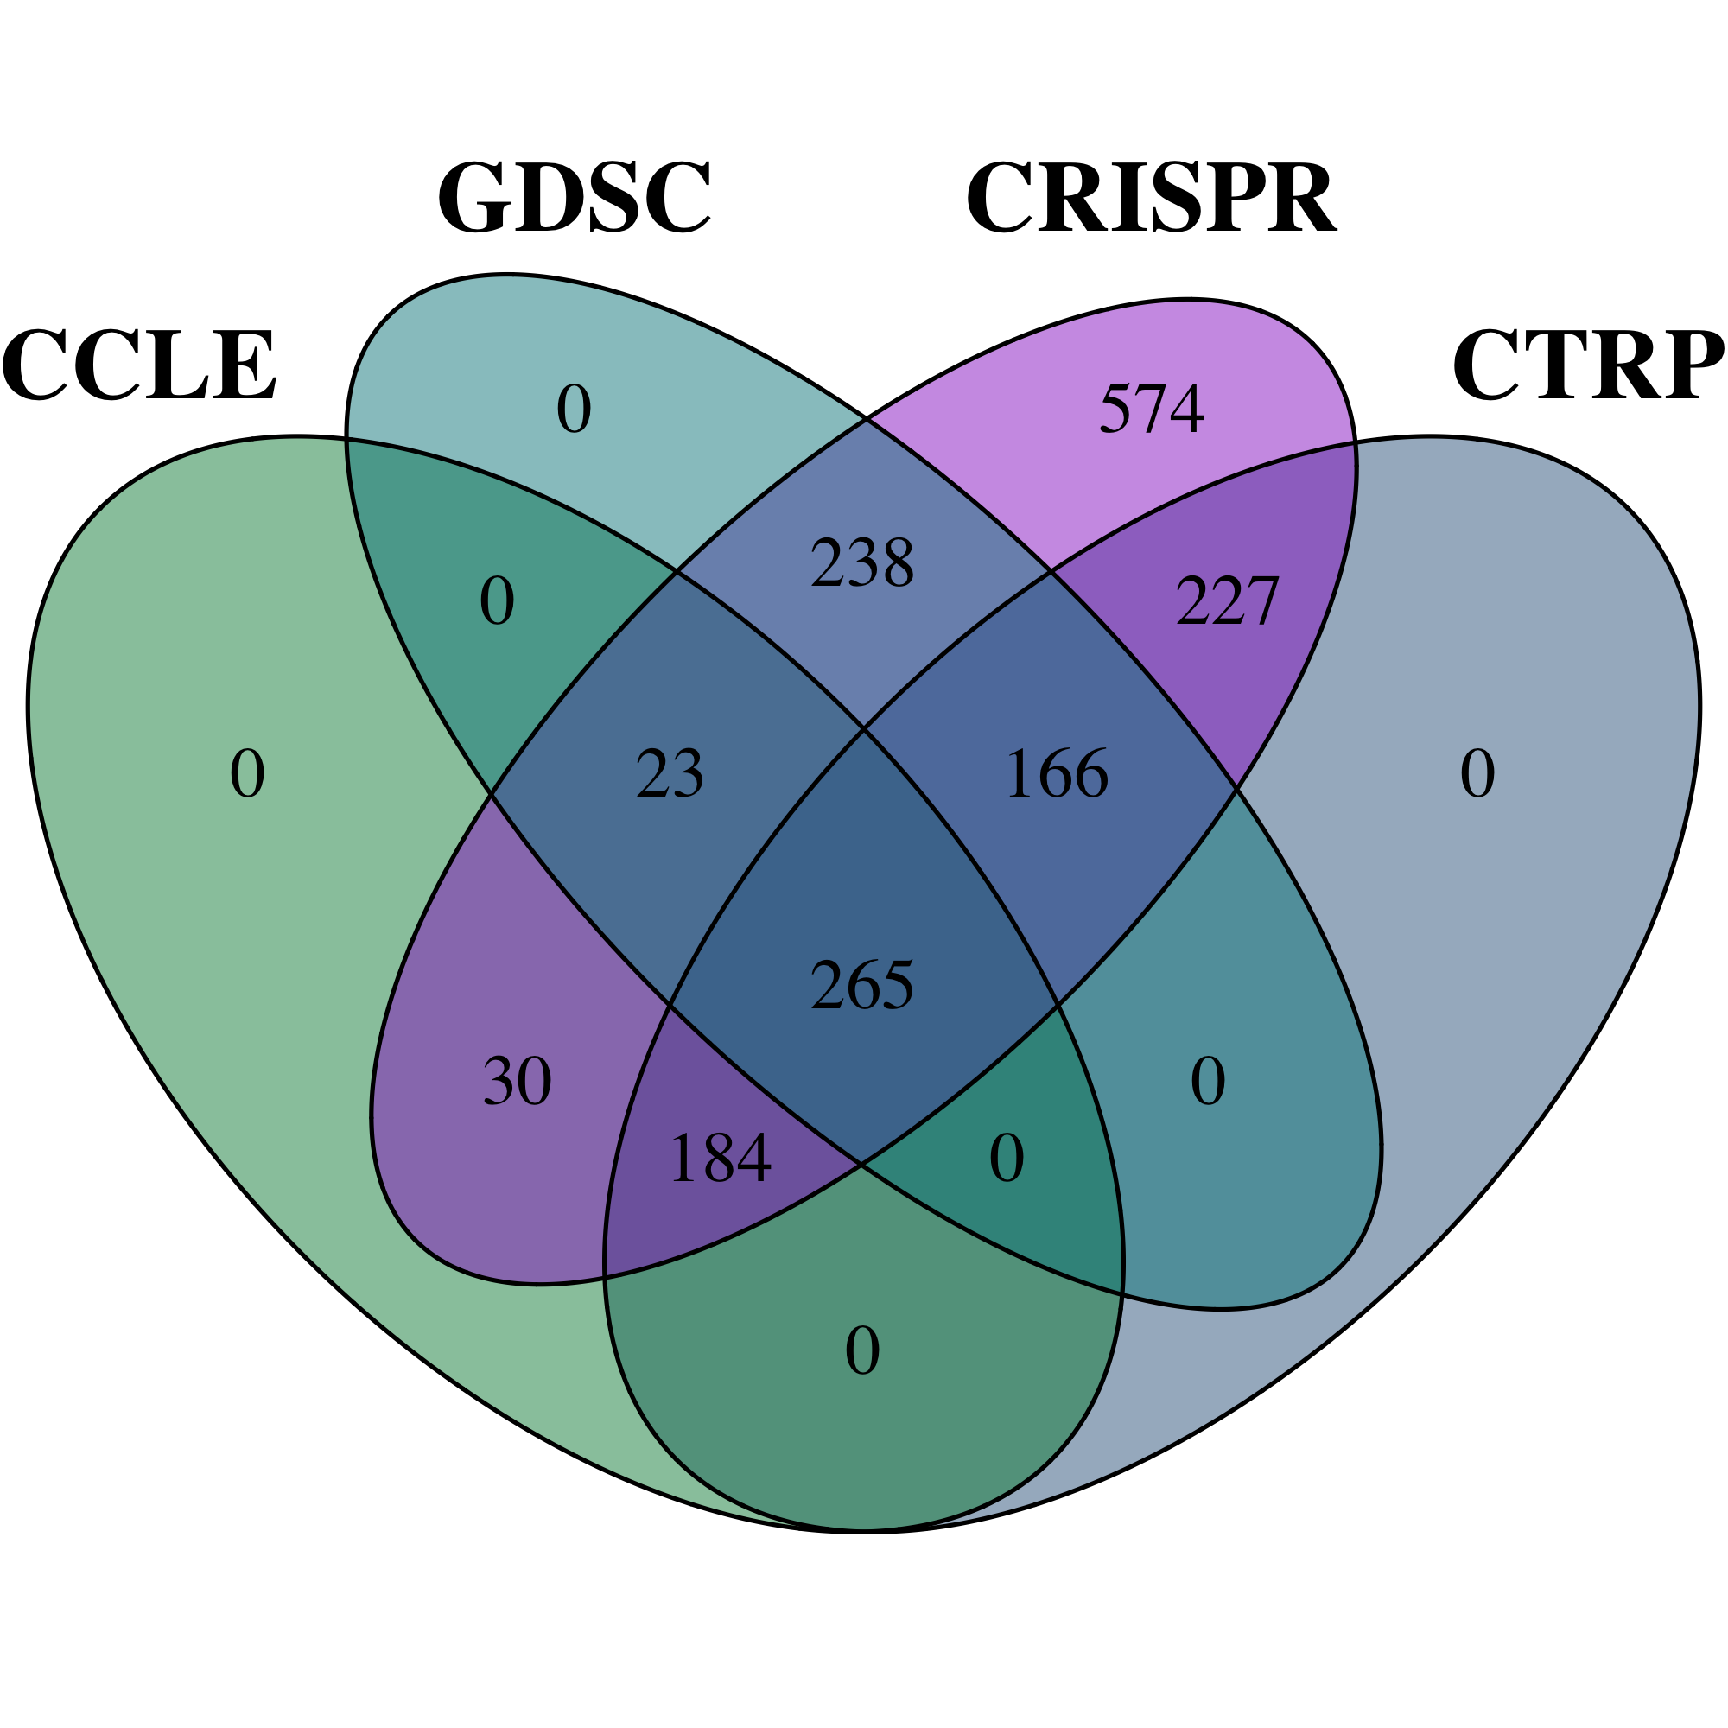

Figure caption.