WATER POTENTIAL WORKSHEET

[**Use the following URL for Lab Bench.**](http://www.phschool.com/science/biology_place/labbench/lab1/watpot.html%20) **Click on concept 6. Complete activities for concepts 6,7, and 8.**

1. Why does water potential effect animal cells differently than plant cells?

The water potential effects animal and plant cells differently because plant cell membranes will resist the addition of more water to avoid the bursting of the cell. This effect is added to the solute potential to obtain the water potential.

2. Explain how Ψ is effected by adding additional solute.

When solute is added, the solute potential lowers and therefore lowers the water potential. This makes sence in context because more water will move to the area of high concentration to have an equal concentration on each side.

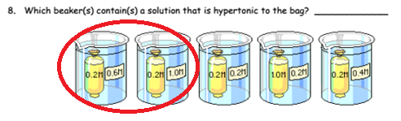

The first and second beakers circled in red.



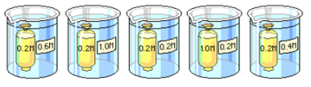

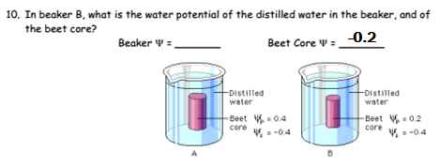

-0.2

0.0

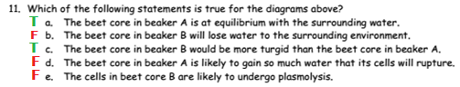



i: ionization constant (number of ions that will form in water)

c: concentration of solution

r: pressure constant (0.0831 (L*bars)/(mol*°K))

t: temperature (°K; 298.15 at standard thermochemical conditions)



ψs = -(1)(0.6)(0.0831)(298.15)

= -14.865759 (@ standard thermochemical conditions)