# Communities

SV communities are presented using an object diagram that uses packages, objects and notes

Table 1 Notation for community diagrams

|  |  |
| --- | --- |
| Figure | Description |
|  | Package in the Unified Modelling Language, is used "to group elements, and to provide a namespace for the grouped elements". A package may contain other packages, thus providing for a hierarchical organization of packages.  Classes, objects, use cases, components, nodes, node instances etc. can all be organized as packages, enabling a manageable organization of the elements of UML models. |
|  | Objects are used to represent communities in the RM.  The name refers to the represented entity  The stereotype indicates the namespace where the object is grouped. Sometimes the stereotype can be an image. The image can be used in place of the figure. For ODP, the stereotype for community is a group of people: |
|  | A note is used to provide additional information about a diagram.  If the note refers to a specific element in the diagram, then it is connected to that object with a simple arc. |

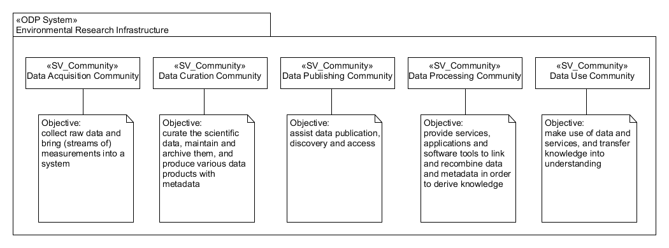

Figure 1 Example of a community diagram

In the example diagram the package represents an Environmental research infrastructure. The infrastructure contains five objects which are all communities. Notes are used to describe the objectives of each of the communities.

# Community Roles

SV Roles are represented using a class diagram with the packages and classes

Table 2 Notation for role diagrams

|  |  |
| --- | --- |
| Figure | Description |
|  | Package in the Unified Modelling Language, is used "to group elements, and to provide a namespace for the grouped elements". A package may contain other packages, thus providing for a hierarchical organization of packages.  Classes, objects, use cases, components, nodes, node instances etc. can all be organized as packages, enabling a manageable organization of the elements of UML models. |
|  | Classes are used to represent roles in the RM.  Classes can have additional compartments to express properties (called attributes) and behaviours (called methods). Omitting the compartments means that the behaviour and attributes are undefined at the time of building the diagram.  Name tag indicates the name of the class. Typically, classes are named using no spaces and starting each word that makes up the name, i.e., camelcase.  The stereotype indicates the namespace where the class is grouped. Sometimes the stereotype can be an image. The image can be used in place of the figure. For ODP, the stereotype for role is a mask: |

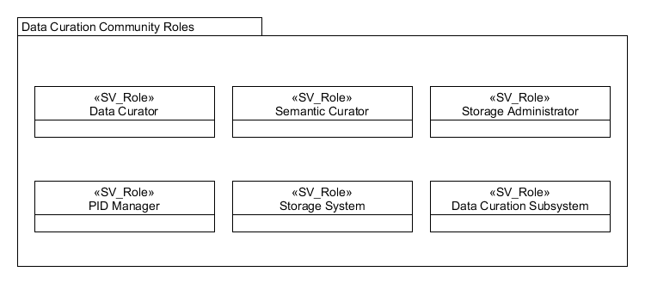

Figure 2 Example of a SV Role diagram

In the example diagram the package represents a community, data curation. The community contains six role classes. The RM also provides a detailed description of each role in text.

# Community Behaviours

SV Behaviours are represented using an activity diagram with packages and activities

Table 3 Notation for behaviour diagrams

|  |  |
| --- | --- |
| Figure | Description |
|  | Package in the Unified Modelling Language, is used "to group elements, and to provide a namespace for the grouped elements". A package may contain other packages, thus providing for a hierarchical organization of packages.  Pretty much all UML elements can be grouped into packages. Classes, objects, use cases, components, nodes, node instances etc. can all be organized as packages, enabling a manageable organization of the elements of UML models. |
|  | Activities are used to represent behaviours in the RM.  Name tag indicates the name of the behaviour. Behaviours are named using a short phrase that describes the event or action being represented.  The small decoration in the activity indicates that the activity is complex and can be subdivided into smaller tasks.  A stereotype can be used to indicate the namespace where the activity is grouped. Sometimes the stereotype can be an image. The stereotype image can be used in place of the figure. For ODP, the stereotype for behaviour is process icon: |

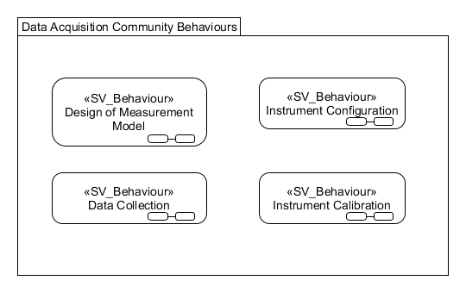

Figure 3 Example of a SV Behaviour diagram

In the example diagram the package represents a community, data acquisition. The community implements four basic behaviours. The RM also provides a detailed description of each behaviour in text.

# Information Objects

IV Objects are represented using a class diagram.

Table 4 Notation for information object diagrams

|  |  |
| --- | --- |
| Figure | Description |
|  | Package in the Unified Modelling Language, is used "to group elements, and to provide a namespace for the grouped elements". A package may contain other packages, thus providing for a hierarchical organization of packages.  Pretty much all UML elements can be grouped into packages. Classes, objects, use cases, components, nodes, node instances etc. can all be organized as packages, enabling a manageable organization of the elements of UML models. |
|  | Classes are used to represent information objects in the RM.  Classes can have additional compartments to express properties (called attributes) and behaviours (called methods). Leaving the compartments blank means that the behaviour and attributes are undefined at the time of creating the diagram.  Name tag indicates the name of the class. Typically, classes are named using no spaces in camelcase.  The stereotype indicates the namespace where the class is grouped. Sometimes the stereotype can be an image. The image can be used in place of the figure. For ODP, the stereotype for information object is an “i” icon with a tag on top: |
|  | Generalisation relationship indicates that one of the two related classes (the subclass) is considered to be a specialized form of the other (the super class).  Generalisation is represented with an arc with a blank triangle decoration. The blank triangle points to the super class and the undecorated end is connected to the subclass.  The generalization relationship is also known as the inheritance or "is a" relationship. |
|  | Aggregation relationship indicates an association that represents a part-whole or part-of relationship.  Aggregation is represented with an arc with a blank rhombus decoration. The blank rhombus shape indicates the composite and the undecorated end of the arc is the component. |

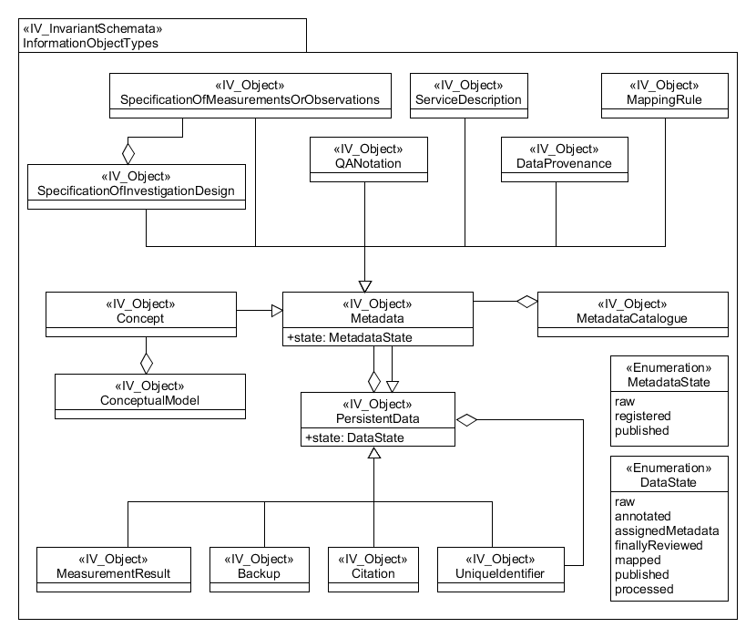

Figure 4 Example of an IV Object diagram

In the example diagram the package represents the collection of all information objects described by the ENVRI RM. The stereotype for the package is invariant schemata, which indicates that these are the parts of the model that are stable. The main objects are persistent data and metadata. The RM also provides a detailed description of each object in the text.

# Information Actions

IV Actions are represented using an activity diagram with packages and activities

Table 5 Notation for activity diagrams

|  |  |
| --- | --- |
| Figure | Description |
|  | Package in the Unified Modelling Language, is used "to group elements, and to provide a namespace for the grouped elements". A package may contain other packages, thus providing for a hierarchical organization of packages.  Pretty much all UML elements can be grouped into packages. Classes, objects, use cases, components, nodes, node instances etc. can all be organized as packages, enabling a manageable organization of the elements of UML models. |
|  | Activities are used to represent action in the RM.  Name tag indicates the name of the action. Actions are named using a short phrase that describes the event or action being represented.  The small decoration in the box indicates that the action is complex and can be subdivided into smaller tasks.  A stereotype can be used to indicate the namespace where the activity is grouped. Sometimes the stereotype can be an image. The stereotype image can be used in place of the figure. For ODP, the stereotype for information action is an arrow icon with a lowercase “i”: |

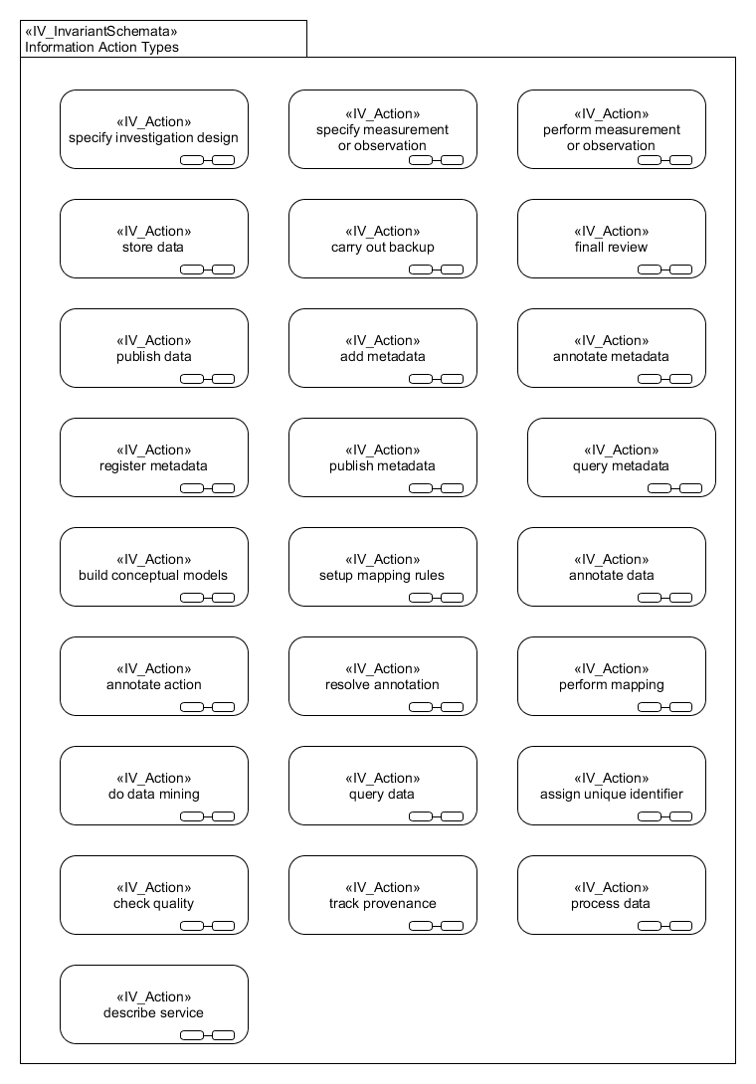

Figure 5 Example of an IV Action Types diagram

In the example diagram the package represents the information action types described by the ENVRI RM. The stereotype for the package is invariant schemata, which indicates that these are the parts of the model that are stable. The RM also provides a detailed description of each action in text.

# Information object instances

IV Objects instances are represented using an object diagram. The type of diagram is similar to the class diagram with the difference that the entities represented are objects not classes. Object instances have a specific state and this can change depending on the moment when the object is observed. Object instances are useful for representing the dynamic nature of the systems.

Table 6 Notation for information object instances diagrams

|  |  |
| --- | --- |
| Figure | Description |
|  | Package in the Unified Modelling Language, is used "to group elements, and to provide a namespace for the grouped elements". A package may contain other packages, thus providing for a hierarchical organization of packages.  Pretty much all UML elements can be grouped into packages. Classes, objects, use cases, components, nodes, node instances etc. can all be organized as packages, enabling a manageable organization of the elements of UML models. |
|  | Classes are used to represent information objects in the RM.  Classes can have additional compartments to express properties (called attributes) and behaviours (called methods). Leaving the compartments blank means that the behaviour and attributes are undefined at the time of creating the diagram.  Name tag indicates the name of the class. Classes are named using no spaces and capitalising the first letter of each word that makes up the name, camelcase.  The stereotype indicates the namespace where the class is grouped. Sometimes the stereotype can be an image. The image can be used in place of the figure. For ODP, the stereotype for information object is an “i” icon with a tag on top: |
|  | Objects are used to represent object instances in the RM.  Name tag indicates of the entity  The set of attributes with a value assigned characterises the state of the object.  The stereotype indicates the namespace where the object is grouped. Sometimes the stereotype can be an image. The image can be used in place of the figure. For ODP, the stereotype for information object instance is an “i” icon: |
|  | Aggregation indicates an association that represents a part-whole or part-of relationship.  Aggregation is represented with an arc with a blank rhombus decoration. The end with the blank rhombus indicates the composite and the other connects to the component. |

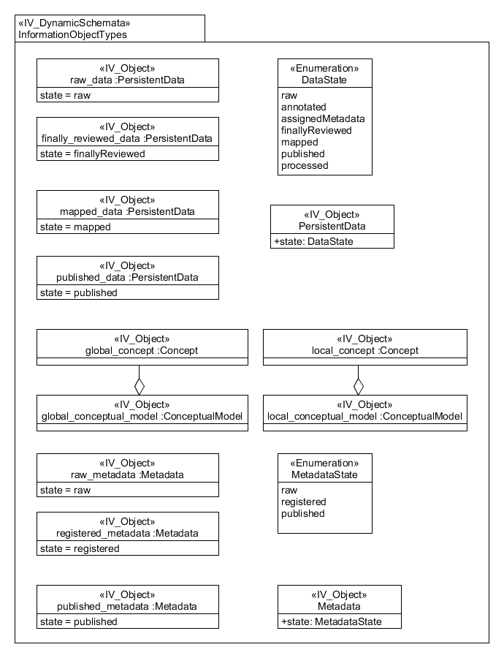

Figure 6 Example of an IV Object diagram

In the example diagram the package represents a collection of some information object instances. The stereotype for the package is dynamic schemata, which indicates that these are the parts of the model that can change depending on when the system is observed. The diagram presents four sample instances of persistent data objects and three examples of metadata objects. The diagram also includes the class definitions of persistent data and metadata objects for reference

# State diagrams

IV Object instances can have different states during their lifespan. The basic information objects persistent data and metadata have specific sets of states associated to them. The state changes, together with the IV Activities can be used to model the behaviour of data as it is managed by the RI. For this we use a state machine diagram. The main components of state machine diagrams are activity frames, states, activities, and pseudo-states

Table 7 Notation for information object instances diagrams

|  |  |
| --- | --- |
| Figure | Description |
|  | Frames are used to indicate the information object instance being represented.  The name indicates the information object instance being modelled |
|  | States are used to represent the state of an information object resulting from the effects of an IV action  The name tag indicates the state reached by the information object  The small decoration in the box can be included to indicate that the state is complex and can be subdivided into sub-states |
|  | The arcs connecting states represent information actions applied to objects at a given state. The arrow end indicates the resulting state, the undecorated end indicates the initial state |
|  | A filled circle is a pseudo-state, it can be used to model a start state or an intermediate connecting state |
|  | A circle with a smaller filled circle in the middle is a pseudo -state to model an end state |
|  | Decision pseudo-state, is used to model an exclusive fork in the execution of activities. It can also be used to model exclusive joins after forks. |
|  | Fork/merge pseudo-state, is used to model a forks and joints in the execution of activities. |

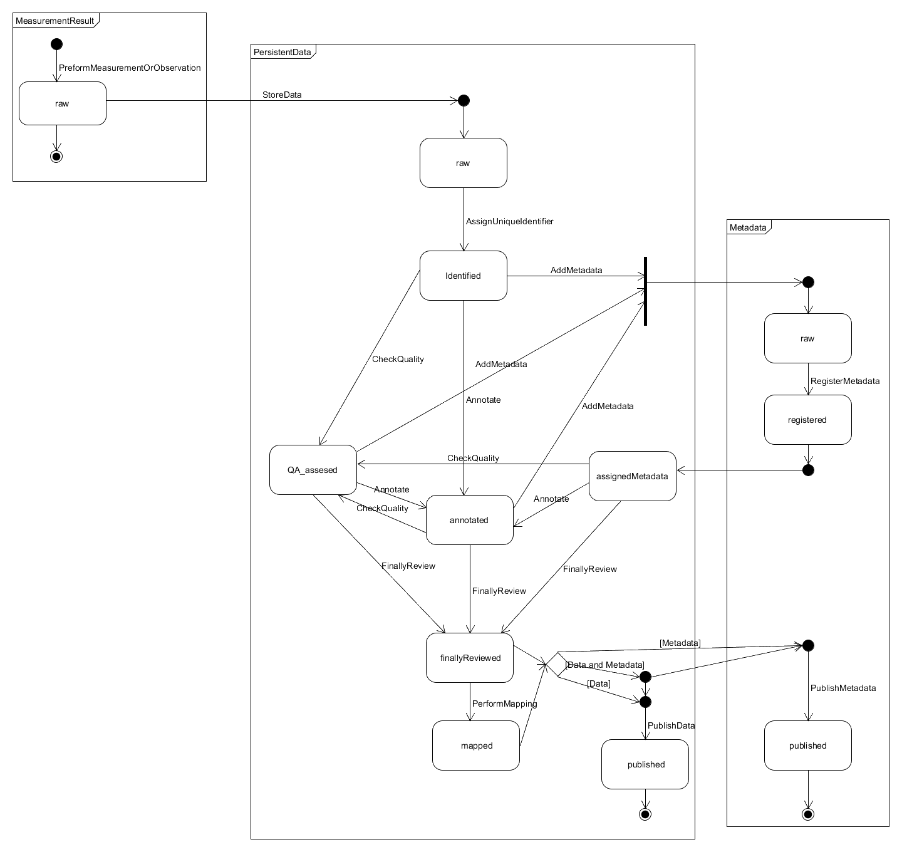

Figure 7 Example of an IV Information Object Evolution diagram

In the example diagram, three information object instances are presented. The possible transitions between states are indicated with arcs labelled using the names of IV actions.

# Evolution of information objects

The evolution of information objects can also be represented using activity diagrams. Activity diagrams combine IV Object Instances and IV actions can also be combined into

Table 8 Notation for information object evolution with activity diagrams

|  |  |
| --- | --- |
| Figure | Description |
|  | Package in the Unified Modelling Language, is used "to group elements, and to provide a namespace for the grouped elements". A package may contain other packages, thus providing for a hierarchical organization of packages.  Classes, objects, use cases, components, nodes, node instances etc. can all be organized as packages, enabling a manageable organization of the elements of UML models. |
|  | Activities are used to represent action in the RM.  Name tag indicates the name of the action. Actions are named using a short phrase that describes the event or action being represented.  The small decoration in the box indicates that the action is complex and can be subdivided into smaller tasks.  A stereotype can be used to indicate the namespace where the activity is grouped. Sometimes the stereotype can be an image. The stereotype image can be used in place of the figure. For ODP, the stereotype for information action is an arrow icon with a lowercase “i”: |
|  | Objects are used to represent object instances in the RM.  Name tag indicates of the entity  The set of attributes with a value assigned characterises the state of the object.  The stereotype indicates the namespace where the object is grouped. Sometimes the stereotype can be an image. The image can be used in place of the figure. For ODP, the stereotype for information object instance is an “i” icon: |
|  | The arcs connecting states represent transitions between information actions. Arcs can connect activities to information object instances, indicating the result of performing an action. When linking an object to and action, the arc indicates that the object is part of the input used to perform that action. |
|  | A filled circle is used to model the start of a set of actions |
|  | A circle with a smaller filled circle in the middle is used to model an end state |

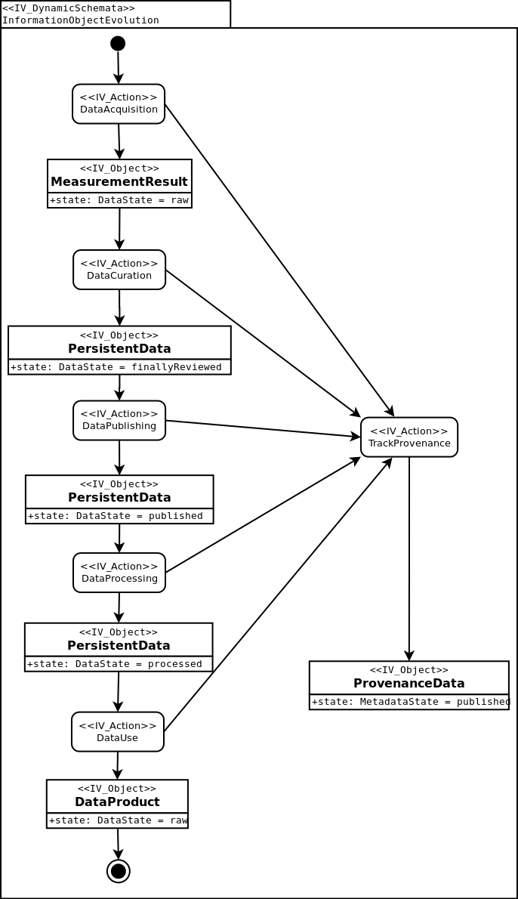

Figure 8 Example of an IV Information Object Evolution using an activity diagram

In the example diagram, an overview of the evolution of data in a RI is presented

# Computational Objects

In the ENVRI RM, component diagrams are used for the representation of computational objects and interfaces.

Table 9 Notation for information object instances diagrams

|  |  |
| --- | --- |
| Figure | Description |
|  | Components are used to represent computational objects. The box contains the name of the computational objet and a decoration indicating that it is a component (UML standard).  Components can also have a stereotype, and an image associated with that stereotype. In ODP the stereotype image for computational objects is the icon of a box with a class tag in front of it:  D:\Dropbox\ENVRIPLUS\ODP\UML4ODP_Icons\UML4ODP icons BMP\Computational - Object.bmp |
|  | Ports and interfaces are used to represent the means of communication between objects. A small box in the border of an object is used to represent a port.  A blank circle connected by an arc to a port represents a server interface  A semicircle with an arc connected to a port represents a client interface  A port with an arc and an arrow pointing away from the object represents a producer streaming interface  A port with an arc and an arrow pointing towards the object represents a consumer streaming interface |
| is a | Generalisation is used to indicate if one object extends another, this can be illustrated using an unfilled arrow from the sub-object to the parent, with the annotation 'is a'. |
| new <object> | The ability to create objects is noted by a single filled arrow extending from the creating object to the object being created, with the annotation 'new <object>'. |
|  | Example of a computational object with four ports and four interfaces |

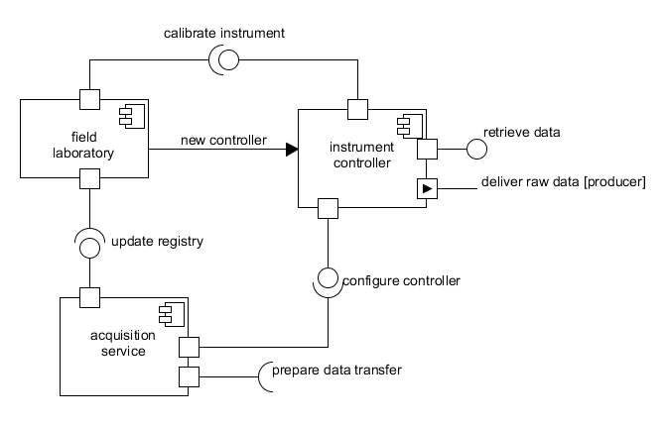

Figure 9 Example of the CV Objects for data acquisition

In the example diagram, three computational objects are presented. Balls and sockets are matched and the names of the client/server interfaces are supposed to be the same. In the example, the field laboratory client interface “calibrate instrument” is connected to the instrument controller server interface “calibrate instrument”