DALEC SuperDoves Investigation update 31st Jan 2024

Matching DALEC and acolite corrected SD (only 2023 data)
- Match ups were good for 666 nm, but less good for 707 nm
- SD Rrs at 707 are all higher by approx 0.005
- To transform the planet data to be more similar to the DALEC data, I fitted a log-log linear regression to the SD-DALEC data (taking logs ensures that we don’t get Rrs negative values when transforming)
- the regression model fitted was in the form:

log(Rrs_sd) = m * log(Rrs_dalec) + c

and so we transform, or correct the superdoves data like so:

Rrs_sd_tx = exp ( (log(Rrs_sd) – c ) / m)

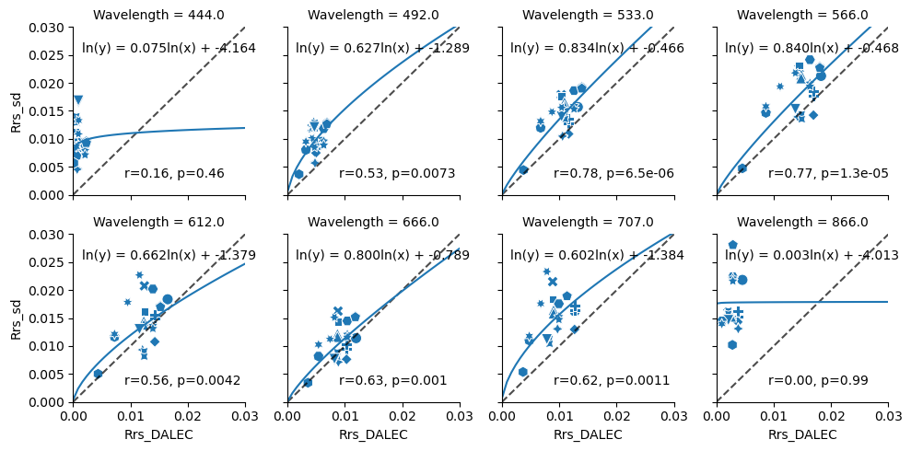
Estimating Chl-a

It makes sense to use a NIR ratio-based algorithm given that the 666 and 707 nm bands fit adequately. Algorithms which rely on the 444 nm band won’t work properly. I’m using a normalised difference chlorophyll index based algorithm, with coefficients from calibration carried out in Neil et. Al 2019
https://www.sciencedirect.com/science/article/pii/S0034425719301786#s0010

the algorithm is of the form:
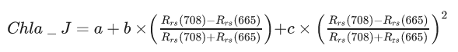
In 2023, we only have a small number of in-situ measurements which correspond to when the DALEC was operating, and even fewer in 2022. However, in 2023 there are sufficient in-situ measurements that we can interpolate the time series to daily values. This is illustrated in the figure below.
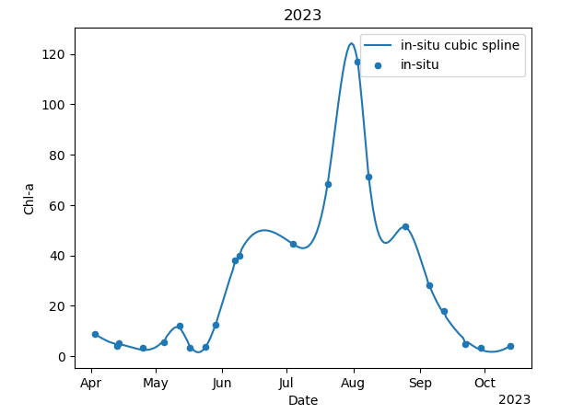
Comparing the daily interpolated in-situ data against the DALEC Chl-a estimates we get the following. The data is well correlated, and appears to follow a quadratic curve. Higher values of Chl-a are consistently under-estimated by the DALEC, and there is poor distinction between lower chl-a values, although this may be in part due to variation not captured by the interpolation. Lower values are over estimated

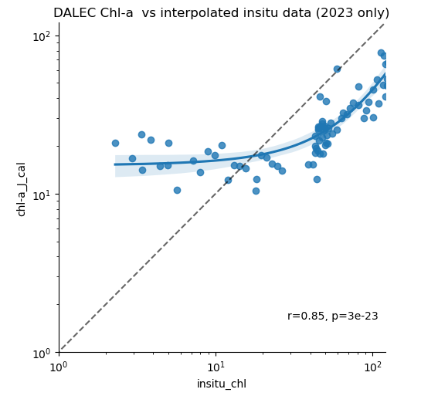

We have more match-ups for superdoves data and in-situ chl-a, and so don’t need to do timeseries interpolation of the insitu data. With the log-log correction of the 707 and 666 nm bands we get the plot below. Low values tend to be over estimated, and higher values fit well around the 1:1 line. There is more scatter than the DALEC data, but still a significant correlation despite some outliers.

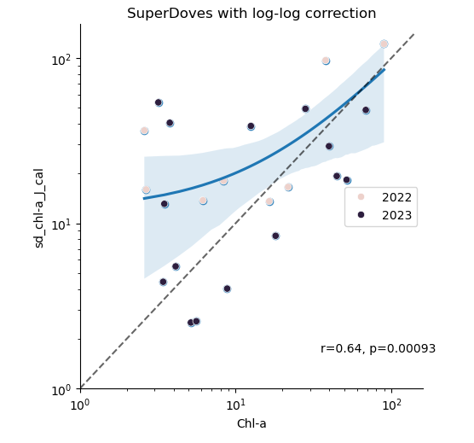
We can also examine the chl-a timeseries generated by the 3 different approaches. Here, we see that there was a significant drop in SD chl-a in mid June, for which there are no in-situ measurements to compare with. There are outliers in the SD data in the first part of the time series, but the majority of the trend is followed, even more-so for 2022.

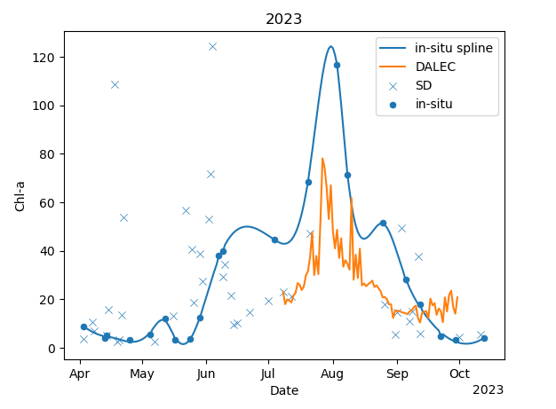
The limited DALEC data from 2022 has very little overlap with the insitu data, and consistently overestimates chl-a. However, the peak seen in the DALEC chl-a in 2022 does also correspond with a superdoves peak, and so there is likely some calibration issue with the DALEC spectra from this year.
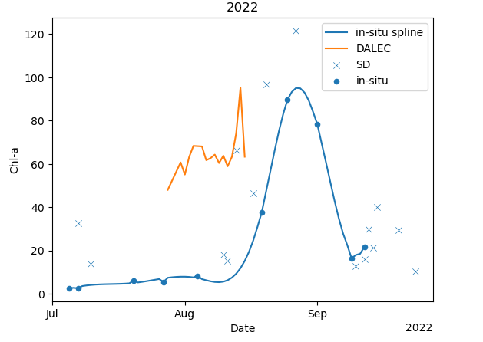
Current Issues
- do we have enough data?
- dalec data from 2022 is completely different from 2023, and has limited in-situ match-ups, which is why I excluded it from the analysis initially
- some concerns about DALEC spectra from 2023 too as they have peaks at 760 nm, which may cause issues for the delta correction procedure
- interestingly, the dalec spectra from 2022 actually look much ‘nicer’ than the spectra from 2023

- From chat with Dalin, I need to investigate the 2023 DALEC spectra some more as these may have been overcorrected.
- likely we’re seeing some bottom effect, scum or vegetation in the signal

