# DALEC / SD Update 8th Feb

* Have been investigating issues with the DALEC spectra from 2023
* See this typical 2023 DALEC spectra below:
* Issue is zero/negative reflectance in blues, and strange features in higher wavelengths
* Have confirmed this isn’t to do with the new calibration file they gave me after repairs
* Have tried Jiang Delta correction, Ruddick delta correction, and 3C Rrs calculation
  + Jiang and Ruddick both have the effect of reducing the reflectance, which has the issue of making some of the blues more negative
  + 3C Rrs calculation has a minor effect

* Interestingly, the DALEC data from 2022 is completely different (see example spectra below)

## Superdoves data from 2022 fits DALEC data better than 2023

* We only have 3 SD dalec match ups from 2022, but all of them look pretty close except for the last band
* In 2023, there is a lot more variation, and the blues and 707 nm bands don’t fit so well

## DALEC data from 2023 works well for Chl-a with NIR algorithm (707/666)

* Using interpolated in-situ chl-a we find that the DALEC chl-a correlates well
* But gradient is a bit shallow. This could be adjusted for

## Initial attempts at SDs chl-a didn’t work until I applied a further correction to the SDs data

* I fitted log-log curves to the 2023 match up data, and then used these to correct the SDs data at 666 and 707 nm to model more closely the DALEC data

## Log-log corrected SDs data can be used for chl-a estimation

## DALEC data from 2022 doesn’t give good chl-a estimates

* But, we probably don’t have sufficient match ups for this

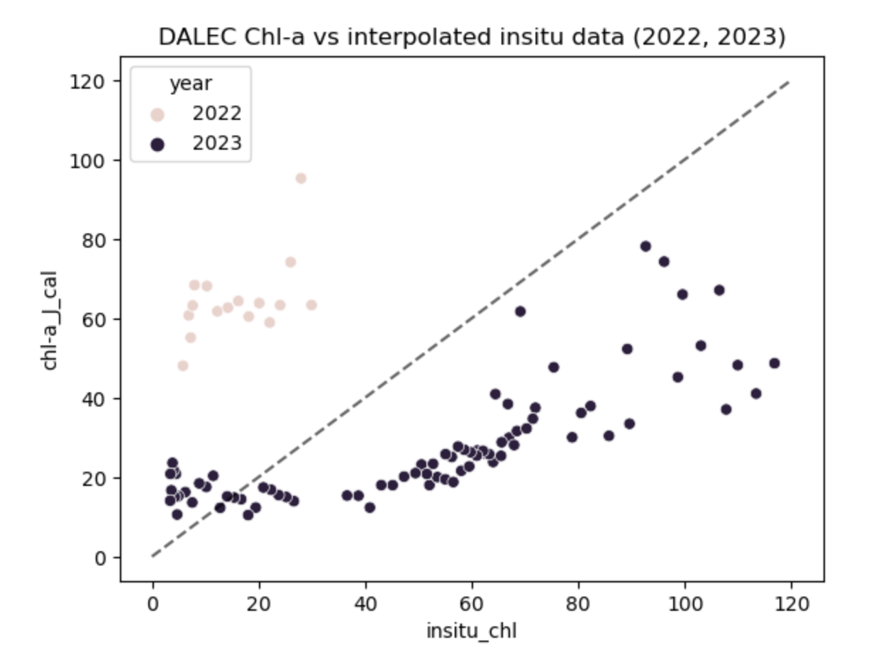

## Applying the log-log correction to the 2022 DALEC data gives good chl-a estimates

* Dalec data matches well with superdoves, and a quite plausible peak in chl-a in mid august is captured (we don’t have any insitu data to confirm this, but it does make sense with the timeseries)

# What to do?

* Time is the limiting factor
  + Don’t really want to collect more data in the summer
  + The results I have show promise but there are issues with the data quality and quantity
  + Need to have a good explanation for the data issues with the DALEC in 2023
    - I’m not sure what else to try, and feels like this might end up being a long investigation