EDA

Sarah McDonald

January 27, 2020

This is a boxplot of publicity data from bishop accountability after I merged it with the educatin data. 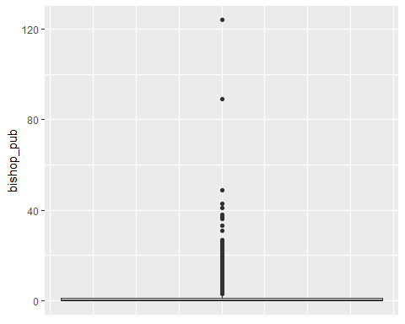

## Min. 1st Qu. Median Mean 3rd Qu. Max.   
## 0.000 0.000 0.000 1.357 1.000 124.000

This shows what the bishop accountability data looks like before merging it with anything. 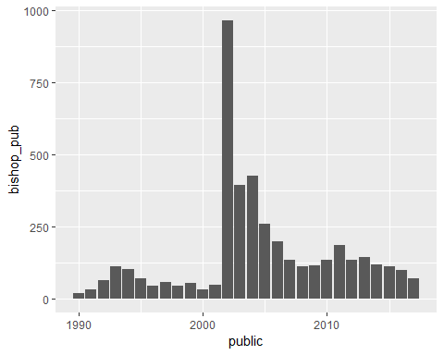

## Appendix

## ---- echo = FALSE, warning= FALSE, message = FALSE----------------------  
data <- read.csv("C:/Users/Sarah McDonald/Documents/honorsthesis/manipulated_data/data_bishop_account.csv")  
bishop <- read.csv("C:/Users/Sarah McDonald/Documents/honorsthesis/manipulated_data/bishop_pub.csv")  
  
library(ggplot2)  
library(dplyr)  
library(tidyr)  
  
  
## ---- echo = FALSE-------------------------------------------------------  
ggplot(data, aes(y = bishop_pub)) +  
 geom_boxplot() +  
 theme(  
 axis.ticks.x=element_blank(),  
 axis.text.x = element_blank()  
 )  
print(summary(data$bishop_pub))  
  
  
## ---- echo = FALSE-------------------------------------------------------  
bishop_sum <- bishop %>% select(public, bishop_pub) %>% filter(public >1989 & public <2018) %>% group_by(public) %>% summarise_each(funs = sum)  
  
ggplot(bishop_sum, aes(x = public, y = bishop_pub))+  
 geom_bar(stat = "identity")  
  
  
  
## ----code = readLines(knitr::purl("EDA.Rmd", documentation = 1)), echo = T, eval = F----  
## NA