**Introduction**

The application we have decided to create is partially social media and partially a game. Individuals will sign onto their account and will be able to create and view groups. In the group a judge will create a topic for all the other members to submit pictures of. For example a judge could say “Artistic” and the job of the group members would be to take the most artistic picture they can. The job of the judge is to choose the best picture or one they like the best. The group members job is to try and get a picture that will likely get chosen by the judge. The winner of each round is awarded points. After each round a new judge will be assigned and the process repeats.

The purpose of this development is to create a fun and interesting way to interact and connect with friends and family. This application will likely appeal to younger audiences but we hope to make it simple enough that older users may be able to join in and enjoy the application as well. We hope to make this application scaleable so that users may use their computers or mobile phones to use the application. Our objective for this product is to create a prototype application that will be able to have a user sign in, join a group, and participate in a group. Some success criteria we have would be as follows: To have a user be able to make an account, To have a user create or join a group, To have a user successfully complete a round in a group.

Stakeholders:

* End-users

Functional Requirements:

* User will obtain ability to upload photos compatible to all common file extensions (.jpeg, .png, .gif, etc)
* User will upload photos to group page in order for photo to be judged and selected
* The “judge” will select the winning photo in each round
* The user that has their photo selected will have points assigned to their score

Nonfunctional Requirements:

* Must ensure that the user-interface is efficient, effective, and fitting
* Usability and design must be simple to enable multi-generational use of the application
* Software must perform to the standards of its intended purpose

Constraints:

* Deadlines

User Stories

* As a Judge I want a easy to use interface so that I can quickly and effectively pick my favorite picture
* As a User I want a simple upload process so that I may easily upload my favorite picture for the Judge to view.

Use Cases

* Create a New Group: The user will have the ability to create a new group with people from their contact list
* View Current Groups: The user will be able to view and select a group to play a game
* View and update contact list: The user will be able to view, add, or remove contacts
* Begin game: The user will either become a judge and choose best photo or become participant and submit photos.

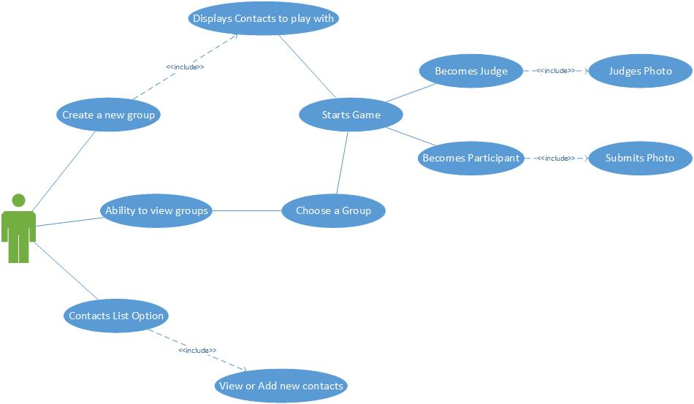

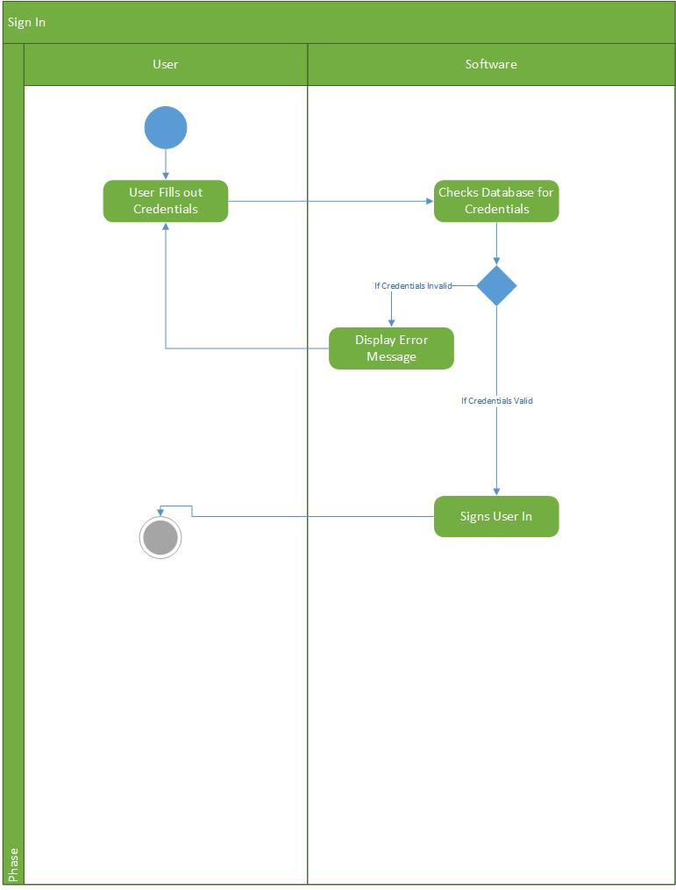

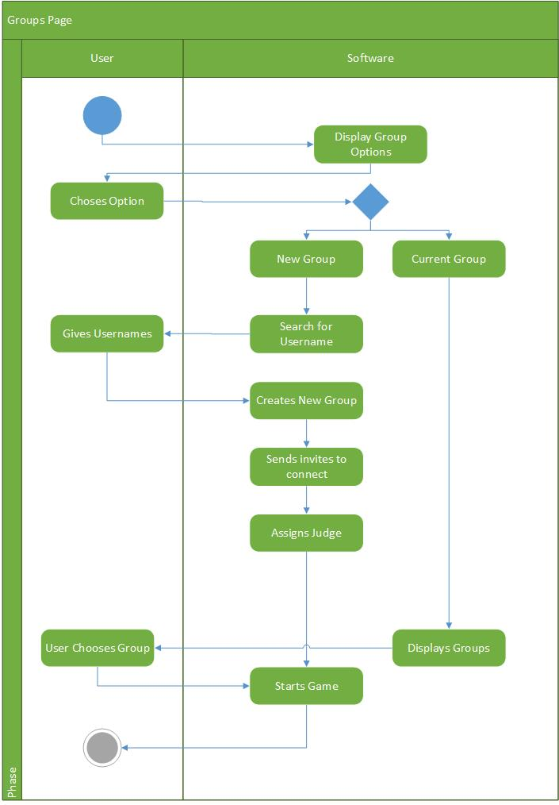

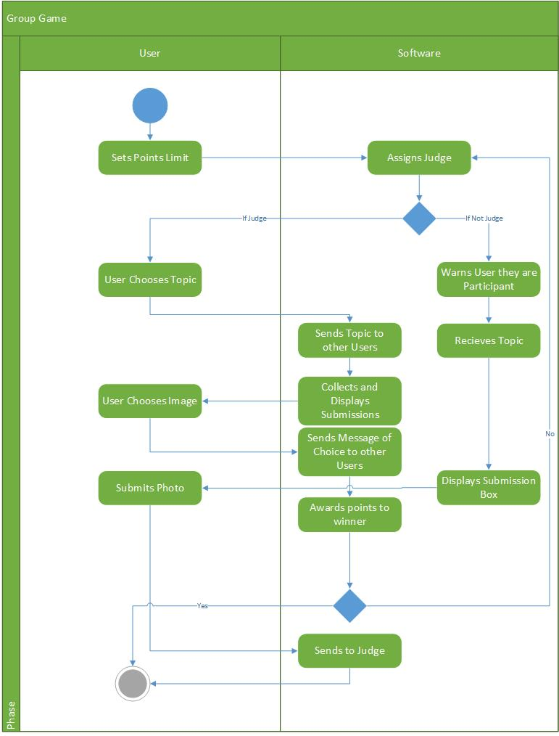

**Gantt Chart**

