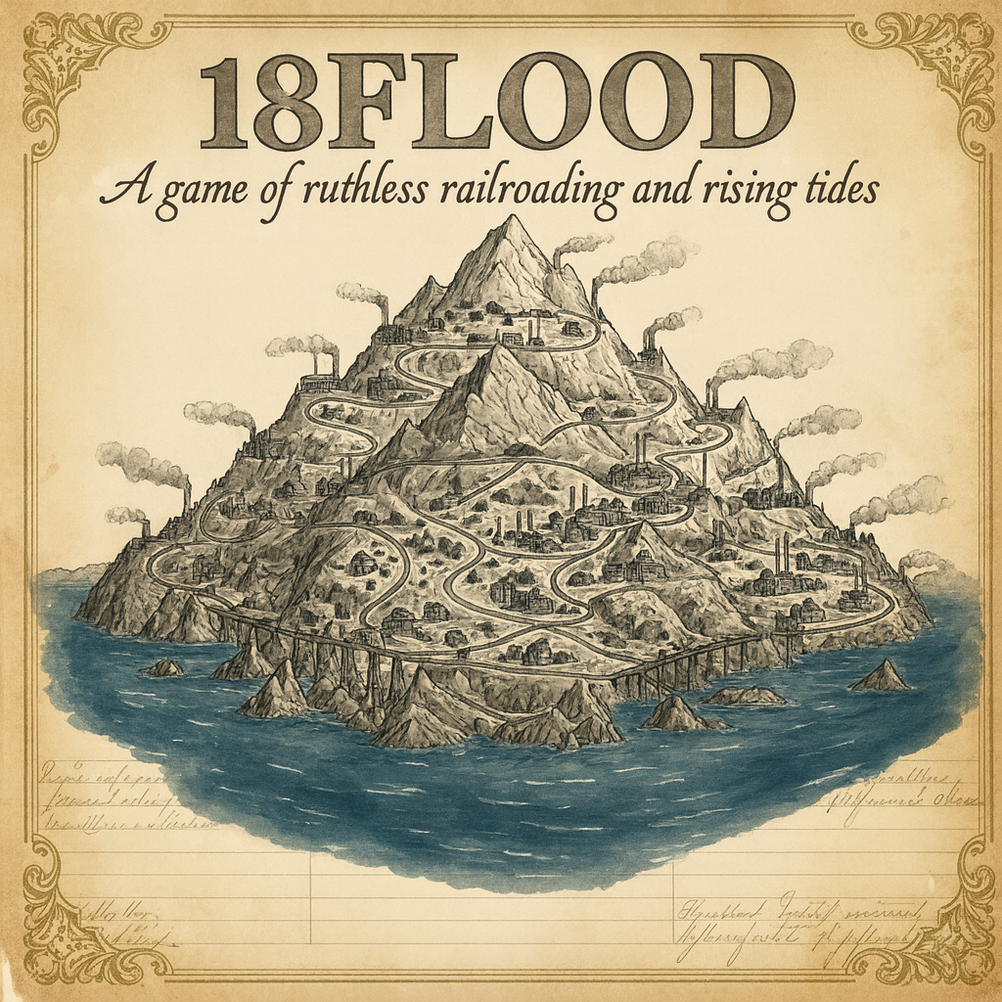

18flood
  - designed by scott ninmer • 3 players • 2–3 hours
rules of play – v.0.1.0

1. introduction
18FLOOD is an 18xx game set on a fictional mountain range slowly being consumed by a rising flood. As the waters advance ring by ring, railways race to climb higher, laying new track and building stations before their networks disappear beneath the surface.
Each player begins as the controller of a national corporation. These nationals drive the engineering effort, carving routes up the mountain and producing the resources needed for survival and expansion. Yet even as disaster looms, profit remains paramount. nationals may form shell corporations, commercial offshoots designed to extract wealth from the network before it’s too late.
Nationals build the infrastructure: track, tokens, and access to vital resources. Shells build nothing, planting a single station upon the nationals’ growing web to claim their share of the mountain’s remaining commerce. The flood will eventually claim the mountain—but which controller will have taken the most from it before the waters rise?

2. game components
- 1 game board
- 1 revenue chart
- 393 track tiles (*TBD*)
- 12 charters
- 84 share certificates/concessions
- 33 station markers
- 40 train cards
- 80 cost markers
- 80 lumber and steel cubes
- 1 timeline marker
- 3 player aids
- These rules
- A bank (players must provide)

3. setting up the game
- Place the game board in the middle of the play area.
- Lay out the corporation charters with their share certificates.
- Place the national corporations’ home station markers in their corresponding spaces on the map.
- Place all remaining station markers nearby. Keep the bank, train cards, and track tiles within easy reach of all players.
- Place the timeline marker on the ‘ISR’ space of the timline.
- Distribute starting capital of $1200 from the bank to each player.
Map Setup: tiles listed below are seeded randomly to the indicated hex bands and are placed in a random rotation. In every case, a tile should only be placed if it is adjacent only to plain hexes at the time of placement. If it can’t be placed, it is skipped.
Plain hex: a hex that has no color and only has a terrain cost with no other features.
Sextant: one-sixth of the map, delineated by the thin boundaries shown on the board.
Ring: a concentric circle of hexes surrounding the center. The outermost ring is referred to as ring 9, the innermost as ring 1.
- In each sextant, place one brown OO tile in ring 7 and one in ring 8.
- Mix the two green OO tile types face-down. In each sextant, place one of these tiles in ring 4, one in ring 5, and one in ring 6.
- Fill any remaining eligible hexes with water tiles.
Now proceed to the initial stock round (see Section 7).

4. overview
The game proceeds in a repeating cycle of rounds: one stock round and some number of operating rounds. This cycle continues until the end of the game is reached.
- Stock rounds: Players may buy and sell shares.
- Operating rounds: Each corporation takes a turn, which may involve laying track, placing station markers, delivering resources, running trains to generate revenue, opening shell corporations, and buying trains.
The game begins in Phase A and advances to later phases as flood waters advance.

4.1 the map
The map depicts an overhead view of a mountain. It is overlaid with a hex grid, with coordinates printed along the edges for reference.

- Large open circles = cities
- Gray hexes with six termini = steel mills
- Brown hexes with six termini = lumber mills
- Blue hexes = water that cannot be built upon

4.2 the stock market
The stock market tracks the current share price of each corporation, shown by the position of its share price marker. The share price equals the value of each individual share.
Corporate revenues are tracked on the revenue chart. Each corporation uses one marker to record its earnings when running trains.

5. the corporate entities

5.1 national corporations
National corporations are run by their respective controllers. At the beginning of the game, each player will hold all ten equity certificates of a single national corporation.
Nationals do not pay dividends and do not have a share price. Instead, at the end of the game, a player will receive 10% of the national’s remaining cash for each equity certificate they hold.
5.2 shell corporations
Shell corporations are opened by national corporations. Shell corporations run trains on their nationals’ routes and pay out these earnings to the shareholders. Shell corporations have share prices whose values contributes to the shareholders’ values.

5.3 corporation controller/president
Each of the three national corporations is controlled by a different player. The player holding one or more equity certificates in a national corporation is its controller.
During the game, national corporations may start shell corporations. After starting a shell corporation, the national will purchase a 50% president’s share certificate in the shell and become its president.
During operating rounds, the controller of a national corporation makes all decisions for the national and the shell corporations that the national has started.

6. game phases
18FLOOD progresses through a sequence of phases. The game begins in Phase A. A new phase begins immediately following the last operating round of a cycle, which triggers several events (see Section 9.11).
As phases change, the number of operating rounds that occur between stock rounds may change. In phase A, there are three operating rounds. In phases B through E, there are two operating rounds. In phase F, there is one operating round between stock rounds. This timeline is shown on the game board.

7. initial stock round
During the initial stock round, players take turns clockwise, beginning with the holder of the priority deal marker
(the active player).
On their turn, the active player must begin an auction by making an opening bid.
- Each bid must be at least $0, a multiple of $5, and must exceed the previous bid by at least $5.
- Bidding proceeds clockwise.
- A player may never bid more cash than they currently hold.
- A player who passes may not re-enter that auction, though they may still participate in later ones.
When all but one player have passed, the highest bidder pays their bid to the bank and immediately selects one of the National Corporations that has not yet been chosen. The player takes that National’s charter and station markers. The National then receives $1,200 from the bank to its treasury, along with five lumber cubes and five steel cubes.

After a National is chosen, the player to the left of the winning bidder becomes the next active player and begins the next auction in the same manner. The process continues until all three Nationals have been selected. The remaining player automatically receives the final National.

The player with the most cash remaining takes the Priority Deal marker. In case of a tie, the player who selected their National last receives it.

Advance the timeline marker to the next space.

8. stock rounds
During a stock round, players take turns clockwise,
beginning with the player who holds the priority deal marker. On their turn, a player may:
- Sell any number of shares or equity certificates.
- Then buy one share (from a treasury or the open market).

8.1 sell shares or equity certificates
A player may sell any number of shares (shells) or equity certificates (nationals) to the open market.
If selling shares, the bank pays the current share price to the player for each. The corporation’s share price moves down by one space, regardless of how many shares were sold.
If selling equity certificates, the bank pays $120 to the player for each. These equity certificates are removed from the game. A player may not sell their last equity certificate.

8.2 buy a treasury or market share
A player may buy one share per turn, either from a corporation’s treasury (paying that corporation) or from the open market (paying the bank).
The following restrictions apply:
- A player cannot buy shares of a corporation if that player sold the corporation’s shares earlier in the same stock round.

8.7 end of stock round
A stock round ends when all players pass in succession. The priority deal marker passes to the player left of the last person to act.
Advance the timeline marker to the next space.

9. operating rounds
During each operating round, shell corporations will act in order of descending share price. If multiple corporations have the same share price, they operate from top to bottom based on the marker location in the share price space. Each shell is operated by the owning corporation’s controller.
After this, national corporations will act starting with the national controlled by the player with priority deal and continuing clockwise.
The operating sequence for each corporation is as follows:
1. Lay and/or upgrade track | 6. Distribute earnings
2. Place a station marker | 7. Center city contribution
3. Deliver resources | 8. Start a shell corporation
4. Place a station marker | 9. Buy trains
5. Run trains

9.1 routes
A route is a continuous line of track that includes at least one station marker belonging to the corporation. The marker may be located at either end of the route or
anywhere along its path.
The following rules apply to routes:
- A city may be included if it has at least one empty slot
or if the corporation already has a station there.
- A route may exit a city along any connected track.
- A route may not reverse direction or reuse the same track
segment.
- A route may not visit the same city more than once, but multiple separate cities on the same hex may be included. The center hex (J19) counts as one city and may only be visited once.

9.2 lay and/or upgrade track
(national only)
During this step, the corporation may place or upgrade track tiles on the board. Taking this action is optional.
The number of track that a corporation may lay or upgrade is limited only by the amount of money and resources that the corporation has.
The board already includes printed hexes with track. These hexes are treated as though a tile of the corresponding color has already been placed. Yellow tiles may not be laid in these hexes, but these hexes may be upgraded
according to the normal rules.
When track containing a station marker is laid or upgraded, move the marker onto the new tile in the same relative position.
9.2.1 laying yellow track
Yellow tiles are placed onto neutral-colored hexes of the map, aligned to the grid. Track on the tile must connect to the corporation’s existing routes. Track may not extend off the board, enter the blank edge on the edge of the board, or run into water printed on the map.
Terrain costs must be paid when laying a tile, shown in the hex.
In addition, one lumber must be expended for each yellow track built.
If a hex contains a city or town, only tiles with the same feature may be placed there. Plain track must be used in non-city, non-town hexes.

9.2.2 upgrading track
Upgrading replaces an existing tile with one of the next color in sequence: yellow to green, green to brown, brown to gray. The type of tile must match the location: plain track with plain track, city with city. Removed tiles are returned to the supply.
The city center (J19) may never be upgraded.
When upgrading, all previously existing track segments must remain. No connections may be removed. New pieces of track on the tile need not connect to the corporation’s existing network.
If station markers are present, move them to the new tile in the same relative positions.
Terrain costs must be paid when upgrading a tile, shown in the hex or on the cost marker on the tile to be upgraded.
In addition, one lumber and some number of steel must be expended for each upgrade built:
Tile color | Resources expended
Green | 1 lumber, 1 steel
Brown | 1 lumber, 2 steel
Gray | 1 lumber, 3 steel

9.3 place a station marker
(national only)
A corporation may place one station marker into any legally reachable city, paying $80. A corporation has an unlimited number of station markers available for use, though only one may be placed per turn. If components run out, use a suitable substitute. Multiple station markers of a corporation may be present in a given hex.

9.4 deliver resources (national only)
For each distinct path that a corporation has from at least one of its station markers to a lumber or steel mill, it receives one resource cube of the corresponding type.

9.5 run trains
A corporation that owns one or more trains must operate them and calculate earnings. Trains run to cities, the value of each being shown on the map or on the tile. Each national owns a virtual train that may visit any number of cities on a single route.
Each train must operate along a legal route:
- A legal route begins and ends at cities.
- The train visits a number of cities equal to its number. If it cannot visit that many cities, it must visit as many cities as possible.
- All trains may run within a single city as a local train if necessary.
The following restrictions apply to routes:
- A train may not reuse any track segments used by the
corporation’s other trains in the same operating turn, except for four-way junctions on brown plain track.
- A train may pass through a city only once per run. Different trains of the same corporation may visit the same city, provided they do not share any track.
Earnings are calculated as follows:
- The revenue of a single run is the sum of the values of the
visited cities.
- A corporation’s total earnings are the sum of all of its train runs.

9.6 distribute earnings
After running trains, a corporation distributes its earnings. National corporations must withhold their earnings. All earnings are placed in the corporation’s treasury.
Shell corporations must pay out their earnings to shareholders. Each shareholder receives a proportion equal to the number of shares held (10% for each 10% share). Dividends for shares owned by a corporation are paid into that corporation’s treasury. Shares in the open market do not receive dividends. When dividends are paid, the corporation’s share price marker is adjusted as follows:
- One step to the left if no amount was paid.
- No movement if the amount paid is greater than $0 but less than the current share price.
- One step to the right if the amount paid is at least equal to the current share price.
To aid bookkeeping, the share price marker of a corporation should be flipped once it has distributed earnings in the current operating round.

9.7 city center contributions
Visits that a corporation makes to the center city contribute to the city’s development fund depending on phase:
Game phase | Amount of contribution
A | $50
B | $40
C | $30
D | $20
E | $10
F | $5
This amount is paid from the bank to the center city fund space on the board.
The city will build a new tile in its hex (J19) if the fund reached as reached or exceeded a certain threshold:
‘C’ tile color | Amount needed in fund
Green | $100
Brown | $200
Gray | $300
Purple | $400
If the amount in the fund meets or exceeds the threshold, deduct the amount needed from the fund, returning it to the bank, and build the tile in the hex.
Once the purple hex has been built, further contributions to not need to be made.

9.8 starting a shell corporation
(national only)
A national corporation is eligible to start a shell corporation if the following conditions are met:
- The national has started less than three shell corporations during the game.
- It has a station marker on the map that is not its home station marker.
- It has at least $400 in its treasury.
If the national’s controller decides to start a shell corporation, the player follows the following procedure:
- Select one of the unstarted shell corporations. Take its charter and place it in front of the player.
- Choose one of the national’s non-home station markers and replace it with the shell’s station marker.
- Select a par price (80, 100, 120, 140, or 160). Five times this amount is moved into the shell’s treasury from the national’s treasury. A given par price may not be selected if the national is unable to make this transfer. The national receives the shell’s 50% president’s share into its treasury. The five 10% shares are placed in the shell’s treasury.
- The controller of the owning national now has the opportunity to buy up to three shares from the shell’s treasury at its current market price. Then, each other player in clockwise order has the opportunity to buy one 10% share in the same fashion.
- The shell then has the opportunity to buy any number of trains from the depot or other shell corporations owned by the same national.

9.9 buy trains (shell only)
A corporation may buy any number of trains during a turn. Trains may be purchased from either the bank or another corporation, with the consent of the selling corporation’s president.
- From the bank: Trains are purchased for the listed cost, paid to the bank.
- From another shell corporation owned by the same national corporation: Trains may be purchased at any mutually agreed price of at least $1.
A corporation is never required to own a train. However, if a corporation does not own a train and does not wish (or is unable) to buy one from the bank or another corporation, it closes (see Section 9.12).
Trains come in only one type: a 4-train. However, the cost of purchasing one varies depending on the game phase:
Phase | Train cost
A | $100
B | $200
C | $300
D | $400
E | $600
F | $800

9.10 end of operating round
If it is the last operating round of the cycle, see Section 9.11. Otherwise, advance the timeline marker to the next space.

9.11 end of cycle
A cycle concludes immediately after the last operating round of the cycle. In the first cycle, this occurs after three operating rounds (ORs). After cycles 2-5, this occurs after two ORs, and after cycles 6-8, this occurs after one OR.
When a cycle concludes, the following events occur:
Flood waters advance. Add a water tile to every hex on the outermost unflooded ring of the board, removing any existing track and tokens present on the hexes.
Corporations close. If any corporation no longer has any station markers on the board, it is closed without compensation (see Section 9.12). If a national closed, any shells that it owns are also closed.
Trains degrade. Each train that shells own degrades:
- Return all 1-train cards to the supply.
- Flip all 2-train cards to their 1-train side.
- Return all 3-train cards to the supply and replace them with 2-train cards from the supply.
- Flip all 4-train cards to their 3-train side.
Finally, advance the timeline marker to the next space.

9.12 closing a corporation
A corporation closes either when it has no remaining station markers on the board after a flood event or if it does not own a train at the end of its operating turn.
Remove the corporation’s charter, share certificates, cash, trains, and station markers from the game.

10. game end
The game end is reached at the conclusion of the 8th cycle.
Each player exchanges all of the player’s equity certificates for cash from the corresponding national corporation. Each certificate is exchanged for one-tenth of the cash in the national’s treasury.
Each player’s total value is the sum of the cash on hand plus the value of each owned share at the shell’s current share price.
Corporations’ remaining assets have no value. The player with the highest total value is the winner.

