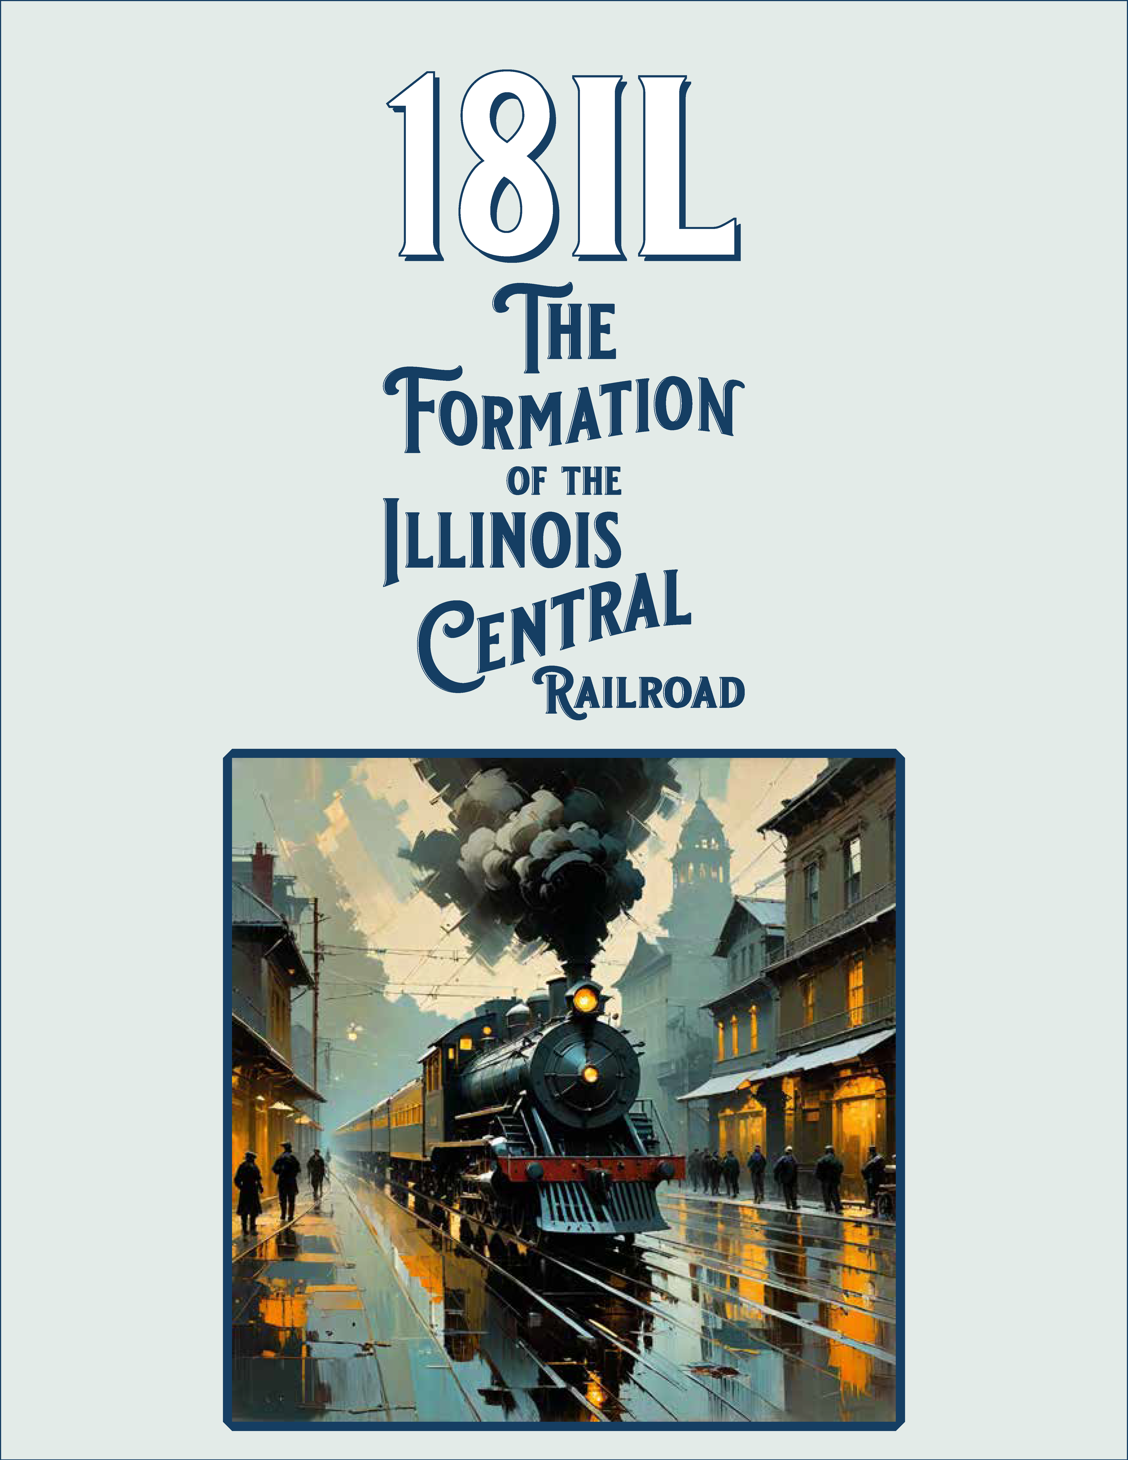
18il
the formation of the illinois central railroad
  - designed by scott ninmer • 2–6 players • 2–4 hours
rules of play – v.0.9.2

1. introduction
18IL is an “18xx” game set in Illinois, a state central to the railroad history of the United States. Players act as investors, using their starting capital to launch and invest in public railroad corporations. Each corporation is controlled by its president, the player who holds the most shares.
Corporations build track and place station markers, enabling them to operate trains and generate revenue. Earnings may be paid out as dividends to shareholders or retained by the corporation to finance further expansion.

2. game components
- 1 game board
- 1 revenue chart
- 150 track tiles
- 9 charters
- 81 share certificates/concessions
- 72 station markers
- 16 private company cards
- 45 train cards
- 10 option cubes (black)
- 2 tracker cubes (green)
- 9 port markers
- 4 home station reservation markers (RI, G&CU, V, CBQ)
- 1 round marker
- 1 priority deal marker
- 6 player aids
- These rules
- A bank (players must provide). The bank is unlimited, but $12,000 in cash is sufficient for play.

3. setting up the game
- Place the game board in the middle of the play area.
- Lay out the public corporation charters with their share certificates.
- Place all station markers nearby. Keep the bank and the yellow track tiles within easy reach of all players. Set aside the green, brown, and gray tiles for later phases.
- Place one option cube on each of the ten hexes marked with a dashed line (the IC Line).
- Place the home station reservation markers in their matching hexes. These indicate home station marker locations after tiles are built there.
- Place the port markers nearby.
- Place the round marker on the ‘CR’ space of the round track.
- Distribute starting capital from the bank to each player:
Player count | Starting capital
2 | $780
3 | $540
4 | $420
5 | $360
6 | $300
- Place the “Rogers” train card on the Northern Cross (NC) charter.
- Sort the remaining train cards by type and place each on its matching location on the board, forming the Train Bank (Train Roster, section 10.8).
- Randomly determine a start player, who receives the priority deal marker.
Now proceed to the auction formation (see Section 7).

4. overview
The game proceeds in a repeating cycle of four rounds: one auction round, one stock round, and two operating rounds. This cycle continues until the game end is
triggered.
- Auction rounds: Players bid for corporations’
concessions.
- Stock rounds: Players may start corporations or buy and sell shares.
- Operating rounds: Each corporation takes a turn, which may involve converting, issuing shares, laying track, placing
station markers, running trains to generate revenue, and
buying trains.
The game begins in Phase 2 and advances to later phases as new types of trains are purchased.

4.1 the map
The map depicts locations connected by the earliest
railroads in Illinois. It is overlaid with a hex grid, with
coordinates printed along the edges for reference.

- Large open circles = cities
- Solid black dots = towns
- Red hex edges = regions beyond the map
- Blue and gray hexes = areas that cannot be built upon

4.2 the stock market
The stock market tracks the current share price of each corporation, shown by the position of its share price marker. The share price equals the value of each individual share. Corporate revenues are tracked on the revenue chart. Each corporation uses one marker to record its earnings when running trains.

4.3 player area
Each player has an area in front of themselves in which to place corporation charters and the player’s assets (cash, certificates). Care should be taken to keep corporations’ assets and players’ assets separate and distinct. A corporation’s assets are always placed on top of its charter, whereas a player’s assets are kept directly on the table. A player’s certificates should be splayed so as to be easily visible by the other players.

5. the corporate entities

5.1 private companies
Public corporations may own private companies. Some provide ongoing abilities; others grant a one-time effect and then close. These abilities may only be used during the corporation’s operating turn. Private companies are divided into two classes.

class a private companies
Interstate Commerce Corridor
When running trains, for each train whose route qualifies for a N/S or E/W route bonus, that train's revenue is increased by $20.
Goodrich Transit Line
At any time during the corporation’s operating turn, the corporation may place a station marker from the corporation’s charter in Chicago (H3) in the GTL slot. This does not count as a station placement action. Place a port marker on the charter for free. This company closes after use. It closes immediately if it remains open when Chicago upgrades to a brown tile.
Rush Delivery
Before the “Run Trains” step, the corporation may buy one train from the bank. Emergency money raising may be used if it has no train. This company closes after use.
Station Subsidy
Whenever the corporation gains station markers from starting or converting, it receives them for free (instead of paying $40 each).
Share Premium
When the corporation issues a share during the “Issue a Share” step, it receives double the current share price from the bank. This
company closes after use.
Train Subsidy
When buying trains from the bank, the corporation receives a 25% discount on all purchases this turn. This company closes after use.
Union Stock Yards
During its station placement step, the corporation may place a
station marker in any connected city except Chicago (H3) or St. Louis (C18). This marker is non-blocking and does not use a city slot. This counts as its station placement for the turn.
U. S. Mail Line
The owning corporation receives a $10 subsidy per city visited by its trains. Each city is counted only once, regardless of how many trains visit it.

class b private companies
Advanced Track
This company begins with two tracker cubes. During the
corporation’s tile-laying step, it may remove a cube to lay or
upgrade one additional tile for free (terrain costs still apply). This can include a tile already acted upon that turn. Only one cube may be used per turn. After both cubes are used, the company closes.
Central Illinois Boom
In Phase D, during the tile-laying step, the corporation may
upgrade Peoria (E8) or Springfield (E12) with its gray tile. This
upgrade does not require a station connection, does not count as a tile lay, and may be done regardless of the city’s current color.
Remove the unused tile from the game. The company closes after use.
Chicago-Virden Coal Company
During its tile-laying step, the corporation may lay or upgrade a town hex/tile (except Galena) with the 838 tile, paying any terrain costs. It must connect to one of its station markers, but this action does not count as the tile lay. The company closes after use.
Efficient Construction
When the corporation performs two tile actions in a turn, the
second action is free instead of $20 (terrain costs still apply).
Engineering Mastery
During its tile-laying step, the corporation may upgrade two tiles (instead of the usual two lays or lay + upgrade).
Frink, Walker, & Co.
During its tile-laying step, the corporation may place the G1 tile in Galena (C2) for free, ignoring terrain costs. This does not require a station connection and does not count as the tile lay. While the corporation is open, it receives a $10 subsidy from the bank to its treasury whenever any other corporation runs one or more trains to Galena (C2).
Illinois Steel Bridge Company
The corporation ignores terrain costs for rivers and lakes. Each time it lays a yellow tile on a lake or across a river, it earns $10 from the bank.
Planned Obsolescence
When a rusting event occurs, the corporation may delay the rusting of one of its trains (except the “Rogers”). Remove that train from play at the end of its next “Run Trains” step. The company closes after use.

5.2 public corporations
Players invest in public corporations by purchasing shares. Each corporation has a treasury that holds its money and shares.
two-share corporations
- Northern Cross Railroad (NC) – E12
- Peoria and Bureau Valley Railroad (P&BV) – E8
Note: Northern Cross Railroad starts with the “Rogers” train.
The “Rogers” Train
The Northern Cross Railroad was the first railroad to operate in Illinois, opening in 1838. Its first locomotive, the “Rogers” (built by Rogers, Ketchum & Grosvenor of New Jersey), hauled passengers from Meredosia to Chapin and back. By 1842, the line connected Jacksonville with Springfield.

five-share corporations
- Chicago, Burlington, and Quincy Railroad (CBQ) – B11
- Galena and Chicago Union Railroad (G&CU) – E2
- Rock Island Line (RI) – C6
- Vandalia Railroad (V) – G16

ten-share corporations
- Chicago and Eastern Illinois Railroad (C&EI) – H21
- Illinois Central Railroad (IC) – H3
- Wabash Railroad (WAB) – I6/I8
Note: IC forms only when the IC Line has been completed.

5.2.1 corporation ownership of private companies
Corporations are limited in the number of private companies that they may own:
- A two-share corporation may not own private companies.
- A five-share corporation may own one Class B private
company.
- A ten-share corporation may own one Class A and one Class B private company.

5.3 corporation president
Most corporation certificates represent one share.
However, the president’s certificate counts as two shares.
The president is the player with the most shares in that corporation and makes all decisions for it during stock and operating rounds.
If another player ever owns more shares, the presidency transfers immediately (see section 9.5).

6. game phases

18IL progresses through a sequence of phases.
- The game begins in Phase 2.
- A new phase begins when the first train of that type is purchased from the bank.
- Exception: Phase 3 begins automatically at the end of the first operating round.
When a phase change occurs, all related rule changes take effect immediately.
The table below provides a summary; details are explained in the following text.

phase | track | red area values | train limit | available train | train rust
2 | Y | Yellow | 4 | 2 | —
3 | Y/G | Yellow | 4 | 3 | “Rogers”
4A | Y/G | Yellow | 3 | 4, 0+3C | 2
4B | Y/G/B | Brown | 2 | 4+2C | —
5 | Y/G/B | Brown | 2 | 5+1C | 3
6 | Y/G/B | Brown | 2 | 6 | 0+3C
D | Y/G/B/Gray | Brown | 2 | D | 4

Phase 2 begins at the start of the game.
- Yellow track tiles are available.
- Red areas are worth their yellow value.
- The train limit is 4.
Phase 3 starts at the end of the first operating round.
- Yellow and green track tiles are available.
- Red areas are worth their yellow value.
- The train limit is 4.
- The “Rogers” train rusts.

Phase 4A starts when the first 4 or 0+3C train is purchased.
- Yellow and green track tiles are available.
- Red areas are worth their yellow value.
- The train limit is 3.
- 2-trains rust.

Phase 4B starts when the first 4+2C train is purchased.
- Yellow, green, and brown track tiles are available.
- Red areas are worth their brown value.
- The train limit is 2.
Phase 5 starts when the first 5+1C train is purchased.
- Yellow, green, and brown track tiles are available.
- Red areas are worth their brown value.
- The train limit is 2.
- 3-trains rust.

Phase 6 starts when the first 6-train is purchased.
- Yellow, green, brown, and gray track tiles are available.
- Red areas are worth their brown value.
- The train limit is 2.
- 0+3C trains rust.
- D trains are available for purchase or exchange.

Phase D starts when the first D train is purchased.
- Yellow, green, brown, and gray track tiles are available.
- Red areas are worth their brown value.
- The train limit is 2.
- 4-trains rust.
- Game end is triggered (see Section 11). At the end of the
subsequent operating round:
  - Unopened corporations are removed from the game, along with their associated concessions in the auction pool.
  - Pullman Strike: 4+2C trains and 5+1C trains are converted to 4-trains and 5-trains, respectively.
  - Certificate limit is adjusted (see Section 9.4).
  - The final cycle begins

7. auction pool formation
The game begins with the formation of the auction pool.
- Arrange the eight concessions in numerical order beside the board.
- Shuffle the eight Class A private companies and place one
directly below each 10-share corporation’s concession. Shuffle the eight Class B private companies and place one
directly below each 5- and 10-share corporation’s concession. These denote the private companies that will be owned by that
corporation if the concession is used to start the corporation.
- Place the unowned private companies near the concessions.
- Place the two tracker cubes on Advanced Track.
- Place the P4 and S4 tiles on Central Illinois Boom and the 838 tile on Chicago-Virden Coal Company.

8. auction rounds
During auction rounds, players take turns clockwise, beginning with the holder of the priority deal marker. On their turn, the active player may perform one of the following:
- Select one concession to put up for auction.
- Select one unowned private company to put up for auction.
- Select one IC share certificate to put up for auction. These only become available after the Illinois Central has formed.
- Decline, in which case the player to their left becomes the new active player.
If a concession or unowned private company is put up for auction, the active player must make the opening bid. Each bid must be at least $10, must be a multiple of $5, and must exceed the previous bid by at least $5. Bidding proceeds clockwise. Players may not bid more cash than they currently hold. A player who passes may not re-enter that auction, though they may still participate in later auctions during the same round.
When all but one player have passed, the highest bidder pays their bid to the bank and takes the concession or private company and places it in the player’s area. If the won item is a concession with assigned private companies, keep those private companies with the concession. The player to the left of the one who initiated the auction becomes the new active player.
If an IC share certificate is put up for auction, the minimum bid is equal to IC’s current share price (double for the president’s certificate), rounded up to the nearest multiple of $5. The winning bidder pays the winning amount to IC’s treasury and takes the certificate, adding it to that player’s holdings. At this time, the player may temporarily exceed both the certificate limit and the ownership limit.
If this gives the player two ordinary IC certificates and IC does not yet have a president, the player becomes IC’s president and immediately exchanges those two certificates for the president’s certificate in the auction pool.
The auction round ends when all players in succession decline to start an auction, or when no items remain to be auctioned. Any unsold concessions and their associated private companies are set aside and remain available for
future auction rounds. Any unowned private companies and IC share certificates are set aside in the same manner.
The round marker is advanced to the next space.

9. stock rounds
During a stock round, players take turns clockwise,
beginning with the player who holds the priority deal marker. On their turn, the active player may:
- Act as themselves (sell/buy shares or start a corporation).
- Act for a corporation they preside over (redeem shares).
- Pass.
A player may choose only one of these options each turn.
Corporation action. A corporation may redeem any number of its own shares from the open market. It pays the current share price from its treasury to the bank.
Redeemed shares are placed back into the corporation’s treasury.
Player action. On their turn, a player may:
- Sell any number of shares.
- Then buy one share (from a treasury or the open market)
or start a new corporation.

9.1 sell share certificates
A player may sell any number of shares to the open
market. The bank pays the current share price for each. Selling shares does not affect the corporation’s share price.
A player cannot sell a corporation’s shares until it has
operated at least once. If a corporation has closed and later reopens, it still counts as having operated.

9.2 buy a treasury or market share
A player may buy one share per turn, either from a corporation’s treasury (paying that corporation) or from the open market (paying the bank).
The following restrictions apply:
- A player cannot buy shares of a corporation if that player sold any of the corporation’s shares earlier in the same stock round.
- A player cannot buy a 10-share corporation’s reserve share from its treasury. It may be purchased if it is in the open market.
- Players must respect certificate and share limits (section 9.4).
Exception: During a stock round, Illinois Central (IC) shares may be purchased from corporations of which the player is president, even if this purchase causes the player to exceed the ownership limit. The certificate limit, however, must still be observed.

9.3 starting a corporation
Instead of buying a share, a player may start a new corporation:
- Select one of the player’s unused concessions. Take its charter and place it in front of the player. Put the assigned private companies on the charter (these are owned by the corporation).
- Select a par price (40, 60, 80, 100, or 120). Twice this amount is paid into the corporation’s treasury from the bank. The
concession is flipped to its president’s certificate side and added to the player’s holdings.
- Check the concession’s size: 2-share, 5-share, or 10-share. Select the correct share price marker (small for 2-share,
medium for 5-share, large for 10-share). Place it logo-side-up on the stock market, beneath any markers already
present.
- Add the corporation’s treasury shares:
- 2-share: none
- 5-share: three 20% shares
- 10-share: eight 10% shares (place the reserve share on the bottom of the stack)
- Place a free home station marker in its starting hex, plus
another marker near the revenue chart.
- Purchase the required number of station markers (see 9.6):
- 5-share: must buy 1
- 10-share: must buy 2–4 (president’s choice)

9.3.1 reopening a corporation
A previously closed corporation may reopen, following the same process for starting a new corporation, with these differences:
- It must reopen with the same share size (2, 5, or 10) that it had before.
- No additional station markers may be purchased at this time.
- Any station markers already on its charter remain available to place during operations.
- Instead of placing a new home station, it must flip one of its abandoned stations face-up for free. If none exist, it places a station marker for free in any available city except Chicago or St. Louis.

9.4 certificate and share limits
Certificate limit. Each player has a maximum number of certificates they may hold, based on the number of players:
Player count | Certificate limit
2 | 24
3 | 18
4 | 15
5 | 13
6 | 11
The limit is reduced by one for every corporation removed from the game. A certificate may be purchased only if the buyer currently holds fewer than the limit. If a player exceeds the limit, the excess must be sold on that player’s next stock round turn. Players may temporarily exceed the certificate limit during operating and auction rounds.
Ownership limit. Players may own at most three shares of a 5-share corporation and at most six shares of a
10-share corporation (seven in a two-player game).

9.5 presidency changes
The president of a corporation changes if another player owns more shares in a corporation than the current president.
- The new president is the player with the most shares.
- In case of a tie, it goes to the tied player sitting closest to the outgoing president’s left.
- The outgoing president must swap the president’s certificate for two ordinary shares, which transfer to the new president.
The president’s certificate cannot be sold directly to the open market. However, if another player owns at least two ordinary shares, the president may exchange the
president’s certificate for those two shares and then sell them to the open market.

9.6 station marker requirements
When starting, corporations must immediately buy station markers. When converting, corporations may buy station markers but are not required to do so.
Starting a new corporation:
- 2-share: none ($0).
- 5-share: 1 marker ($40).
- 10-share: 2–4 markers ($40 each, chosen by the president).
Converting:
- 2-share to 5-share: may buy 1 marker ($40).
- 5-share to 10-share: may buy 1-3 markers ($40 each).
All purchased station markers are placed on the corporation’s charter until used.

9.7 end of stock round
A stock round ends when all players pass in succession.
Share prices are then adjusted in order from highest to lowest:
- If all shares of a 5-share corporation are held by players, move its share price marker one diagonal step forward.
- If all shares of a 10-share corporation are held by players or corporations (IC included), move its marker one horizontal step forward.
- For each share in the open market, move the marker one
diagonal step back.
All unused concessions, along with their associated private companies, are returned to the auction pool.
The priority deal marker is given to the player to the left of the last player who took an action in the stock round.
The round marker is advanced to the next space.

10. operating rounds
During each operating round, public corporations act in order of descending share price. If multiple corporations have the same share price, they operate from top to bottom based on the marker location in the share price space. Each corporation is directed by its president.
Private company abilities may be exercised only during the turn of the corporation that owns them, unless
otherwise noted. These abilities are classified as follows:
- One-time use (marked “1x”): once activated, the company immediately closes and is removed from play.
- Ongoing use: a continuing effect that lasts throughout the game.
The operating sequence for each corporation is as follows:
1. Convert | 5. Scrap trains/Buy port marker
2. Issue a share | 6. Run trains
3. Lay and/or upgrade track | 7. Distribute earnings
4. Place a station marker | 8. Buy trains
Route Requirements. Several operating actions refer to a corporation’s route. A route is a continuous line of track that includes at least one station marker belonging to the corporation. The station marker may be located at either end of the route or anywhere along its path.
The following rules apply to routes:
- A city may be included if it has at least one empty slot, if it has a reserved slot, or if the corporation already has a station marker there. Slots with abandoned stations do not count as empty.
- Towns may always be included in a route but may not serve as endpoints.
- Lake Michigan (H1) may be included only if the corporation owns a port marker. A route may end at Lake Michigan.
- A route may exit a city, town, or port along any connected track.
- A route may not reverse direction or reuse the same track segment.
- A route may not visit the same location more than once.

10.1 convert
A corporation may convert once to a larger size (2 → 5 or 5 → 10). When conversion occurs, replace its share price marker with the one matching its new size.

10.1.1 convert a 2-share corporation
When a 2-share corporation converts to 5-share:
- Add the three reserved 20% shares to its treasury.
- The corporation may acquire one Class B private company owned by its president. Place this company on the corporation’s charter.
- The president may immediately buy one share from the treasury at the current price (even if this places a player above the certificate limit).
- In clockwise order, each other player may choose one of the following actions:
- Buy one share from the treasury (even if this places a player above the certificate limit).
- Sell any number of the corporation’s shares to the open market.
- The corporation may buy one station marker for $40, placing it on the corporation’s charter. It is not required to do so.

10.1.2 convert a 5-share corporation
When a 5-share corporation converts to 10-share:
- Flip all 20% shares to their 10% side.
- The corporation may acquire one Class A private company owned by its president. Place this company on the corporation’s charter.
- Add the five reserved 10% shares to its treasury (place the reserve share on the bottom of the stack).
- The president may buy any number of shares from the treasury at the current price, up to the ownership limit (even if this places a player above the certificate limit).
- In clockwise order, each other player may choose one of the following actions:
- Buy one share from the treasury (even if this places a player above the certificate limit).
- Sell any number of the corporation’s shares to the open market.
- The corporation may buy 1-3 station markers for $40 each, placing them on the corporation’s charter. It is not required to do so.

10.2 issue a share
A corporation may issue one share from its treasury to the open market. The bank pays the corporation the current share price for that share. Afterward, the corporation’s share price marker moves one step backward horizontally on the stock market.

10.3 lay and/or upgrade track
During this step, the corporation may place or upgrade track tiles on the board. Taking this action is optional. A corporation may perform one of the following tile actions:
- Lay a yellow tile.
- Upgrade one yellow tile to green, one green tile to brown,
or one brown tile to gray.
For an additional $20, the corporation may perform a
second tile action. At most one of the two actions may be an upgrade. A corporation may not lay and then immediately upgrade that same tile in the same turn. No more than two tile actions may be performed in a turn.
Available tiles depend on the current game phase:
- Green tiles are available beginning in Phase 3.
- Brown tiles are available beginning in Phase 4B.
- Gray tiles are available beginning in Phase D.
The board already includes printed yellow and gray hexes with track. These hexes are treated as though a tile of the corresponding color has already been placed. Yellow tiles may not be laid in these hexes, but yellow hexes may be upgraded to green tiles according to the normal rules.
When track containing a station marker or a home station reservation marker is laid or upgraded, move the marker onto the new tile in the same relative position. If track is laid or upgraded in another corporation’s home station hex, place that corporation’s home station reservation marker in one of the station slots of the new tile.
IC Line Completion. When the final IC Line hex is completed, whether by laying yellow track or by upgrading to green, the Illinois Central is scheduled to form after the currently active corporation completes its operating turn (see Section 10.11). If Phase D begins before the IC Line is completed, the Illinois Central never forms. If the IC Line is completed before Phase D begins, the Illinois Central still forms after the current operating turn, even if Phase D begins later during that same turn.

10.3.1 laying yellow track
Yellow tiles are placed onto neutral-colored hexes of the map, aligned to the grid. If the corporation’s home hex does not already contain a colored track tile, an appropriate city tile must be placed there. Track on the tile must connect to the corporation’s existing routes. Track may not extend off the board, enter the blank edge of a red area, or run into water or gray hexes printed on the map.
Placing yellow track is free unless it is the second tile
action, in which case the $20 fee applies.
Terrain costs must be paid when laying a tile in a
mountain or lake hex, or when connecting track across a river edge.
If a hex contains a city or town, only tiles with the same feature may be placed there. Plain track must be used in non-city, non-town hexes.
Certain labeled tiles (C, G, K, S) must be placed in their assigned hexes.
IC Line Tile Lays. When yellow track is laid along this line, one of two outcomes occurs:
- If the dashed line is completely overlaid (using tiles 8, 9, C13, or K12), move the option cube from the hex to the corporation’s charter.
- If only one end of the dashed line is overlaid, place the option cube on top of the new tile.
After laying a yellow track tile on the IC Line, the corporation’s treasury receives a $20 rebate from the bank.

10.3.2 upgrading track
Upgrading replaces an existing tile with one of the next color in sequence: yellow to green, green to brown, brown to gray. The type of tile must match the location: plain track with plain track, city with city, town with town, and labeled locations (C, J, K, P, S, Chi) with their assigned
upgrades. Brown C and K tiles may not be placed until the IC Line has been completed. Removed tiles are returned to the supply.
When upgrading, all previously existing track segments must remain. No connections may be removed. At least one track segment on the new tile, not necessarily a newly added segment, must connect to the upgrading corporation’s routes.
If station markers are present, move them to the new tile in the same relative positions. No terrain costs are paid during upgrades.
IC Line Tile Upgrades. When a yellow IC Line tile is
upgraded, the green replacement must fully overlay and complete the dashed track. If an option cube is present on the yellow tile, the corporation upgrading it receives the cube.

10.4 place a station marker
A corporation may place one station marker from its
charter into any legally reachable city. Only one station marker of a corporation may be present in a given hex.
Station markers are free to place. They are placed face-up in an open station slot. Towns do not contain station slots and therefore cannot receive station markers.
Station markers may not be placed in reserved slots.
Reserved slots include a corporation’s home station and the IC-reserved spaces along the IC Line, which are
reserved only when those cities contain green tiles.

10.4.1 st. louis station marker
Instead of placing a station marker in a city slot, a corporation with a legal route to St. Louis may place one of its station markers in St. Louis. This allows the corporation to run one train to St. Louis.
Station markers are placed in the color-coded slots in St. Louis. Each slot becomes available when its corresponding track color becomes available.

10.4.2 abandoned stations
Instead of placing a new station marker, a corporation with a legal route to another corporation’s abandoned station (face-down marker) may take over that slot. To do so, it pays $40 to the original owner, removes the abandoned marker, and places one of its own markers there. The removed marker is returned face-up to the original corporation’s charter, where it remains available if that corporation reopens.
A corporation may also spend $40 to flip one of its own abandoned station markers on the board face-up, reclaiming that slot.
In either case, this action counts as the corporation’s station placement for the turn.

10.5 scrap trains / buy port marker
Before running trains, a corporation may:
- Scrap any number of its trains, provided that at least one train remains. Scrapped trains are removed from the game without compensation.
- Purchase a port marker for $40 if it does not already own one. Owning a port marker allows the corporation to include Lake Michigan (H1) in its routes, as described under Route Requirements (beginning of section 10), and increases that train’s revenue by $20.

10.6 run trains
A corporation that owns one or more trains must run them and calculate earnings. Trains run along legal routes, as defined under Route Requirements.
Trains run to revenue locations, which include cities, towns, ports, and red areas. The value of each revenue location is shown on the map or on the tile.
Each train must begin and end at revenue locations, subject to the endpoint restrictions in Route Requirements (beginning of Section 10). The train’s number indicates the maximum number of stops it may count. Cities and red areas count against this limit. Towns and ports do not count against this limit.
A route may not connect one east (E) red area to another east red area, or one west (W) red area to another west red area.
A train may not reuse any track segment used by another of the corporation’s trains in the same operating turn, except for four-way junctions on brown plain track.
Different trains of the same corporation may visit the same revenue location, provided they do not share any track.
Earnings are calculated as follows:
- The revenue of a single run is the sum of the values of the
visited revenue locations.
- A corporation’s total earnings are the sum of all its train runs.
- Corporations must run for the maximum possible earnings. The only exception is when the corporation owns a private company that grants subsidies; in that case, it may choose to maximize subsidy income.
Some routes provide additional bonuses:
- A route ending at both a north (N) and a south (S) red area earns an additional $100.
- A route ending at both an east (E) and a west (W) red area earns an additional $80.
Certain trains have special properties:
- Pullman cars (C) double the value of the cities they visit. A Pullman car (1C, 2C, 3C) is assigned to the base train but may not visit red areas, including Detroit (I6). Pullman cars may also include any number of towns and ports.
  - A 0+3C train doubles three cities.
  - A 4+2C train visits four revenue locations plus two additional cities, which are doubled. The doubled cities need not be adjacent.
  - A 5+1C train visits five revenue locations plus one additional city, which is doubled.
- Diesel (D) trains may visit any number of revenue locations on a single route.

10.6.1 red areas
The map contains eight red areas: Omaha, Sioux City,
Milwaukee, Detroit, Indianapolis, Louisville, St. Louis, and New Orleans. Each red area must serve as either the starting point or the ending point of a train’s route.
Special restriction: a route may not originate in St. Louis. A route may end in St. Louis only if the operating
corporation has placed a station marker there.
Each red area has two printed values, shown in yellow and brown. The yellow value applies during Phases 2–4A, while the brown value applies during Phases 4B–D.

10.6.2 the “rogers” train
At the start of the game, the Northern Cross Railroad (NC) owns the “Rogers” train. This train may operate only on the route between Springfield and Jacksonville.
It must run in the first operating round and rusts immediately after it runs.

10.7 distribute earnings
After running trains, a corporation distributes its
earnings. It may:
- Withhold: All earnings are placed in the corporation’s
treasury. The share price marker moves one horizontal step backward.
- Pay full dividends: All earnings are distributed to shareholders. Each shareholder receives a proportion equal to the
number of shares held (50% for a 50% share, 20% for a 20% share, or 10% for a 10% share). Dividends for shares owned by a corporation are paid into that corporation’s treasury. Shares in the open market do not receive dividends.
- Pay half dividends: Half the earnings are placed in the
treasury, while the other half are paid out to shareholders as described above. The amount paid out must be rounded up to the nearest even number (e.g., if the earnings were $50, $26 would be paid out and $24 would be withheld).
When dividends (full or half) are paid, the share price marker adjusts as follows:
- One diagonal step backward if the amount paid is greater than $0 but less than half of the current share price.
- One diagonal step forward if the amount paid is at least half but less than the full share price.
- One horizontal step forward if the amount paid is at least equal to the current share price but less than double.
- Two horizontal steps forward if the amount paid is at least double but less than triple.
- Three horizontal steps forward if the amount paid is at least triple.
To aid bookkeeping, the share price marker of a corporation should be flipped once it has distributed earnings in the current operating round.

10.8 buy trains
A corporation may buy trains provided it is below the
current train limit. Trains may be purchased from either the bank or another corporation, with the consent of the selling corporation’s president. Multiple trains may be purchased during the same turn, but never in excess of the limit. Purchases must be made one train at a time.
Buying a train may immediately trigger a phase change (see Section 6).
- From the bank: Trains are purchased in order at the listed cost, paid to the bank.
- From another corporation: Trains may be purchased at any mutually agreed price of at least $1.
There are two distinct Phase 4 trains, printed on the front and back of the train card. Either type may be purchased from the bank, but once chosen, the type may not be changed.
D trains become available for purchase or exchange after the first 6-train has been purchased. D trains may be purchased normally or a corporation may instead opt to exchange a 4+2C, 5+1C, or 6-train for a D train at a reduced cost of $750. The exchanged train is removed from the game.
The first D train purchased triggers the end of the game (see Section 11).
If a phase change reduces the train limit, corporations holding excess trains must immediately discard trains of their choice until they are compliant.
If a corporation owns no trains, it must purchase one. It may buy any train it can afford from the bank. A corporation is never required to purchase a train from another corporation, regardless of the price offered. If a corporation cannot afford a bank train and does not wish (or is unable) to buy one from another corporation, it must
conduct emergency money raising (see Section 10.9).

train roster
train | cost | number of trains | notes
“Rogers” | — | 1 | The Northern Cross Railroad begins the game with the “Rogers” train. This train runs from Springfield to Jacksonville and rusts at the end of the first operating round.
2 | $80 | Unlimited (16*) | All unpurchased 2-trains are removed at the end of the first operating round.
3 | $160 | 6 | —
4  0+3C | $240  $320 | 5 | A 0+3C train doubles the revenue of cities it visits. It may not visit red areas.
4+2C | $800 | 4 | A 4+2C train may visit six cities/red areas (in addition to towns/ports),  doubling the value of two cities. It downgrades to a permanent 4-train in phase D.
5+1C | $720 | 3 | A 5+1C train may visit six cities/red areas (in addition to towns/ports),  doubling the value of one city. It downgrades to a permanent 5-train in phase D.
6 | $640 | 2 | —
D | $1000* | Unlimited (8*) | Available after the purchase of the first 6-train. A corporation may buy a D train for $1000 or exchange a 4+2C, 5+1C, or 6-train for $750. A D train may visit any number of revenue locations on a route.
*The provided number of ‘unlimited’ trains should be sufficient for most games; if there is a shortage, use a suitable substitute.

10.9 emergency money raising
If a corporation cannot afford a train, it must raise money to purchase the cheapest available train from the bank. Emergency money raising may not be used to purchase a train from another corporation.
The process is as follows:
- Sell IC shares: The corporation sells any Illinois Central (IC) shares from its treasury to the open market, receiving their current value from the bank.
- Issue shares: If additional funds are still required, the
corporation issues shares from its treasury to the open market, receiving half of the current share price (rounded down) for each share. No more shares may be sold or issued than necessary to afford the cheapest train. After all shares have been issued, each issued share reduces the corporation’s share price by one diagonal step. If this causes the share price marker to enter a “close” space, the corporation closes
immediately without purchasing a train (see Section 10.13).
- Presidential contribution: If the treasury still lacks sufficient funds, the president contributes the exact amount
required. The president may not contribute more than the amount needed.
- Sell presidential shares: If funds remain insufficient, the president must sell personal shares until the cost of the train is met. The president chooses which shares to sell but must stop once the required amount is raised. These shares are placed in the open market.
During emergency money raising, the presidency of the corporation currently operating cannot transfer. However, if the sale of shares causes the presidency of another
corporation to change hands, that transfer occurs
immediately before the train purchase is completed.
If, after completing all these steps, the corporation still cannot purchase a train, it becomes insolvent (see Section 10.12).

10.10 end of operating round
At the end of the first operating round, remove all
remaining 2-trains from the bank and advance to Phase 3.
The “Rogers” train is also removed at this time.
At the end of each subsequent operating round, remove the next available train from the bank.
When a phase change occurs, trains from earlier phases may rust and are removed immediately.
If the first D train is purchased, the game end is triggered (see Section 11).
Finally, advance the round marker to the next space.

10.11 illinois central formation
The Illinois Central Railroad (IC) forms once the IC Line (the dashed track from Chicago to New Orleans) has been
completely overlaid with yellow and/or green track.
IC forms after the currently active corporation has
completed its turn.
- Place IC’s share price marker at $80 on the stock market,
below any markers already present at that value.
- Place five 10% IC shares into the open market.
- Place the remaining three 10% shares and the 20% president’s certificate into the auction pool.
- IC receives $400 from the bank and one port marker.
The IC Line
The IC Line represents the Illinois Central’s original north-south trunk through Illinois, linking Chicago with Cairo and the Mississippi Valley.

10.11.1 reorganization of private interests
All player-owned private companies are returned to the auction pool. Corporate-owned private companies
remain owned by the corporations.

10.11.2 option cube exchange
Two-cube exchanges. Every two cubes that a corporation holds (including closed corporations) are discarded for one IC share from the open market, which is placed in that corporation’s treasury. Resolve all two-cube exchanges
before any one-cube exchanges.
One-cube exchanges. In descending order of share prices, each corporation with exactly one cube must
discard it and choose one of the following:
- Receive $40 from the bank.
- Pay $40 to the bank and take one IC share from the open
market into its treasury.
If no IC shares remain in the open market when a share would be taken, the corporation must receive $40.
Any closed corporation with a cube discards it and receives $40.

10.11.3 mergers
Each solvent corporation with a station marker in at least one of the non-Chicago IC Line cities (Kankakee, Champaign, Centralia, or Cairo) is eligible to merge into Illinois
Central. Beginning with Kankakee and proceeding southward, each president decides whether to accept or decline the merger offer. If a corporation has station markers in multiple IC Line cities and declines the offer, it does not receive any further offers.
If a corporation accepts, its president must choose one of the following:
- Receive one 10% IC share from the auction pool.
- Receive cash from the bank equal to the corporation’s current share price.
Flip the merging corporation’s president’s certificate to its concession side and place it, along with any open private companies that the corporation had, in the auction pool.
The merging corporation then sells any IC shares in its treasury to the open market at IC’s current share price.
Next, the merging corporation attempts to redeem all
outstanding shares at half of its current share price (rounded down).
- Compute the total required by multiplying the number of shares held by players and in the open market by one-half of the share price.
- If the treasury contains enough money, pay half price per share (rounded down) to players and to the bank (for market shares). Any remaining treasury funds remain on the charter.
- If the treasury is insufficient, transfer all treasury cash to the bank. The bank then guarantees full redemption for all non-president shares, paying the full share price to the holders. Shares owned by the president are treated as redeemed for $0.
All shares are then returned to the corporation’s treasury.
After each merger is resolved, check whether a player qualifies to become president of Illinois Central:
- If a player owns at least two IC shares, that player becomes IC’s president and exchanges two ordinary shares for the
president’s certificate.
- If two players each own two IC shares, the first to have reached that total becomes president.
- If no player qualifies, IC remains without a president and may continue to merge with other corporations.

10.11.4 share price adjustment and cleanup
The Illinois Central’s new share price is determined by
averaging the share prices of all merged corporations,
including IC itself. This average is rounded down to the nearest printed value on the stock market, and IC’s share price marker is placed accordingly.
Place one IC station marker in Chicago and six station markers on its charter.
For each corporation that merged into IC:
- Remove its northernmost station marker among Kankakee, Champaign, Centralia, or Cairo. Return it to the corporation’s charter and place an IC station marker from IC’s charter in that city. If the city is on a green tile, place the IC marker in its reserved slot.
- Flip all of its remaining station markers on the map face-down. These now count as abandoned stations (see Section 10.4.2). If the corporation owns the Union Stock Yards private company, remove the associated station marker from the map and place it on the corporation’s charter.
- Transfer all cash and trains to IC.
- Set aside the corporation’s charter along with its share price and revenue markers. Station markers on the charter should remain on the charter. The corporation is now closed.
IC then places markers depending on how many corporations merged:
- If two or more corporations merged, no additional markers are placed.
- If one corporation merged, place one marker in the northernmost IC-Line city without an IC station that still has an available slot.
- If no corporations merged, place one marker in each of the two northernmost IC-Line cities without IC stations that still have available slots.
Note: If a required city has no open slots, place the IC marker beside another corporation’s marker in that city. It functions as a normal station marker and moves into IC’s reserved slot once the tile upgrades to green. In the rare case that multiple cities are blocked, place one IC marker beside the occupied station in each such city.
If IC has no train, it immediately purchases the cheapest available train from the bank if it can afford to do so.
If IC has no president, it enters receivership (see Section 10.11.6).
IC then operates based on the following:
- If at least one merged corporation operated earlier in the round, IC takes its first turn in the next operating round.
- If no merged corporations operated, IC instead takes its first turn in the current operating round, following normal share price order. If its share price is the highest among the corporations still waiting to operate, IC acts immediately.
Example: When IC forms, WAB has four option cubes. It discards them in exchange for two IC shares from the open market, which are placed in its treasury. NC has one option cube and pays $40 from its treasury to gain one IC share.
Player A is president of NC (station in Champaign). Player B is president of V (station in Centralia). Player C is president of WAB (station in Kankakee).
Mergers are offered north to south: WAB, NC, then V.
WAB – Share price $90; treasury $250; one 3-train; one share in the market
  - The president chooses a 10% IC share from the auction pool instead of $80 cash.
  - WAB sells its two IC shares to the open market for $160.
  - It then attempts to redeem outstanding shares at half value. Player A (2 shares) is paid $90. Players B, C, and the bank (one share each) receive $45 each.
  - The remaining $185 and the 3-train transfer to IC.
NC – Declines to merge.
V – Share price $144; treasury $20; one 0+3C train; no shares in market.
  - The president chooses $144 cash from the bank instead of an IC share.
  - It attempts to redeem shares at half value. Each player owns one share. This would require $216, but the treasury only holds $20. That $20 goes to the bank, which guarantees full redemption. Players A and C receive $144 each. Player B’s share is redeemed for $0.
  - The 0+3C train transfers to IC.
Neither Player A nor B owns two IC shares, so IC enters receivership.
IC’s new share price is the rounded-down average of $80, $90, and $144 = $100. Its treasury now contains $585, a 3-train, and a 0+3C train. The president’s certificate and two ordinary shares are in the auction pool, with two more in the market.
WAB’s and V’s stations in Kankakee and Centralia are returned to their charters. Their other station markers are flipped face-down. IC places stations in Kankakee, Centralia, and Chicago, plus four on its charter.
Because V operated earlier in the round, IC will take its first turn in the next operating round.

10.11.5 illinois central regulations
The Illinois Central is subject to the following special
regulations:
- IC may buy and sell trains only at face value.
- IC’s train limit is always one higher than the standard limit for the current phase.
- If IC does not own a train when it runs trains, it leases the next available train from the bank. The leased train is not purchased and is returned to the bank after IC runs. IC runs the leased train for maximum revenue, withholds half of its earnings, and pays the other half to the bank as the lease payment. IC’s share price does not move when it leases a train.
- During the train-buying step:
  - IC is not required to purchase a train if its treasury does not contain enough funds to afford the cheapest available train.
  - If IC has sufficient funds and is below its train limit, it must purchase at least one train from the bank.
  - If IC does not have sufficient funds to buy a train but
has sufficient funds to exchange a train for a D train, it must do so.
- IC’s share price marker may never move into the “close” space on the stock market.
- Along the IC Line, station slots are reserved for IC. These slots become available when the respective cities upgrade to green. When IC places a station marker in such a city, it must occupy the reserved slot.
- IC shares located in the auction pool are not considered treasury shares. They cannot be issued and do not generate dividends for IC.

10.11.6 illinois central receivership
If Illinois Central forms without a president, it immediately enters receivership. While in receivership:
- If IC does not own a train, it leases a train (section 10.11.5).
- IC shares cannot be sold. However, they may be auctioned during auction rounds and purchased during stock rounds.
- IC leaves receivership as soon as a player acquires the president’s certificate, either by winning it in an auction round or by exchanging two ordinary shares.
- IC’s share price does not move if shares remain in the open market at the end of a stock round.
Receivership Operations. IC continues to operate in its normal position in share-price order. While in receivership, it does not convert, issue shares, lay track, or place station markers. It runs any trains it owns for maximum revenue and withholds all earnings. If IC does not own a train, it leases one (section 10.11.5). After running trains, if IC has sufficient funds and is not at its train limit, it purchases the next available train from the bank.

10.12 insolvency
A corporation becomes insolvent if it remains unable to afford a train after completing all steps of emergency money raising.
When insolvency occurs, proceed as follows:
- Rotate the corporation’s charter sideways.
- Take from the bank an amount equal to the difference
between the corporation’s current funds and the cost of the next available train. Place this money on the charter, kept separate from its other funds.
- Place a spare marker on this borrowed money to indicate that this amount was loaned by the bank.
- Return any funds on the charter that are not marked as part of the loan to the bank.
- Place the next available train from the bank on the charter.
While insolvent, the following special rules apply:
- The corporation’s shares may not be purchased or sold during stock rounds.
- The corporation must withhold all earnings. Withheld
revenue is placed on the charter and equal amounts are
simultaneously deducted from both the withheld funds and the outstanding loan to the maximum extent possible.
Once the debt is fully repaid, remove the spare marker. The corporation becomes solvent again and its charter is rotated back to its normal position.

10.13 closing a corporation
A corporation closes either when its share price enters a “close” space on the stock market or when it merges into Illinois Central during IC’s formation. A closed corporation may be restarted later.
When a corporation closes due to reaching the “close” space on the stock market:
- Flip all of its station markers on the map face-down. These now count as abandoned stations (see Section 10.4.2).
- If the corporation owns the Union Stock Yards private
company, remove the associated station marker from the map and place it on the corporation’s charter.
Next, resolve the corporation’s holdings:
- Sell any IC share certificates it owns to the open market at IC’s current share price.
- Place the corporation’s charter aside, along with any unused station markers, cash, option cubes, and trains remaining on it.
- Return all of the corporation’s share certificates held by
players, corporations, or the open market to its treasury.
- Set aside the corporation’s share price marker and revenue marker.
- The former president retains ownership of the corporation’s concession and any still-open associated private companies. These are placed together in front of the player. This allows the player to re-open this corporation in the next stock round. If they elect not to do so, the concession and associated private companies will return to the auction pool at the end of the stock round as normal.

11. game end
The game end is triggered when the first D train is purchased or if the 500 space is reached on the stock market.
When the first D train is purchased, finish the current
operating round. Then, regardless of whether this was the first or second operating round of the set, play one
additional operating round. In this additional operating round, corporations may not buy the last train from a
corporation that has already operated in this round. After this operating round, enter the final cycle.
The final cycle consists of an auction round, a stock round, and three operating rounds. Before the auction round, perform these steps:
- Remove all unopened corporations from the game, along with their associated concessions in the auction pool.
- Adjust the certificate limit (see Section 9.4).
- Pullman Strike: flip all 5+1C trains to their 5-train side and flip all 4+2C trains to their 4-train side. These 4-trains do not rust.
The Pullman Strike
The Pullman Strike of 1894 began in Illinois when
workers at the Pullman Company protested wage cuts.
It quickly escalated into a nationwide railroad strike, halting much of the country’s rail traffic and prompting federal
intervention. The strike’s legacy reshaped U.S. labor relations and highlighted the pivotal role of Illinois railroads in national commerce.
The final stock round proceeds as normal. In the final three operating rounds, corporations may only run trains and distribute earnings, always paying the full amount.
Designer note: Before the final stock round, it is helpful to
calculate the earnings of each corporation for the upcoming
operating rounds. These values may have changed significantly due to the Pullman Strike and the additional home station markers. Having them determined in advance allows players to make quicker decisions in the stock round and enables the
final operating rounds to be resolved quickly, as the earnings will not change from round to round.
At any time during the game, if a corporation reaches the 500 space on the stock market, the game ends at the end of the current operating round, regardless of whether the other end-game condition has been met.
Each player’s total value is the sum of the cash on hand plus the value of each owned share at its current share price.
Corporations’ remaining assets have no value. The player with the highest total value is the winner.

12. variants
Several optional variants are available and should be agreed upon before play begins.

12.1 introductory game
For a simpler and faster experience, private companies may be omitted entirely. In auction rounds, players then bid only on concessions without any private companies assigned.

12.2 private draft variant
In this variant, players draft private companies before the first auction round.
Place the eight Class A private companies in one row and the eight Class B private companies in a second row. After determining the first player, draft in snake order: beginning with the first player and proceeding clockwise, each player selects one private company and places it in their play area. After the last player has selected, draft direction reverses and players select in counterclockwise order. Continue alternating direction after each pass through the player order.
In a 2- or 3-player game, each player drafts four private companies and may draft no more than two Class A companies and two Class B companies.
In a 4-, 5-, or 6-player game, each player drafts two private companies and may draft no more than one Class A company and one Class B company.
After the draft is complete, place all undrafted private companies in the auction pool along with the concessions.

12.3 full draft variant
In this variant, players draft concessions and private companies before the first auction round. This draft replaces the first auction round.
Place the eight concessions, eight Class A private companies, and eight Class B private companies in three separate rows. After determining the first player, draft in snake order: beginning with the first player and proceeding clockwise, each player selects one item and places it in their play area. After the last player has selected, draft direction reverses and players select in counterclockwise order. Continue alternating direction after each pass through the player order.
The number of items drafted by each player depends on player count:
- 2 players: 12 items each, with no more than 4 concessions,
4 Class A companies, and 4 Class B companies.
- 3 players: 6 items each, with no more than 2 concessions,
2 Class A companies, and 2 Class B companies.
- 4 players: 6 items each, with no more than 2 concessions,
2 Class A companies, and 2 Class B companies.
- 5 players: 3 items each, with no more than 1 concession,
1 Class A company, and 1 Class B company.
- 6 players: 3 items each, with no more than 1 concession,
1 Class A company, and 1 Class B company.
After the draft is complete, place all undrafted concessions and private companies in the auction pool.

13. acknowledgements
This game owes its existence to the generous support of the Virginia Creepers playtest group, whose willingness, enthusiasm, and insight were invaluable. Special gratitude is due to Lewis Thornberry for his thoughtful feedback and steady encouragement, both of which were essential to the completion of the design.
Above all, a debt of gratitude is owed to the late Francis Tresham, whose brilliant designs laid the foundation for the 18xx system on which 18IL is built.

14. corporation histories
Chicago, Burlington, & Quincy Railroad
Chartered in 1849 as the Aurora Branch Railroad, the CB&Q grew through a series of mergers and acquisitions into one of the most extensive rail systems in the American Midwest. By the turn of the century it operated over 8,000 miles of track connecting Chicago to Denver, Kansas City, and the Twin Cities, earning it the nickname "the Burlington Route."
The railroad gained national prominence through its Zephyr streamliners, introduced in 1934. The Pioneer Zephyr made a record-breaking dawn-to-dusk run from Denver to Chicago, covering 1,015 miles in just over thirteen hours and announcing the diesel streamliner age to the world. The California Zephyr, introduced in 1949, became one of the most celebrated passenger trains in American history for its scenic routing through the Rockies.
The CB&Q was absorbed into the Burlington Northern system in 1970 following a merger with the Great Northern, Northern Pacific, and Spokane, Portland & Seattle railroads. Burlington Northern itself later merged with the Atchison, Topeka & Santa Fe in 1995 to form BNSF Railway, one of the largest freight rail networks in North America today.
Chicago and Eastern Illinois Railroad
Founded in 1877 from several predecessors, C&EI ran south from Chicago, splitting at Woodland Junction
toward Evansville (for connections to the Southeast) and St. Louis. Coal from southern Illinois and western Indiana anchored its freight base, and C&EI was one of the owners of Chicago’s Dearborn Station. In the streamliner era it handled the Chicago–Evansville leg of the Dixie Route to Florida, including the Dixie Flyer, Dixie Limited, and Dixie Flagler, and also hosted L&N’s Georgian and
Humming Bird.
Control shifted in the late 1960s. Missouri Pacific assumed control in May 1967, and in 1969 the Louisville &
Nashville purchased the Evansville line (with joint ownership north toward Chicago). What remained of C&EI was merged into Missouri Pacific in 1976 (later part of Union Pacific).
Galena and Chicago Union Railroad
Chartered in 1836, the Galena and Chicago Union was the first railroad built out of Chicago. Intended to reach the lead-mining towns of Galena, construction began in 1848, and the Pioneer locomotive made the inaugural run from its first Chicago station at Canal and Kinzie. The line reached Elgin in 1850 and Freeport by 1853, but
construction stalled before reaching Galena itself.
At that point, the Illinois Central later completed the route to Galena by following the well-established stagecoach corridor of Frink, Walker, & Company, whose lines had long connected Chicago with Galena and other northern Illinois towns. This continuity between stage and rail made the transition to faster, more reliable transport seamless for passengers and freight alike.
William B. Ogden, Chicago’s first mayor, was instrumental in launching the G&CU and later helped fold it into the Chicago & North Western system, where it was formally consolidated in 1864–1865.
Illinois Central Railroad
Chartered in 1851, the Illinois Central was the first
land-grant railroad in the United States. Upon completion of its 705-mile charter line in 1856, it was the longest
railroad in the world.
By 1855, with just 600 miles of rail, IC generated $1.3
million in revenue – half from passenger service alone. It even entered the steamboat business in the 1850s and
employed a young Samuel Clemens (Mark Twain) as a riverboat pilot.
During the Civil War, IC carried over 626,000 soldiers,
totaling 128 million passenger miles, which gave critical support to Union operations.
The railroad gained national renown through its premier train, the Panama Limited, named in 1911 in anticipation of the Panama Canal’s opening. It featured luxurious
dining with Creole-themed meals, which were discontinued during the Depression (1932–34), then reintroduced with air-conditioned cars and a faster schedule. In 1942,
it became streamlined and diesel-powered with an
impressive 18-hour schedule. Operating under Amtrak, the “City of New Orleans” later became a folk legend,
immortalized by Steve Goodman’s song.
IC continued expanding in the early 1870s into Iowa and later extended into the South and the Midwest. It became a true multi-state system that connected to New Orleans, Omaha, and other major destinations.
In its centennial celebration in 1901, IC boasted over 5,000 miles of line across 13 states, nearly $37 million in annual receipts, 32,000 employees, and 900 locomotives, declaring that control had returned from Europe to America.
In 1972, IC merged with Gulf, Mobile & Ohio to form
Illinois Central Gulf. By the late 1990s, Canadian National Railway acquired IC, and while operations have been
absorbed, the IC lives on as a non-operational subsidiary.
Northern Cross Railroad
The Northern Cross was the first railroad in Illinois, originating in Meredosia following the Illinois Internal
Improvement Act of 1837. The first locomotive in the state, dubbed “The Rogers”, began operations on November 8, 1838, on a short stretch near Chapin. By 1842, the line connected Jacksonville and Springfield, eventually
extending to Decatur and the Indiana state line by 1856.
Passage on the Northern Cross was primitive. Passenger cars resembled buses with side benches, the jerky link-and-pin couplers caused sliding and discomfort, and “snakeheads” (loose iron rail ends) presented real danger. Frequent stops for wood and water further slowed
progress, and in some cases, mules replaced locomotives when equipment deteriorated.
Chronic underfunding led the state to sell the line in 1847 for only $21,000 (far less than its original cost) to Nicholas Ridgely, who renamed it the Sangamon and Morgan
Railroad. The line ultimately became part of the Wabash Railroad.
Peoria and Bureau Valley Railroad
Incorporated under a special act on February 12, 1853, the Peoria and Bureau Valley was granted a perpetual charter to build from Peoria into the Bureau River Valley. The
47-mile line opened on February 1, 1855, immediately transferring to the Chicago & Rock Island Railroad under a perpetual lease.
The railroad brought the first train into Peoria County on November 7, 1854, marking a major moment in the
region’s rail development. Its route crossed the historic Hennepin Canal just south of Bureau Junction and continues today under newer operators. The infrastructure enabled Peoria’s industrial expansion and helped
transform it into a transportation hub.
Rock Island Line
By 1854 the railroad had reached the Mississippi River at Rock Island; in 1856 it helped complete the first railroad bridge over the Mississippi, linking to the Mississippi & Missouri at Davenport. The bridge’s collision with the steamboat Effie Afton (1856) led to the famous court case Hurd v. Railroad Bridge Company, in which Abraham Lincoln argued for the railroad; the hung jury allowed the bridge to stand and set an early precedent for rail
infrastructure on navigable waters.
RI was an early diesel-streamliner adopter with its “Rocket” trains (1937) powered by EMC TA locomotives and sleek Budd train cars. After years of financial struggle, the road was ordered liquidated in January 1980, with the last trains operating March 31, 1980.
Vandalia Railroad
Created on January 1, 1905 by merging the Terre Haute & Indianapolis, St. Louis, Vandalia & Terre Haute, Terre Haute & Logansport, Logansport & Toledo, and Indiana & Vincennes, the Vandalia formed a 471-mile system linking Indianapolis–St. Louis with branches north to South Bend/Butler and connections into central Illinois
(Decatur/Peoria). In 1917, it merged with PRR’s Pittsburgh, Cincinnati, Chicago & St. Louis (“Panhandle”), giving the Pennsylvania Railroad a direct New York–
St. Louis route.
Wabash Railroad
Wabash emerged from a complex series of 19th-century mergers and ultimately controlled a strategic lattice of lines connecting Kansas City, St. Louis, Detroit, and
Chicago under the slogan “Follow the Flag.” Its passenger service became famous for two trains. The first was the streamlined Blue Bird, introduced on February 26, 1950, and among the earliest dome-equipped trains in the
Chicago–St. Louis corridor. The second was the Wabash Cannon Ball, which operated between Detroit and
St. Louis from 1950 until 1971 and took its name from the folk song of the same title.
As part of pre-Penn Central reshuffling, Norfolk &
Western leased the Wabash on October 16, 1964 (the
Wabash corporate shell persisted for years afterward within the N&W/NS family).

15. rules summary for experienced players

Auction round:
- Active player puts up an item for auction or declines.
- When auctioning, players bid in clockwise order.
- Passing removes player from current auction but not from the CR.
- Winner pays amount to bank (or to IC if it is an IC certificate) and takes item.
- Player seated to the left of previous active player becomes new active player.
- CR ends once all players decline to start an auction in succession.
Stock round:
- Sell any number of shares, then buy one share (or start a corporation). Cannot sell shares of a corporation that has not operated. 60% ownership limit for 5- and 10-share corps (70% in 2-player games).
- Alternatively, a corporation can redeem shares.
- May not buy shares of a corporation sold in this SR.
- Starting a corporation:
  - Choose par price.
  - Pay 2x amount to its treasury and take the president’s certificate.
  - Add three (5-share) or eight (10-share) shares to treasury.
  - Place home station marker on the map.
  - 5-share must buy one station marker for $40.
  - 10-share must buy two to four station markers for $40 each.
  - May start a closed corporation. Do not buy any station markers.
    - Flip station marker or, if none, choose any open space on the map.
Operating round:
Remove all remaining 2-trains in the bank from the game at end of the first OR. After each subsequent OR, remove the train on top of the stack from the game.
- Convert
  - 5-share corporation may acquire one Class B private.
10-share corporation may acquire one Class A private.
  - Add three shares to 5-share corporation; add five shares to 10-share corporation.
  - 5-share may buy 1 token for $40; 10-share may buy 1-3 tokens for $40 each.
  - President can buy up to 60%; others in clockwise order can sell any or buy one share.
- Issue a share
  - Issue one share from treasury to open market, receiving current share price into its treasury.
- Lay and/or upgrade track
  - One yellow + one yellow/upgrade. Second track action costs $20.
  - Yellow track along IC line grants $20 subsidy after lay. Must be laid such that it completes at least one edge of the dashed path.
  - Green track along IC line must complete both edges of dashed path.
  - Yellow or green track laid on IC line grants option cube to corporation if it completes the dashed path.
  - IC forms when final IC Line track is built (see Section 10.11)
- Place a station marker
  - Station marker placements are free. A marker slot in STL is only open if the color of the slot is an available tile color.
- Scrap trains / Buy port marker
  - May remove any of its trains from the game except the last one.
  - May purchase a port marker for $40.
- Run trains
  - A 0+3C train doubles up to three cities and may not visit red areas.
  - A 4+2C train doubles up to two cities.
  - A 5+1C train doubles up to one city.
  - Towns do not count toward run number; can’t be endpoints
  - Lake Michigan does not count toward train length. A corporation must have a port marker to include Lake Michigan and adds $20 to that train’s revenue.
  - Full pay, half pay, or withhold.
  - Share price movement:
    - payout = 0: horizontal left
    - payout < ½ share price diagonal left
    - ½ share price <= payout < share price: diagonal right
    - share price <= payout < 2x share price: horizontal right
    - 2x share price <= payout < 3x share price: 2x horizontal right
    - payout >= 3x share price: 3x horizontal right
- Buy trains
  - Buy from the bank at face value or from other corporations at a price of at least $1.
  - If EMRing, may only buy cheapest-available train from the bank.
  - EMR (until necessary money raised):
    - Sell IC shares owned by corp at full value
    - Issue shares at half value (rounded down)
    - President contributes cash
    - President sells shares
    - Corporation enters insolvency and takes a loan
Game End:
- Triggered when first ‘D’ is purchased or when corporation reaches 500 on the stock market.
- If a corporation reaches 500, the game ends at the end of the current OR.
- If the first ‘D’ was purchased, one more OR is played, then final set occurs:
  - Pullman Strike: all 4+2C and 5+1C trains flip to become 4- and 5-trains, respectively.
  - All unopened corporations are removed from the game, along with their associated concessions in the auction pool.
  - Certificate limit is reduced by one for each corporation removed.
  - Play the CR and SR normally, then a final set of three ORs.
  - In these ORs, corporations may only run trains and pay out
earnings in full.
- The player with the highest combined cash and stock value is the winner.

16. tile manifest

9 |  | 6 | 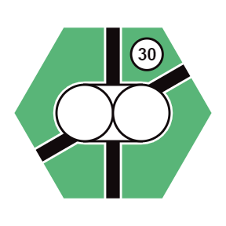 | 8 |  | 1 | 
4 |  | 6 | 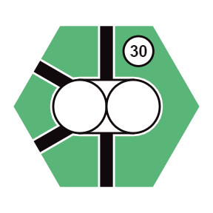 | 4 |  | 2 | 
4 | 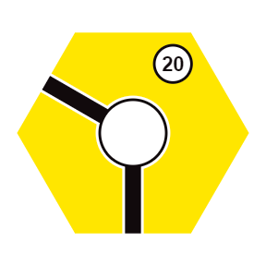 | 6 | 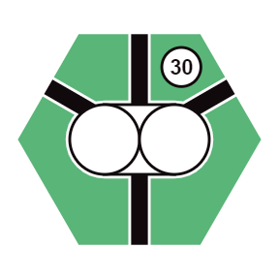 | 4 |  | 1 | 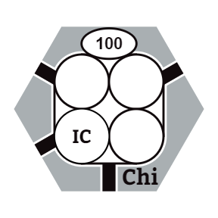
4 | 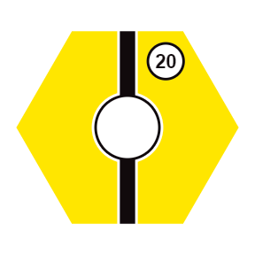 | 5 |  | 4 |  | 1 | 
5 |  | 5 |  | 1 | 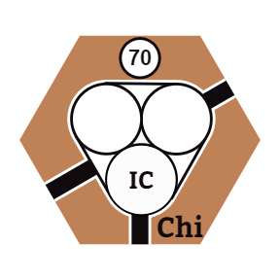 | 1 | 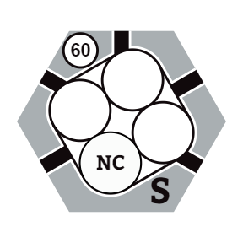
12 |  | 8 |  | 1 | 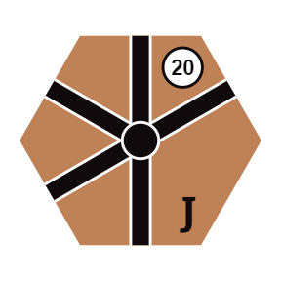
12 |  | 8 |  | 1 | 
2 | 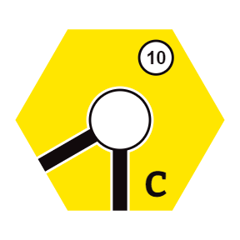 | 1 | 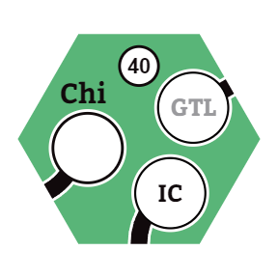 | 2 | 
2 | 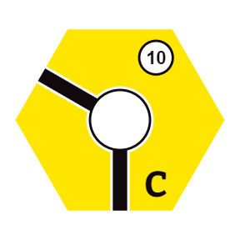 | 1 | 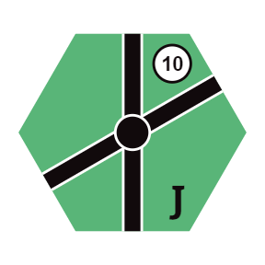 | 2 | 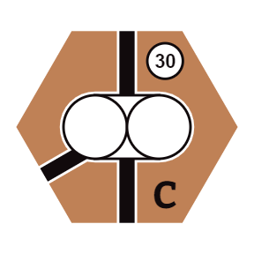
3 | 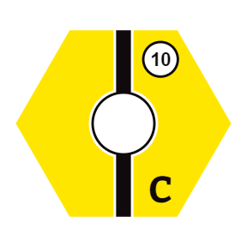 | 1 | 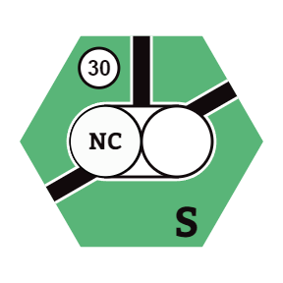 | 1 | 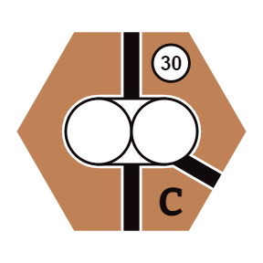
1 | 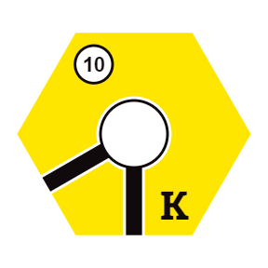 | 1 |  | 1 | 
1 | 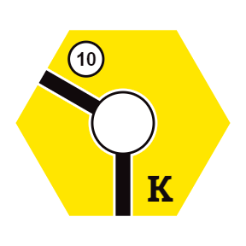 | 2 | 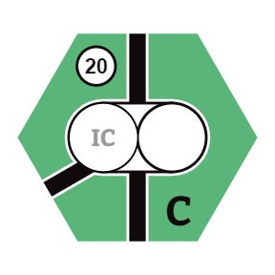
1 | 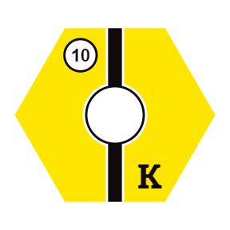 | 2 | 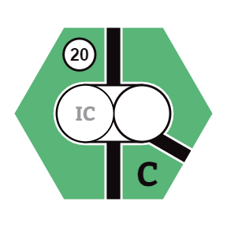
1 | 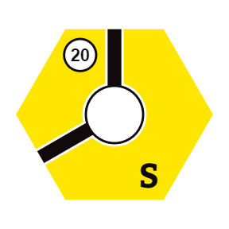 | 1 | 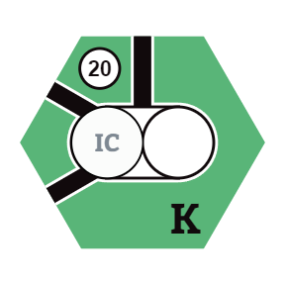
1 | 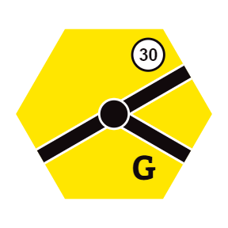 | 1 | 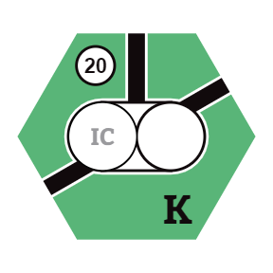

17. map


18. table of contents
1. introduction - 2 -
2. game components - 2 -
3. setting up the game - 2 -
4. overview - 3 -
4.1 the map - 3 -
4.2 the stock market - 3 -
4.3 player area - 3 -
5. the corporate entities - 3 -
5.1 private companies - 3 -
5.2 public corporations - 4 -
5.2.1 corporation ownership of private companies - 4 -
5.3 corporation president - 4 -
6. game phases - 5 -
7. auction pool formation - 6 -
8. auction rounds - 6 -
9. stock rounds - 6 -
9.1 sell share certificates - 6 -
9.2 buy a treasury or market share - 7 -
9.3 starting a corporation - 7 -
9.3.1 reopening a corporation - 7 -
9.4 certificate and share limits - 7 -
9.5 presidency changes - 7 -
9.6 station marker requirements - 8 -
9.7 end of stock round - 8 -
10. operating rounds - 8 -
10.1 routes - 8 -
10.1 convert - 9 -
10.1.1 convert a 2-share corporation - 9 -
10.1.2 convert a 5-share corporation - 9 -
10.2 issue a share - 9 -
10.3 lay and/or upgrade track - 9 -
10.3.1 laying yellow track - 10 -
10.3.2 upgrading track - 10 -
10.4 place a station marker - 10 -
10.4.1 st. louis station marker - 10 -
10.4.2 abandoned stations - 10 -
10.5 scrap trains / buy port marker - 11 -
10.6 run trains - 11 -
10.6.1 red areas - 11 -
10.6.2 the “rogers” train - 11 -
10.7 distribute earnings - 12 -
10.8 buy trains - 12 -
train roster - 13 -
10.9 emergency money raising - 13 -
10.10 end of operating round - 13 -
10.11 illinois central formation - 14 -
10.11.1 reorganization of private interests - 14 -
10.11.2 option cube exchange - 14 -
10.11.3 mergers - 14 -
10.11.4 share price adjustment and cleanup - 15 -
10.11.5 illinois central regulations - 15 -
10.11.6 illinois central receivership - 16 -
10.12 insolvency - 16 -
10.13 closing a corporation - 17 -
11. game end - 17 -
12. variants - 18 -
12.1 introductory game - 18 -
12.2 private draft variant - 18 -
12.3 full draft variant - 18 -
13. acknowledgements - 18 -
14. corporation histories - 19 -
15. rules summary for experienced players - 21 -
16. tile manifest - 22 -
17. map - 23 -
18. table of contents - 24 -

