CS 410 Exercise Assignment 1
Name:___Sean Coady__________

- If the user types “ls –a –l ” into the shell, what will argc’s value be? What will the C strings pointed to by argv contain, assuming the bottom of the array is 0? 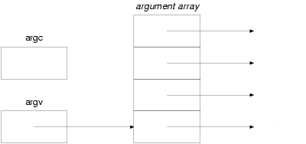

- The following program invokes the fork command. Assuming the child’s process id is 1000, what will the value of x and pid be of both the parent and child after the commands are executed?

Child tempPid: ____0___ x: ___1__________

Parent tempPid: __1000___ x: ___0___________

int x=0;
pid_t tempPid = fork();
if (tempPid==0)
{
x=1;
}

- Describe the differences among short-term, medium-term, and long-term scheduling.

- short term- selects jobs from memory, which are ready to execute, and allocated the CPU to them.
- medium term- used for time-sharing systems, a swapping technique is used to remove partially run programs from memory and then re-use them later where they stopped at before.
- long term- determines which jobs are put into memory to be processed.
- The main difference between all of these, is their frequency of use. Short term is selecting new jobs all the time, where long-term is used less often and usually has to wait a while before it selects other jobs to send into memory.

- What is the PCB and what’s it used for?

-PCB : Process Control Block
-It is used to keep track of the contents of the process while switching between processes.

- Label the memory segments:
From Top - Bottom:
- Stack
- Heap
- Data
- Text
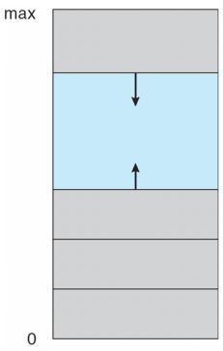

- Briefly describe each of the memory segments:

- Stack - contains the system stack; temporary storage. Simple Data Structure with a LIFO policy.
- Heap - pool of memory used to for dynamically allocated memory (malloc() )
- Data Segment - contains static data and variables that exist throughout runtime.
- Text (code) - contains the machine instructions for the program to run.

- Explain the difference between fork() and pthread_create(). What happens if you fork a process with multiple threads?

- processes spun off by fork() don’t share global variables, and must pass information through sockets/pipelines instead of using shared memory.
- threads created with pthread_create share all global variables - sharing that much information can lead to errors though.
- forking a process with multiple threads created a copy of the process, all of the memory associated with the process.

- What does pthread_join(pthread_t thread, void **value_ptr) do?
What could happen in a multithreaded application if the main thread exits using exit(0) without running pthread_join for each thread, assuming the OS is Linux?
- pthread_join( ) suspends execution of the calling thread until the target thread terminated, unless the target thread has already been terminated.
- If the main thread exits with exit(0), the other threads will not be merged back in to the main thread.
- Explain the difference between the many-to-one and the many-to-many multithreading models.

- In the many-to-one model, many user level threads are all put onto a single kthread. In the many-to-one model, you are not allowed to have individual processes split across multiple cores.
- The many-to-many model takes any number of user threads onto <= of kthreads. Users have no restrictions on number of threads created, and processes can be split across multiple cores.

10.) Explain and diagram the Consumer-Producer problem using shared memory. You do not need to provide source code.

- What is a blocking call? What is a non-blocking call?
- a blocking function call blocks the calling function. i.e. the caller can’t do anything until the blocking function returns control to it.
- a non-blocking call does not require the caller to wait until control is returned. They call the function and proceed to the next instruction.

- Which of the following components of a program state are shared across threads in a multithreaded process?
  - Register values
  - Heap memory x
  - Data memory x
  - Stack memory
  - Text memory

- The program shown below uses the Pthreads API. What would be the output from the program at LINE C and LINE P?

  - LINE C: CHILD: value = ________5________

  - LINE D: PARENT: value = ______0________

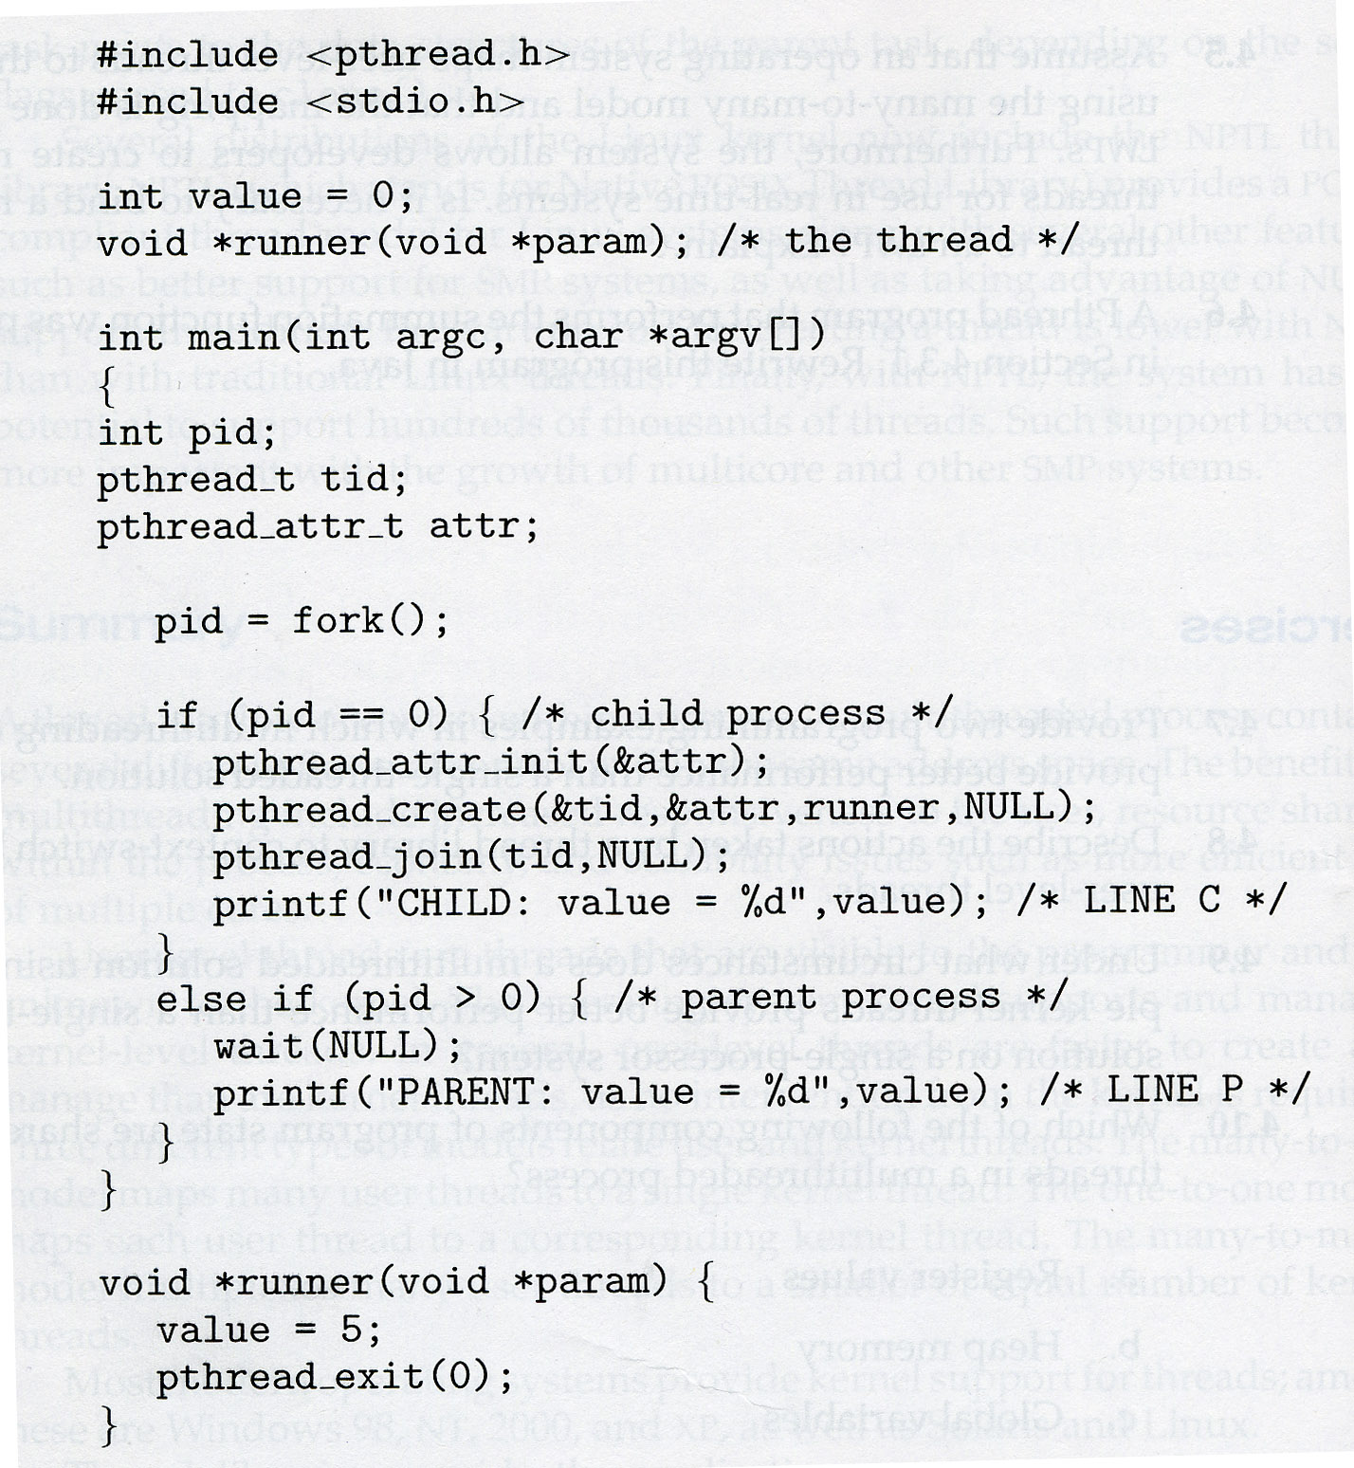

- Can a multithreaded solution using multiple user-level threads with one kernel thread achieve better performance on a multiprocessor system than on a single processor system? Explain. Assume this process is the only one running on the system.

- A multithreaded system with multiple user level threads can’t use different processors on a multiprocessor system at the same time. The OS won’t schedule different threads of the main process on separate cores. There is no performance benefit with executing multiple user level threads on a multi-core system.

- Draw a diagram drawing how the factorial of 16 (16!) can be accomplished by using multithreading.

