Sean Coady
10 September 2013
CS 420
Assignment 1
- Physical Address: 01-1c-42-01-29-b3
IPV4 Address: 10.211.55.4
a.) The MAC (physical) address belongs to the 2nd layer of the OSI model, the Data-Link Layer. The IPV4 address belongs to the 3rd layer of the OSI model, the Network Layer. An adapter needs two addresses because an IP address isn’t always a permanent number. The IP address will give an approximate location, but the MAC address will always be the same, so a network can be positive it is sending data to the right device.

- ping toolman.wiu.edu -l 64 -f* - I couldn’t get this command to work. Tried both on terminal (OS X), and on PuTTY (Windows VM) and both times the server returned an error that I couldn’t preload ping with a value more than 3.
- netstat -p tcp -n result: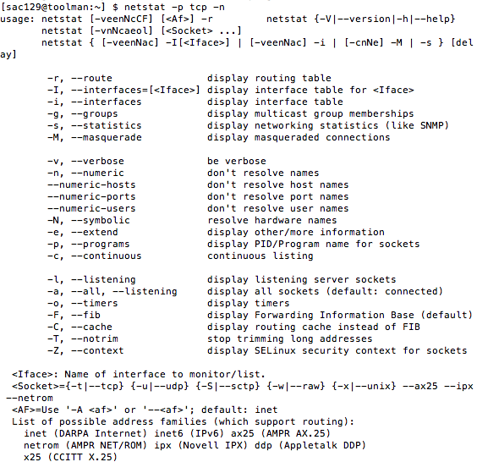
a.) What are the TCP port address of the SSH session that you created?
- Port address: 22 (SSH), the difference between this port and the IPv4 address I provided in question 1 is that the IPv4 number is my IP address.
R19. (a). Minimum throughput available is 500 kb/s
(b). 4 x 10^6 x 8 / (500 x 10^3) = 64s
P3 (a). A circuit-switched network. We already know what the transmission rate is, and it’s consistent, we can set aside bandwidth for each app session circuit without wasting much bandwidth.
(b). The network doesn’t need congestion control. Each link offers enough bandwidth to handle all of the application’s data, so no congestion will occur.
P24. One would want to use FedEx. 40 TB at 100mb/s would take over a month to fully transmit.
P31. (a). Time to send from source to first packet switch: 8 x 10^6 / 2x10^6 sec = 4 sec.
With store and forward switching, 4sec X 3hops = 12sec.
(b). Time to send first packet from source to first packet switch: 2x10^3/2x10^6 sec = 1ms.
2nd packet is received at the first switch: 2 x 1ms = 2ms
(c). Time which 1st packet received at destination: 1ms x 3hops = 3ms. After first packet reaches destination, every 1ms another will arrive, so... 3ms+3999*1ms = 4.002 sec

