**Information on Writing a White Paper[1] and Use of this Document**

**“A white paper is a persuasive essay that uses facts and logic to promote a certain product, service, or viewpoint**.”[2]

In this case you are promoting what you have done in your project. This means you have to report on your developed tool, technology, design or artefact. Remember **not** to write in the first person in any section of your report. The word count, not including references, appendices or diagram/figure/table legend should not exceed 7,000 words (±10%).

**How to use this form:**

This document is only a template. You **must** change the content under the headers and replace it with your own material. You may also create your own document, but make sure you adhere to the structure outlined in this document.

**Checklist before you submit your white paper:**

* Proof read your document and use the spell/grammar check and correct any mistakes
* Check the format, e.g. are any images, tables, diagrams legible etc.
* Check whether your white paper looks professional, e.g., you should probably use a font that looks professional, not something that looks like a handwritten font (or, indeed, an illegible font); there should not be large areas of white space but sufficient space to make the document look tidy; font and spacing are consistent etc.
* Make sure you refer to figures, tables and references in the body of the text. (see Appendix C for examples for the format of figures and tables)
* Include your signed Deliverables & Requirements sheet in an Appendix
* Include minutes of team meetings in an Appendix



**Smart Eco System - Future of Gardening**

Dorota Marczak, Scott Allan, Nader Sobhi

*CMP311: Professional Project Development & Delivery*

2018/2019

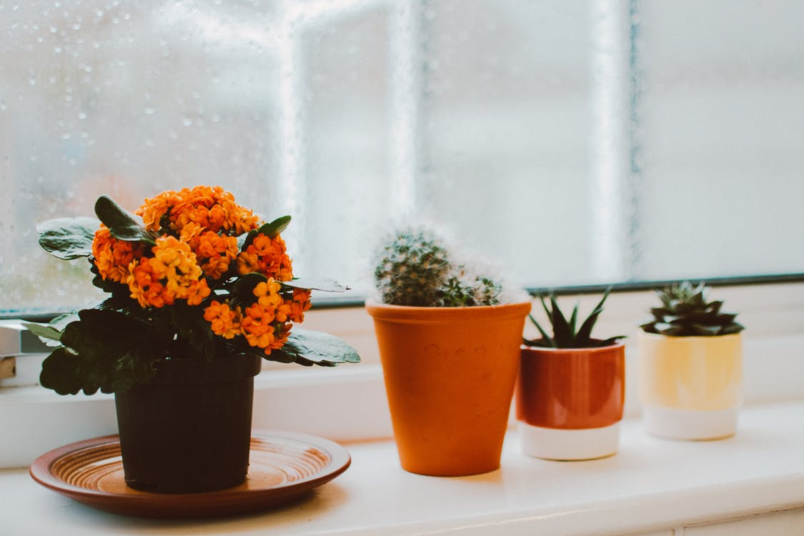

*Please note that Information contained in this document is for educational purposes.*

**Abstract**

**Background to the paper (brief and client) and aim of project**

With the advent of new technologies, which gradually revolutionized countless areas of human life many employers realized, that multiple activities may now be automated, or even performed remotely at relatively low costs. Amidst trending tech solutions such as 3D printing and wireless conference rooms there is one inconspicuous, yet very powerful tool. Internet of Things, concept that emerged barely a decade ago, turned out to be a blessing especially for small companies, which constantly compete for shares on the market while having a quite limited budget and human resources. Simple activities, which do not require advanced knowledge or complex operations, performed with users consent and according to their instructions – IoT technology can be used for a variety of tasks.

Dr Lynsay Shepherd, representing Abertay Plant Systems, decided to take advantage of the opportunities created and ask the local tech start-up - DNS Team – to design and develop a plant monitoring system utilizing above-mentioned technology, as well as similar web based solutions. The client stressed, that the company expects a device that could be used by anyone; not only to appeal to their existing customer base but also to “tech obsessed Millennials who care about the environment but don’t keep any plants in their home”. The idea to merge contemporary technology with the age old art of plant keeping was perceived by DNS team as a unique challenge and that is also how it was implemented.

The aim of the project, settled after closer familiarization with provided brief, was to provide an easy to use system that required no expert knowledge to operate and maintain – ideally a ‘plug and play’ device that would begin operation as soon as the end user registered the device on the companion website. Once registered, the device would start to collect data which would then be displayed via the website, as well as via a built in LCD screen. The user could then use this data to ascertain if their plant was growing in the optimal conditions .

**Methodology**

In order to deliver high-quality product within settled time, development of the hardware system and the website was conducted concurrently, which minimized the risk of a potential delay. Team members has been assigned to certain tasks according to their strengths, which facilitated breaking the work down using the Sprint methodology on a later stage. Following Scrum methodology allowed to set clear goals over the course of the development, meaning team leader could track the progress over time. Regular meetings (see *minutes*) were held to ensure the project proceeded as planned, the workload was distributed fairly and finally, that all team members have a chance to air any problems they may have faced with a certain task.

Ready to use product consists of three main elements: Arduino board, connected to a network of sensors and Wemos, database storing the readings, as well as the website, that provides constant control over wellbeing of the plants’ collection. The physical device processes the data received from the attached sensors and sends them in JSON format to the database via Wi-Fi connection, provided by Wemos adapter. The data hold in normalized form are then accessed by the website, that utilizes them to create intuitive data visualizations.

**Outcome**

Professional attitude of each team member to their entrusted tasks resulted in delivering high-quality product a few weeks before settled deadline, what may turn out to be highly beneficial for client’s business and its growth. Smart Eco System, as a user-friendly and visually attractive interface providing reliable information about plant’s conditions and its needs (based on individual settings) has a chance to become a bestseller in the gardening market, which has not fully experienced technological revolution yet. This fact, in turn, may bring common attention of gardeners devoted to their plants and ipso facto originate a mode for smart gardening devices.

This section should be an **attention grabber**. It should provide a short summary of what your paper is about so provide enough detail to satisfy your client that you met his/her needs and allows the reader to decide if the report is of interest. This is stand alone and should not refer to any other part of the document. You should include 3 short sections: (600words) 3.What you found and what you conclude from your findings (not too much detail but enough to show that your project is clearly wonderful).

Contents

1 Introduction 5

1.1 Background 5

1.2 Aim 5

2 Procedure 6

2.1 Overview of Procedure 6

2.2 Procedure part 1 6

3 Results 7

3.1 Results for part 1 7

4 Discussion 8

4.1 General Discussion 8

4.2 Countermeasures (for a project in ethical hacking) 8

4.3 Conclusions 8

4.4 Future Work 8

4.5 Call to action 8

References 9

Appendices 11

Appendix A - Example 11

Appendix B - Example 11

Appendix C - Suggestions for formatting figures/tables/screenshots in the body of the text 11

Appendix D - Deliverables & requirements 13

Appendix E - Minutes 15

Appendix F – Other 16

# Introduction

## Background

Here, you need to ‘hook in’ your audience. This section introduces the report, i.e. sets out what the report is all about. Provide the background to the work and the brief - define the context and critical issue of your project and provide a generic discussion to build up the credibility of your product. Consider, for example, why it is important to do this work.

Identify the ‘business problem’ your technology/code/design solves. Make sure that you write in a way that entirely addresses the problem **from the perspective of the target audience.** Write in the **Present Tense**.

* Provide a background into the subject area.
* Introduce what the technology/design/etc. is – definition? What it does?
* Problems with the technology? Describe the problems in the area that you will be trying to solve. What are the technology/designs/tools out there that could do the job, but can’t cut the mustard – provide reasons for this. Naturally, whatever you do is so much better than anything else – make a case for it.
* Support your arguments with facts and figures, press quotes etc.
* Graphs illustrating the problem are good in here too.
* **Do not include any of your work or findings at this stage of the report, remember it is an** **introduction to the problem**.
* Use references to back up your work (see end of document for examples); you can also use references for all the following section where appropriate, e.g., to justify your procedure or to relate to novel developments in your discussion. References in the body of the text typically follow the format: Author (year), or (Author, year), for example: “Smith (2019) found that…” or “Others found that …. (Smith, 2019)”; in case of several authors or papers, other examples are “Smith *et al.* (2010) found that or “Others found that… (Smith, 2018, 2010; Miller, 2010)”.

## Aim

State the aims and objectives of this project.

* Be general for the high-level aim and specific regarding the objectives.
* Clearly state the **objective(s)** of the work you did. What did you expect **to** **do** in this project that enables you to meet the aim?

The fundamental high-level aim of Smart Eco System project was to create an IoT device, that would collect the environmental data on a plant and place them into a database. Obtained readings would then be used by a web interface to notify the user about their plant’s current health by displaying sensors data (or their averages) in the form of clear and visually-attractive graphs. Correctly implemented, the system would give the user means to control the plants as precisely and meticulously as if they were placed in a scientific laboratory. Regarding an experienced gardener, such an opportunity could become the beginning of the plant growth optimizations, what could potentially save their time and money.

First step taken towards designing the successful system would be creating an extensive list of functional and non-functional requirements, defined based on the brief provided by Product Owner and then making necessary corrections wherever inaccuracies or misunderstandings were identified.

Each requirement was seen as an objective that needed to be completed to achieve the final product. Some objective outlined in this section however did not have any direct relation to these requirements but rather were derived or assumed from the work that was done.

General Objectives of project:

* Create a website that houses all the tools needed to monitor a plants health based on collected data
* Develop a device that collects data on the plants health and potentially react to this data input
* Create and manage a database that holds the data on devices and separates the data based on type and device

Work that was completed not directly related to the requirements:

* Connect the wemos and the Arduino and allow for communication between the devices
* Place and align the elements of the website in such away that they look presentable to a client
* Install and use plugins that allow the developer to create graphs of the data

Functional Requirements:

* Wemos device connects to the database
* Gather data on plants (Temperature, Light, Moisture, Humidity)
* Put this Data into a database
* Present the data in a graphical manner on website
* Feature in place on website to register device
* Feature in place for users to register
* Feature in place for users to login
* Require device-account registration
* Require registering on the website before utilizing any of the services
* Require login on the website before allowing the viewing of data
* Present current status on device itself
* Section of website accessible to all users with information on the Clients company
* Section of website accessible to all users with information on the functionality of the device
* Section of website accessible to all users with information on the system as a whole
* Section of website accessible to all users with contact information of the clients company
* The website will give users the option to select the time period they want to view the data on (such as a month, week, day)
* Email user when status of plant is low in any of the measurements
* Website must be responsive
* Users should be able to clear data pertaining to them

Non-Functional Requirements:

* Website should be accessible to all users
* Website and database should be able to be scalable to user size
* Device should be easy to setup for users
* Device should be able to be produced on a commercial scale
* Website should be user friendly
* Device should be reliable in terms of data handling and performance
* System as a whole should be available with as little interruption as possible
* Website should be easily maintainable after it is delivered to the user
* Websites login and register features should be secure to malicious attacks or tampering
* Data collected and stored in a manner that is compliant with the relevant laws of the region of operation
* The data’s integrity should be preserved throughout its life-cycle
* Database should be secure and non-accessible to users
* Device has some functionality in place to ensure that data loss is minimal

# Procedure

## Overview of Procedure

In the previous section you have explained the problem in detail. Now describe how you solved it in detail. Consider why your solution is so much better than anybody else’s. From now on use **Past Tense**.

* There should not be too much detail since you are aiming at a **technical user** (i.e. a fellow student).
* If you are using software, web designs prototypes etc. then screenshots of important features should be included here – with descriptions. If it is a hardware project then pictures / diagrams should be included here. These should be clearly labelled (for example “Figure 1 list of wireless LANS”) and referenced in the text. For example “see Figure 1 for an example of the results at this stage in the project”
* There should be **no analysis** of the results at this stage. This will be looked at in the discussion.
* Note that a reader should be able to re-create your work from this description. When you write this section, keep this in mind.

## Procedure part 1

* Use as many sub-headings in the Procedure as you think are necessary

# Results

Put your results in here. Any tables or results should be included here unless there is a large amount of data. Appendices should be used for large amounts of data and referenced in the text. Only important details should be included in this section, i.e. material that convinces your client about the (hopefully fantastic) performance of your design/tool/etc. Consider what is important here to make your project look good.

## Results for part 1

* Include results for part 1
* Use as many sub-headings as necessary.

# Discussion

## General Discussion

Here, you want to discuss your results/outcomes.

* What does it all mean? Discuss anything of interest. How do findings relate to other work in this area?

* Relate the findings back to your aims - **how well have you met your aim**? Consider performance indicators.
* Discuss, for example, return on investment (ROI), usability, adherence to standards, speed of implementation, exploits found etc. Ensure that you make clear you understand your client’s pain and can relieve it.

## Countermeasures (for a project in ethical hacking)

* You may wish to discuss countermeasures if this is appropriate, or describe any future work that could be undertaken based on your project (you can skip section 4.4 Future Work in this case).

## Conclusions

* Provide a brief summary of the benefits of your solution for the client and what would happen if they did not use it.
* Any conclusions that you have should be short and “to the point”. Finish with the most important points you want the client to remember.
* Write this part as if it were a **standalone document, i.e. imagine your clients would only read this part** - list your most important selling points.

## Future Work

* What would you do if given more time and resources?

## Call to action

* ‘Wet’ your client’s appetite to use your product, e.g., what could you do for them for free? E.g. free trial version, training etc.
* Provide contact information or a url that they can use to get in contact with you for further information (you can make this up for the purpose of this assessment).

# References

**For URLs, Blogs:**

Bremer, J. 2012. *x86 API Hooking Demystified*. [blog]. 2 July. Available from: [http://jbremer.org/x86http://jbremer.org/x86-api-hooking-demystified/api-hooking-demystified/](http://jbremer.org/x86-api-hooking-demystified/) [Accessed 15 April 2016].

**Ours:**

**https://www.smallbusinesscomputing.com/News/Networking/what-the-internet-of-things-means-for-small-business.html**

**For Books:**

Dahl, R., 2004. *Charlie and the chocolate factory*. 6th ed. New York: Knopf.

**For Citations in Books:**

Desikan, S. and Ramesh, G., 2006. *Software testing*. Bangalore, India: Dorling Kindersley, p.156.

**For Chapters in Books:**

Bressler, L., 2010. My girl, Kylie. In: L. Matheson, ed., *The Dogs That We Love*, 1st ed. Boston: Jacobson Ltd., pp. 78-92.

**For Journals:**

Ross, N., 2015. On Truth Content and False Consciousness in Adorno’s Aesthetic Theory. Philosophy Today, 59(2), pp. 269-290.

**For Journals Accessed via a Database/Website:**

Raina, S., 2015. Establishing Correlation Between Genetics and Nonresponse. *Journal of Postgraduate Medicine*, [online] Volume 61(2), p. 148. Available at: http://www.proquest.com/products-services/ProQuest-Research-Library.html [Accessed 8 Apr. 2015].

For other examples see: <http://libweb.anglia.ac.uk/referencing/harvard.htm>

# Appendices

## Appendix A - Example

Put any large amounts of data here (e.g. code).

**Hello.Php**

<html>

<head>

<title>PHP Test</title>

</head>

<body>

<p>Hello World</p>

</body>

</html>

## Appendix B - Example

And here….

## Appendix C - Suggestions for formatting figures/tables/screenshots in the body of the text

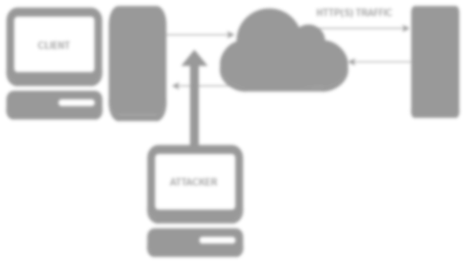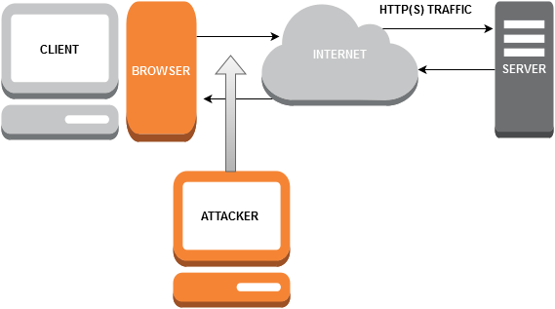

**Figure 1-1** A diagram of the system that was used in the security test.

**Table 1-1** Advantages of the X versus Y

|  |  |
| --- | --- |
| **Advantage Description** | |
| **1** | Can be programmed easier. |
| **2** | More flexible that the traditional system. |
| **3** | More secure than the traditional setup. |

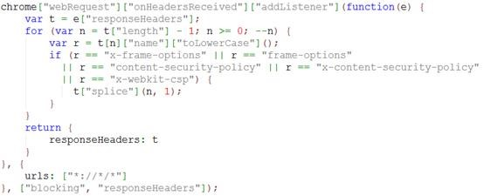

**Figure 1-1** Snippets of code can be formatted like this.

## Appendix D - Deliverables & requirements

**Agreement Form: Project Deliverables**

|  |  |
| --- | --- |
| **Group Number, Names of Team Members, and Programme** |  |
| **Programme specialist’s Name** |  |
| **The deliverables listed below will be submitted by the team by the due date.** | |
| **Part A deliverables** | **To be agreed by programme specialist and team, for example:**   * Executable code/investigation report * User/reference manual |
|  | * Requirements Specification, signed off by the programme specialist (see overleaf) * Software Design specification or investigation methodology * Testing * …. |
| **Programme specialist’s signature** |  |
| **Team members’ signatures** |  |

**Agreement Form: Requirements**

Group Number:

Team members (print):

Project Title:

Please refer to the attached documentation for full details on the project. The requirements are listed in Table 1. The signatures below indicate that the requirements for this project have been agreed by the project stakeholders.

Any changes to the project documentation should be made using the correct change authorisation procedure agreed with the programme specialist.

Table 1

|  |  |
| --- | --- |
| **ID** | **List of Agreed Requirements (fill in)** |
|  |  |

|  |  |  |
| --- | --- | --- |
| **Stakeholders** | **Signatures** | **Date** |
| Team members |  |  |
| Programme Specialist |  |  |
| Client (if applicable) |  |  |

## Appendix E - Minutes

This section should contain **detailed** minutes of meetings.

This should comprise:

• Date, time and venue of the meeting

• Who is present

• Any absences and apologies for absences received

• Approval or amendments of previous minutes if available (review)

• A description of what is discussed and agreed upon (or not) in the current meeting

• Any challenges flagged up (in the team) and how were they addressed

• Actions for next meeting

• Date, time and venue for next meeting

There should also be a brief section on the atmosphere/challenges within the team, how team dynamics were addressed etc.

## Appendix F – Other

1. Document prepared and revised by Natalie Coull, Colin McLean, Andrea Szymkowiak
2. Graham, G., 2005. *The White Paper FAQ (Frequently Asked Questions)/That White Paper Guy – Gordon Graham*. [online] Available at < <https://www.thatwhitepaperguy.com/white-paper-faq-frequently-asked-questions/#what_is>> [Accessed 9 May 2016].