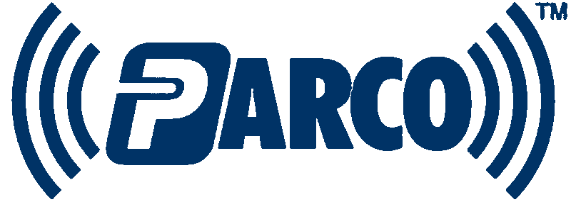

Parco RTLS™ Messaging

Overview

The Parco system passes xml messages between system level programs via the TCP/IP protocol. 3rd Party applications (SDK clients) can receive data from a published Parco system resource. In the context of the Parco system, a resource is defined as a program running at a particular TCP/IP address and port which supplies real time Parco streaming location data. Resources may be found by querying the RTLS database for the type of resource that you need.

From the 3rd party application point of view, resources are available in two flavors: full stream and subscription. Full stream resources relay all received data back out to all connected SDK clients. Subscription resources relay only the data that is subscribed to by the SDK client. The Parco messaging system is built into the RTLS SDK. Because the messaging and rules are built into the SDK, the developer only needs to create business objects and respond to events raised by the SDK. Accessing a resource without using the SDK is possible providing that you know what the messaging requirements are in order to communicate with a given resource. Full stream resources are intended for use in services. Subscription resources may be used by client applications and services. Full stream resources may overload client applications as the tag count increases.

Important Considerations: Parco reserves the right to change out internal messaging format at any time. The current message format is XML based. Parco will be implementing a non XML based message format in the very near future. Reducing the message weight will increase system performance and reduce network traffic. The messaging changes will not affect your code unless you choose to interact with the socket stream directly. Code using our SDK Datastream class will be transparent when these changes are implemented – i.e. no changes required.

Message Definitions
Parco Request Message
The messaging system relies on a request/response paradigm. To establish a connection, you must connect to the SDK server via a TCP/IP socket. A request message must be sent to the SDK server. Figure 1 is an example of the request message format. XML messages are case sensitive and are required to be UTF-8 encoded.

Figure 1.
Request Message
<?xml version="1.0" encoding="utf-8" ?>
<parco version="1.0">
<type>request</type>
<request>BgnStrm/EndStrm/AddDvc/RemDvc</request>
<reqid>yourID</reqid>
<params>
<deviceid data="true">XXXX</deviceid>
<deviceid data="false">12345</deviceid>
</params></parco>

Each request message is processed and a corresponding response message is returned to the requester. If you do not receive a response message you must assume that the request was not received. The response message’s <reqid> tag contains the senders request id and <request> tag contains original request tag value. If the <msg> tag is empty, your request was valid for the resource and the available data will be sent. If the resource could not process your request, the <msg> tag will include the reason why your request was not granted.

Figure 2.
Response Message
<?xml version="1.0" encoding="utf-8" ?>
<parco version="1.0">
<type>response</type>
<request>BgnStrm/EndStrm/AddDvc/RemDvc</request>
<reqid>yourID</reqid>
<msg>Any Error is here</msg>
</parco>

Parco GIS Data Message
Parco Tag data is delivered by a standard Data message. The <type> tag indicates what type of data is present and may be anything. The current values are listed below and may change in the future. The <gis> tag contains the tag and geo-location data.

Tag descriptions:
<id> the Tag id
<ts> the timestamp of the data in UTC.
<gwid> the originating gateway of the data (hub or Precis Location engine)
<cnf> the confidence factor of the x/y/z data.
<x>, <y>, and <z> are the positional coordinates
<bat> is the battery indicator, value 0 through 15 where a value of 15 indicates fully charged.
<data> deprecated tag and will not be used.
<type> is the data type an may be any value. The current values are:
L: 2-D calculation valid for X and Y with a fixed Z for the area.
H: 2-D estimated calculation for X and Y with a fixed Z for the area. The X-Y point is on the line between the two receivers. The actual location of the tag is on a hyperboloid intersecting the point.
R: 3-D calculation valid for X,Y, and Z (Multispectral Hardware)
T: 2-D calculation valid for X, and Y. Z will be the Z location for the hub (Multispectral Hardware)
O: 2-D estimated calculation for X and Y, Z will be the Z location for the hub. (Multispectral Hardware)
P: Presence indicator with X, Y, and Z as location of the receiver that saw the tag.
Sim: Data from the Parco Data Simulator.

Figure 3.
Data Message
<?xml version="1.0" encoding="utf-8" ?>
<parco version="1.0">
<type>L/H/R/T/O/P/Sim/anything</type>
<gis>
<id>1234aeb</id>
<ts>07/07/2003 10:35:27.45 PM</ts>
<gwid>25x</gwid>
<cnf>234</cnf>
<x>23.2</x>
<y>34.2</y>
<z>12.1</z>
<bat>15</bat>
</gis>
<data>any data here</data>
</parco>

Parco Heartbeat Message

The Parco Heartbeat message is sent out by server connections on Parco system services. All TCP/IP client connections must listen for heartbeat messages and relay them immediately back to the sender. The ticks tag contains the Microsoft ticks property for the origination UTC date and time. Clients not responding to heartbeats in a timely manner will be disconnected from the service.

Figure 4
Heartbeat Message
<?xml version="1.0" encoding="utf-8" ?>
<parco version="1.0">
<type>HeartBeat</type>
<ts>ticks</ts>
</parco>

Connecting To Resources

Full stream resources supply all incoming data to the SDK client. A resource receiving 20,000 tags per second will relay 20,000 tags per second to your application. Likewise, if the resource is not receiving data, your application will not receive data.

To connect to a Full Stream resource:
- Create a request message with these tag values:
<type>request</type>
<request>BgnStrm</request>
<reqid>AUniqueValue</reqid>

- The <params> tag should be empty as full stream resources do not look for device subscriptions.
- Connect to the SDK server on the published TCP/IP address and port.
- Send the request message via the TCP socket.
- Wait for the response message. If you do not receive a response message you should assume that the request was not received.
- Check the response message for an error message. A message will be present if the resource can not process your request. If there is not an error message, data will be arriving shortly.
- When you are done receiving data, create and send a request message with these values to the resource.
<type>request</type>
<request>EndStrm</request>
<request>yourId</request>

- The resource will send a response message and then disconnect your socket.

To connect to a Subscription resource:
- Create a request message with these tag values:
<type>request</type>
<request>BgnStrm</request>
<reqid> yourId</reqid>

- Add at least 1 tag id to the params tag. The tag id you wish to subscribe to goes in the deviceid tag. If you wish to also receive transmitted device data, set the data attribute to true. Device data is not currently available, but is included for future use.
<deviceid data="true">256</deviceid>

- Connect to the SDK server on the published address and port.
- Send the request message via the TCP socket.
- Wait for the response message. If you do not receive a response message you should assume that the request was not received.
- To add a device to your subscription, send an AddDvc request message with one or more devices in the params tag.
- Wait for the response message. If your request was processed, the msg tag will be empty.
- To remove a device from your subscription, send a RmvDvc request message with one or more devices to remove.
- Wait for the response message. If your request was processed, the msg tag will be empty.
- If your device subscription count drops to 0 at any time, the resource will send you a response message and disconnect your socket.
- When you are done receiving data, send an EndStrm message to the resource.
- The resource will send a response message and then disconnect your socket.

Resources can handle forcible disconnects. Parco considers this practice to be inappropriate. For your application to be Parco Certified, You should always close your connections by sending an Endstream request message, receiving the response message, and letting the SDK server close your socket.

