**Philosophy Club**

**Meeting**

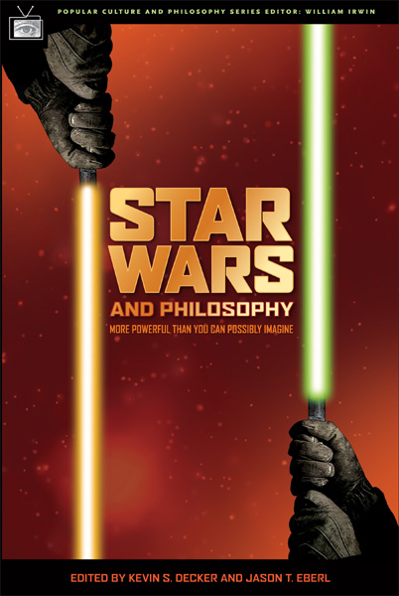

**Jedi or Sith where do you stand?**

**September 22nd 3-4pm**

**Hepburn Hall 220**