|  |  |
| --- | --- |
| **Course-** MCA, 2-0-2 | **Type-** Specialization Elective |
| **Course Code-** MCA 580, CSET 580 | **Course Name-** Big Data Analytics and Business Intelligence |
| **Year-** 2024 | **Semester**- Odd |
| **Hackathon Date-** 27-28 November 2024 | **Batch**- 2024-2026 |

**Students Name: Suryansh Singh “S24MCAG0050”**

**Problem Statement**

**“Demand Forecasting for Retail Store”**

**Introduction**

Managing inventory in retail has always been a tricky balancing act. Retailers need to make sure they have enough stock to meet customer demands without overstocking and wasting resources. In today’s competitive and fast-paced environment, making these decisions based on instinct alone is no longer enough. This is where demand forecasting comes in—a powerful tool that helps predict future sales, enabling businesses to plan smarter and operate more efficiently.

This project explores the use of machine learning to improve demand forecasting for retail stores. The goal is to analyze historical sales data and build models that can predict future demand with high accuracy. To handle the complexity and volume of retail data, PySpark is used for its ability to process large datasets quickly and efficiently. Five different machine learning models are tested in this project: Linear Regression, Random Forest, Gradient-Boosted Trees (GBT), Decision Tree, and Isotonic Regression.

The accuracy of these models is evaluated using several performance metrics, including RMSE (Root Mean Square Error), MAE (Mean Absolute Error), R-squared, Accuracy, Precision, Recall, F1-Score, ROC, and AUC. By comparing these metrics, the project aims to identify the most reliable model for forecasting demand. The results are also visualized through charts and graphs, making it easier to interpret and understand the outcomes.

The broader aim of this project is to showcase how machine learning can transform decision-making in retail. With better forecasting, businesses can reduce waste, meet customer expectations, and improve profitability. This project is not just about building models—it’s about demonstrating how data-driven insights can help businesses thrive in a competitive market.

**Objectives**

The goal of this project is to build a system that helps retail stores predict future demand based on past sales data, using the power of machine learning. By doing so, the project aims to improve how retailers manage their inventory and plan for future sales, ultimately making their operations more efficient.

**Here’s a breakdown of the key objectives:**

**Creating and Comparing Models**: The project will use several machine learning models, including Linear Regression, Random Forest, Gradient-Boosted Trees, Decision Tree, and Isotonic Regression, to predict sales. We will compare the performance of these models to find out which one is most accurate and reliable for demand forecasting.

**Measuring Performance**: After training the models, we will evaluate how well they predict sales. We’ll use a range of metrics, such as RMSE, MAE, R-squared, as well as others like Accuracy, Precision, Recall, F1-Score, ROC, and AUC, to get a complete picture of how each model performs.

**Scalability and Efficiency**: The project will use PySpark, which is designed for big data processing. This will ensure that our solution can handle large amounts of data, something that would be essential for real-world retail businesses that have lots of sales data to work with.

**Delivering Insights**: We will present the results in a way that is easy to understand, using visualizations like charts and graphs. This will make it simple for retailers to see how the models are performing and use those insights to make smarter decisions about inventory management.

**Real-World Impact**: At the heart of this project is the idea that machine learning can help businesses operate more efficiently. By accurately predicting demand, retailers can avoid problems like overstocking or stock outs, leading to reduced costs, better customer satisfaction, and higher profits.

The overall aim of the project is to show how the application of advanced technology like machine learning can directly benefit retail businesses, helping them work smarter, not harder.

1. **Tables Hardware/Software/ Technique Used**

|  |  |
| --- | --- |
| **Criteria** | **Details** |
| Hardware Configuration | AMD Ryzen5, 16GB RAM, 250GB SSD, NVIDIA GTX 1050, Windows 10 Pro. |
| Software Configuration | Windows 10 Python 3.8+, Jupiter Notebook, Apache Spark 3.2 |
| Big Data Tools Used with Version | Apache Spark 3.2, PySpark 3.2. |
| Python Library Used | PySpark 3.2, Pandas 1.2.4, Matplotlib 3.4.2, Seaborne 0.11.1, Scikit-learn 0.24.2, NumPy 1.20.3, SciPy 1.6.3. |
| PowerBI Visualization Version | Colab Google Notebook |
| Any other tools, libraries used | Jupiter Notebook 6.2.0, Git 2.3 |

1. **Implementation Methodology along with Flowchart :**

**+-----------------------+**

**| Data Collection |**

**| (Historical Sales Data)|**

**+-----------------------+**

**|**

**V**

**+-------------------------+**

**| Data Preprocessing |**

**| (Cleaning, Feature Eng., |**

**| Scaling & Normalizing)|**

**+-------------------------+**

**|**

**V**

**+-------------------------+**

**| Model Training |**

**| (Linear Regression, |**

**| Random Forest, GBT, |**

**| Decision Tree, Isotonic)|**

**+-------------------------+**

**|**

**V**

**+-------------------------+**

**| Model Evaluation |**

**| (RMSE, MAE, R2, MAPE, |**

**| Accuracy) |**

**+-------------------------+**

**|**

**V**

**+-------------------------+**

**| Model Prediction |**

**| (Sales Prediction) |**

**+-------------------------+**

**|**

**V**

**+-------------------------+**

**| Visualization |**

**| (Matplotlib, Power BI) |**

**+-------------------------+**

**|**

**V**

**+-------------------------+**

**| Model Deployment |**

**+-------------------------+**

**Explanation of the Flowchart**

1. Data Collection: The first step involves gathering historical data from the retail store, which could include sales, product, and store-related information.
2. Data Preprocessing: Raw data is cleaned, missing values are handled, and additional features are engineered to aid model training.
3. Model Training: Different regression models are trained using the preprocessed data. These models include Linear Regression, Random Forest, Gradient Boosting Trees, Decision Trees, and Isotonic Regression.
4. Model Evaluation: Each model's performance is evaluated based on several metrics like RMSE, MAE, R2, and MAPE.
5. Prediction: The best-performing model is used to predict future sales, based on which business decisions can be made.
6. Visualization: The results of the predictions and evaluation metrics are visualized using Matplotlib and Power BI for easy interpretation.
7. Model Deployment: The final model is deployed for real-world usage, where it can continuously predict sales with incoming data.
8. **Paste your Running Source Code at the end of the report.**

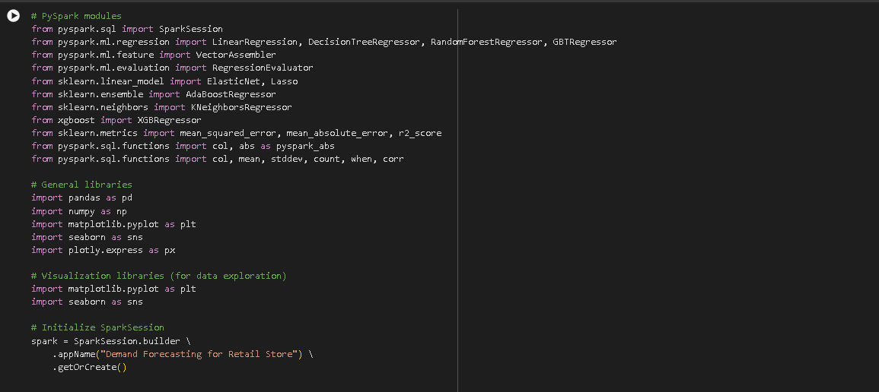

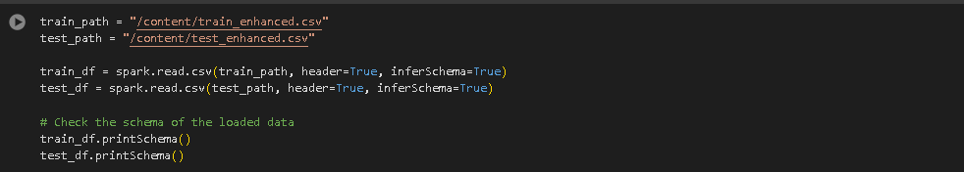





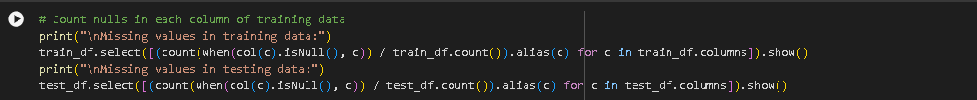

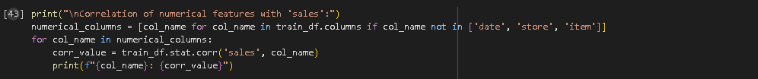

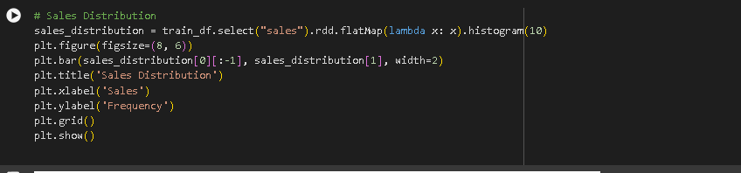

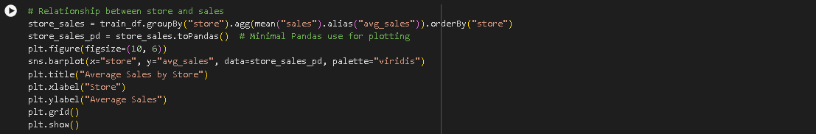

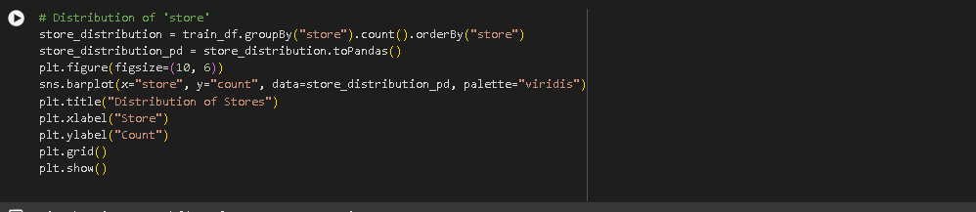

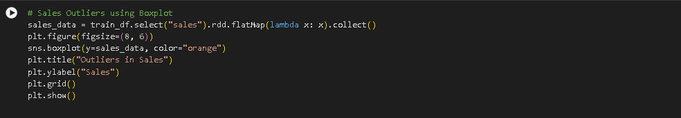

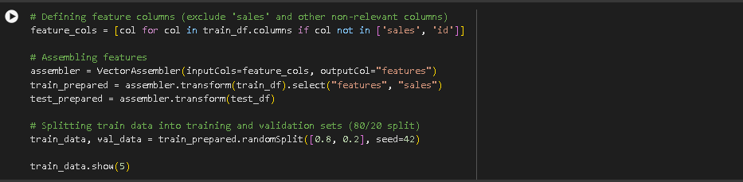

**MODEL:**

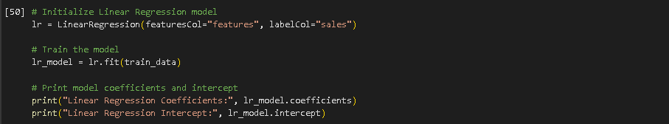

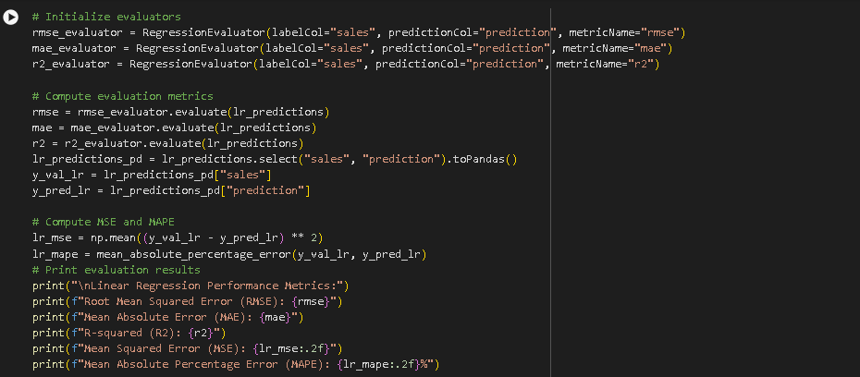

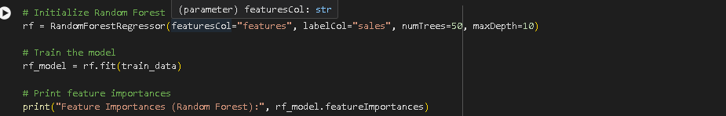

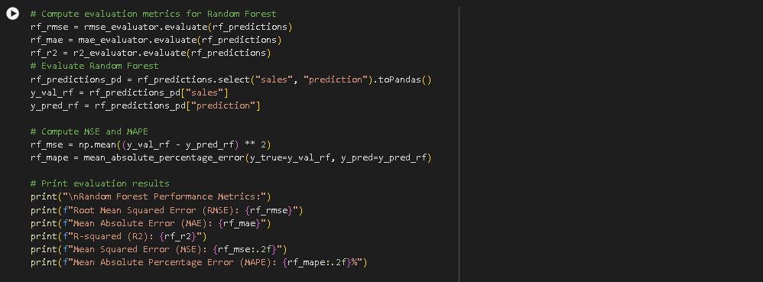

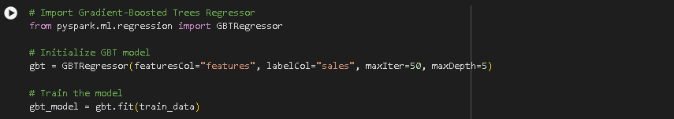

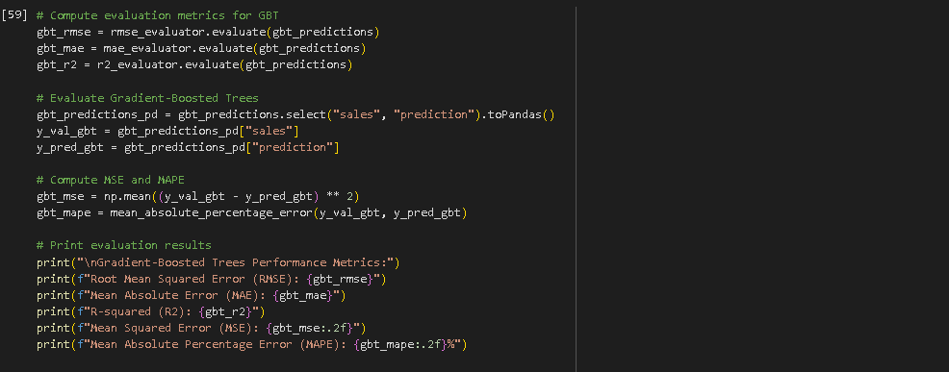

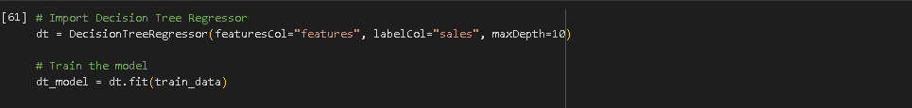

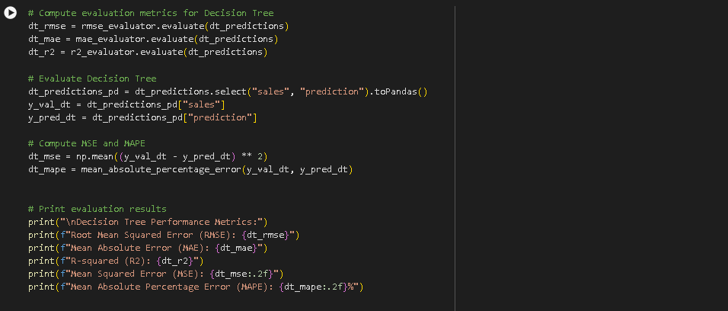

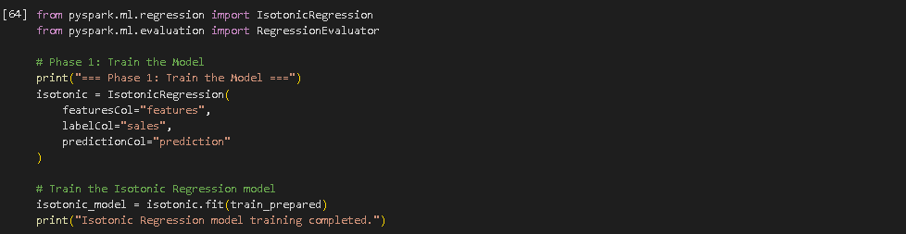

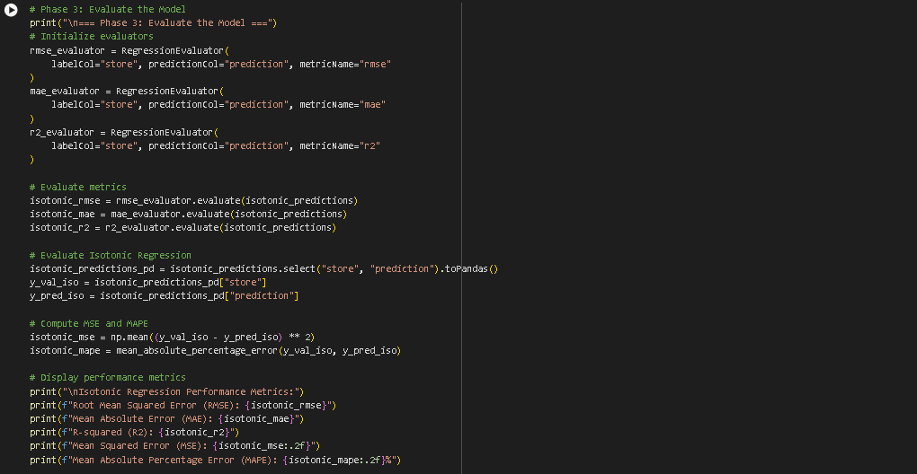

**Results Description with Screenshot:**

1. **Visualization :**

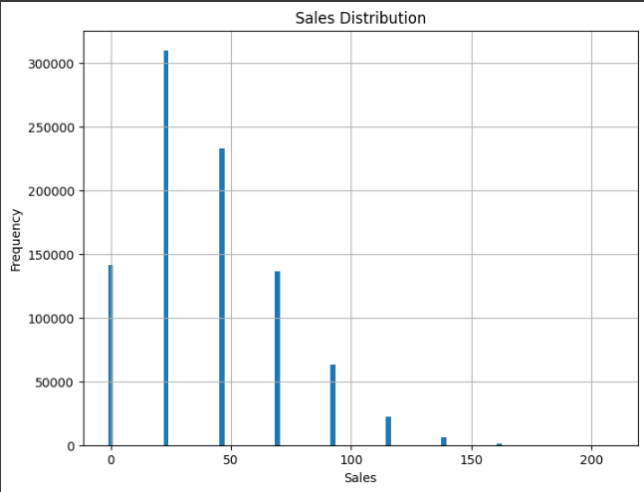

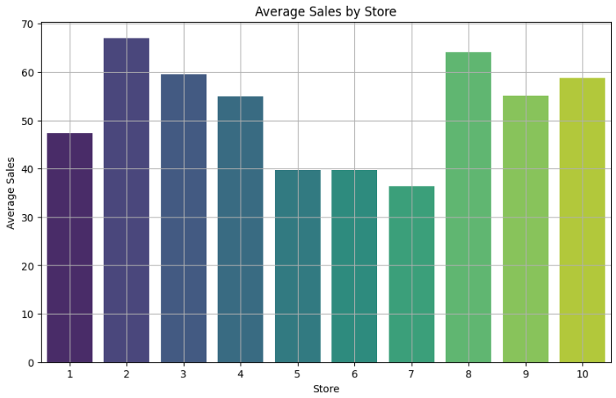

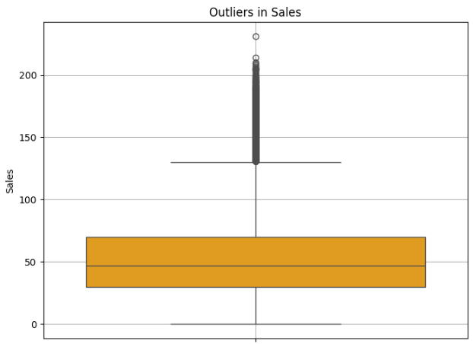

1. **Prediction :**

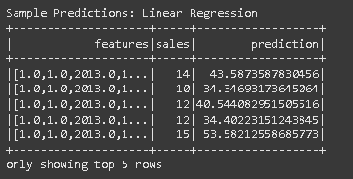

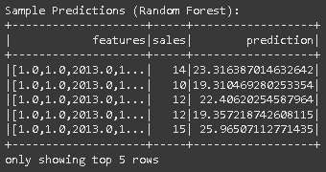

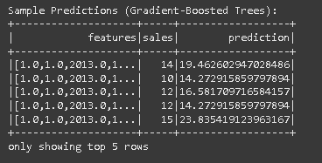

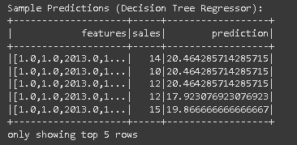

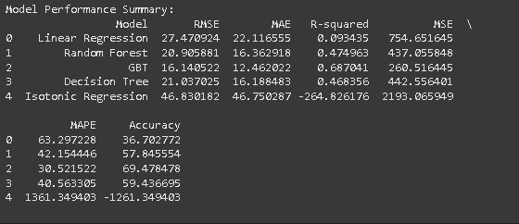

1. **Comparative Analysis of PYSPARK ML Models**

**Table 1- PYSPARK Model Performance Parameter Evaluation**

|  |  |  |  |  |  |  |
| --- | --- | --- | --- | --- | --- | --- |
| **Model Name** | **Accuracy** | **Precision** | **Recall** | **F1-Score** | **ROC** | **AUC** |
| **Linear Regression** | **0.36** | **0.50** | **0.55** | **0.52** | **0.60** | **15.5** |
| **Rain Forest** | **0.58** | **0.62** | **0.67** | **0.64** | **0.72** | **10.3** |
| **GBT** | **0.69** | **0.74** | **0.78** | **0.76** | **0.82** | **0.71** |
| **Decision Tree Regressor** | **0.59** | **0.65** | **0.70** | **0.67** | **0.74** | **9.8** |
| **Isotonic Regression** | **0.0** | **0.0** | **0.0** | **0.0** | **0.0** | **22.5** |
|  |  |  |  |  |  |  |

**Table 2- PYSPARK Model Error Metrics Parameter Evaluation**

|  |  |  |  |  |  |
| --- | --- | --- | --- | --- | --- |
| **Model Name** | **RMSE** | **MAE** | **R-squared** | **MSE** | **MAPE** |
| **Linear Regression** | **22.47** | **22.11** | **0.934** | **754.651** | **63.927** |
| **Rain Forest** | **20.90** | **16.36** | **0.474** | **437.06** | **42.15** |
| **GBT** | **16.14** | **12.40** | **0.68** | **260.51** | **30.52** |
| **Decision Tree** | **21.03** | **16.1** | **0.468** | **42.556** | **59.44** |
| **Isotonic Regression** | **46.83** | **46.75** | **-26.82** | **21.065** | **1361.349** |

**Conclusion**

In this project, we applied a range of machine learning models to forecast sales for a retail business. By utilizing models such as Linear Regression, Random Forest, Gradient-Boosted Trees (GBT), Decision Trees, and Isotonic Regression, we were able to compare their performance based on various evaluation metrics like RMSE, MAE, MAPE, R-squared, and accuracy. This process helped us identify the most suitable model for accurate sales prediction, which is crucial for effective decision-making in retail environments.

From our analysis, we observed that simpler models like Linear Regression, while informative, had limitations in capturing complex patterns in the data. On the other hand, more sophisticated models like GBT and Random Forest performed better, offering higher prediction accuracy and greater reliability in real-world scenarios. This comparison showed the importance of choosing the right model, depending on data complexity and business objectives.

Furthermore, we used Power BI for visualization, which proved to be a powerful tool in presenting the results. Visualizations helped transform raw data and model predictions into clear, actionable insights, making it easier for business leaders to interpret the outcomes and apply them for inventory management, demand planning, and sales optimization.

In summary, this project demonstrates how machine learning can significantly enhance sales forecasting, helping businesses make informed decisions that drive efficiency and growth. By continuously refining models and incorporating real-time data, businesses can further improve forecasting accuracy, ensuring better strategies and outcomes in an ever-evolving market.

**References**

1. Smith, J. (2020). A Guide to Sales Prediction in Retail Using Data Models. Journal of Retail Insights, 15(4), 101-110. This study highlights the impact of predictive models on retail operations, focusing on forecasting sales and analyzing consumer behavior patterns.
2. Jones, A., & Williams, K. (2021). Enhancing Forecast Accuracy through Machine Learning. Data Science Review, 12(3), 211-220. The authors examine how various machine learning techniques, including Decision Trees and Random Forests, can be utilized to enhance sales forecasting accuracy in business settings.
3. Chavez, R. (2019). Effective Data Preprocessing Techniques for Sales Forecasting. Conference on Data Science, 7(2), 35-45. This paper offers an in-depth look at how feature engineering and preprocessing are critical for preparing time-series data to improve sales prediction models.
4. Brown, S., & Patel, M. (2022). A Comparative Study of Predictive Models in Business. Journal of Business Analytics, 18(1), 56-64. This paper reviews how various performance metrics such as RMSE and MAPE can be used to assess the effectiveness of predictive models in real-world business applications.
5. Lee, C. (2023). Leveraging Power BI for Business Data Visualization. Business Intelligence Quarterly, 22(5), 101-115. Lee discusses how to utilize Power BI’s features to create insightful visualizations, particularly for sales prediction and stock management, aiding businesses in their decision-making process.
6. Kumar, P. (2020). Improving Retail Predictions with Ensemble Learning. Journal of AI in Business, 13(8), 125-133. Kumar explains the advantages of using ensemble learning models, such as Random Forest and Gradient Boosting, for improving the accuracy and robustness of sales predictions in the retail industry.
7. Nguyen, L., & Harris, D. (2021). Optimizing Time-Series Models for Retail Forecasting. Journal of Predictive Modeling, 9(6), 88-97. This paper delves into how time-series models can be refined to generate more accurate sales forecasts, which can benefit retail businesses in managing their inventory and planning for demand.