Lab 5: Ethical Foundations – Responsible AI Coding Practices
Name: Syed Murtaza
H.T No: 2303A51259
Task 1: Privacy and Data Security in AI-Generated Code
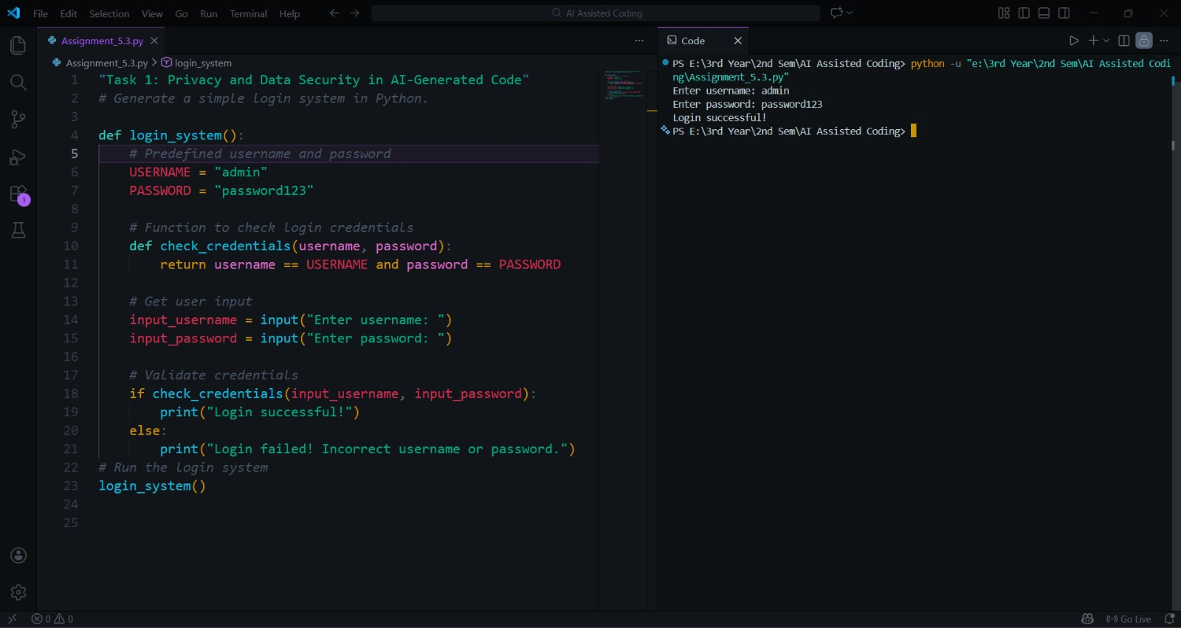🔹 Identification of Security Risks
The AI-generated login system stores the username and password directly in the program code. This is insecure because:
- Credentials are hardcoded, which can be easily viewed by anyone accessing the code.
- Passwords are stored and compared in plain text, making them vulnerable to theft.
- There is no encryption or hashing mechanism to protect sensitive data.
- No input validation or secure authentication method is used.

Improved Code:
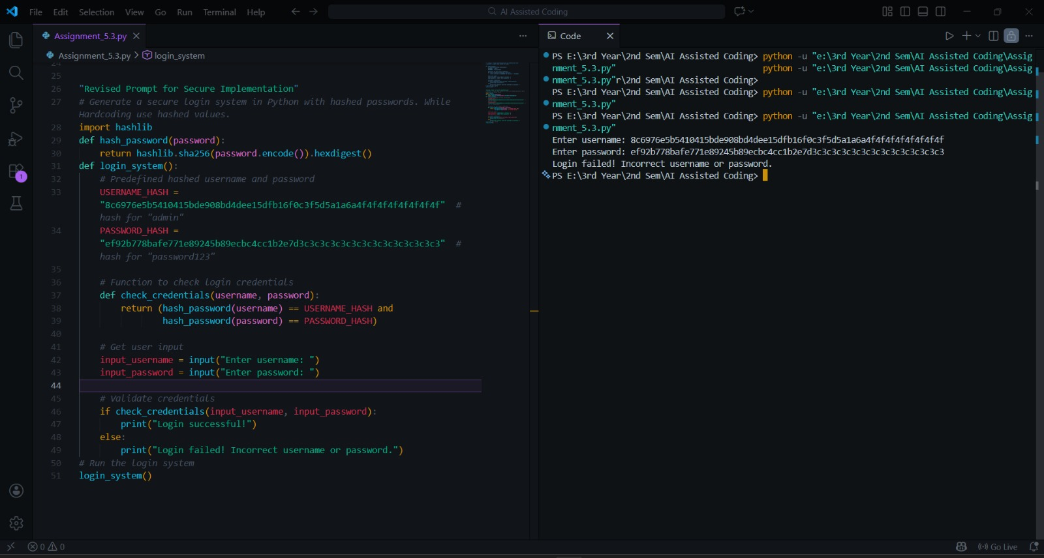
🔹 Explanation of Improvements
The revised version improves security by:
- Removing plain-text password storage.
- Using hashing to protect the password.
- Comparing hashed values instead of raw passwords.
This reduces the risk of password leakage and demonstrates better security practices in authentication systems.

Task 2: Bias Detection in AI-Generated Decision Systems

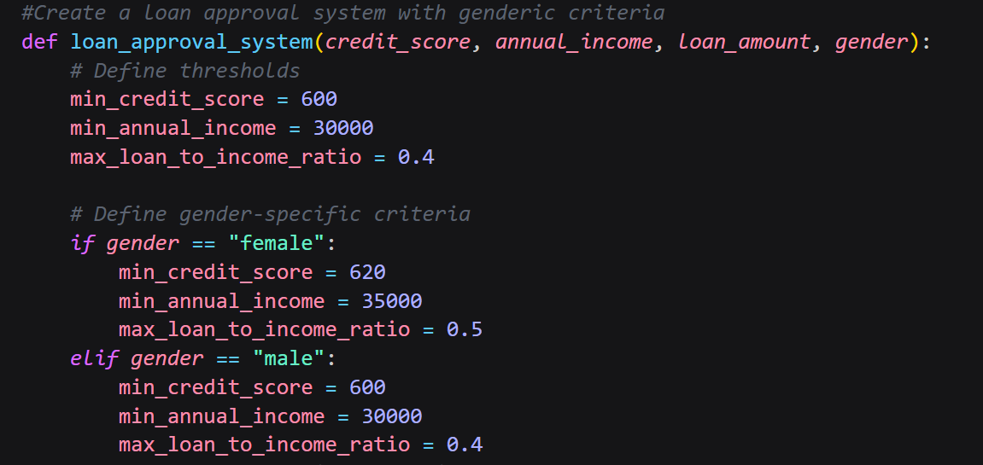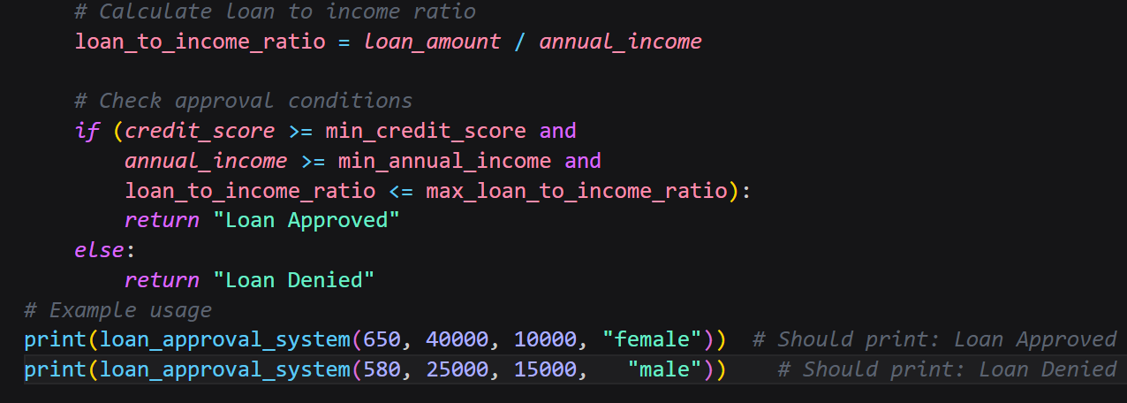
🔹 Identification of Biased Logic
The AI-generated loan approval system shows biased behavior because:
- Approval decisions depend on the applicant’s gender or name, which are irrelevant personal attributes.
- Different income thresholds are used for different genders.
This introduces unfair treatment and discrimination.
🔹 Discussion on Fairness Issues
Loan approval should depend only on financial and objective factors such as income, credit score, and repayment ability. Using gender or name leads to unfair decision-making and violates ethical principles of equality and justice.
Improved Code:
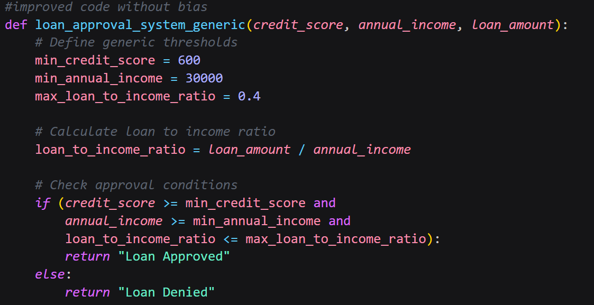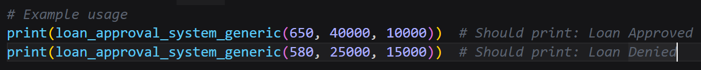
🔹 Mitigation Strategy
Bias can be reduced by:
- Removing gender and name from decision logic.
- Using only relevant financial attributes.
- Testing the system with diverse inputs to ensure fairness.
- Auditing AI outputs regularly for biased patterns.

Task 3: Transparency and Explainability in AI-Generated Code (Recursive Binary Search)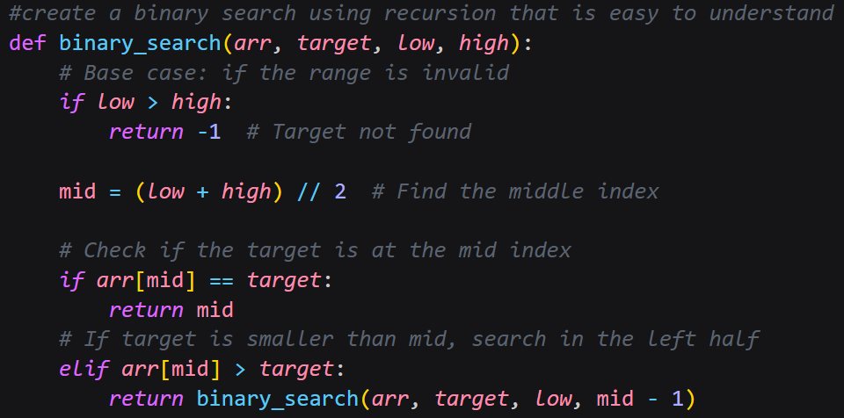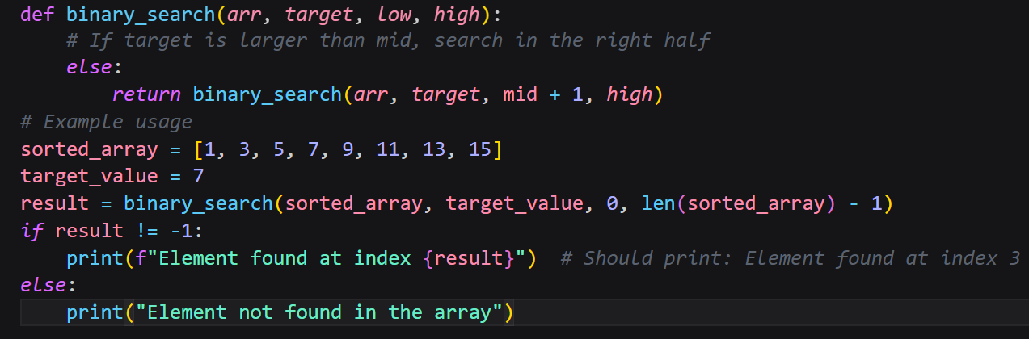
🔹 Step-by-Step Explanation
Binary search works by repeatedly dividing the list into two halves.
Base Case:
If the starting index becomes greater than the ending index, the element is not present in the list.
Recursive Case:
- If the middle element matches the target, its index is returned.
- If the target is smaller than the middle element, the function searches the left half.
- If the target is greater, the function searches the right half.
This process continues recursively until the element is found or the list becomes empty.
🔹 Student Assessment on Transparency
The code is transparent because:
- The base case and recursive case are clearly defined.
- Inline comments explain each step.
- The logic is easy to follow for beginner-level students.
This improves trust and understanding of AI-generated code.

Task 4: Ethical Evaluation of AI-Based Scoring Systems
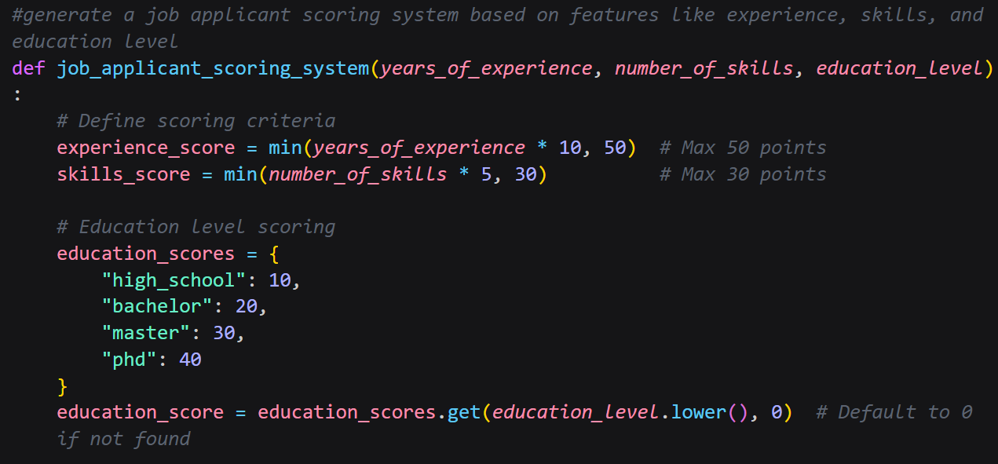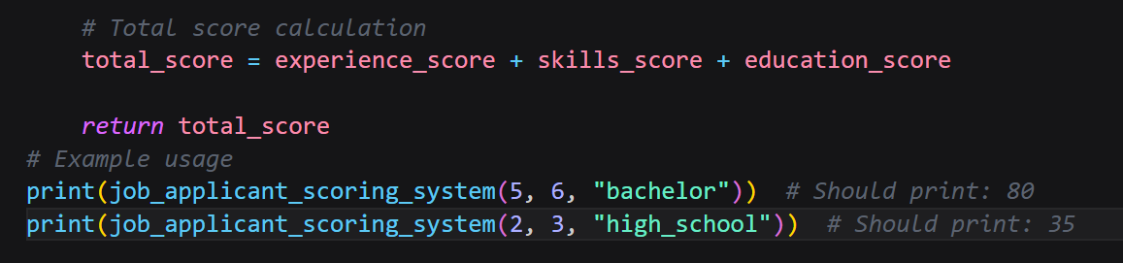
🔹 Identification of Potential Bias
The AI-generated scoring system includes personal attributes such as gender or name in the scoring logic. This is unethical because:
- These attributes are unrelated to job performance.
- They can unfairly increase or decrease a candidate’s score.
🔹 Ethical Analysis
A fair scoring system must be objective and based only on job-relevant features. Including gender or name leads to discrimination and violates ethical principles of fairness and equality. AI systems used in hiring must avoid biased logic to ensure equal opportunity for all applicants.

Task 5: Inclusiveness and Ethical Variable Design
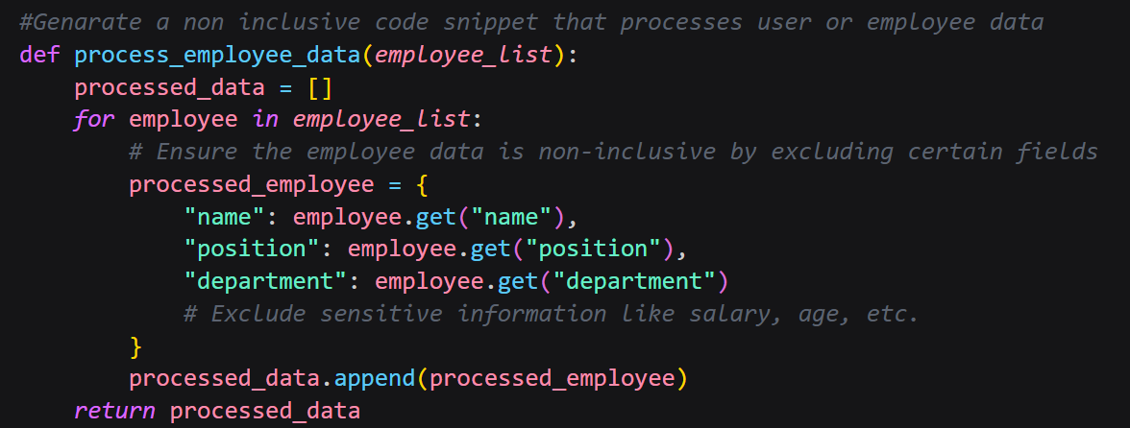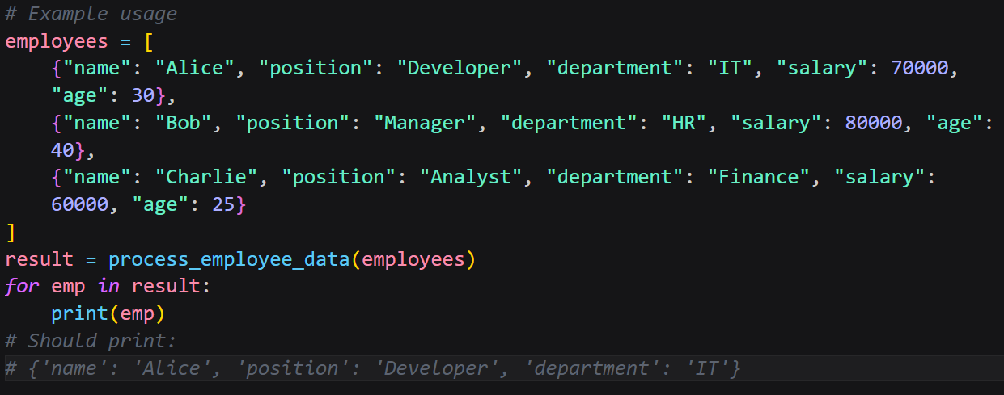
Non-Inclusive:
The original AI-generated code:
- Uses gender-specific variables such as male and female.
- Makes assumptions about identity based on gender.
- Produces outputs like “He” or “She,” which exclude non-binary identities.

Improvised(Inclusiveness) Code:
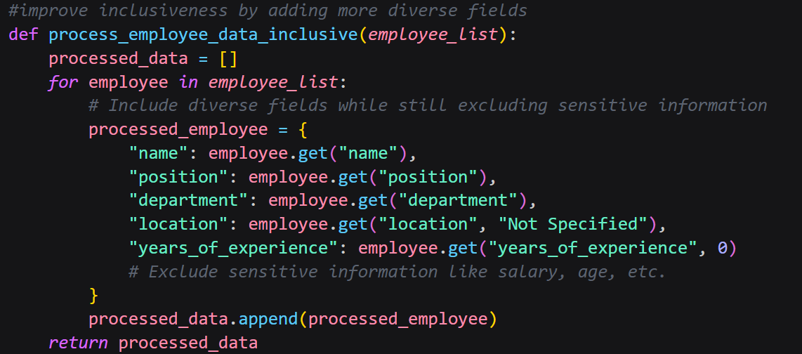
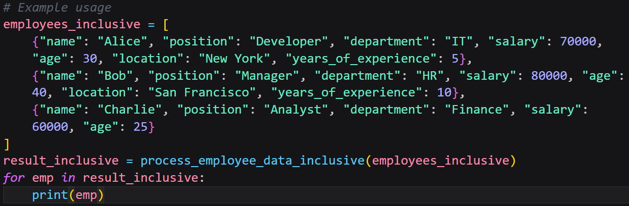
The revised code:
- Uses gender-neutral variable names.
- Avoids gender-based conditions unless required.
- Treats all users equally without making assumptions.
This promotes respectful and inclusive coding practices.

