DAM WATER LEVEL MONITORING SYSTEM USING ULTRASONIC SENSOR

AIM
The aim of this project is to design and implement an automated Dam Water Level Monitoring System using an ultrasonic sensor and Arduino microcontroller to continuously monitor water levels and provide timely alerts during warning and danger conditions.

OBJECTIVES
• To monitor water level without physical contact
• To display real-time distance and status on LCD
• To provide visual indication using LEDs
• To generate distinct audible alerts for warning and danger
• To improve safety and early flood warning

COMPONENTS REQUIRED
1. Arduino Uno
2. Ultrasonic Sensor (HC-SR04)
3. I2C LCD (16×2)
4. Green, Yellow, Red LEDs
5. Buzzer
6. Resistors (330Ω)
7. Connecting Wires
8. Power Supply

WORKING PRINCIPLE
The ultrasonic sensor emits ultrasonic waves toward the water surface. The waves reflect back and are received by the sensor. The time taken is measured and converted into distance using the speed of sound. Based on the measured distance, the system determines the water level condition.

SYSTEM OPERATION
Safe Condition (>20 cm): Green LED ON, buzzer OFF
Warning Condition (10–20 cm): Yellow LED ON, warning buzzer for 3 seconds
Danger Condition (≤10 cm): Red LED ON, continuous danger alarm

BLOCK DIAGRAM
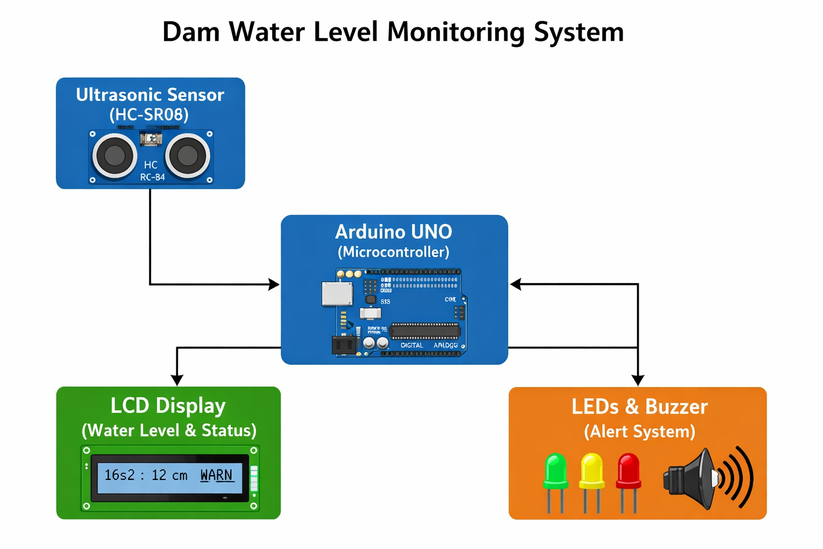
Ultrasonic Sensor → Arduino → LCD Display
↓
LEDs & Buzzer

FLOWCHART
[PLACEHOLDER FOR FLOWCHART IMAGE]
Start → Trigger Sensor → Measure Distance → Compare Thresholds → Display Status → Alarm Output → Repeat

CIRCUIT DIAGRAM
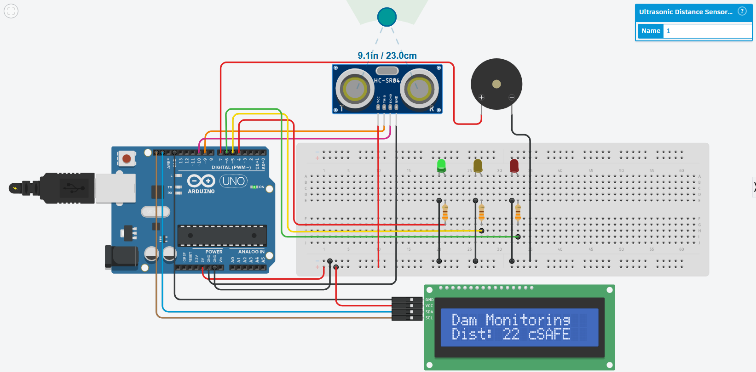
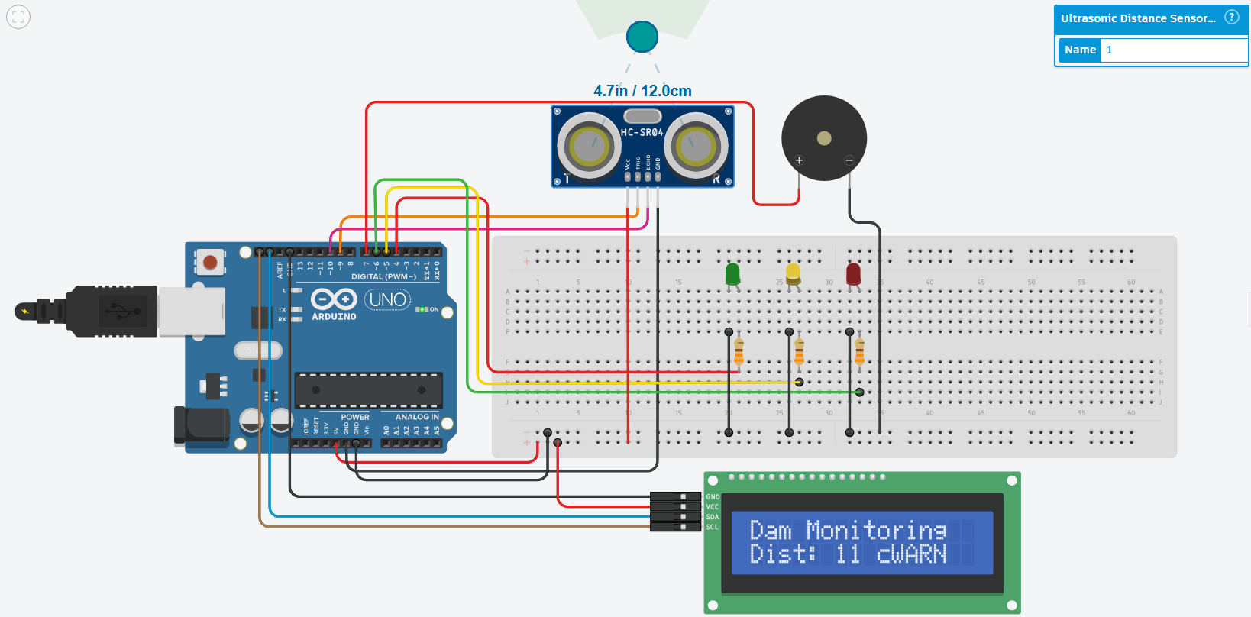
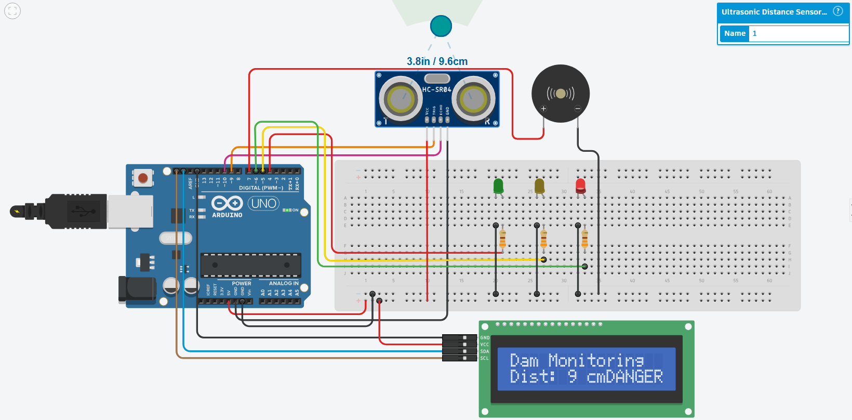
TRIG → Pin 9
ECHO → Pin 10
Green LED → Pin 4
Yellow LED → Pin 5
Red LED → Pin 6
Buzzer → Pin 7
LCD → SDA & SCL

ADVANTAGES
• Non-contact measurement
• Low cost
• Real-time monitoring
• Easy to implement
• Expandable to IoT

LIMITATIONS
• Affected by environmental conditions
• Limited sensing range
• Requires stable mounting

APPLICATIONS
• Dam monitoring
• Flood warning systems
• Water tank monitoring
• Irrigation systems

FUTURE SCOPE
• GSM-based SMS alerts
• IoT cloud monitoring
• Automatic gate control
• Data logging and analytics

CONCLUSION
The project successfully demonstrates a reliable dam water level monitoring system using ultrasonic sensing. The use of visual and audible alerts enhances safety, and the system can be further upgraded for real-world deployment.

