EXECUTION Architecture Document

Lori Gildersleeve  
Cody Nelson  
Jennifer Martin

**Execution Architecture for a Simple Sudoku Game**

**Overview**

The execution architecture for the Sudoku game will focus on:

1. a single computer
2. with a single process
3. running as a single-threaded system

**Deployment Views**

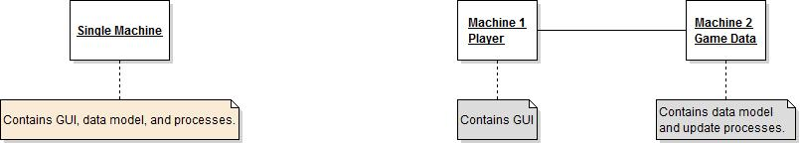

Single Machine View versus Multiple Machine View

**Hardware**

In general, any computer capable of running a Java application will suffice. In practice, a computer must have a Java Virtual Machine capable of running compiled Java 1.7 code.

**Processes**

The Sudoku game will have a single process with a main thread. The GUI is event-driven. It is backed by a system event process; however, there is no direct control over it.

**Threads**

The Sudoku game will have a single thread for operations; however, asynchronous interactions for this thread can occur and will be both managed and optimized by the Java Swing Framework.