Logical

Architecture Document

Lori Gildersleeve  
Cody Nelson  
Jennifer Martin

**Logical Architecture for a Simple Sudoku Game**

The architecture for the Sudoku game will be divided into three main components:

1. the user interface
2. the verification component
3. the data model/data store

These components will use a model-view-controller pattern to interact with one another. Provided is a simple diagram (Figure 1) showing how the user will interact with our Sudoku program and how these 3 components will exchange interactions with one another.

Provided are an activity diagram (Figure 2) and a state diagram (Figure 3) to show how the user will interact with the Sudoku program.

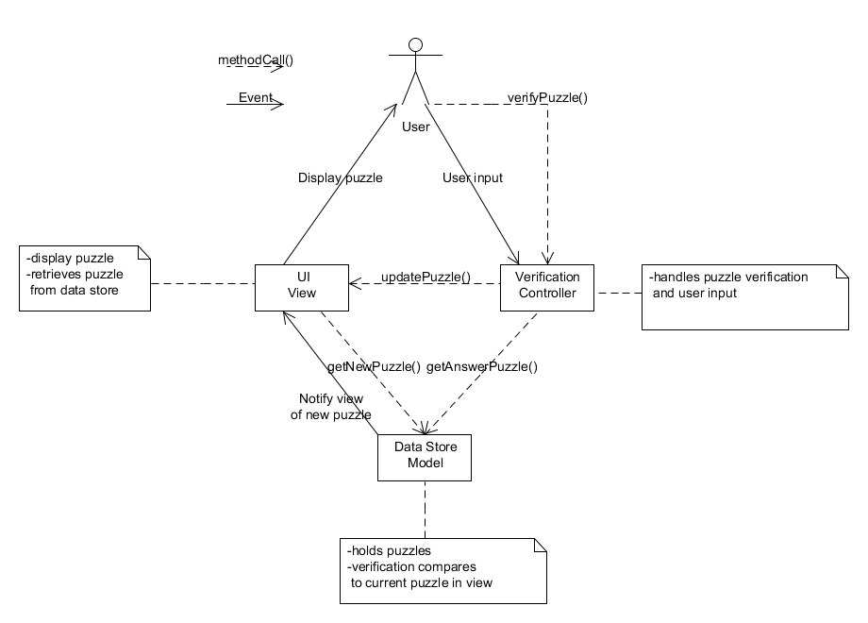

Figure 1: Simple MVC diagram for Sudoku program

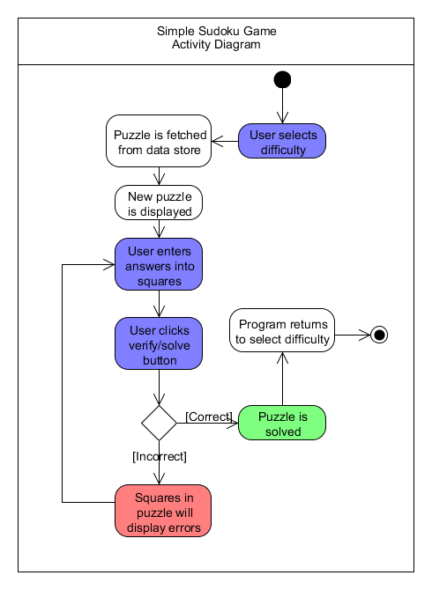

Figure 2: Activity diagram for Sudoku program

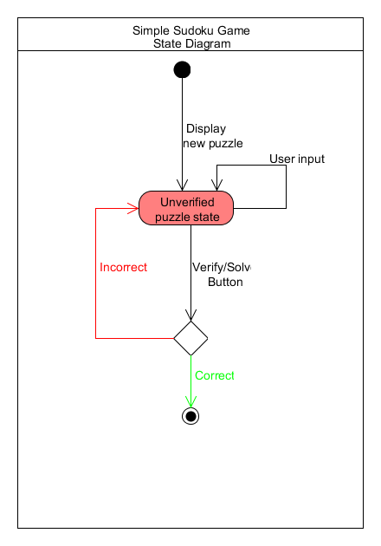

Figure 3: State diagram for Sudoku program

Provided is a UML class diagram (Figure 4) that shows the usages, creations, and relations of the object model for the Sudoku game.

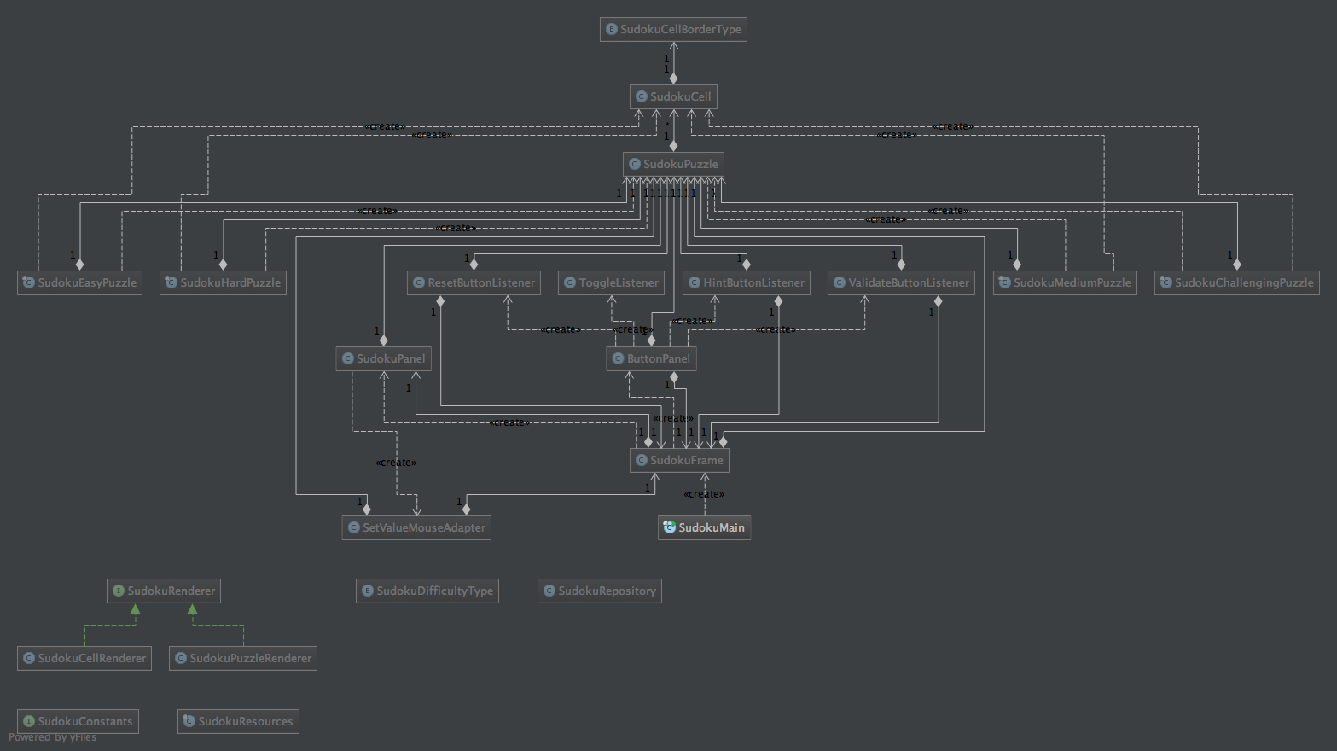

Figure 4: UML class diagram for Sudoku program