New, Quick Print, and spelling quick access toolbar icons added. Was a little confused if you wanted the Ribbon Display Options set to Show Tabs and Commands or just Show Tabs but it says after step 8 so I went with Show Tabs and Commands.

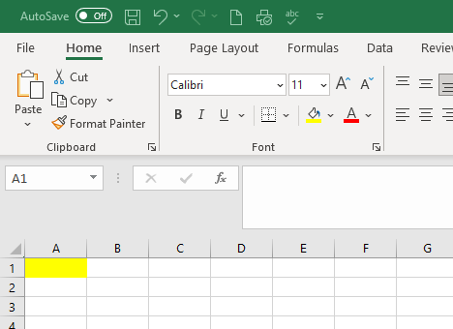

Pinned folder screenshot, including you can see I am signed into OneDrive.


