Browser Fingerprinting and Tracking Insights
Sean F. Coggeshall
American Military University
Table of Contents
Browser Fingerprinting and Tracking Insights 3
Am I Unique 3
Cover Your Tracks 3
Browser Leaks 4
Privacy Analyzer 5
Device Info 6
References 7

Browser Fingerprinting and Tracking Insights
Below is a write up of my findings from tools designed to analyze browser uniqueness, privacy, and security. Overall, I am content with where my online privacy is, but think it is important to always stay mindful of your digital fingerprint.

Am I Unique
It feels good seeing the “Yes! You are unique among…” at the top of the screen. I was shocked to see Windows as the most popular Operating System in their All-Time Global Statistics sections. I would have guessed it was Android, but Windows had 48.72 percent when I checked. Chrome, which I used often, was their most popular browser which was not shocking. I think fingerprinting has pros and cons, when it comes to fraud prevention and user tracking.
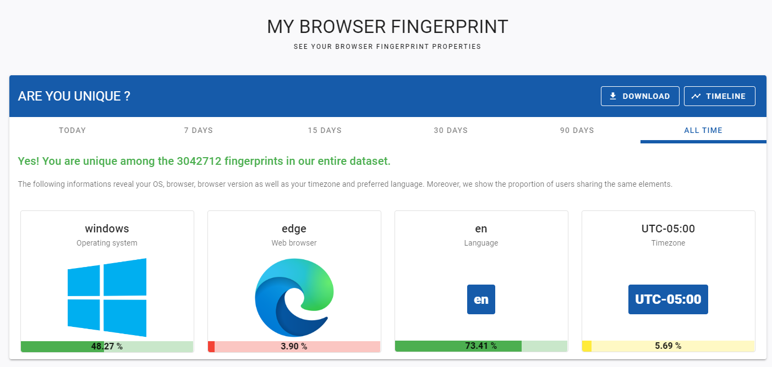

Cover Your Tracks
Seeing “strong protection against Web tracking” felt good. I try and remove targeted advertising whenever possible. Whether that is in a web browser, or an applications setting, I turn them off. Main ones that come to mind are Instagram, Snapchat, Amazon, and Google/YouTube that I have them turned off within the app as well.
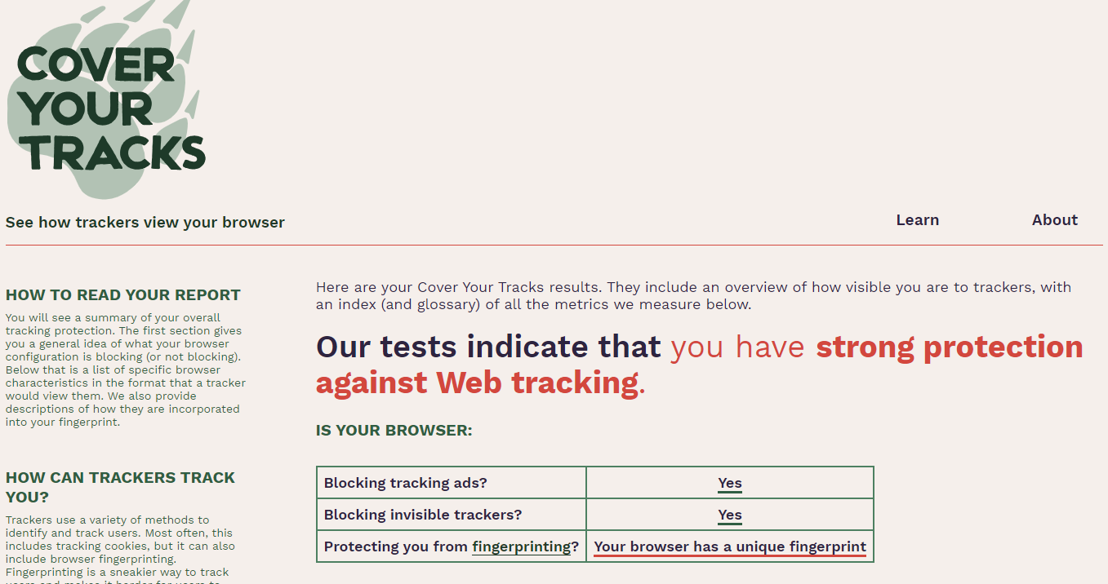

Browser Leaks
I don’t like seeing all the information on Canvas and how it can be used for tracking. Previously I had only seen it for Web Development and how it can be used as a tool to enhance websites. Seeing it from this side really makes you think about how every technology has pros and cons. Seeing the uniqueness be at 99.9% was not something I would want to see. I will test out some Canvas blockers to see if it has a major impact on user experience.

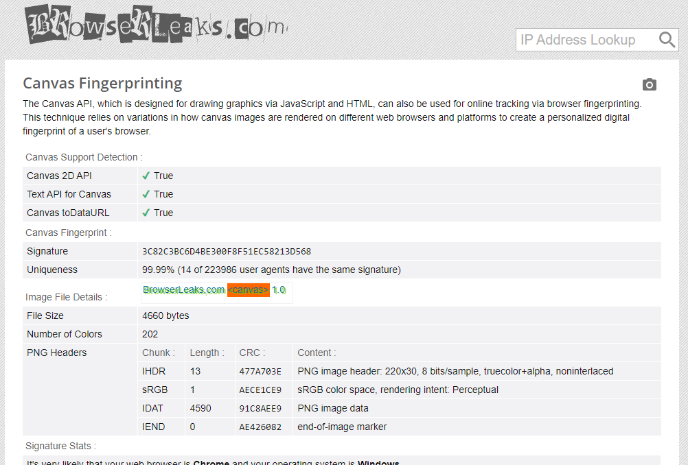

Privacy Analyzer
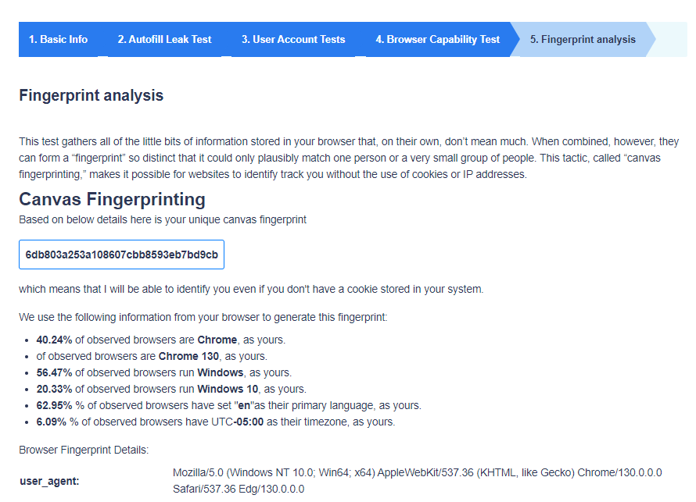
What stood out to me on this site was the Autofill test. There was a couple options that showed when I tested in Chrome, which I think I can remove and not turn off. I know malicious sites can add sections to fill out that aren’t even on screen hoping that autofill gives away information without your consent, so not something I want turned on.

Device Info
The results were interesting to say the least. Specifically, just how much information can be gathered about your system without you explicitly giving it away, I hit block on all the pop-ups. Things like my operating system and browser being listed weren’t surprising, but seeing specific details like my exact screen resolution, local time zone, and memory felt a bit invasive. Knowing my location through my IP address just adds to how easy it is for websites to gather personal data.
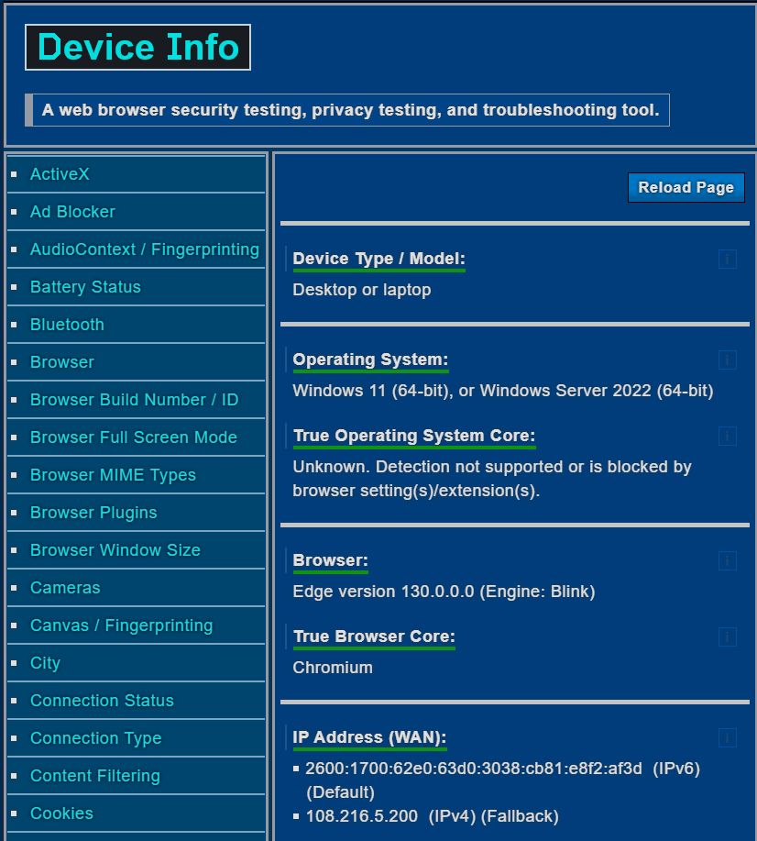

References
My fingerprint- Am I unique ? (n.d.). https://amiunique.org/fingerprint
Cover your tracks. (n.d.). https://coveryourtracks.eff.org/
Browserleaks - Check your browser for privacy leaks. (n.d.). BrowserLeaks. https://browserleaks.com/
Ruxd. (2020, June 5). Privacy Test & Analyzer: See what information websites know about you. Privacy.net. https://privacy.net/analyzer/
Device Info - Web browser security, privacy, and troubleshooting tool. (n.d.). https://www.deviceinfo.me/

