Week 2 Database Assignment
Sean F. Coggeshall
American Military University

Table of Contents
Week 2 Database Assignment 3
Part II 3
Client-Server Architecture 3
Compared 4
References 6

Week 2 Database Assignment
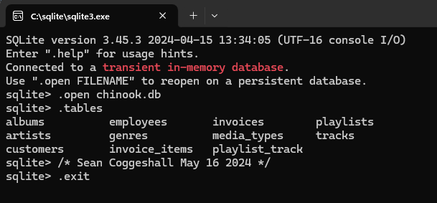

Part II

Client-Server Architecture
The term ‘client-server architecture’ refers to a computer model where a server hosts, transfers, and manages all data requests sent by the clients. When a request is sent by a client to the server, the server either accepts and transfers the data, or denies the request and does not complete the transfer. In a client-server architecture the clients do not share any of their own resources. In short, it is a network-based model where clients communicate to servers over a network.
Some advantages of client-server architecture are its flexibility. Multiple clients can connect to the server simultaneously, and clients can be added or removed as needed. This allows a business to adapt to its needs as the business grows or downsizes. They offer data protection and security, all data is centralized on the server, making user authorization and data security an easier process. This also helps with data backup, which can be a security feature if recovery was needed. It also offers an easier method for users to find and retrieve records.

Compared Client-server architecture is a network model where the server hosts data and delivers that data to the clients. It’s known for its flexibility, supporting multiple clients, and data protection. In contrast to a peer-to-peer (P2P) connection architecture, which is decentralized, and organizes software into layers. The National Institute of Standards and Technology (NIST) defines three different service models. One being Software as a Service (SaaS), where users use applications running on a cloud infrastructure. Platform as a Service (PaaS), which allows users to deploy their own applications onto the cloud infrastructure which is managed by the cloud provider. And Infrastructure as a Service (IaaS), which provides users with the ability to use computing resources that are hosted by the cloud provider. These models are all cloud based and offer flexibility, scalability, data integrity and security.
I see the scalability of a cloud-based infrastructure as the most important. A business does that have to worry about upscaling their infrastructure as the business grows but lets the cloud provider handle those aspects. They can be run on as a pay as you go service, so you only pay for what you need at that time.
The biggest risk I would see being data breaches. All data being held on the cloud can be more secure but is a bigger target for cybercriminals and a breach would have greater damage sense it is all in the same location.

Microsoft Access stands out as a relational database management system. It combines a powerful engine for storing and managing data with a graphical user interface that simplifies database creation and interaction. Additionally, Access provides developer tools for building custom applications. While Access utilizes its own data format, it offers the flexibility to import or link directly to existing databases from other sources. On the other hand, SQLite is a lightweight and embedded SQL database engine, offering a different approach for data management.
MS Access and SQLite are both good products for small scale datasets. Access can only be run on a Windows OS, whereas SQLite can run on Windows, Mac OS, Linux, and Android.
Primary usage of Access is importing data from Excel or from different databases, data tracking and management, and data analysis and reporting. It’s most often used when integrating with other Microsoft Desktop applications and when there is a need for a friendly user-interface.

References
CSRC Content Editor. (n.d.). Software as a Service (SAAS) - Glossary | CSRC. https://csrc.nist.gov/glossary/term/Software_as_a_Service
Nishtha. (2024, May 15). Client Server architecture - working, types, and examples. Intellipaat. https://intellipaat.com/blog/what-is-client-server-architecture/#no1
GeeksforGeeks. (2024, April 19). Client-Server model. GeeksforGeeks. https://www.geeksforgeeks.org/client-server-model/
SQLite Home page. (n.d.). https://www.sqlite.org/

