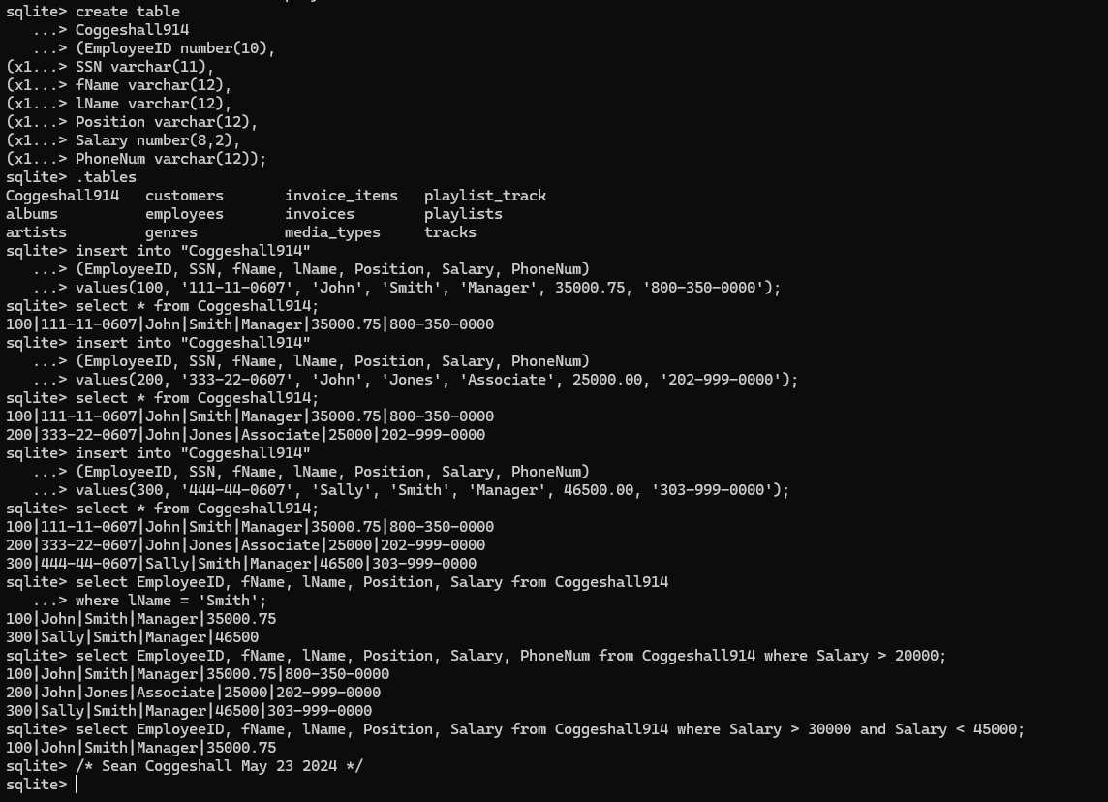

Task 1
create table
Coggeshall914
(EmployeeID number(10),
SSN varchar(11),
fName varchar(12),
lName varchar(12),
Position varchar(12),
Salary number(8,2),
PhoneNum varchar(12));

Task 2:
insert into "Coggeshall914"
(EmployeeID, SSN, fName, lName, Position, Salary, PhoneNum)
values(100, '111-11-0607', 'John', 'Smith', 'Manager', 35000.75, '800-350-0000');
insert into "Coggeshall914"
(EmployeeID, SSN, fName, lName, Position, Salary, PhoneNum)
values(200, '333-22-0607', 'John', 'Jones', 'Associate', 25000.00, '202-999-0000');
insert into "Coggeshall914"
(EmployeeID, SSN, fName, lName, Position, Salary, PhoneNum)
values(300, '444-44-0607', 'Sally', 'Smith', 'Manager', 46500.00, '303-999-0000');

Task 3 Use the Select * command to list all fields for all records in the table.
select * from Coggeshall914;
Task 4 Use a Select command to list the EmployeeID, fName, lName, Position, and Salary fields for all employees with a last name of Smith.
select EmployeeID, fName, lName, Position, Salary from Coggeshall914
where lName = 'Smith';
Task 5 Use a Select command to list the EmployeeID, fName, lName, Position, Salary and PhoneNum fields for all employees with a salary greater than 20000.
select EmployeeID, fName, lName, Position, Salary, PhoneNum from Coggeshall914 where Salary > 20000;
Task 6 Use a Select command to list the EmployeeID, fName, lName, Position and Salary fields for all Employees with a Salary greater than 30000 and less than 45000.
select EmployeeID, fName, lName, Position, Salary from Coggeshall914 where Salary > 30000 and Salary < 45000;

