Week 4 Database Exercise
Sean F. Coggeshall
AMU INFO222
Dr. Sherrilyn Magby

Table of Contents
Week 4 Database Exercise 3
Design Steps and their Value 3
Bottom-Up vs Top-Down 5
Multiplicity Relationships 6
References 7

Week 4 Database Exercise
Medical Record Database
Table:
Field Name | Description
PatientID | Unique Identifier for each patient
LastName | Last Name of the patient
FirstName | First Name of the patient
DOB | Date of Birth of the patient
Gender | Gender of the patient
Address | Address of the patient
ContactNumber | Contact number of the patient
MedicalHistory | Medical history of the patient

Design Steps and their Value
- Identify all the database design steps and describe each.
- B) Highlight the value of each step. Each step and description should be approximately 50+ words.
The first step is the Requirements Analysis for building a database. This step is how you understand the needs of the people that will be using the product. You can get this by gathering information from them and what it will be used for, this can be done through surveys, interviews, questionnaires, or just speaking with them. Once you have the information you can define the scope of the project.
Second, we need to create a System Definition for the database. This is where we will define what the boundaries and functionalities of the database system are. Knowing what data will be used and what functionalities will be offered will be needed to create the definition. This helps keep the project in scope and ensures no resources (time/money) are wasted on unnecessary components.
We now move on to Logical Model Creation. This can be referred to as ‘Data on Paper’, it is a conceptual model of the database that does not cover any software or hardware aspects. It focuses on how the data will be stored and how it will relate to each other. Both the entities (real-world objects) and their attributes (properties) are identified. Data modeling techniques are used to create visual representations of the structure.
After the Logical Model we move onto Physical Model Creation. This step takes the logical model and converts it into a real database structure, a DBMS must be selected as well as physical storage limitations set. The entities are converted into tables with data types assigned to their attributes. You would apply constraints and establish keys, create table names, property names, and attribute names.
Once the Physical Model is created it needs to be Implemented. Data from existing tables can be imported and converted into the new database format. The data may need to be cleaned and formatted prior to importing.
Once implemented, the database needs to be Tested. This involves checking if the database functions as intended and how it handles any errors. Data retrieval, manipulation, and integrity constraints are tested thoroughly to verify outputs are as expected.

Bottom-Up vs Top-Down
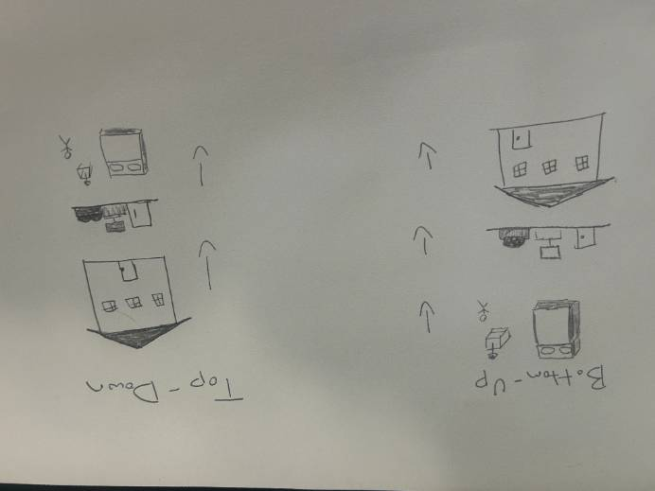
My sketch is aiming to show in the bottom-up approach, you can start with the details. Such as the design of your bedroom and then the living room. Once you have the critical things laid out you can focus on the bigger infrastructure, like the overall house. Whereas in the top-down approach, you start with the house and work your way down to the details of your bedroom.
A top-down design process can be thought of as logical to physical. It starts with a broad overview of the database. This allows for a more comprehensive understanding of the system from the beginning which provides a clearer sense of direction. By starting at the top- and higher-level view, it is easier to avoid redundancy and maintain consistency, this approach is better for more complex systems.
The bottom-up approach starts with specifics of the database, which can be beneficial if the details are critical to your system. It’s a more flexible approach due to changes only affecting one part of the system without affecting others. You can implement certain parts of the system without the entire system being complete, which is helpful if you have different timelines for different aspects. Overall, the bottom-up approach is better for a simple database with a relatively small number of attributes due to your ability to be extremely detailed from the start of the process.
Multiplicity Relationships Multiplicity refers to the number of occurrences of one entity in relation to another entity within a database.
One-to-One (1:1): In a one-to-one relationship, a single instance of one entity can be associated with one other entity, and vice versa. An example can be an access card, you can only have one access card and that card can only go to one person.
One-to-many(1:N): An entity of X can be related to multiple instances of Y, but Y can only be related to one instance of X. An example could be a classroom setting, one teacher can have many students, but the students will only go to one teacher.
Many-to-many(N:M): A single instance of one entity can be associated with multiple instances of another entity, and vice versa. A separate table is used to link the two tables and establish the many-to-many connections. An example could be students enrolling in a course, the students can enroll in many courses and the course can have many students.
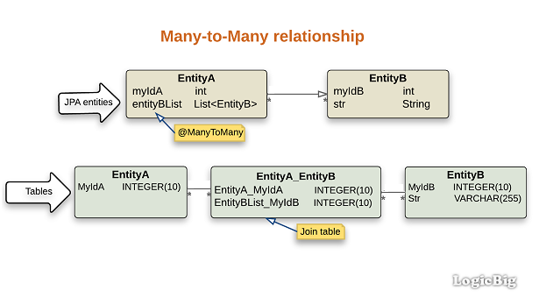
(JPA + Hibernate - ManyToMany Relationship, n.d.)

References
Multiplicity in Entity Relationships (The Java EE 5 tutorial). (n.d.). https://docs.oracle.com/cd/E19316-01/819-3669/bnbqh/index.html
Relationship vs Multiplicity. (n.d.). Stack Overflow. https://stackoverflow.com/questions/36796222/relationship-vs-multiplicity
Kaur, T. (2023, August 27). Mastering Database Selection: A guide to choosing the right database for your application. Medium. https://medium.com/plumbersofdatascience/mastering-database-selection-a-guide-to-choosing-the-right-database-for-your-application-f0f7009daf29
JPA + Hibernate - ManyToMany relationship. (n.d.). https://www.logicbig.com/tutorials/java-ee-tutorial/jpa/many-to-many.html
Multiplicity vs Cardinality. (n.d.). Stack Overflow. https://stackoverflow.com/questions/17877582/multiplicity-vs-cardinality

