WK8 Final Project
Sean F. Coggeshall
American Military University

Table of Contents
WK8 Final Project 3
Computer Literacy 3
Computer Algorithms 3
Internet/WWW Growth. 4
Systems Development Life Cycle 5
Major Hardware Components 6
Open System Interconnection (OSI). 7
References 8

WK8 Final Project

Computer Literacy
Computer literacy is increasingly important in today's digital world, as more and more tasks and activities rely on computers and the Internet. It can also be helpful in a variety of careers, as many jobs now require some level of computer proficiency.
Computer literacy can be broken down into basic computer skills, internet skill, digital literacy, programming skills, and problem-solving skills.
Having basic computer skills is thought of as having the ability to use a mouse and keyboard to navigate a computer’s operating system and file system and create and edit documents using different word processing applications. Internet skills is when one can use a web browser to access and navigate, the internet, search information, and communicate with others online. Digital literacy is when a user can use different digital tools and platforms, such as social media, online communication tools, and productivity software. Programming skills would be on the more advanced side of computer literacy. This is when a user can write and debug code, create and modify programs, and understand concepts and languages. Lastly, we have problem solving skills. This would also be on the more advanced side of computer literacy. When a user can troubleshoot problems and find solutions when using computers and related technologies, they would be considered to have problem solving skills.

Computer Algorithms1
An algorithm is a set of steps that defines a procedure for solving a problem or achieving a goal. Algorithms can be designed to perform a wide variety of tasks, from simple calculations to complex data processing and analysis. There are several different types of algorithms, including search algorithms, sorting algorithms, optimization algorithms, and machine learning algorithms.
Search algorithms are used to search through data to find a specific group of items that the user has entered. Sorting algorithms arrange items in a defined order, such as ascending or descending numerical order. Optimization algorithms are used to find a solution to a problem, such as finding the shortest path between two points or the highest profit in a business decision. Lastly, machi ne learning algorithms are used in artificial intelligence and machine learning systems to analyze data and make predictions or decisions.
The significance of algorithms lies in their ability to automate and streamline various tasks and processes. By defining a set of steps for a computer to follow, algorithms can help computers perform tasks more efficiently and accurately than if they were done manually. This can save a company both time and money for a variety of processes. Algorithms are also used to analyze and interpret large amounts of data, allowing for the extraction of valuable insights and decision-making.
Internet/WWW Growth. There have been several different technologies that have helped with the expansion of the internet and World Wide Web (WWW). The first we can look at are the protocols that professionals have agreed upon. Protocols are a set of rules and standards that govern the wat data is transmitted over the Internet. They define how computers and smartphones communicate with each other and exchange information. Some examples of Internet Protocols are Hypertext Transfer Protocol (HTTP), Transmission Control Protocol (TCP), and Internet Protocol (IP).
HTTP allows web browsers to request and receive web pages from web servers and is the foundation of the web. It was developed by Tim Berners-Lee, a British computer scientist. He is widely considered the creator of the World Wide Web, and HTTP is one of the technologies that made that possible. TCP is a transport layer protocol that ensures data is delivered reliably and in the correct order. It is implemented within many protocols, including HTTP. IP is a network layer protocol that defines how data is routed between devices (Such as routers) on the internet. Its two main purposes are device identification and location addressing. There are two main types of IP addresses: IPv4 and IPv6. IPv4 (Internet Protocol version 4) is the original version of the Internet Protocol and is still the most widely used. It uses 32-bit addresses, allowing for a total of approximately 4.3 billion unique IP addresses.
Web browsers and search engines are other forms of technology that widely contributed to the expansion of the internet and world wide web. Web browsers are software programs that allow users to access and view web pages. The development of web browsers such as Mosaic, Netscape Navigator, and Internet Explorer made it easier for users to access and navigate the Web. Search engines are tools that allow users to search for information on the Web. The development of search engines such as Google, Yahoo, and Bing made it easier for users to find the information they were looking for, leading to a significant increase in the use of the Web.

Systems Development Life Cycle. The Systems Development Life Cycle (SDLC) is a process used to develop software systems. It is a systematic approach that involves a series of steps or phases that are followed in a specific order to ensure the development of a high-quality software system. There are several different models that can be used to describe the SDLC, including the Waterfall model, the Agile model, and the Spiral model.
The Waterfall Method uses a 7-phase model that involves a sequence of distinct phases, such as planning, analysis, design, implementation, testing, deployment, and maintenance. This model is often used for smaller, well-defined projects where the requirements are well understood and are unlikely to change significantly.
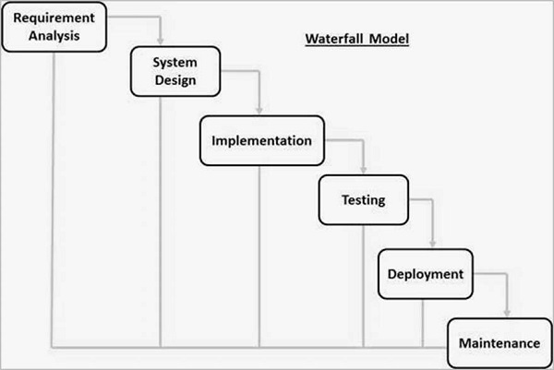

Major Hardware Components. Major hardware components of computers are composed of the Central Processing Unit (CPU), memory (RAM), Hard Drives (HDD or SSD), the motherboard, a power supply, the graphics processing unit (GPU), and Input/Output (I/O) devices.
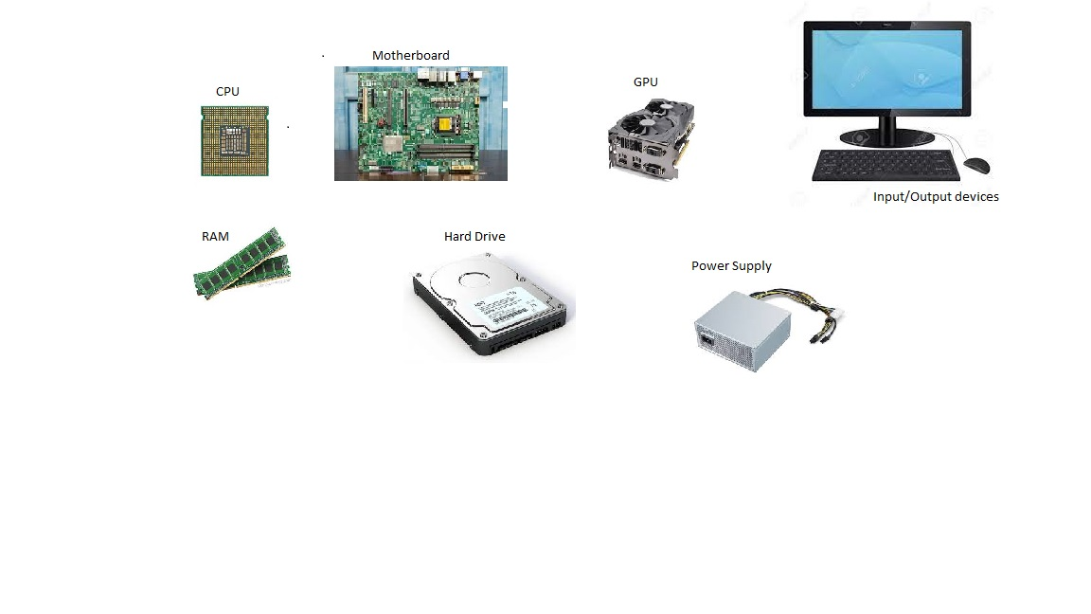
Open System Interconnection (OSI). The Open Systems Interconnection (OSI) model is a framework that is used to understand how data is transmitted over a network. There are seven layers to the OSI model as follows:
Physical Layer | The Physical Layer is responsible for transmitting raw data over a communication channel. It deals with the physical aspects of the connection, such as the type of cable or wireless technology used.
Data Link Layer | The Data Link Layer is responsible for creating a link between two devices and ensuring that the data is transmitted reliably. It includes error detection and correction, as well as flow control.
Network Layer | The Network Layer is responsible for routing data between devices on a network. It uses logical addresses (such as IP addresses) to identify devices and determine the best path for the data to take.
Transport Layer | The Transport Layer is responsible for ensuring that data is delivered reliably and in the correct order. It includes error checking and retransmission of lost or damaged packets.
Session Layer | The Session Layer is responsible for establishing, maintaining, and terminating communication sessions between devices.
Presentation Layer | The Presentation Layer is responsible for translating data into a format that can be understood by the receiving device. It includes encoding and compression of data.
Application Layer | The Application Layer is the highest layer of the OSI model and is responsible for providing services to the application programs that use the network.

References

Tim Berners-Lee. (n.d.). https://www.w3.org/People/Berners-Lee/

Computer Hardware. (n.d.). https://web.stanford.edu/class/cs101/hardware-1.html

SDLC - Waterfall Model. (n.d.). https://www.tutorialspoint.com/sdlc/sdlc_waterfall_model.htm

Messer. (2021, December 14). Professor Messer’s SY0-601 CompTIA Security+ Course. Professor Messer IT Certification Training Courses. https://www.professormesser.com/security-plus/sy0-601/sy0-601-video/sy0-601-comptia-security-plus-course/
Ciccarelli, P. (2004). Networking Foundations: Technology Fundamentals for IT Success (1st ed.). SY.

