Software Requirements Specification Final Draft

for

Week 8 Assignment
Version 1.3 approved
Prepared by Sean Coggeshall
American Military University
October 24, 2024

Revision History
Name | Date | Reason for Changes | Version
Sean Coggeshall | 09 09, 2021 | Creating initial document | 1.0
Sean Coggeshall | 09 16, 2024 | Adding Safety, Security, Software Quality, and Business Rules. | 1.1
Sean Coggeshall | 10 07, 2024 | Completing Appendix D and adding Entity Relationship Diagram | 1.2
Sean Coggeshall | 11 23, 2024 | Adding a UML Class Diagram and completing Section E. | 1.3

Contents
1. Introduction 1
1.1 Purpose 1
1.2 Document Conventions 1
1.3 Intended Audience and Reading Suggestions 1
1.4 Product Scope 1
1.5 References 2
2. Overall Description 3
2.1 Product Perspective 3
2.2 Product Functions 3
2.3 User Classes and Characteristics 3
2.4 Operating Environment 4
2.5 Design and Implementation Constraints 4
2.6 User Documentation 4
2.7 Assumptions and Dependencies 4
3. External Interface Requirements 5
3.1 User Interfaces 5
3.2 Hardware Interfaces 5
3.3 Software Interfaces 5
3.4 Communications Interfaces 5
4. System Features 7
4.1 Appointment Scheduling 7
4.2 Provider Management 8
4.3 Use Cases 8
5. Other Nonfunctional Requirements 10
5.1 Safety Requirements 10
5.2 Security Requirements 10
5.3 Software Quality Attributes 11
5.4 Business Rules 11
6. Other Requirements 12
6.1 Performance Requirements 12
Appendix 13
Appendix A: Glossary 13
Appendix B: Use Case Models 14
Appendix C: DataFlow Diagrams 18
Appendix D: Entity Relationship Diagram 20
Appendix E: Class Diagram 21

Introduction
This document covers the software requirements for the FCS Appointment Scheduling System. We will define the purpose, scope, and the system’s key functions. We will also cover the external interface and system features that support efficient appointment scheduling.

Purpose
The FCS Appointment Scheduling System is designed to automate the appointment process for patients, doctors, and administrative staff. This SRS covers the system’s main functions, which include appointment management, user authentication, and billing integration. Our goal is to minimize administrative workload and maximize patient processing.

Document Conventions
This document follows standard SRS format. Key requirements will be in bold text and all mandatory features will be marked with (mandatory) at the beginning of the section. Priorities will be noted as High (H), Medium (M), or Low (L).

Intended Audience and Reading Suggestions

This document is intended for the following:

- Developers: For guidance on developing system features.
- Project Managers: For project scope and progress tracking.
- Testers: For system functionality testing.
- End Users: Doctors, patients, and administrative staff who will be using the system.

It is recommended that the document be read in its entirety for developers, project managers, and testers. End users can skip to section 2 for system overview and section 4 to read system features.

Product Scope
The FCS Appointment Scheduling System will be streamlining the process of managing appointments for both healthcare professionals and patients.

References
References include:

- FCS Vision Document
- HIPAA Compliance Documentation

Overall Description
This section will provide a high-level overview of the product’s features, its users, and the operating system environment.

Product Perspective
The FCS Appointment Scheduling System is a standalone solution that will have features to integrate with other systems, such as patient management and billing systems. FCS operates as a web-based application accessible through standard web browsers (Chrome, Safari, Edge, Firefox), supporting FCS’s need for an efficient and secure scheduling system.

Product Functions
The FCS Appointment Scheduling System offers the following key features:

- Appointment scheduling – patients can book, modify, and cancel appointments
- Provider management – clinical staff can modify their availability
- Billing integration – connects with billing system for accurate invoicing
- Notifications – real-time alerts for upcoming appointments and any changes
- Security – Role-based access control and data encryption for HIPAA compliance

User Classes and Characteristics
Primary users and characteristics:

- Patients – casual users with minimal technical expertise
- Clinical Staff – business experts who use the system frequently
- Receptionist – Administrative staff managing appointments daily
- Service Providers – manage patient billing
- Administrators – IT personnel responsible for system maintenance and security

Operating Environment
The FCS Appointment Scheduling System operates on standard web browsers (Chrome, Safari, Edge, Firefox) and is compatible with major operating systems, including Windows, macOS, and Linux. It requires a stable internet connection for real-time updates.

The application will be hosted on Microsoft Azure, using a relational database to store information.

Design and Implementation Constraints
- Regulatory Compliance – The system must follow HIPAA and local data privacy laws.
- Network – Limited bandwidth can cause constraints on multiple client connections.

User Documentation
The system will come with the following:
- User manuals for patients, doctors, and receptionists.
- Online help and tutorial
- Onsight IT assistance during the implementation phase.

Assumptions and Dependencies
Third-party systems:

- Assuming integration with FCS’s existing billing and patient management systems.
- Assumes a want to grow the business post optimization, using cloud services for this purpose.

User Competency:

  - Assumes basic technical skill for patients
  - Assumes advanced skills for receptionist and clinical staff.

External Interface Requirements
This section describes the graphical user interface (GUI) between the system and external components.

User Interfaces
The system will provide a GUI for the following users:

- Patients – simple forms for booking and managing appointments.
- Clinical Staff – a calendar view for managing availability
- Receptionists – tools to manage appointments, showing both patients and staff current scheduling
- Administrators – an admin portal to apply updates

Hardware Interfaces
The system will interact with Microsoft Azure portal requiring minimal hardware adjustments.
Current tablet, laptop, desktop, and mobile devices will work for client connections.

Software Interfaces
The FCS system will interface with:

- Patient Management System – to retrieve and update patient data
- Billing System – to manage invoicing and financial data.
- Email/SMS Gateways – for sending notifications and appointment reminders.

Communications Interfaces
The system will use HTTPS protocol for all web-based communication. HTTPS will provide secure, encrypted communication while using the web app.
FCS will enforce TLS 1.3 for HIPAA compliance standards.
The web application will use input validation on all forms to prevent any injection attacks.

Emails will be scanned for malicious attachments using Microsoft Exchange.

System Features

This section covers the core features of FCS and any associated requirements.

Appointment Scheduling
4.1.1 Description and Priority
The system will allow patients and clinical staff to book, modify, and cancel appointments. Priority: High

4.1.2 Stimulus/Response Sequences
- A patient or receptionist selects a date and time for an appointment.
- The system checks clinical staff availability.
- The system confirms the appointment and sends a notification.

4.1.3 Functional Requirements
The following functional requirements cover the necessary capabilities of the FCS scheduling appointment system.

REQ-1: Appointment Booking

Description: The system shall allow patients and clinical staff to book appointments by selecting a data, time, and clinical provider from the available list.

Use Case Reference: Use Case 1 – Make Appointment

REQ-2: Appointment Modification

Description: The system shall allow patients and clinical staff to modify existing appointments.

Use Case Reference: Use Case 2 – Modify Appointment

REQ-3: Appointment Cancellation

Description: The system shall allow patients and clinical staff to cancel appointments.

Use Case Reference: Use Case 3 - Appointment Cancellation

Provider Management
4.2.1 Description and Priority

The provider management feature allows clinical staff to manage their availability. Priority: High

4.2.2 Stimulus/Response Sequences

- A provider updates their weekly availability in the system.
- The system blocks unavailable time slots from patient booking and notifies patients if their appointments are affected.
- The system updates the provider’s calendar view and synchronizes and changes.

4.2.3 Functional Requirements
REQ-1: Availability Management

Description: The system shall allow providers to update their availability, including blocking off time for personal or professional time.

Use Case Reference: Use Case 4 – Manage Availability

Use Cases

Use Case 1. Make Appointment

Description: Allows patients or receptionists to book an appointment with a chosen clinical provider, selecting an available time slot from the provider's schedule.

Use Case 2. Modify Appointment

Description: Allows users to modify an existing appointment, changing the time, date, or provider as needed.

Use Case 3. Cancel Appointment

Description: Allows users to cancel a booked appointment, freeing up the slot for other patients and sending a cancellation notification.

Use Case 4. Manage Availability

Description: Allows clinical staff to manage their availability, blocking or opening specific time slots for appointments.

Other Nonfunctional Requirements

This section covers the nonfunctional requirements for the FCS Appointment Scheduling System, including safety, security, software quality, and business rules.

Safety Requirements
Safety 1. Data Loss Prevention

Description:

The system shall utilize one full back-up a week, followed by an incremental backup each day leading to the next full backup.

Safety 2. System Downtime Reduction

Description:

The system shall include failover mechanisms in place to ensure continuous operations in the event of a failure. The system will utilize power backup, georedundancy, and RAID 5 configuration.

Safety 3. Unauthorized Access Prevention

Description:

The FCS system will prevent unauthorized access by utilizing strict password policies and implementing multi-factor authentication (MFA).

Security Requirements

Security 1. HIPAA Compliance

Description:

The system shall comply with HIPPA regulations to protect the privacy and security of all patient data.

Security 2. Role-Based Access Control (RBAC)

Description:

The system shall implement role-based access control, ensuring users only access the data they need to complete the job function.

Security 3. Data Encryption

Description:

All sensitive data, including personal health information (PHI) and personally identifiable information (PII) will be encrypted using AES-256 for data at rest and TLS 1.2 or higher for data in transit.

Software Quality Attributes
Quality 1. Availability

Description:

The system shall maintain 99.9% availability to ensure minimal downtime, providing patients and staff with consistent access to appointment scheduling and management features.

Quality 2. Usability

Description:

The system interface shall be intuitive and easy to use, requiring no more than two steps to book or modify an appointment. Usability testing with end-users shall be conducted to ensure the system meets this requirement.

Quality 3. Reliability

Description:

The system shall ensure that all data related to appointments, patients, and providers is accurate and consistent. The system must perform thorough data validation checks during each interaction.

Quality 4. Maintainability

Description:

The system codebase shall be modular and well-documented to facilitate future updates and maintenance. Changes or updates to individual modules should not disrupt the overall system functionality.

Quality 5. Testability

Description:

All system components shall be fully testable with automated tests covering at least 85% of the codebase to ensure that each feature performs as intended without introducing new bugs. Tests will include static review and fuzzing.

Business Rules
Business Rule 1. Appointment Cancellation Window

Description:

Patients must cancel appointments at least 24 hours in advance to avoid a cancellation fee. The system shall automatically enforce this rule and send notifications to patients when they attempt to cancel within the 24-hour window.

Business Rule 2. Maximum Appointments Per Day

Description:

Clinical providers shall have a maximum number of appointments per day based on their availability and workload. The system shall enforce this rule and notify the provider if the limit is reached.

Business Rule 3. Patient Appointment Reminders

Description:

Patients shall receive automated reminders via email or SMS 24 hours and 1 hour before their appointment. The system shall send these reminders automatically without requiring manual intervention.

Business Rule 4. User Role Restrictions

Description:

Patients, receptionists, and clinical staff shall have distinct roles, each with specific permissions. For example, only receptionists and providers can modify or cancel appointments on behalf of patients.

Other Requirements
This section covers any additional requirements that are needed for the completion of the FCS Appointment Scheduling System and has not been covered by any other category.

Other Requirement 1. Database Requirements

Description:

The system shall use a relational database (e.g., MySQL or PostgreSQL) to store appointment data, patient information, provider schedules, and billing details. Regular backups must be performed daily, and disaster recovery procedures must be in place.

Other Requirement 2. Internationalization

Description:

The system shall support localization for multiple languages, including English and Spanish, to serve a diverse patient base. The user will be able to adjust the default and be saved in their session cookies, this includes translating the user interface, notifications, and appointment confirmations. The system must handle various time zones based on the user's location.

Other Requirement 3. Reusability

Description:

The system shall be designed in a modular architecture to allow code reuse for future projects. Components such as user authentication, appointment scheduling, and notification services shall be reusable across other applications developed by FCS or its partners.

Performance Requirements
This section will cover the performance requirements that relate to our key metrics. This includes system speed, scalability, and data processing functionality.

Performance 1. System Response Time

Description:

The system shall respond to user inputs (e.g., booking, modifying, or canceling appointments) within 2 seconds. This ensures a smooth user experience for both patients and staff by minimizing delays in scheduling activities.
The system shall process new appointments, modifications, or cancellations within 1 second. This includes saving the data to the database and sending real-time confirmation notifications to both patients and providers, ensuring that the process is completed without delays.

Performance 2. Scalability

Description:

The system shall be scaled to support up to 1,000 concurrent users with no degradation in performance. The backend infrastructure must dynamically scale based on demand, ensuring that the system continues to operate efficiently during periods of high user traffic, such as peak appointment booking hours.

Performance 3. Data Synchronization

Description:

The system shall synchronize all data updates, such as new appointments, provider availability, and modifications, in real-time across all system modules. All changes must be reflected within 1 second to prevent scheduling conflicts and ensure data consistency.

Appendix

Appendix A: Glossary
Administrator
A user responsible for managing system settings, users, and roles within the FCS system.

Appointment
A scheduled meeting between a patient and clinical staff for healthcare services.

Clinical Staff
Healthcare professionals provide medical services to patients.

FCS
Family Clinic Services, the organization implementing the appointment scheduling system.

HIPAA
Health Insurance Portability and Accountability Act, a US law ensuring the privacy and security of healthcare data.

Patient
An individual receiving medical services from the clinic.

Receptionist
A staff member managing appointments and patient schedules within the system.

Role-Based Access Control (RBAC)
A security model restricting system access based on the user’s role (e.g., Patient, Receptionist).

Appendix B: Use Case Models

B1. FCS Use Case Diagram

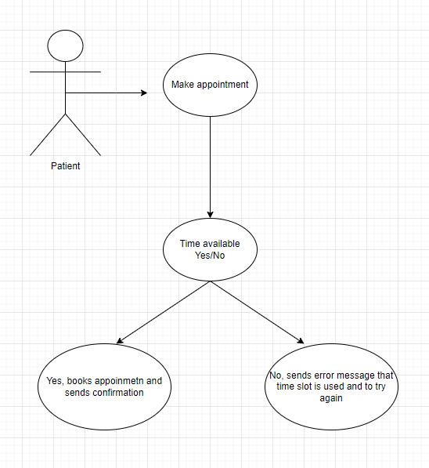

B2. Use Case and Actor Descriptions

Actor Table
Actor Name | Actor Definition
Patient | A person receiving medical care
Receptionist | A staff member responsible for scheduling appointments.
Clinical Staff | A medical professional providing patient care.

Use Case Table
Use Case Name | Use Case Description
Schedule Appointment | Book, modify, or cancel appointment.
Mange Patient Information | Update patient demographics and medical history.
View Appointment Schedule | View upcoming appointments
Send Appointment Reminders | Automatically send reminders to patients

B3. Detailed Use Cases

Detailed Use Case Template

Based on Figure 4-1 (p 151) and Figure 4-3 on p (155) in your textbook.
Use Case Name:  Schedule Appointment | ID:  01 | Priority:  High
Actors:

Patient, Receptionist

Description:

This use case follows a patient or receptionist booking an appointment with the FCS Appointment Scheduling System.

Trigger:

The patient or receptionist initiates the schedule process by opening the calendar and selecting the “Book Appointment” option.

Preconditions:

The patient and user have an account and are logged into the system.

Normal Course: (Alternate Actor Response with System Response)

- The use case begins when the patient or receptionist selects the "Book Appointment" option.
- The system displays available providers and time slots.
- The patient or receptionist selects a provider, date, and time.
- The system checks the provider's availability and confirms the appointment.
- The system sends a confirmation message to the patient and provider.

Alternative Course: (Alternate Actor Response with System Response

- If the selected time is unavailable, the system suggests alternative time slots.
- The patient or receptionist selects a new time, and the system confirms the appointment.

Postconditions:

- The appointment is successfully booked and stored in the system.
- The patient and provider receive confirmation notifications.

Exceptions:

- If the patient is not logged in, the system prompts them to log in or register.
- If the system detects a conflict in the provider’s schedule, it displays an error message and suggests alternative times.
- If the time and date are available but not confirmed, an error is presented to contact IT Support.

Appendix C: Data Flow Diagrams

C.1. Context DFD

Context DFD for Case Study

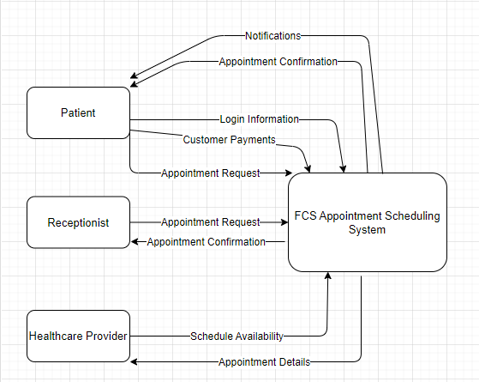
Discussion of Context DFE for FCS Case Study

The context diagram provides a high-level overview of the FCS Appointment Scheduling System. It illustrates the key entities involved in the system and their interactions.

- Entities: Patient, Receptionist, Healthcare Provider, FCS Appointment Scheduling System, System Database, Payment Gateway.

- Interactions: Patients request appointments, Receptionists schedule, Providers confirm, System manages, Database stores data, Gateway processes payments.

C2. Level 0 DFD

C2.1 Level 0 DFD for the Case Study

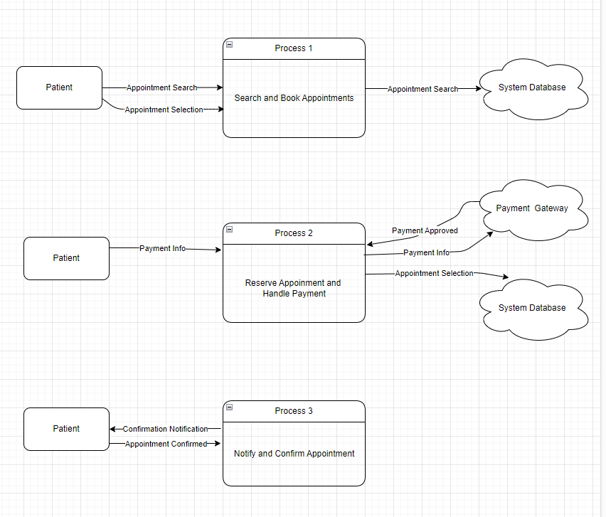
C2.2 Discussion of Level 0 DFD for FCS Case Study

This diagram breaks the system process into three main sub-processes while maintaining balance with the original context diagram, showing internal interactions and data flows.

C.3. Data Dictionary for DFDs.

C.3.1 Process Table

Process Number Name | Process Description | Input Data Flows and Source |  | Output Data Flows and Destination
Process Number Name | Process Description | Data Flows | Data Flow Source | Data Flows | Data Flow Destination
1.  Search and Book Appointments | Allows patients to search available appointments and select an available time. | Input:  Appointment Search | Source:  Patient | Output:  Appointment Selection | Destination:  System Database
2.  Reserve Appointment & Handle Payment | Reserves the appointment selected by the patient and handles payment processing through the gateway. | Input:  Payment Info | Source:  Patient | Output:  Payment Approved | Destination:  Payment Gateway
3.  Notify & Confirm Appointment | Sends confirmation to the patient and healthcare provider | Input:  Appointment Confirmed | Source:  System Database | Output:  Confirmation Notification | Destination:  Patient, Provider, Receptionist

C.3.2 External Entity Table

External Entity Name | External Entity Description
Healthcare Provider | Entity providing healthcare service
Patient | User searching for and booking appointment
Payment Gateway | External system that processes payment information
Receptionist | Staff responsible for managing appointments

C.3.3 DataStore Table

DataStore Number and Name | DataStore Description | List of Elements in the DataStore
D1.  Available Appointment Slots | Stores information about all available time slots for appointments | Appointment ID, Available Slots, Time, Date, Provider Availability
D2.  Patient Information | Stores patient data, such as their medical history and past appointment details | Patient ID, Patient Name, Contact, Information, Medical History
D4.  Appointment Requests | Temporarily holds requested appointments before confirmed | Appointment ID, Patient Name, Requested Slot, Requested Date

C.3.4 DataFlow Table

DataFlow Name | DataFlow Description | List of Elements in the DataFlow
Appointment Confirmation | System confirms the appointment and stores the confirmed details | Appointment ID, Patient Name, Provider Name, Date, Time
Appointment Search | Flow where the patient sends a search request for available appointments | Patient Name, Appointment Slot, Provider Name, Time, Date
Appointment Selection | Flow where the patient selects an available appointment | Patient Name, Appointment Slot, Provider Name, Time, Date
Confirmation Notification | Notifications are sent to patient, and receptionist to confirm | Appointment ID, Patient Name, Provider Name, Date, Time, Confirmation Status
Payment Approved | The payment gateway sends back the status of the payment after processing | Appointment ID, Payment Status
Payment Info | Patient submits information for the selected appointment | Credit card info, Appointment ID, Patient Name, Payment Amount

Appendix D: Entity Relationship Diagram
This appendix presents the Entity Relationship Diagram (ERD) for the FCS Appointment Scheduling System case study.

D.1 Case Study ERD
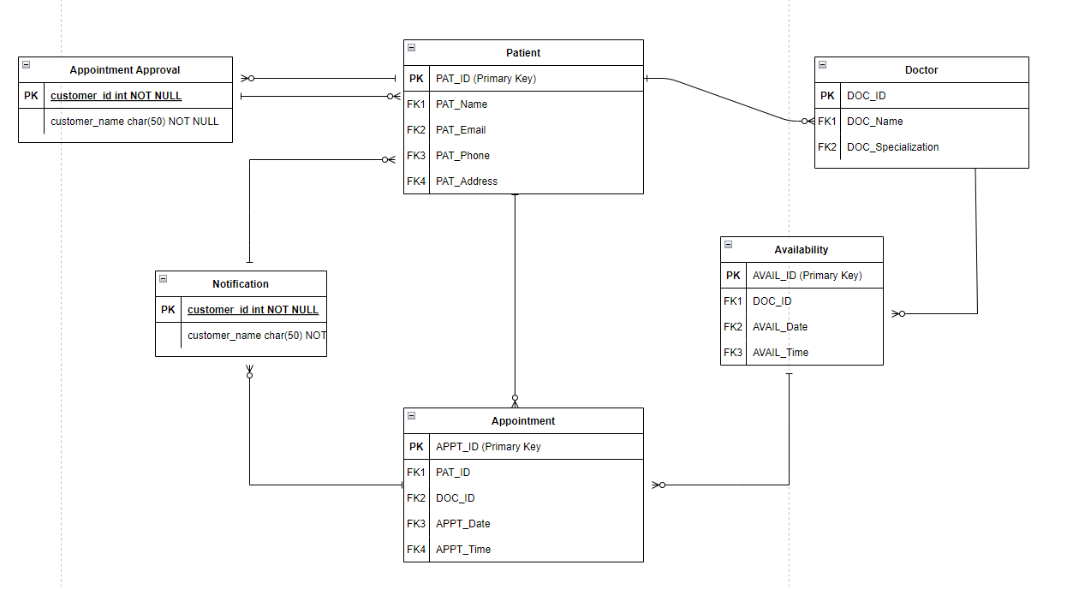

D.2 Case Study Entity Definitions

Entity Definitions
Appointment | An Appointment is a scheduled meeting between a Patient and a Doctor.
Appointment Approval | An Appointment Approval is a confirmation of an Appointment by a Doctor.
Availability | An Availability is a time slot when a Doctor is available to see Patients.
Doctor | A Doctor is a person who provides services to Patients of FCS.
Notification | A Notification is a message sent to a Patient regarding their Appointment.
Patient | A Patient is an individual who receives services from FCS.

D.3 Discussion of the ERD for the Case Study

The ERD illustrates the relationships between entities in the FCS Appointment Scheduling System:
- A Patient schedules an Appointment with a Doctor.
- A Doctor has multiple Availability time slots.
- An Appointment requires Approval from a Doctor.
- A Notification is sent to a Patient regarding their Appointment.

D.4 Corrections for previous SRS.

No corrections were made to the previous Software Requirements Specification (SRS).

Appendix E: Class Diagram
The UML Class Diagram for the Family Clinic System (FCS) is a visual representation of the system's structure. It consists of entities such as Patient, Appointment, Clinical Staff, Receptionist, and Administrator, each with defined attributes and methods. The diagram models relationships among these entities, such as scheduling and rescheduling, and includes multiplicity constraints to define possible connections.

E.1 FCS Class Diagram

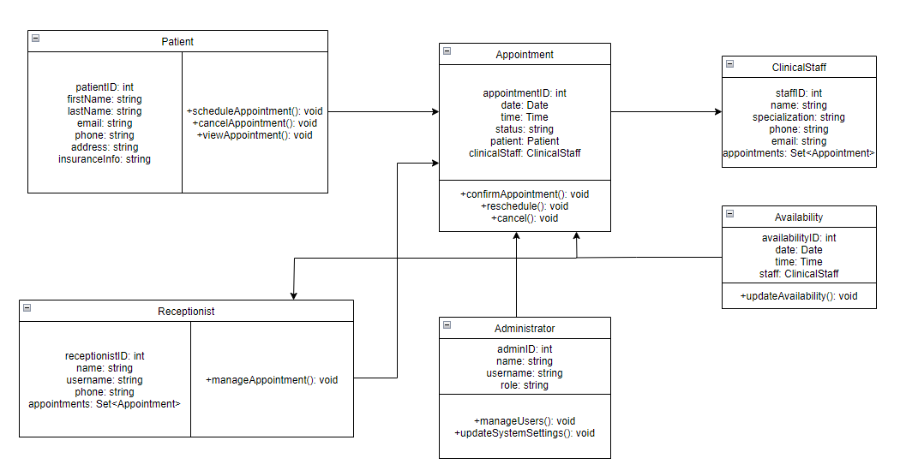

E.2 Class Definitions

Class Name | Definition
Patient | A Patient is a person who is registered with FCS and receives services.
Appointment | An Appointment is a scheduled event between a Patient and Clinical Staff.
Clinical Staff | A Clinical Staff member is a healthcare professional who provides services to patients.
Receptionist | A Receptionist is a staff member who manages appointment scheduling.
Administrator | An Administrator is a user responsible for managing the system, users, and roles.

E.3 FCS Class Diagram Discussion

The FCS Class Diagram provides a clear structural representation of the Family Clinic Services system by defining key classes, their attributes, operations, and relationships. The primary classes include Patient, Appointment, Clinical Staff, Receptionist, and Administrator, each representing roles and processes within the system.

This diagram shows how Patients interact with the system by scheduling, viewing, or canceling appointments, with each appointment linked to both Clinical Staff and Patients. Clinical Staff manage appointments, while Receptionists handle scheduling tasks. Administrators oversee users and roles.

Relationships include:

- A Patient can schedule multiple appointments, but each appointment belongs to only one patient (1..*).
- Each Appointment is managed by a Clinical Staff member and a Receptionist.
- Administrators manage security and user roles.

This class diagram enables data and process alignment, guiding the development user roles and appointment management. It serves as a foundation for building interfaces, forms, and controllers for the FCS Appointment Scheduling System.

